**ST JOSEPH'S BOYS' HIGH SCHOOL**



**27 Museum Road, Bengaluru 560025**

**PROGRESS REPORT**

**Final Examination** ${academic_year}

**STUDENT NAME :** ${student_name}

**CLASS & SECTION :** ${class_section_name}

**REG NO :** ${student_id}

**DATE :** ${date}

|  |  |  |  |  |
| --- | --- | --- | --- | --- |
| **Sl. No** | **Subjects** | **Max. Marks** | **Marks Obtained** | **Grade Obtained** |
| ${serial.all} | ${particulars.all} | ${maxmarks.all} | ${marksobtained.all} | ${gradeobtained.all} |

**PROFILE: CONDUCT AND CO-CURRICULAR ACTIVITIES**

|  |  |
| --- | --- |
| Respectful towards his Teachers | A |
| Sociable in class | A |
| Is focused and concentrates in class | A |
| Personal Appearance | A |
| General Knowledge | C |
| Public Speaking | B |
| Art | A |
| Music | A |
| Physical Education | A |

**ATTENDANCE No. of days attended / No. of working days**

${attendance}

**Teacher's Observation on Performance:**

•Promoted

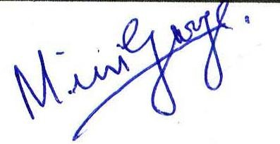

**Parent's Signature Principal's Signature Class Teacher's Signature**

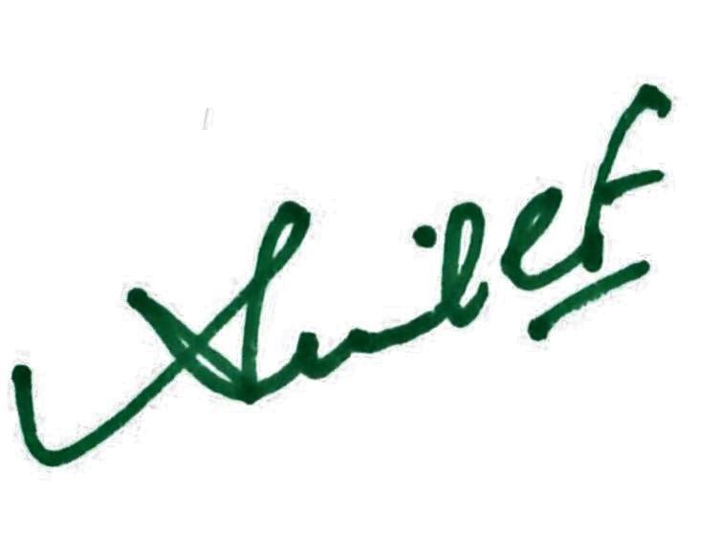

**Academic Grading**

|  |
| --- |
| ${grade_configuration.all} |

**Powered by**

