University of Birmingham
School of Mathematics – MSc Statistical Data Science
Generative vs. Discriminative Classifiers for Financial Sentiment
Ng–Jordan Learning Curves and Minority-Class Recovery on the Financial PhraseBank

Candidate: LUOHUA YANG
Student ID: 2922362
Programme: MSc Statistical Data Science
University: University of Birmingham

Draft Dissertation
Submitted: 21 August 2026
Prepared in accordance with the University of Birmingham MSc dissertation regulations
AI assistance limited to proofreading, typesetting, and formatting in line with institutional policy

Table of Contents
1. Introduction 1
1.1 Motivation: financial sentiment and its difficulty 1
1.2 Generative versus discriminative: the theoretical question 1
1.3 Research questions and contributions 1
2. Background & Related Work 2
2.1 Financial sentiment analysis 2
2.2 Ng–Jordan theory of learning curves 2
2.3 The two classifiers 3
2.3.1 Multinomial Naive Bayes 3
2.3.2 Linear SVM 4
2.4 Classic models in the LLM era 5
2.5 Label noise and class imbalance 5
3. Methodology 6
3.1 Data: the Financial PhraseBank 6
3.2 Preprocessing and features 6
3.3 Models and hyperparameters 7
3.4 RQ1 design: learning curves 7
3.5 RQ2 design: agreement as a label-noise proxy 7
3.6 RQ3 design: recovering the rare negative class 7
3.7 Evaluation 8
4. Experiments & Results 8
4.1 Baseline and overall comparison 8
4.2 RQ1: learning curves 8
4.3 RQ2: robustness to label uncertainty 10
4.4 RQ3: recovering the negative class 12
4.5 Summary of findings 13
5. Discussion 14
5.1 The Ng–Jordan prediction holds under accuracy, but not under macro-F1 14
5.2 The minority class as the persistent weakness of the generative model 15
5.3 Practical implications 16
5.4 Limitations 16
5.5 Future work 16
6. Conclusion 16
Appendix A 19
Error Decomposition of Generative and Discriminative Learning 19
A.1 Setup and the error decomposition 19
A.2 The asymptotic term: the discriminative model is never worse in the limit 19
A.3 The estimation term: why the generative model needs fewer examples 19
A.4 Two regimes and the crossover 20
Appendix B 21
Experimental Configuration 21
B.1 Software and hardware environment 21
B.2 Dataset 21
B.3 Feature pipeline (shared by both models) 21
B.4 Models and configurations 22
B.5 Evaluation protocol 22
B.6 Research-question-specific settings 22
B.7 Reproducibility 22

1. Introduction

1.1 Motivation: financial sentiment and its difficulty
Automated analysis of financial text is highly valuable in the information age, as such text profoundly shapes market movements. In particular, earnings announcements from major corporations (e.g., Apple, Microsoft), analyst reports from top investment banks (e.g., Goldman Sachs, J.P. Morgan), and policy communications from the Federal Reserve and the White House often trigger substantial price fluctuations. Financial sentiment analysis is the task of extracting the polarity of such texts—determining whether a statement conveys positive, neutral, or negative news for a given company.
For general-purpose methods, however, this task is deceptively difficult. Unlike other sentiment analysis settings, financial language frequently inverts everyday semantics: "costs fell" is a positive signal for a company, whereas "profits fell" is negative. A generic sentiment lexicon would systematically misclassify such sentences. Reliable annotation therefore requires domain expertise, making the process both slow and expensive; in our dataset, each Financial PhraseBank sentence was labelled by up to eight finance experts. The consequence is structural: labelled financial text is scarce and is likely to remain scarce.
This scarcity raises a concrete practical question: when studying different companies or news sources, the volume of available textual data varies considerably across entities. With limited data, which model should we choose? Classical statistical learning theory provides a theoretical answer to this question, and the goal of this thesis is to empirically test that answer in the financial domain.

1.2 Generative versus discriminative: the theoretical question
Ng and Jordan (2002) showed that generative classifiers reach their asymptotic error faster than discriminative ones: a generative model's estimation error shrinks roughly as O(log n), while a discriminative model's shrinks as O(n). Their analysis predicts a two-phase picture — the generative model wins on small samples, the discriminative model wins in the large-data limit, and a crossover exists in between. Naive Bayes (NB) and the linear Support Vector Machine (SVM) are the canonical representatives of the two families, and both are cheap, interpretable, and competitive on small text corpora. We deliberately restrict attention to these classic linear models rather than large language models: the regime under study — scarce data — is precisely where LLMs are least practical and least interpretable, and where a theoretically grounded choice matters most (§2.4 returns to this).

1.3 Research questions and contributions
This thesis tests the Ng–Jordan prediction on a real financial corpus — the Financial PhraseBank — through three research questions:
- RQ1 (learning curves). Does the predicted small-sample advantage of the generative model, and the crossover into discriminative dominance, appear in financial sentiment classification — under accuracy, and under macro-F1?
- RQ2 (label uncertainty). Does either model's advantage survive when label quality degrades, using annotator agreement as a proxy for label noise?
- RQ3 (class imbalance). Can the rare negative class be recovered, and which model configuration recovers it best?
The contributions are threefold. First, we provide the first systematic test of the Ng–Jordan prediction on a financial sentiment corpus, showing that it holds under accuracy but not under macro-F1. Second, we localize the generative model's weakness: it degrades sharply on the rare negative class under label uncertainty, while the discriminative model degrades gracefully. Third, we compare four configurations for negative-class recovery and derive actionable guidance for practitioners.
The rest of the thesis is organized as follows. Section 2 reviews financial sentiment analysis, the Ng–Jordan theory, the two classifiers, and the place of classic models in the LLM era. Section 3 describes the data, features, and the design of the three experiments. Section 4 reports the results, Section 5 discusses their meaning and implications, and Section 6 concludes.

2. Background & Related Work

2.1 Financial sentiment analysis
Financial sentiment analysis has developed in two waves. The first wave was dictionary-based: fixed word lists, such as the Loughran–McDonald dictionary built for 10-K filings (Loughran & McDonald, 2011) or Tetlock's media-content measures (Tetlock, 2007), assign polarity by vocabulary lookup. Such methods are transparent and need no labelled data, but they are brittle in the financial domain, where the same word can flip polarity by context — the dictionary cannot know that "costs fell" is good news. The second wave is learning-based: models are trained on manually labelled financial text, which adapts to domain semantics at the price of requiring exactly the scarce annotation discussed in §1.1 (Kumar & Ravi, 2016, survey this line). Our study belongs to the second wave and examines its scarce-data constraint.

2.2 Ng–Jordan theory of learning curves
The theoretical question of this thesis is whether generative or discriminative classifiers should be preferred when data are limited. Ng and Jordan (2002) answer this with a two-stage argument. First, asymptotically — with unlimited data — a discriminative classifier's error is never higher than a generative classifier's, because it directly models the decision boundary rather than the full data-generating distribution. Second, in finite samples the generative classifier's parameter estimates converge faster: roughly O(log n) for the generative model versus O(n) for the discriminative one. The two effects trade off: with little data, the generative model's faster convergence wins despite its worse asymptotic error; with much data, the discriminative model's better asymptotic error dominates. The crossover between the two phases depends on the problem. A formal sketch of this error decomposition (asymptotic term plus estimation term) is given in Appendix A; the body of this thesis uses only the intuitive two-phase picture.
This theory is our test bed: RQ1 asks whether the predicted crossover appears on financial text, and at what sample size.

2.3 The two classifiers
Naive Bayes is the representative generative classifier: it models the joint distribution of features and labels under a conditional-independence assumption, then classifies by Bayes' rule. Despite the assumption being false in practice, NB is near-optimal under zero-one loss in many settings (Domingos & Pazzani, 1997; Zhang, 2004). For text, we use the multinomial variant with Laplace smoothing; the smoothing parameter acts as a prior over class proportions — a detail that becomes central in RQ3 (§3.6). The SVM is the representative discriminative classifier: it learns a maximum-margin decision boundary directly, without modelling the data distribution (Cortes & Vapnik, 1995), and it has long been one of the strongest linear learners for text (Joachims, 1998). We use the linear-kernel form, so that the two models consume identical features and differ only in learning philosophy — generative versus discriminative.

2.3.1 Multinomial Naive Bayes
Naive Bayes classifies by choosing the class that maximises the posterior $P(y∣\text{x})$, which by Bayes' theorem is proportional to
$$\hat{y}=arg⁡\underset{y}{max⁡}P(y)P(\text{x}∣y)\text{.}$$
The "naive" assumption — conditional independence of the features given the class — reduces the joint to a product of univariate terms,
$$P(\text{x}∣y)=\prod_{i=1}^{d}{}x_{i}∣y),$$
so that each class $y$ is described by one distribution per feature $x_{i}$. In the multinomial variant used here, features are word (and 2-gram) counts, and with Laplace smoothing $α$ the class-conditional estimate is
$$P(x_{i}∣y)=\frac{N_{y,i}+α}{N_{y}+αd},$$
where $N_{y,i}$ is the count of feature $i$ in the class-$y$ training sentences, $N_{y}$ the total feature count of class $y$, and $d$ the vocabulary size. The class prior is estimated with the same smoothing,
$$P(y)=\frac{n_{y}+α}{n+αC},$$
where $n_{y}$ is the number of training sentences in class $y$, $n$ the total number of training sentences, and $C$ the number of classes. The parameter $α$ thus interpolates between the empirical class proportions ($α→0$) and a uniform prior ($α→\text{∞}$). This parametrisation makes explicit the direct equivalence between adjusting the smoothing parameter and manipulating the class prior in §3.6: pushing α towards infinity corresponds to imposing a uniform prior over classes, which is precisely the configuration we evaluate against the default empirical prior in RQ3. The same smoothing mechanism that stabilises the per-class feature estimates therefore also governs the class-level bias — a duality that connects the NB implementation directly to the imbalance recovery experiments in §3.6.

2.3.2 Linear SVM
The linear SVM places a separating hyperplane ${\text{w}}^{\text{⊤}}\text{x}+b=0$ in feature space and classifies by its sign. Among all separating hyperplanes it selects the one with the maximum margin — the distance between the boundary and the nearest training points of either class, the support vectors — which for a linearly separable problem solves
$$\underset{\text{w},b}{min⁡}\frac{1}{2}\text{∥}\text{w}{\text{∥}}^{2} \text{subject to} y_{i}({\text{w}}^{\text{⊤}}{\text{x}}_{i}+b)≥1, i=1,…,n,$$
with geometric margin $2\text{/∥}\text{w}\text{∥}$. Because text data is rarely separable, the soft-margin (hinge-loss) form adds slack variables $ξ_{i}$,
$$\underset{\text{w},b,ξ}{min⁡}\frac{1}{2}\text{∥}\text{w}{\text{∥}}^{2}+C\sum_{i=1}^{n}{}ξ_{i}, ξ_{i}=max⁡(0,1-y_{i}({\text{w}}^{\text{⊤}}{\text{x}}_{i}+b)),$$
where $C$ penalises margin violations; we fix $C=1$ (§3.3). Because the hinge loss is zero for correctly classified points away from the boundary, only the support vectors determine the solution — the model concentrates its capacity on the region where the two classes are hardest to separate.

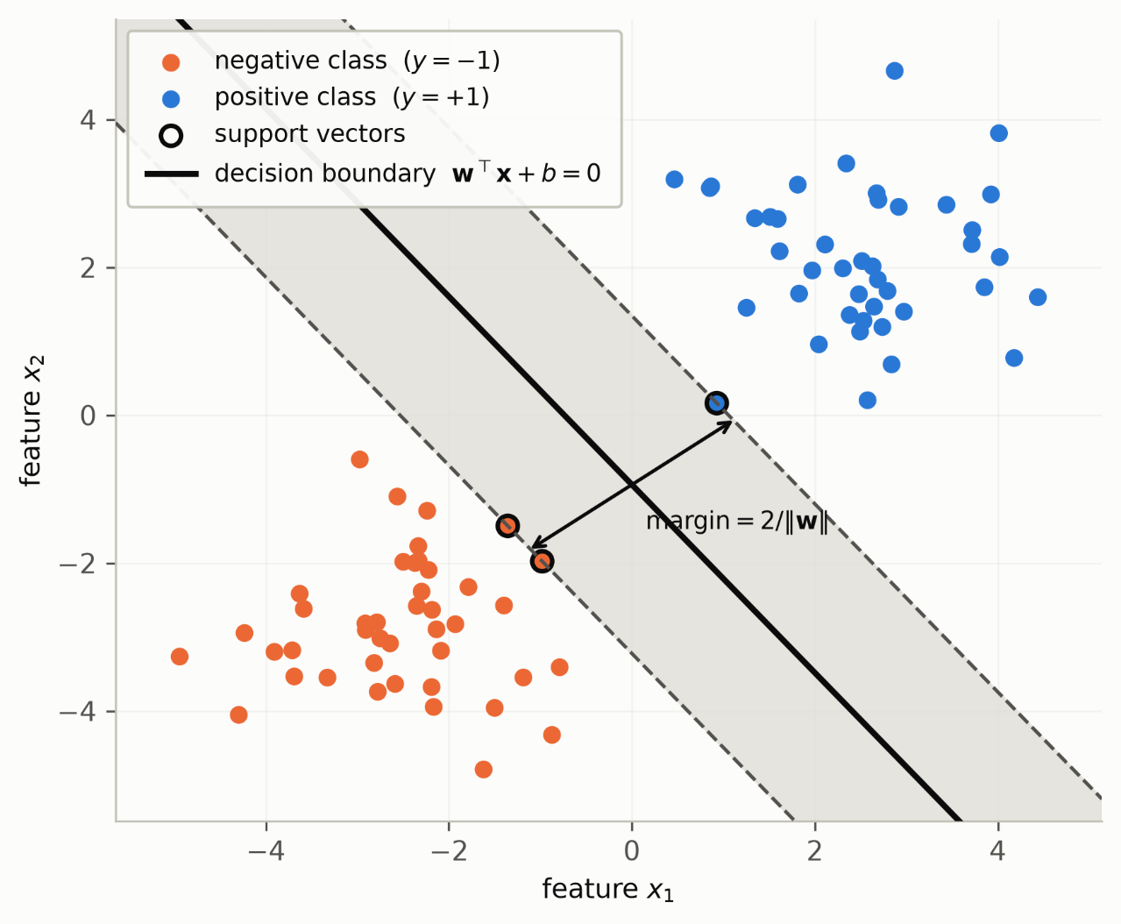

2.4 Classic models in the LLM era
Why study NB and SVM when large language models dominate the field? Three reasons.
First, data: LLMs need large in-domain corpora to fine-tune, and the entire PhraseBank is smaller than a single paragraph of a modern pretraining corpus — in the regime this thesis studies, LLM fine-tuning is often not even applicable.
Second, cost and reproducibility: NB and SVM train in seconds on a laptop, with deterministic, fully documented configurations (Appendix B), whereas LLM results depend on sampling, decoding, and prompt choices.
Third, interpretability: the linear decision boundary and class-conditional probabilities are directly inspectable, which matters in regulated financial settings. This is not to claim classic models beat LLMs; it is to claim the question "which classic model, and under what data conditions" is still the one that is practically answerable for scarce, high-stakes financial text (cf. Wang & Manning, 2012, on strong simple linear baselines).

2.5 Label noise and class imbalance
Two further properties of real financial data complicate the picture. The first is label noise: human annotation is imperfect, and disagreement between annotators is a well-documented source of label uncertainty (Frénay & Verleysen, 2014). The second is class imbalance: in financial text, negative statements — often the most decision-relevant — are typically the rarest class (He & Garcia, 2009). Both problems have rich literatures, but they are usually studied on synthetic datasets. The Financial PhraseBank offers a natural joint experimental field: because every sentence was annotated 5–8 times by finance experts, the dataset ships with an agreement score, and its four nested agreement subsets (2,264 / 3,453 / 4,217 / 4,846 sentences at 100% / 75% / 66% / 50% agreement thresholds) provide graded label uncertainty, while its negative class forms only 12.5% of the data. This combination lets us study label noise and class imbalance in a real financial corpus with no artificial corruption — the setting of §3.

3. Methodology

3.1 Data: the Financial PhraseBank
We use the Financial PhraseBank (Malo et al., 2014), a corpus of 4,846 English sentences sampled from financial news, each annotated for polarity — positive, neutral, or negative — from the perspective of a stock investor ("does this news affect the company's share price?"). Annotation was performed by 16 finance professionals (3 researchers and 13 MSc finance students), with every sentence annotated 5–8 times. Crucially for this thesis, the corpus publishes an agreement score per sentence; the four nested agreement subsets — 2,264 sentences on which all annotators agree, and 3,453 / 4,217 / 4,846 at the 75% / 66% / 50% thresholds — form the experimental field for RQ2. Class distribution is strongly imbalanced: neutral 59.4%, positive 28.1%, negative 12.5% (Table 1).

Table 1 — Financial PhraseBank agreement subsets and class distribution.

subset | agreement threshold | n | positive | neutral | negative
AllAgree | 100% | 2,264 | 570 | 1,391 | 303
75Agree | >75% | 3,453 | 887 | 2,146 | 420
66Agree | >66% | 4,217 | 1,168 | 2,535 | 514
50Agree | >50% | 4,846 | 1,363 | 2,879 | 604

3.2 Preprocessing and features
Both models consume an identical feature pipeline: TF-IDF vectors over word 1- and 2-grams, with min_df=2, sublinear term frequency, and English stopwords removed. Sharing one vectorizer is a deliberate fairness decision: any performance difference between NB and SVM can then be attributed to the learning algorithm, not to feature engineering (full configuration in Appendix B).

3.3 Models and hyperparameters
We train a multinomial Naive Bayes with Laplace smoothing α=1 (the default prior), and a linear Support Vector Machine (LinearSVC) with C=1, both from scikit-learn. We deliberately fix hyperparameters at their defaults rather than tuning them per model, so that the comparison reflects the two learning philosophies as used out of the box — the situation of a practitioner with scarce data, who cannot afford a tuning loop either.

3.4 RQ1 design: learning curves
RQ1 asks whether the Ng–Jordan crossover appears in financial sentiment classification. We construct learning curves by stratified 80/20 splitting, holding out a fixed test set, and training on increasing subsets of the remaining data at sizes [32, 64, 128, 256, 512, 1024, 2048, 3876], across 5 random seeds. As the primary mode, each training subset is drawn within a single agreement stratum (per-subset), matching how a practitioner would collect data of a given quality; as a robustness check, we also train on fixed-pool random samples across all agreement levels. We report accuracy, which mirrors the 0–1 error of the Ng–Jordan framework, and macro-F1, which treats the rare negative class as equally important.

3.5 RQ2 design: agreement as a label-noise proxy
RQ2 asks how the two models behave as label quality degrades, using the agreement strata as a proxy for label noise. Three layers of evidence isolate the effect. (a) Within-subset cross-validation: train and test inside each agreement subset, measuring the joint effect of data quantity and label uncertainty. (b) A fixed clean test set: train on each agreement subset but always evaluate on a held-out 20% of the all-agreement sentences, which removes test-set difficulty from the comparison. (c) Fixed-size disjoint intervals: with n fixed at 600, non-overlapping agreement bands (all / 75–100% / 66–75% / 50–66%) isolate label certainty from data quantity entirely.
We treat agreement as an operationalization of label noise, and this is an assumption, not a fact: low agreement need not equal random label corruption — it may reflect that the sentence itself is genuinely harder, and our agreement bands are nested, so lower thresholds also admit more data. Design (c) removes the data-quantity confound, and design (b) separates "labels are wrong" from "test sentences are harder", but the proxy limitation remains: results in this section are evidence about low-consensus text, which we interpret as label uncertainty under this stated assumption.

3.6 RQ3 design: recovering the rare negative class
RQ3 asks whether the 12.5% negative class can be recovered. We compare four configurations: NB with its empirical class prior (the default) versus a uniform prior — the smoothing hook from §2.3 — and SVM without versus with balanced class weights. The uniform prior and balanced weights are the textbook remedies for imbalance (He & Garcia, 2009), and the question is which model family converts them into a better recovered minority class. We report negative-class F1 and recall (the recovery targets), plus macro-F1 and accuracy.

3.7 Evaluation
All main results use stratified 10-fold cross-validation with 5 random seeds, reported as mean ± standard deviation; the RQ1 learning curves use the fixed held-out protocol described in §3.4. Every number below is reproducible from the pinned configuration in Appendix B.

4. Experiments & Results

4.1 Baseline and overall comparison
Table 2 reports the full-scale comparison on the whole corpus (10-fold CV, 5 seeds). SVM outperforms NB on both metrics: accuracy 0.757 vs 0.698 (+0.059), and macro-F1 0.691 vs 0.515 (+0.175). The macro-F1 gap is nearly three times the accuracy gap. This baseline frames the two questions below: whether the gap ever closes at small scale (RQ1), and whether it is driven by the negative class (RQ2, RQ3).
Table 2 — Baseline comparison on the full 50% agreement corpus (stratified 10-fold CV, mean over 5 seeds).

model | accuracy | macro-F1
NB (Multinomial, $α=1$) | 0.698 | 0.515
SVM (LinearSVC, $C=1$) | 0.757 | 0.691

4.2 RQ1: learning curves
Accuracy (Fig. 1). The learning curves show the predicted two-phase pattern. NB is ahead at every size up to n=256 (0.600 vs 0.576 at n=32; 0.641 vs 0.636 at n=256); the largest generative lead is 0.046 at n=64. At n=512, SVM overtakes (0.659 vs 0.657), and the lead widens with data. The crossover therefore lies between n≈256 and 512, and it occurred in all 5 seeds.

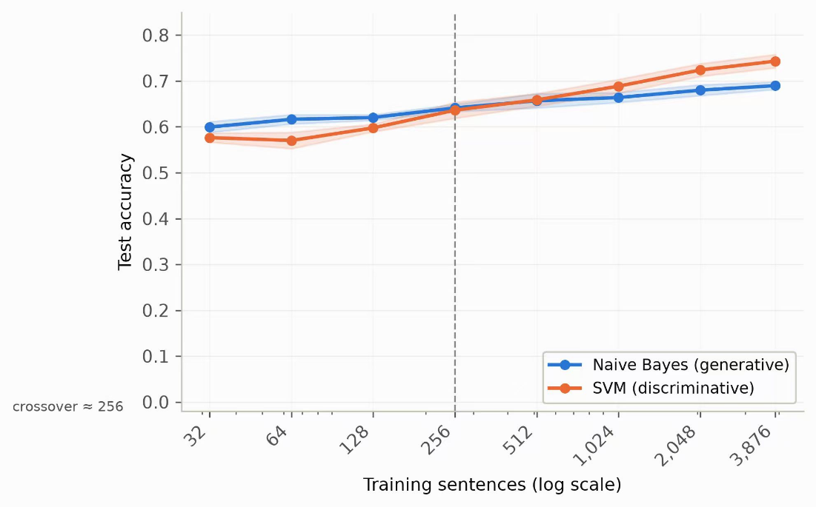
Figure 1: Test accuracy of NB (blue) and SVM (orange) as a function of the number of training sentences (log scale), evaluated on a fixed 20% held-out test set from the 50% agreement corpus, per-subset feature mode. Mean over 5 stratified splits; shaded bands are ±1 SD. The dashed line marks the crossover at which SVM accuracy first reaches or exceeds that of NB, between 256 and 512 training sentences.
Macro-F1 (Fig. 2). Under macro-F1 the picture is different: SVM leads at every scale, from 0.389 vs 0.317 at n=32 to 0.681 vs 0.501 at full data, with no crossover.
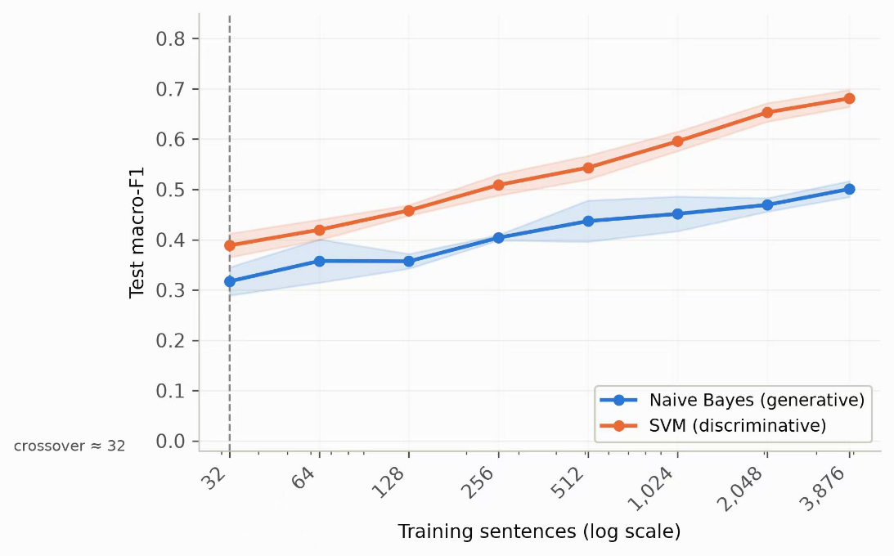
Figure 2: As in Figure 1, but reporting macro-averaged F1. SVM macro-F1 is higher than NB at every training size in the range 32–3876.

Robustness. In the fixed-pool mode, the small-sample NB lead in accuracy also disappears: SVM matches or leads from n=32 onward (0.596 vs 0.594). One phenomenon is worth noting: the NB small-sample advantage is present in per-subset mode but absent in fixed-pool mode; its explanation is deferred to §5.

4.3 RQ2: robustness to label uncertainty
(a) Within-subset CV (Fig. 3). As the agreement threshold relaxes from 100% to 50% — and the data grow from 2,264 to 4,846 sentences — macro-F1 falls for both models: NB from 0.623 to 0.515, SVM from 0.802 to 0.691. The performance drop despite more data indicates that the label-uncertainty effect dominates the data-quantity effect.
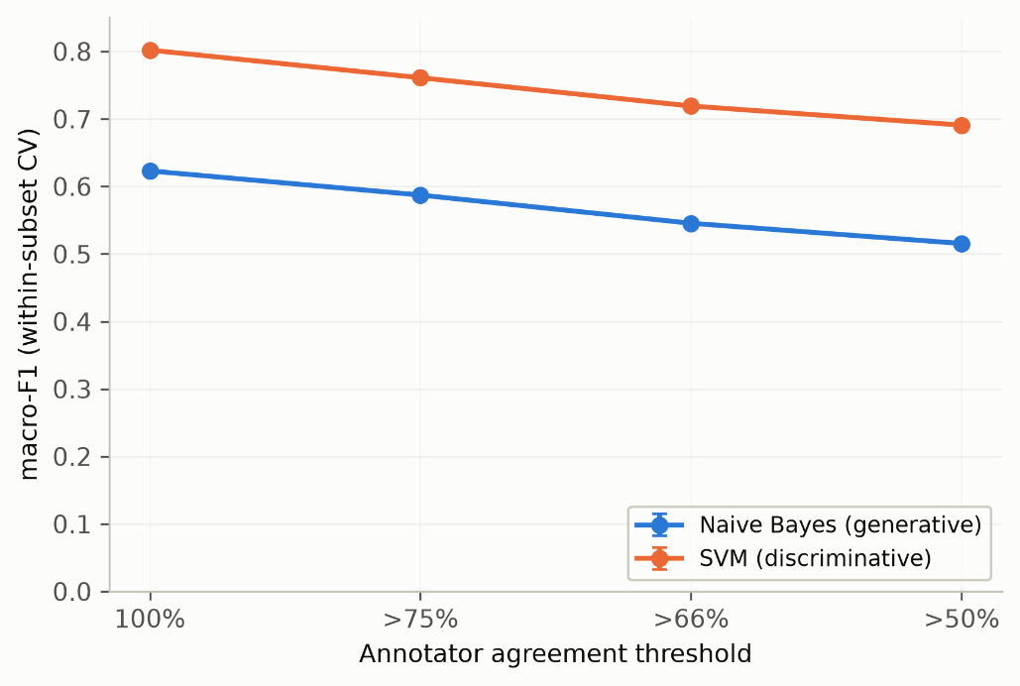
Figure 3: macro-F1 from stratified 10-fold CV, computed separately within each agreement subset (100%, >75%, >66%, >50%). Error bars are standard deviations across 5 seeds. The subsets are nested: lower thresholds contain more sentences with labels of lower consensus.

(b) Fixed clean test set (Fig. 4). Trained on degraded subsets but tested on clean all-agreement sentences, both models are nearly flat: SVM 0.766 → 0.777, NB 0.607 → 0.626. The low-agreement labels are thus mostly correct in absolute terms; the within-subset decline of (a) partly reflects harder test sentences rather than wrong labels.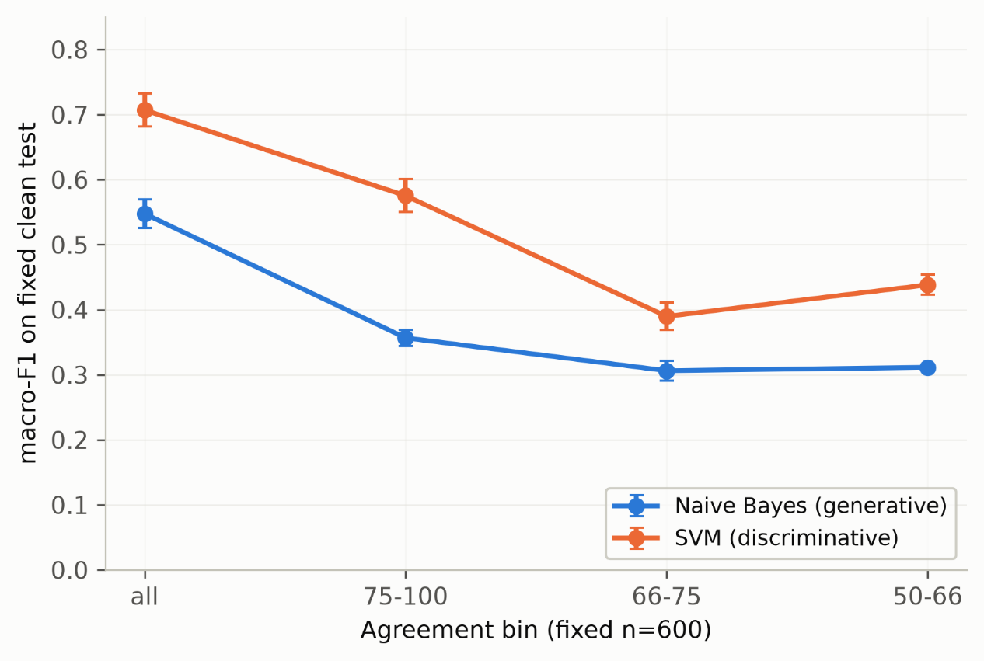
Figure 4: macro-F1 on a fixed clean test set (20% hold-out of the 100% agreement subset) for models trained on each of the four agreement subsets (test sentences excluded from training). Error bars are standard deviations across 5 seeds.

(c) Fixed n=600 intervals (Fig. 5, Table 3). With sample size held constant, agreement is decisive: macro-F1 drops monotonically from the all band to the 66–75% band — NB 0.548 → 0.357 → 0.306 → 0.312; SVM 0.707 → 0.575 → 0.390 → 0.438. The most striking number is in the negative class: NB's negative-class F1 falls to 0.000 in the 66–75% band, with recall exactly zero — it labels no negative sentence correctly — while SVM's negative-class F1, though also declining (0.561 → 0.332), never approaches collapse.

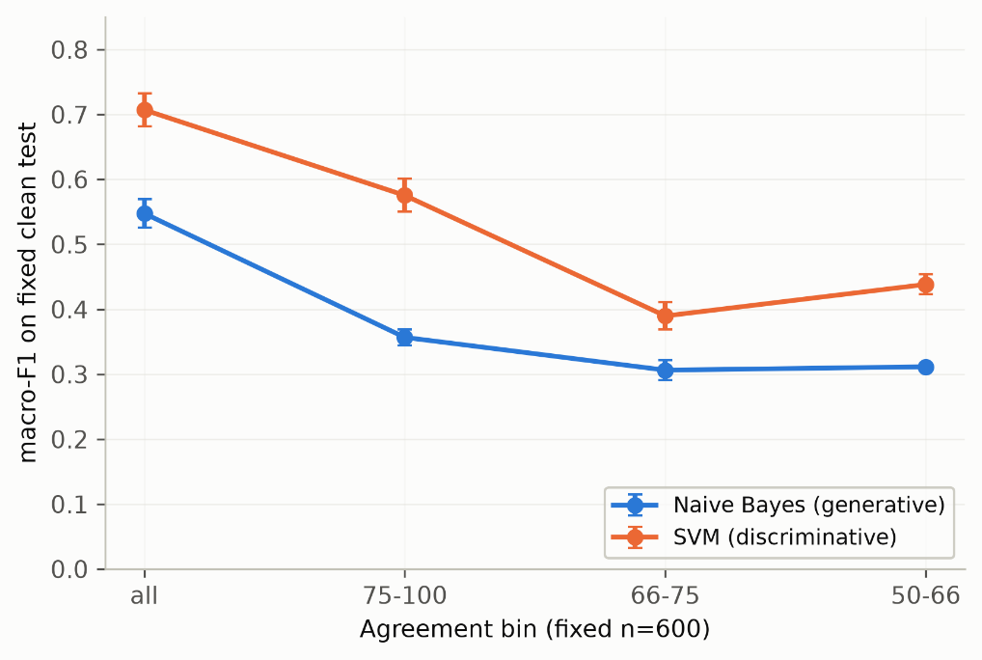
Figure 5: macro-F1 on the same fixed clean test set for models trained on 600 sentences drawn from each of the four non-overlapping agreement bins (all, 75–100%, 66–75%, 50–66%), stratified by class. Error bars are standard deviations across 5 seeds.

Table 3 — RQ2 across the three experimental layers (macro-F1, mean over 5 seeds).
layer | NB (all → 50) | SVM (all → 50)
(a) within-subset CV | 0.623 → 0.515 | 0.802 → 0.691
(b) fixed clean test | 0.607 → 0.626 | 0.766 → 0.777
(c) fixed n = 600 | 0.548 → 0.312 | 0.707 → 0.438

4.4 RQ3: recovering the negative class
Table 4 — RQ3: class-imbalance recovery configurations (stratified 10-fold CV, mean over 5 seeds).
configuration | accuracy | macro-F1 | neg F1 | neg recall | neg precision
NB, empirical prior | 0.698 | 0.515 | 0.256 | 0.151 | 0.891
NB, uniform prior | 0.714 | 0.632 | 0.513 | 0.456 | 0.591
SVM, unweighted | 0.757 | 0.691 | 0.598 | 0.516 | 0.717
SVM, balanced | 0.752 | 0.695 | 0.612 | 0.582 | 0.650

Table 4 and Fig. 6 report the four configurations. With the default empirical prior, NB catches only 15.1% of negative sentences (negative recall 0.151, F1 0.256, precision 0.891 — high precision, low recall) and reaches macro-F1 0.515, accuracy 0.698. The uniform prior changes the picture: negative recall triples to 0.456, negative F1 rises to 0.513, macro-F1 to 0.632 (+0.117), and — unusually — accuracy also rises, to 0.714 (+0.016). SVM without weights already reaches negative F1 0.598 and recall 0.516; balanced weights add a further 0.066 recall (F1 0.612) at a cost of 0.005 accuracy. The best recovered configuration is SVM with balanced weights (negative F1 0.612), which still beats NB with a uniform prior (0.513) by a wide margin.
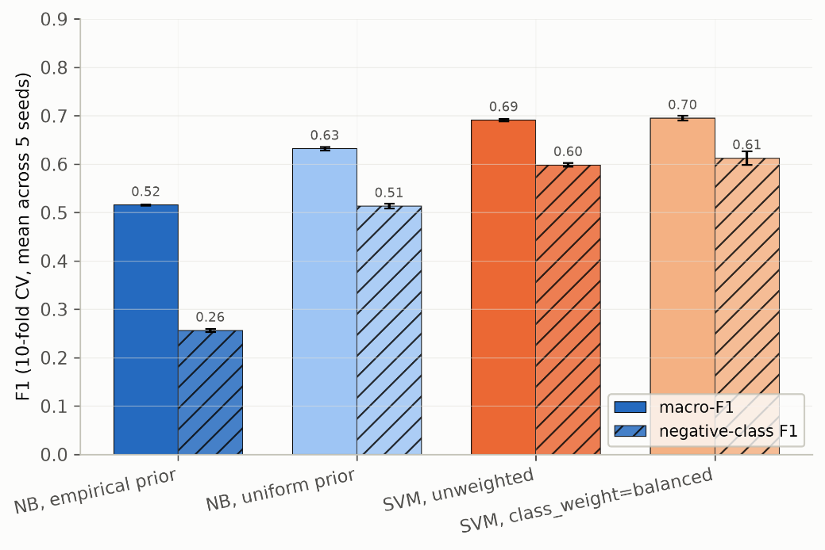
Figure 6: macro-F1 (solid bars) and negative-class F1 (hatched bars) from stratified 10-fold CV on the full 50% agreement corpus, for four configurations: NB with empirical and uniform priors; SVM unweighted and with class_weight='balanced'. Error bars are standard deviations across 5 seeds.

4.5 Summary of findings
Table 5 — Summary of research questions and main findings.
RQ | question | key finding
RQ1 | sample size | crossover at $n≈256$–512 under accuracy; SVM leads at all sizes under macro-F1
RQ2 | label agreement | performance falls as agreement falls even as $n$ grows; NB negative class collapses (neg-F1 $→$ 0)
RQ3 | class imbalance | NB uniform prior: neg-F1 0.256 $→$ 0.513; SVM balanced best at 0.612

Table 5 consolidates the three RQs. Under accuracy, the Ng–Jordan crossover appears between n≈256 and 512. Under macro-F1, SVM leads at all scales. Under label uncertainty, NB's negative class collapses (F1 0.000) while SVM degrades gracefully. Under imbalance, prior adjustment rescues NB but balanced-weight SVM remains the strongest configuration.
The three results lines converge on a single pattern: Across all three research questions, the discriminative model's advantage over the generative model consistently — and almost exclusively — localises to the rare negative class: macro-F1 at full data (0.681 vs 0.501), negative-class F1 under low agreement (0.332 vs 0.000), and even after prior adjustment (0.612 vs 0.513) all point to the same locus.

5. Discussion

5.1 The Ng–Jordan prediction holds under accuracy, but not under macro-F1
The results give a split verdict on the Ng–Jordan theory. Under accuracy, the prediction is confirmed: NB leads on small samples, the crossover appears between n≈256 and 512, and SVM dominates thereafter (Fig. 1) — and the crossover is stable across all five seeds. Under macro-F1, the prediction fails: SVM leads at every scale, with no crossover (Fig. 2).
The same data thus tell two different stories depending on the evaluation metric. This is not a contradiction in the measurements; it is a reflection that the two metrics ask fundamentally different questions. Accuracy — the 0–1 error rate that Ng and Jordan analyse theoretically — weights every instance equally. Macro-F1, by contrast, weights each class equally before averaging, so the performance of the smallest class contributes as much to the final score as the largest, despite having far fewer instances.
Where does the generative model's weakness lie? The evidence across RQ1–RQ3 points consistently to the rare negative class. Under accuracy, NB's poor negative-class performance is numerically invisible: the negative class constitutes only 12.5% of the data, so even if the model systematically underpredicts it, the overall error rate changes little. Under macro-F1, that same weakness is fully exposed — NB trails SVM at full data by a wide margin (0.501 vs 0.681), a gap nearly three times the accuracy gap (Table 2). RQ2 sharpens the picture: when label certainty drops, NB's negative class collapses to F1 0.000 with zero recall, while SVM holds a floor (0.332). RQ3 confirms the diagnosis: NB's default empirical prior captures only 15.1% of negative sentences, a blind spot that accuracy hides but macro-F1 amplifies.
This split verdict does not refute the Ng–Jordan theory. Rather, it identifies a boundary condition on it. The theory's prediction — generative models win on small samples — is framed in 0–1 error, and under that metric it holds on financial text. The prediction fails under macro-F1 because the metric shifts the objective from per-instance correctness to per-class balance, and the generative model's faster convergence does not compensate for its systematic weakness on the rarest class. In other words, the generative small-sample advantage survives when errors are counted per instance, and disappears when rare classes are counted per class. The minority class — the negative class — is the thread that runs through all three RQs, and it is to this thread that we now turn.

5.2 The minority class as the persistent weakness of the generative model
All three results lines converge on one pattern. RQ1: under macro-F1, NB trails at every scale (0.501 vs 0.681 at full data), a gap that accuracy hides. RQ2: when label certainty drops, NB's negative class collapses to F1 0.000 with zero recall, while SVM holds a floor. RQ3: even with a uniform prior tripling NB's negative recall (0.151 → 0.456), NB (negative F1 0.513) never catches the default SVM (0.598), let alone the balanced one (0.612). The pattern is unmistakable: across sample size, label quality, and prior configuration, the generative model's weakness consistently localises to the rare negative class.
Why is this so? The answer lies in how the two learning philosophies handle class-specific estimation. NB models the joint distribution P(x, y) by estimating a separate class-conditional distribution P(x | y) for each class. For the negative class — only 12.5% of the data — the estimate is based on an order of magnitude fewer training examples than for the neutral class. With scarce data, the class-conditional parameters for the minority class are inherently high-variance. The Laplace smoothing parameter α, which interpolates between the empirical prior and a uniform prior, further compounds this: with the default empirical prior, the classifier's decisions are already tilted toward the majority classes before any feature evidence is considered. A negative sentence must therefore provide unusually strong evidence to overcome this prior bias — which explains the default NB's characteristic pattern of high precision (0.891) but extremely low recall (0.151): it only predicts negative when it is virtually certain.
SVM, by contrast, does not model class distributions at all. It directly learns a decision boundary by minimising hinge loss, which is determined only by points near the margin — the support vectors. The class prior does not enter the objective; the boundary is placed to maximise separation, not to match observed class proportions. Moreover, the cost parameter C (or class-specific costs, as in the balanced-weight configuration) can directly penalise misclassifications of the minority class more heavily, shifting the boundary toward the negative region without compromising the model's global geometry. This asymmetry in how the two models handle class-specific costs — implicit in NB's prior, explicit in SVM's hinge loss — is the structural reason for the generative model's persistent minority-class weakness.
The practical implication is direct. In financial text, the negative class is typically the risk signal — credit downgrades, profit warnings, regulatory actions — and it is precisely this signal that the default generative model misses. This is not a bug in the implementation; it is a consequence of the generative learning philosophy itself. Any classifier that models each class's distribution separately will, under class imbalance, allocate its estimation capacity disproportionately across classes; the rarest class inevitably receives the weakest estimate. The discriminative approach, by ignoring class distributions and focusing only on the boundary, sidesteps this problem. The question, then, is not whether a generative model can be fixed — the uniform prior does improve it substantially — but whether its inherent minority-class weakness can be overcome enough to match a discriminative model. The evidence from RQ3 suggests that while prior adjustment rescues NB, it does not close the gap: the best recovered NB (0.513) still falls short of even the default SVM (0.598), let alone the balanced one (0.612). The generative model's blind spot sits exactly where the financial practitioner's attention is most urgently needed.

5.3 Practical implications
Two recommendations follow. First, for risk-sensitive financial applications — credit news screening, short-side monitoring, early warning — the negative class is the signal, and SVM with balanced weights is the safer default: it recovered negative F1 0.612 at a 0.005 accuracy cost (§4.4), and it degrades gracefully rather than collapsing under label uncertainty (§4.3). Second, in genuinely small-data settings (n below a few hundred), a generative model is not a mistake: NB with a uniform prior delivered a free lunch — negative recall 0.456 (×3) and accuracy +0.016 (§4.4) — and its class-conditional probabilities are directly interpretable. A third, broader lesson is about data quality rather than quantity: with n fixed at 600, agreement determined macro-F1 more than anything else (SVM 0.707 → 0.438 from the all band to 50–66%), so a practitioner should spend annotation effort on consensus-building before adding more sentences.

5.4 Limitations
Four limitations bound this study. First, the agreement-based operationalization is a proxy for label noise, not random corruption; low-agreement text may be genuinely harder, and our interpretation rests on the assumption stated in §3.5. Second, all evidence comes from a single corpus, PhraseBank, and a single language. Third, we compare only two linear models with fixed default hyperparameters; no tuning was performed, and no significance tests accompany the differences reported in §4 — although the cross-over is stable across all five seeds, the small-sample intervals (n ≤ 256) are noisy. Fourth, per-subset training couples data quality with data quantity; we decoupled them in design (c), but the 66–75% band's NB collapse deserves replication on other agreement-stratified corpora before being generalized.

5.5 Future work
Future work could extend this study in several directions. First, replicating the same experimental design on additional financial corpora (e.g., Reuters news, SEC filings, earnings call transcripts) and in other languages would test the generalisability of our findings beyond the PhraseBank. Second, as data become more abundant, it would be valuable to compare these classic linear models against deep-learning baselines (e.g., fine-tuned BERT) and small LLMs (e.g., LLaMA, Mistral) to assess whether the generative–discriminative trade-off persists at scale or is superseded by representation learning. Third, refining the label-noise proxy with per-sentence difficulty models (e.g., using annotator entropy or response times) could disentangle ambiguity from corruption, providing a cleaner test of how each model handles genuine uncertainty. Fourth, extending the analysis to a regression formulation (predicting sentiment intensity rather than discrete polarity) would probe whether the minority-class weakness of generative models also appears in continuous-output settings. Finally, investigating whether this minority-class degradation generalises to other imbalanced text classification tasks (e.g., fraud detection, medical triage) would clarify whether the phenomenon is domain-specific or structural to the generative learning philosophy.

6. Conclusion

This thesis asked whether the choice between a generative and a discriminative classifier matters on financial text, and the answer is yes — in ways that are specific, measurable, and actionable.
RQ1 (learning curves). Under accuracy, the Ng–Jordan prediction holds on the Financial PhraseBank: NB leads at small training sizes, the crossover occurs between n≈256 and 512, and SVM dominates beyond it. Under macro-F1, the prediction does not hold: SVM leads at every scale, 0.681 vs 0.501 at full data.
RQ2 (label uncertainty). Using annotator agreement as a proxy for label noise, both models degrade as agreement drops, but asymmetrically: NB's negative class collapses to F1 0.000 at the 66–75% band with zero recall, while SVM retains a floor of 0.332. With sample size held constant, agreement was the dominant factor — SVM macro-F1 fell from 0.707 to 0.438 between the cleanest and noisiest bands.
RQ3 (class imbalance). The rare negative class can be recovered by configuration, not just by model choice: a uniform prior tripled NB's negative recall (0.151 → 0.456) and raised its macro-F1 by 0.117 — while also raising accuracy — yet SVM with balanced weights remained the strongest overall configuration (negative F1 0.612).
Two recommendations follow for practitioners. In risk-sensitive applications where negative news is the signal, use a discriminative model with class weighting. In small-data settings where interpretability and cost matter, NB with a uniform prior is a defensible and nearly free choice. And one broader lesson: in this domain, the quality of labels outranks the quantity of data.
On financial text, generative and discriminative classifiers are not interchangeable; the theory that separates them predicts where each wins, and the negative class decides the rest.

References
Cortes, C. and Vapnik, V. (1995) 'Support-vector networks', Machine Learning, 20(3), pp. 273–297. doi: 10.1007/BF00994018.
Domingos, P. and Pazzani, M. (1997) 'On the optimality of the simple Bayesian classifier under zero-one loss', Machine Learning, 29(2–3), pp. 103–130. doi: 10.1023/A:1007413511361.
Frénay, B. and Verleysen, M. (2014) 'Classification in the presence of label noise: A survey', IEEE Transactions on Neural Networks and Learning Systems, 25(5), pp. 845–869.
Galar, M., Fernández, A., Barrenechea, E., Bustince, H. and Herrera, F. (2012) 'A review on ensembles for the class imbalance problem: Bagging-, boosting-, and hybrid-based approaches', IEEE Transactions on Systems, Man, and Cybernetics, Part C (Applications and Reviews), 42(4), pp. 463–484. doi: 10.1109/TSMCC.2011.2161285.
He, H. and Garcia, E. A. (2009) 'Learning from imbalanced data', IEEE Transactions on Knowledge and Data Engineering, 21(9), pp. 1263–1284. doi: 10.1109/TKDE.2008.239.
Joachims, T. (1998) 'Text categorization with support vector machines: Learning with many relevant features', in Nédellec, C. and Rouveirol, C. (eds.) Machine Learning: ECML-98. Berlin: Springer (Lecture Notes in Computer Science, vol. 1398), pp. 137–142. doi: 10.1007/BFb0026683.
Kumar, B. S. and Ravi, V. (2016) 'A survey of the applications of text mining in financial domain', Knowledge-Based Systems, 114, pp. 128–147.
Loughran, T. and McDonald, B. (2011) 'When is a liability not a liability? Textual analysis, dictionaries, and 10-Ks', The Journal of Finance, 66(1), pp. 35–65. doi: 10.1111/j.1540-6261.2010.01625.x.
Malo, P., Sinha, A., Korhonen, P., Wallenius, J. and Takala, P. (2014) 'Good debt or bad debt: Detecting semantic orientations in economic texts', Journal of the Association for Information Science and Technology, 65(4), pp. 782–796. doi: 10.1002/asi.23062.
Ng, A. Y. and Jordan, M. I. (2002) 'On discriminative vs. generative classifiers: A comparison of logistic regression and naive Bayes', in Advances in Neural Information Processing Systems 14. Cambridge, MA: MIT Press, pp. 841–848.
Pedregosa, F., Varoquaux, G., Gramfort, A. et al. (2011) 'Scikit-learn: Machine learning in Python', Journal of Machine Learning Research, 12, pp. 2825–2830.
Tetlock, P. C. (2007) 'Giving content to investor sentiment: The role of media in the stock market', The Journal of Finance, 62(3), pp. 1139–1168. doi: 10.1111/j.1540-6261.2007.01232.x.
Vapnik, V. N. (1998) Statistical Learning Theory. New York: Wiley. ISBN 0-471-03003-1.
Wang, S. and Manning, C. D. (2012) 'Baselines and bigrams: Simple, good sentiment and topic classification', in Proceedings of the 50th Annual Meeting of the Association for Computational Linguistics (Volume 2: Short Papers). Jeju Island, Korea: Association for Computational Linguistics, pp. 90–94.
Zhang, H. (2004) 'The optimality of naive Bayes', in Proceedings of the Seventeenth International Florida Artificial Intelligence Research Society Conference (FLAIRS 2004). Menlo Park, CA: AAAI Press, pp. 562–567.

Appendix A

Error Decomposition of Generative and Discriminative Learning
This appendix sketches the formal error decomposition underlying §2.2 — the asymptotic term versus the estimation term whose trade-off produces the crossover between generative and discriminative classifiers.

A.1 Setup and the error decomposition
Notation. Let $P(X, Y)$ be a joint distribution over inputs $X$ and $C$ class labels $Y$ (here $C = 3$), and let the training set consist of $m$ independent examples drawn from $P$. A classifier $h$ incurs the 0–1 risk
$$ε(h) = Pr[h(X) ≠ Y]$$
where the probability is over $(X, Y)$ drawn from $P$. Write $ε^{*}$ for the Bayes error — the minimal risk over all measurable classifiers. Fix a model family and a learning rule that maps a sample of $m$ examples to a classifier; let $h_{m}$ denote the classifier returned from such a sample, and $h_{∞}$ the rule's infinite-data (population) limit within the family, i.e. the classifier the rule would produce from unlimited data. The expected risk of the finite-sample classifier decomposes as
$$E_{S}[ε(h_{m})] = [ε(h_{∞}) - ε^{*}] + E_{S}[ε(h_{m}) - ε(h_{∞})]$$
The first bracket is the asymptotic term: how far the family's population solution sits above the Bayes error. It depends only on the family and the true distribution, not on the sample size. The second bracket is the estimation term: how far the finite-sample solution sits above its own asymptote — the part that shrinks as $m$ grows. Ng and Jordan (2002) show that generative and discriminative families differ on both axes: the discriminative family has the smaller asymptotic term, while the generative family's estimation term vanishes faster. The two claims below restate their results in the form used in §2.2.

A.2 The asymptotic term: the discriminative model is never worse in the limit
The families are first compared with unlimited data, within a fixed family of linear classifiers. The discriminative rule — logistic regression in the original theory, the linear SVM in this thesis (§2.3) — optimises the decision boundary directly and converges to the best classifier in the linear class. The generative rule, naive Bayes, converges to the classifier induced by the true class-conditional probabilities under the conditional-independence assumption; since the naive Bayes decision boundary is linear in the features, this classifier is itself a member of the linear class. The asymptotic comparison (Prop. 1 of Ng and Jordan, 2002) is then immediate:
$$ε(h_{∞}^{disc}) ≤ ε(h_{∞}^{gen})$$
Equivalently: when the conditional-independence assumption holds for the true distribution, the two population classifiers coincide at the Bayes error; when it fails, the generative classifier is constrained by an incorrect structural assumption, while the discriminative classifier is not. Asymptotically, therefore, the discriminative model can never be worse — it may only be better.

A.3 The estimation term: why the generative model needs fewer examples
With finite data the two families separate, and the decisive quantity is the number of free parameters, which the original paper denotes by $n$. In our setting $n$ is of the order of the vocabulary size, and both families have on the order of $n$ parameters — one weight per feature for the discriminative model, one class-conditional probability per feature and class for the generative one. (Here $n$ is a model dimension, not a sample size; the sample size is denoted $m$ throughout.) The families differ in how the parameters are estimated.
Generative model: decoupled estimation. The naive Bayes parameters are the class-conditional probabilities $P(x_{j} | y)$, estimated independently, one class and one feature at a time, by relative-frequency counting on that class's own examples. Each estimate is a one-dimensional Bernoulli mean: by Hoeffding's inequality, to be within $δ$ of the true probability with probability at least 1 − $η'$ requires $O(δ^{-2} log(\frac{1}{η^{'}})$ examples of that class. All $n$ parameters must be accurate simultaneously; a union bound over them replaces $η'$ by $\frac{η}{n}$, and the total requirement is
$$m_{gen} = O(δ^{-2} log(\frac{n}{η}))$$
The required sample size therefore grows only logarithmically in the number of parameters — the source of the O(log n) sample complexity of the generative model. Ng and Jordan (2002, Lemma 3) prove exactly this uniform guarantee for the naive Bayes estimates, and note that Laplace smoothing (α = 1 in our pipeline) adds only a perturbation of order O(1/m). Under a mild condition that the population discriminant is rarely close to zero (their Theorem 4), closeness of the parameters transfers to closeness of the predictions, and the risk approaches its asymptotic value at the same logarithmic rate.
Discriminative model: coupled estimation. Logistic regression — and the linear SVM in our implementation — estimates all $n$ parameters jointly, as the single solution of one optimisation problem; the estimates cannot be decomposed into independent sub-problems. The standard uniform-convergence argument over the class of linear classifiers in the feature space, whose VC dimension is $O(n)$, therefore gives a linear sample complexity (Prop. 2 of Ng and Jordan, 2002): to come within a fixed tolerance of its own asymptote with high probability, the discriminative model requires
$$m_{disc} = Ω(n)$$
training examples, and the same order is a worst-case lower bound. The contrast between the two requirements is the theory in miniature: the generative model pays O(log n) examples for its possibly higher asymptote; the discriminative model pays O(n) examples for its lower one. Mechanically the difference is that generative parameters are estimated independently, so their errors accumulate only through the union bound, whereas discriminative parameters are coupled in a single joint optimisation, whose sample complexity is governed by the VC dimension of the whole hypothesis class.

A.4 Two regimes and the crossover
Together, the two results combine into the two-phase picture that motivates RQ1. Small $m$: the generative model is already close to its asymptotic error, while the discriminative model still pays the O(n) estimation cost, so the generative model can be the better classifier despite its asymptotic disadvantage. Large $m$: the discriminative model has converged to its lower asymptote and dominates. Between the two regimes lies a crossover whose location is problem-dependent — it shifts with the true distribution, the feature dimension and the signal strength — and cannot be predicted a priori; RQ1 measures where it falls on financial text.
Relation to RQ1. The sample-complexity statements above are expressed in the model dimension $n$; this thesis fixes the model — one shared feature pipeline and fixed hyperparameters, §3.2–§3.3 — and varies the sample size $m$ from 32 to 3,876 sentences. With $n$ fixed, growing $m$ traverses exactly the two regimes above, so the predicted crossover should appear in 0–1 error, i.e. in accuracy — which is precisely the RQ1 result of §4.2. The theory is framed in 0–1 risk; macro-F1, which weights all classes equally, lies outside this framework, and §5.1 discusses why the prediction does not transfer to it.

Appendix B

Experimental Configuration
This appendix pins down the full reproducible configuration referenced in §2.4, §3.2, and §3.3.

B.1 Software and hardware environment
All experiments were run with the following pinned versions:
Table B.1 — Software versions used in all experiments.
Component | Version
Python | 3.14.7
scikit-learn | 1.9.0
NumPy | 2.5.2
SciPy | 1.18.0
pandas | 3.0.5
matplotlib | 3.11.1
joblib | 1.5.3

B.2 Dataset
The Financial PhraseBank v1.0 (Malo et al., 2014) is used as four nested agreement subsets, each stored in a separate file:
Table B.2 — Agreement subsets of the Financial PhraseBank used in this thesis.
Subset | Agreement threshold | Sentences | Positive | Neutral | Negative
AllAgree | 100% | 2,264 | 570 | 1,391 | 303
75Agree | >75% | 3,453 | 887 | 2,146 | 420
66Agree | >66% | 4,217 | 1,168 | 2,535 | 514
50Agree | >50% | 4,846 | 1,363 | 2,879 | 604
Class order is fixed throughout as [positive, neutral, negative]; the files use latin-1 encoding, one sentence per line with the gold label separated by an @ symbol.
The corpus is released under the CC BY-NC-SA 3.0 licence and is used here for non-commercial research. Each sentence was annotated five to eight times by 16 finance experts (3 researchers and 13 MSc finance students); the per-sentence agreement score is the operationalisation of label quality used in RQ2 (§3.5).

B.3 Feature pipeline (shared by both models)
A single TfidfVectorizer (scikit-learn) is fitted per experimental condition (the fitting rule is given in B.6) and shared by the two classifiers, so that any performance difference is attributable to the model rather than to feature engineering. Its parameters are:
Table B.3 — TF-IDF vectoriser parameters (scikit-learn).
Parameter | Value
ngram_range | (1, 2) — unigrams and bigrams
min_df | 2 (a term must appear in at least two sentences)
stop_words | 'english' (scikit-learn's built-in list)
sublinear_tf | True (term frequency as 1 + log tf)
lowercase | True
norm / use_idf / smooth_idf | 'l2' / True / True (scikit-learn defaults)
Hyperparameters not listed above are scikit-learn defaults.

B.4 Models and configurations
Both classifiers are wrapped in a scikit-learn Pipeline of vectoriser and classifier. Hyperparameters are fixed at their defaults, with deliberately no per-model tuning — the situation of a scarce-data practitioner. The generative model is configured as MultinomialNB(alpha=1.0), i.e. naive Bayes with Laplace smoothing; in RQ3 the class prior is the manipulated variable:
Table B.4 — Naive Bayes configurations used in RQ3.
Configuration (RQ3) | alpha | class_prior
NB, empirical prior (default) | 1.0 | None (empirical class frequencies)
NB, uniform prior | 1.0 | [1/3, 1/3, 1/3]
The discriminative model is configured as LinearSVC(C=1.0, class_weight=None, random_state=0, max_iter=5000); in RQ3 cost sensitivity is the manipulated variable:
Table B.5 — Linear SVM configurations used in RQ3.
Configuration (RQ3) | C | class_weight
SVM, unweighted (default) | 1.0 | None
SVM, balanced | 1.0 | 'balanced'
The balanced weighting assigns class $j$ the weight $w_{j} = \frac{m}{C·m_{j}}$, where $m$ is the total number of training sentences, $m_{j}$ the number of sentences in class $j$, and $C$ = 3 the number of classes.

B.5 Evaluation protocol
Cross-validation. Stratified 10-fold cross-validation (StratifiedKFold with shuffling) is repeated over five fixed random seeds, {0, 1, 2, 3, 4}; every reported number is the mean of the per-fold scores, with the standard deviation of the per-fold scores as its spread.
Metrics. Accuracy, macro-averaged F1, and per-class precision, recall and F1 (computed with zero_division=0) are recorded for every configuration; accuracy and macro-F1 are the headline metrics of §4.

B.6 Research-question-specific settings
RQ1 (learning curves). A stratified 80/20 split (StratifiedShuffleSplit, test fraction 0.2) is drawn per seed, giving a fixed held-out test set; training sizes are 32, 64, 128, 256, 512, 1024, 2048 and 3,876 sentences, the last being the full 80% training pool (3,876 of 4,846 sentences). Two feature modes are compared: per-subset, in which the vectoriser is re-fitted on each training subset so that the vocabulary grows with the sample (the primary mode, reproducing the setting of the Ng–Jordan theory); and fixed-pool, in which the vectoriser is fitted once on the full training pool, holding the vocabulary fixed as a robustness check.
RQ2 (label uncertainty). Three layers: (a) within-subset stratified 10-fold cross-validation on each of the four agreement subsets; (b) a fixed clean test set — models trained on any subset are evaluated on a held-out 20% of the AllAgree (100% agreement) sentences, with those test sentences excluded from training; (c) fixed-size disjoint bands — 600 sentences drawn from each non-overlapping agreement band (all / 75–100% / 66–75% / 50–66%), stratified by class, evaluated on the same clean test set.
RQ3 (class imbalance). The four configurations of B.4 run on the full 50Agree corpus (4,846 sentences) with stratified 10-fold cross-validation over the five seeds.

B.7 Reproducibility
The configuration source of truth is src/config.py, and shared evaluation utilities live in src/experiment_utils.py. Every run logs its configuration snapshot and its results to results/*.jsonl, and every number quoted in §4 is read from these files; figures are rendered at 300 dpi (PNG) with vector PDF copies in figures/. Rerunning the pipeline with the pinned versions of B.1 and the fixed seeds above reproduces the reported values to numerical precision.

