DATA ANALYTICS PROJECT REPORT
Customer Churn Analysis
An interactive dashboard and prediction model for a telecom company
Developer | Aditya Chauhan
GitHub | github.com/Vertina174/Customer-churn-analysis
Date | October 2026
Technology | Python · Streamlit · Pandas · Plotly · Scikit-learn
Dataset | IBM Watson Analytics, Telco Customer Churn

CUSTOMERS  7,043 | CHURN RATE  26.54% | MONTHLY REVENUE AT RISK  $139,131 | MODEL ROC-AUC  84.18%

1. Executive Summary
Customer churn, when customers stop using a service, is one of the most important metrics for subscription businesses. Acquiring a new customer typically costs 5 to 7 times more than keeping an existing one. This project delivers an end-to-end interactive dashboard that helps a telecom company understand why customers leave, who is most at risk, and what it can do about it.
The dashboard analyses 7,043 real customer records and includes a Logistic Regression model with a ROC-AUC of 84.18%, meaning it ranks a randomly chosen churner above a randomly chosen non-churner about 84% of the time.
Insight: Contract type is the strongest churn driver. Month-to-month customers churn at 42.71%, against only 2.83% for two-year contracts. Moving customers onto longer contracts is the single most effective retention action.

2. Problem Statement
The company has a churn rate of 26.54%, so more than 1 in 4 customers leave. This puts $139,131 of monthly recurring revenue at risk. The business needs to:
- Understand the key drivers of churn
- Identify high-risk customer segments
- Predict which individual customers are likely to churn
- Make data-driven retention decisions

3. Dataset Description
Property | Details
Source | IBM Watson Analytics, Telco Customer Churn
File | WA_Fn-UseC_-Telco-Customer-Churn.csv
Records | 7,043 customers
Features | 21 original columns
Target variable | Churn (Yes / No)
Class split | 73.46% retained · 26.54% churned
Duplicates | 0
Missing values | 11 blank TotalCharges (new customers with tenure = 0), fixed

3.1 Feature Categories
Category | Count | Columns
Demographics | 4 | gender, SeniorCitizen, Partner, Dependents
Services | 9 | PhoneService, MultipleLines, InternetService, OnlineSecurity, OnlineBackup, DeviceProtection, TechSupport, StreamingTV, StreamingMovies
Account | 6 | tenure, Contract, PaperlessBilling, PaymentMethod, MonthlyCharges, TotalCharges
Other | 2 | customerID (identifier), Churn (target)

3.2 Data Quality Fixes
Issue | Column | Fix applied
Blank strings instead of NaN | TotalCharges | Converted to numeric; blanks set to 0
Integer encoding (0/1) | SeniorCitizen | Mapped to Yes / No
Duplicate rows | All | Checked: none found

4. Technology Stack
Layer | Technology | Version | Purpose
Language | Python | 3.14 | Core programming language
Dashboard | Streamlit | 1.65.0 | Interactive web interface
Data processing | Pandas | 2.x | Loading, cleaning, transformation
Numerics | NumPy | 1.26+ | Array operations, statistics
Visualisation | Plotly | 5.20+ | Interactive charts
Machine learning | Scikit-learn | 1.4+ | Logistic Regression, evaluation
Version control | Git + GitHub | n/a | Source control and deployment

4.1 Project Workflow
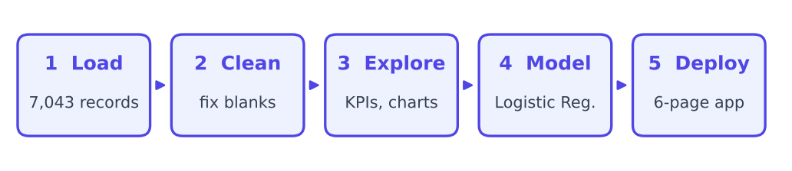
Figure 1. Project workflow from raw data to dashboard

5. Application Features
The dashboard has six pages, selected from the sidebar. All pages respond to the same global filters.
Page | Contents
Overview | 8 KPI cards, churn donut chart, contract distribution, tenure trend chart
Demographics | Churn by gender, senior citizen, partner and dependents; interaction heatmap; tenure box plot
Services | Internet service churn, add-on services comparison, payment method analysis
Financials | Revenue table by contract, charges distribution, scatter plot, box plot
Predictive Model | Accuracy, precision, recall, F1 and ROC-AUC metrics; confusion matrix; feature importance; ROC curve; live predictor
Data Explorer | Data quality report, filterable table, column selector, CSV export, correlation heatmap

5.1 Global Sidebar Filters
Contract type · Gender · Senior citizen · Internet service · Tenure range · Monthly charges range
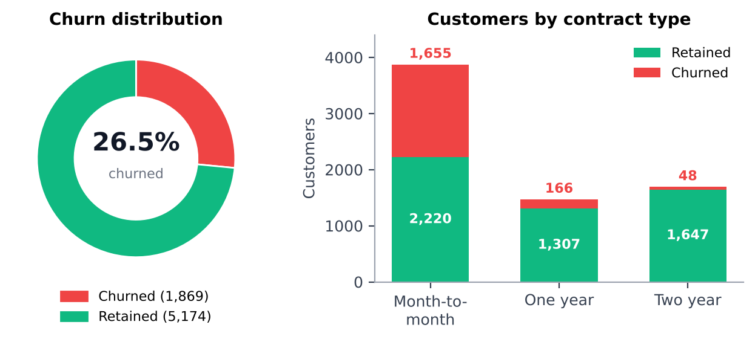
Figure 2. Overview page: churn split and customers by contract type

6. Key Findings and Insights

6.1 Overall Churn
- Churn rate: 26.54% (1,869 of 7,043 customers)
- Monthly revenue at risk: $139,131
- Average tenure: about 18 months for churned customers, against about 38 months for retained ones

6.2 Contract Type: The Strongest Driver
Contract | Customers | Churn rate
Month-to-month | 3,875 | 42.71%
One year | 1,473 | 11.27%
Two year | 1,695 | 2.83%

Takeaway: Converting month-to-month customers to annual contracts would have the largest single impact on churn.

6.3 Payment Method
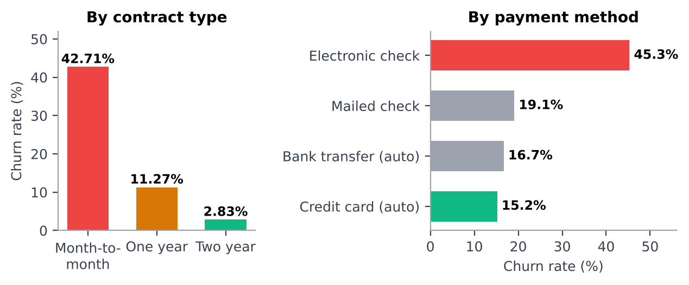
Figure 3. Churn rate by contract type and payment method
Electronic check users churn at about 45%, three times the rate of customers paying by credit card or bank transfer automatically. Automatic payment appears to reduce the friction that leads to cancellation.

6.4 Internet Service and Demographics
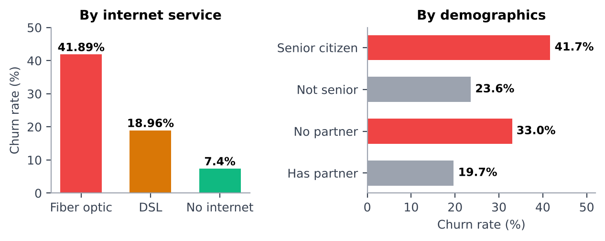
Figure 4. Churn rate by internet service, senior status and partner status
- Internet service: fiber optic customers churn at about 42%, against about 19% for DSL. Higher charges and unmet service expectations are likely causes.
- Seniors: senior citizens churn at about 42%, against about 24% for non-seniors.
- Partner: customers without a partner churn at about 33%, against about 20% with one.

6.5 Add-On Services
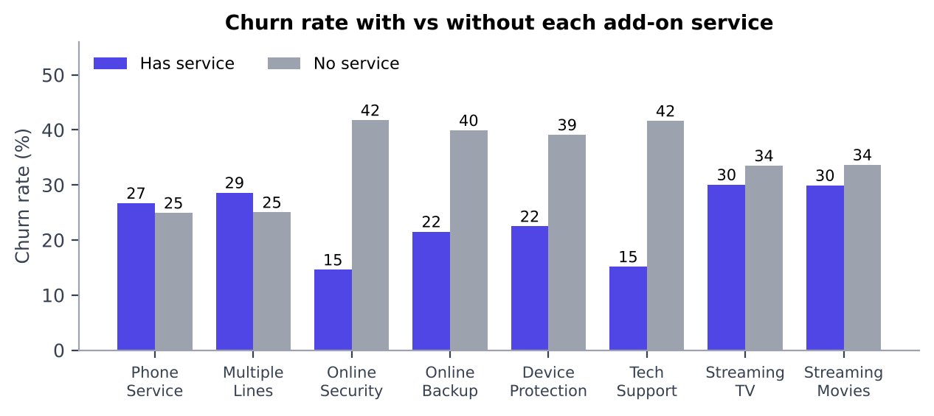
Figure 5. Churn rate for customers with and without each add-on service
Protective add-ons make the biggest difference. Customers without OnlineSecurity churn at 41.8% against 14.6% with it, and customers without TechSupport churn at 41.6% against 15.2% with it. Streaming and phone services show little effect.
Insight: Bundling security and support add-ons is a proven retention lever.

6.6 New Customer Risk
- The first 12 months are the highest-risk period.
- After month 24, the churn rate drops significantly.
- Early engagement programs in the first year are critical.

7. Machine Learning Model

7.1 Approach
- Algorithm: Logistic Regression (interpretable, fast, suited to binary classification)
- Preprocessing: one-hot encoding for categorical features and StandardScaler for numeric ones
- Split: 80% training / 20% test, stratified by churn class (1,409 test customers)

7.2 Model Results
ACCURACY  80.7% | PRECISION  65.84% | RECALL  56.68% | F1 SCORE  60.92% | ROC-AUC  84.18%

Metric | Score | Interpretation
Accuracy | 80.7% | Correctly classifies 4 in 5 customers
Precision | 65.84% | When it predicts churn, it is right 66% of the time
Recall | 56.68% | Catches 57% of all actual churners
F1 score | 60.92% | Balance of precision and recall
ROC-AUC | 84.18% | Separates churners from non-churners 84% of the time

7.3 Confusion Matrix and Top Predictors
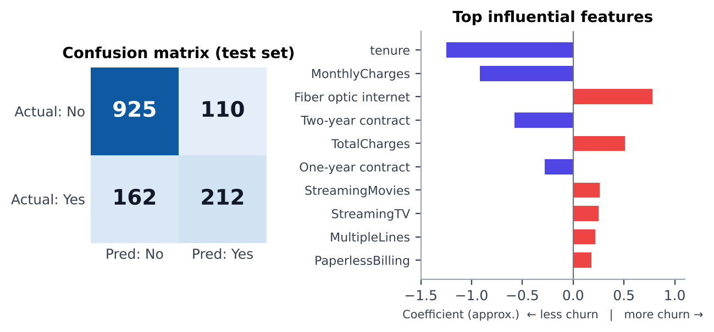
Figure 6. Confusion matrix and the most influential features (coefficients approximate)
Of 374 actual churners in the test set, the model catches 212 and misses 162. It also flags 110 customers who stay. Strong retention signals are longer tenure and two-year contracts; strong churn signals are fiber optic internet and higher total charges.

7.4 Live Predictor
The dashboard includes a real-time churn probability calculator. A user fills in any customer profile and gets an instant prediction with a HIGH or LOW risk label.

8. Business Recommendations
Priority | Action | Expected impact
High | Offer discounts to move month-to-month customers onto annual contracts | Churn falls from about 42% to about 11% for converted customers
High | Launch an onboarding program for customers in their first 12 months | Targets the highest-risk period
Medium | Encourage automatic payment enrollment | Reduce the 45% churn rate among electronic check users
Medium | Bundle OnlineSecurity and TechSupport with fiber optic plans | Bring fiber churn closer to DSL (about 19%)
Low | Create a senior citizen retention program | Address the 42% churn rate in this segment
Low | Use the ML predictor to list top at-risk customers each month | Enables outreach before they leave

9. Limitations and Future Work
- Recall of 56.68% means the model misses a large share of churners. Tuning the decision threshold or trying tree-based models could improve this.
- The dataset is a single snapshot, so it cannot show how customer behavior changes over time.
- Findings show association, not cause. Retention offers should be tested with A/B experiments before wide rollout.
- Future additions: cost-aware thresholds, customer lifetime value, and automated monthly scoring.

10. Conclusion
The project turns a raw customer table into a decision tool. Churn is concentrated among month-to-month, fiber optic, electronic check and early-tenure customers, and those without security and support add-ons. With an ROC-AUC of 84.18%, the model gives the company a practical way to rank customers by risk and focus retention effort where it matters most.

