**App Definition Statement:**

* Purpose: The purpose of this app is to manage events. This app will allow users to view on a map events that are “open” (ie not private).
* Who is this app for: This app is for users who are seeking things to do in a nearby area (events). This app is also for users who want to view how many people/friends are currently checked into an event/events of interest.
* Core Functionality: The core functionality of the app is to show users events in nearby areas. This app will allow creating / adding private/public events.
* How they’ll use it: Track and View Events on a Map or as a list
* Features that fit the definition:
  + Create public/private events
  + Filter events in nearby areas (ie concerts, workshops, etc)
  + Map View / List View (Trending events)
  + Ability to view number of check-ins at an event
  + E-ticket to event (QR-code)
  + Auto-check into event
* Features that don’t fit the definition or exceed the project scope:
  + Support payment of ticket to event (Implement if time permits)

**Possible API’s / Frameworks that I will use:**

* Mapbox : <https://www.mapbox.com/?utm_source=GOOGLE&utm_medium=cpc&utm_term=map%20box&utm_campaign=Brand%20-%20HV&k_clickid=26e55889-ddfe-4a81-8695-efb38780c72e&gclid=Cj0KEQjw44exBRCu8vfS_bPEtNoBEiQACrt005NEQjh3r29kyrw6JPGEG9Wx4nZBtrz9jMrLGkFR5EgaAgWC8P8HAQ>
* Parse (as Backend) : <https://www.parse.com>
* AV Foundation Framework : <https://developer.apple.com/av-foundation/>

**Story Board :**

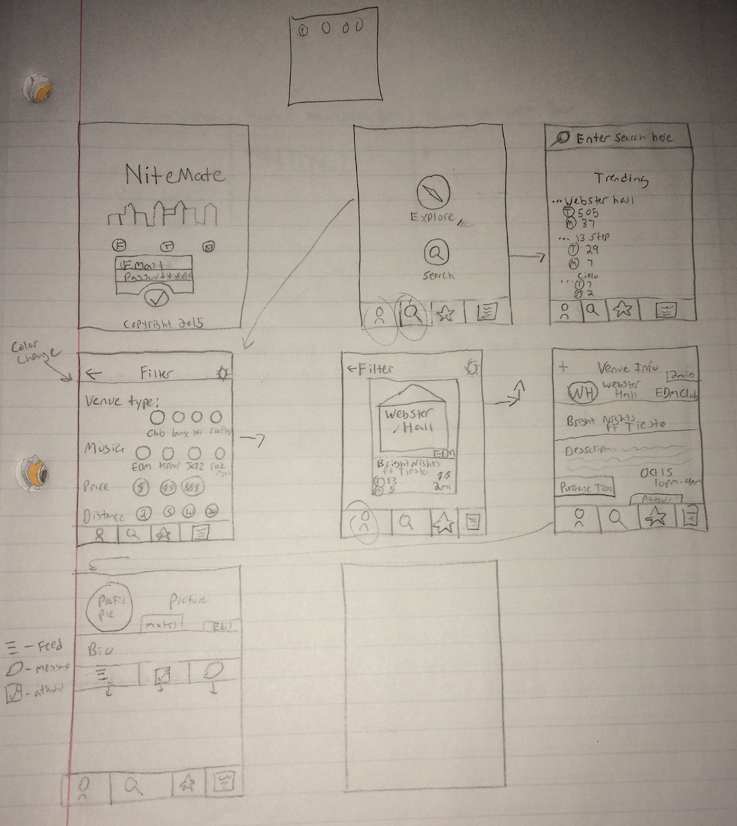

**Features:**

Project Herd Goals and Objectives (Phase I):

1. Goals:
   1. Anonymous Browsing
      1. signup/login once found
   2. Check-ins
      1. Friends/Individuals -> Events
         1. Group of Friends seeking/attending events
         2. Multiple individuals seeking/attending events
      2. Searching Features
         1. Places close by (food/furniture/grocery/parks/gym) according to each profile/place
         2. Average cost for Events in area
   3. Recurring Events (**Recurring per _______**)
   4. Communicate between Friends (Maybe not this semester)
   5. Listings (Basically look at Zillow.com/airbnb.com and see what entails a “pretty” listing) (on the administrator or coordinator side)
      1. Location (Address)
      2. Pictures (MUST)
      3. Price of event
      4. Event Coordinator contact
      5. About Event
   6. Event Offers for groups?
   7. Facebook Events Auto Import / Auto Manage
   8. Types of Events:
      1. Music Concerts
      2. Food Events(Restaurant Specials)
         1. Holiday Specials (Trivia night, Cinco De Mayo)
      3. Event Registration
         1. QR Code
         2. Transferrable tickets if registration rules are met (age, etc)
         3. Group buy tickets for events)
   9. In app event purchases (maybe not this semester, but a goal to try to achieve this semester)
   10. Recurring payments to recurring events (maybe not this semester, but a goal to try to achieve this semester)
   11. Administrator portal to manage / view number of tickets sold, number of views of events, and the amount of purchases. Useful data tracking.
   12. Trending Events (Like Facebook according to check-ins)

**Timeline:**

Week 1 : Log In / Sign Up

Week 2 : Integrate Parse and Mapbox into Project

Week 3 : Ability to add Simple events to Herd

Week 4 : Trending Events

Week 5 : Integrate Social Aspect of functionality into app (auto import facebook events, Trending events via twitter, etc)

Week 6 : Integrate Groups functionality (attending events with friends, and transferrable event tickets through app). Integrate Management/Coordinator Portal into App