GSM/GPRS/GPS TRACKER
USER MANUAL

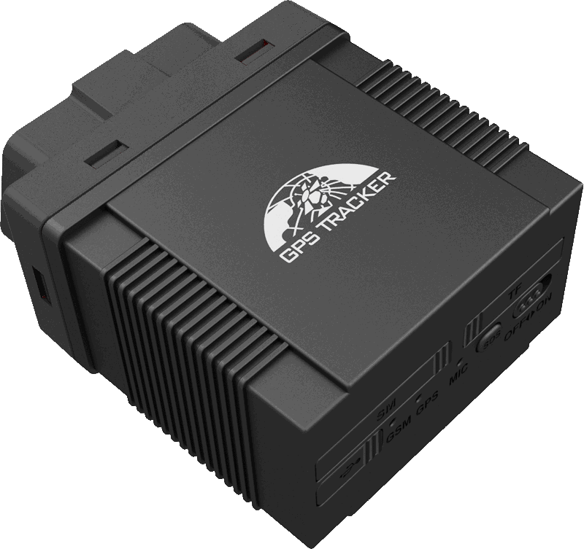
Preface

Thank you for purchasing the tracker. This manual shows how to operate the device smoothly and correctly. Make sure to read this manual carefully before using this product. Please note that specification and information are subject to changes without prior notice in this manual.
Any change will be integrated in the latest release. The manufacturer assumes no responsibility for any errors or omissions in this document.
Contents
1. Introduction 3
2. Applications 3
3. Product Appearance 4
4. Accessories 4
5. Specification 4
6. Operating Instructions 5
6.1. OBD compatibility 5
6.1.1. Protocol compatibility 5
6.1.2. Vehicle Compatibility 5
6.2. SIM CARD Installation 6
6.3. Plug into the car OBD socket 6
6.4. GSM/GPS LED Indicator 6
6.5. Initialization 7
6.6. Change Password 7
6.7. Authorization 7
6.8. 2.4G Attendance Management (Model B) 7
6.9. Configure how OBD data to be sent to Server Center 8
6.10. Request for OBD data by SMS 8
6.11. Set mileage 8
6.12. Set Fuel tank volume 9
6.13. Notification of Vehicle fault 9
6.14. Vehicle maintenance notification 9
6.15. Single Locating 9
6.16. Auto track continuously 10
6.16.1. Track with limited times upon time interval: 10
6.16.2. 6.16.2 Track with unlimited times upon time interval: 10
6.16.3. Smart track upon time and distance interval: 10
6.16.4. Cancel 10
6.17. Automatic update positions of vehicle turns 10
6.18. GPS drift suppression 11
6.19. Location based service (LBS) / Cell-ID locating 11
6.20. Exact street address by SMS 11
6.21. Voice Monitor 11
6.22. Data logging 11
6.23. Data Load 12
6.24. Alarm Functions 12
6.24.1. Low Battery Alarm 12
6.24.2. External Power off alarm 12
6.24.3. GPS blind Spot alert 13
6.24.4. SOS 13
6.24.5. Geo-fence 13
6.24.6. Multi-area management 13
6.24.7. Movement alarm 14
6.24.8. Over speed alarm 14
6.25. Set up arm/disarm by SMS 14
6.26. Alarms under Arm State 15
6.26.1. Shock sensor alarm 15
6.26.2. ACC alarm 15
6.27. Forward the third parties’ message 15
6.28. Charges Inquiry 15
6.29. Check the Vehicle State 16
6.30. Check IMEI 16
6.31. Terminal (local) Time Setting 16
6.32. TCP/UDP switch 16
6.33. Reset Tracker 16
6.34. Sleep Mode 17
6.34.1. Sleep by time 17
6.34.2. Sleep by shock sensor 17
6.34.3. Deep Sleep by shock sensor 17
6.34.4. No sleep mode 17
6.35. Awake at specific time 17
6.36. GPRS Setting 18
6.36.1. Configure APN 18
6.36.2. GPRS User Name and password Setup 18
6.36.3. IP and Port Setup 18
6.37. Less GPRS traffic 18
6.38. Modes Switch between “SMS” and “GPRS” 19
6.39. Web platform and PC installation tracking software user manual 19
7. Cautions 19
8. Faults & the Solutions 19

Introduction
This product is based on GSM / GPRS network and GPS satellite positioning system, built-in GSM and GPS antenna, built-in 2.4G attendance management functions. Insert into the car OBDII interface directly to read the data from car computer, you can locate and manage the vehicle remotely via SMS or GPRS. Easy to install, no wiring harness.

Applications
Mainly used for vehicle management and location tracking services.

Product Appearance
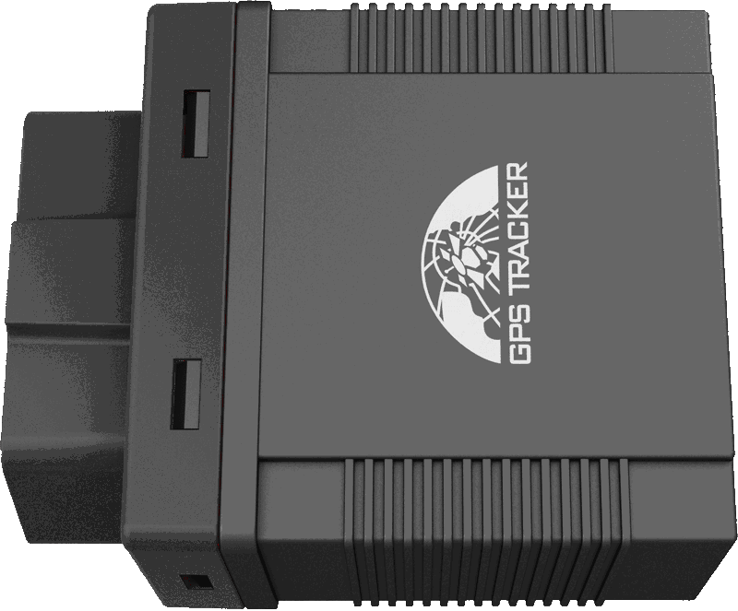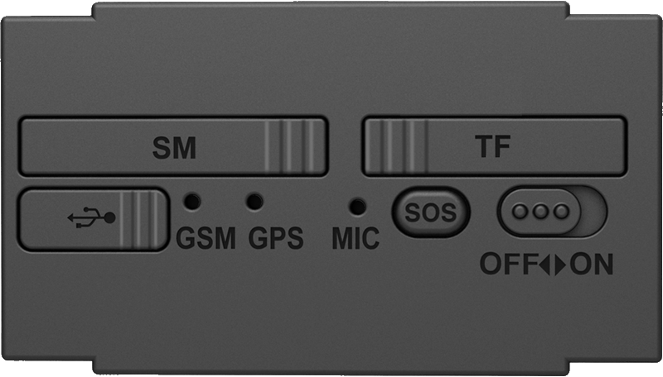

Accessories
No. | Photo | Item | Specification | Note
1 | 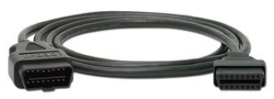 | OBD extension cord | 1.5Meter | Optional

Specification
Content | Specification
DIM | 64.5×50×27mm
Weight | 60g
Network | GSM/GPRS
Band | 850/900/1800/1900Mhz
GPS Sensitivity | -165dBm
GPS Accuracy | 5m
GPS Start Time | Cold status 30s  Warm status 11s  Hot status 1s
Backup Battery | Chargeable changeable 3.7V 200mAh Polymer Li-Battery
Storage Temp. | -40°C to +85°C
Operation Temp. | -20°C to +70°C
Humidity | 5%--95% non-condensing

Operating Instructions

OBD compatibility

Protocol compatibility
The product supports existing OBD protocol:
- SAE J1850 PWM
- SAE J1850 VPW
- ISO 9141-2
- ISO 14230-4 (KWP2000_5BPS)
- ISO 14230-4 (KWP2000_FAST)
- ISO 15765-4 (CAN500_11BIT)
- ISO 15765-4 (CAN500_29BIT)
- ISO 15765-4 (CAN250_11BIT)
- ISO 15765-4 (CAN250_29BIT)

Vehicle Compatibility
Applies to all vehicles which are compatible with OBDII(Including, but not limited to the following models)
- US-produced gasoline vehicles are sold after 1996; all Chinese domestic car are sold after 2003;
- European gasoline vehicles are sold after 2001 or are produced after 2000; Diesel vehicles are sold after 2004 or are produced after 2003 .
Support vehicle models:
No. | Model | No. | Model | No. | Model | No. | Model
1 | Mercedes-Benz | 2 | BMW | 3 | Audi | 4 | Land Rover
5 | Buick | 6 | Chevrolet | 7 | Ford | 8 | Honda
9 | TOYOTA | 10 | Volkswagen | 11 | Hyundai | 12 | SSANG YONG
13 | Citroen | 14 | Mazda | 15 | subaru | 16 | Roewe
17 | Peugeot | 18 | Chery | 19 | Cadillac | 20 | JINBEI
21 | Haima | 22 | Kia | 23 | BYD | 24 | SKODA
25 | FAW | 26 | Nissan | 27 | Geely | 28 | JMC
29 | Dongfeng | 30 | MITSUBISHI | 31 | Porsche | 32 | Suzuki
33 | Soueast | 34 | Isuzu | 35 | Acura | 36
  Volvo

SIM CARD Installation
SIM Card:  Open the cover with SIM Card marking, and insert the SIMCARD as picture shows(chip down), and then put cover back.  Note:  ●Make sure there is enough balance in the sim card.  ●PIN code should be locked.  ●Displaying incoming calls function is available. | 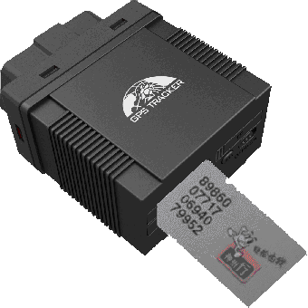

Plug into the car OBD socket
The tracker device will beep a sound after plugging into the car OBD socket, it means tracker device is connected to power successfully. Then turn on the battery switch.
After plug into car OBD socket, tracker will search for the match protocol. It will sound 3 times when the protocol is matched successfully.

GSM/GPS LED Indicator
- Green LED indicator on: No GSM network signals.
- Green LED indicator flashes fast (one time each second): GSM Network signal is normally, and tracker works under GSM mode.
- Green LED indicator flashes slowly (one time each three second): Tracker works under GPRS mode.
- Blue LED indicator flashes: GPS signal is normal.
- Blue LED indicator off: No GPS signals.

Initialization
Send SMS “begin+password” to the unit, it will reply “begin ok” and initialize all the settings to default factory settings.（default password: 123456）
E.G: send SMS “begin123456”, it will reply “begin ok”.

Change Password
6.6.1 Send SMS “ password+old password+space+new password” to the unit to change the password.
For example: send SMS “password123456 888888” to the unit. If succeeded, “password ok” will reply to your cell phone from the device tracker.
6.6.2 Be sure to keep the new password in mind, you have to upload the software to restore the original setting in case of losing the new password.
6.6.3 Attention: Make sure the new password is in 6 digits Arabic numbers, or else the tracker cannot recognize the password.
6.6.4 The “+” in the command, please don’t type “+”, space means press the space keyboard on your cell phone.

Authorization
There are 5 numbers to be allowed to authorize in the tracker at most. Please authorize phone numbers before using this tracker device to receive alerts SMS and call authorized numbers via the SOS button.
6.7.1 Call and track the tracker device for 10 times from cell phone in success, it will make the cell phone number as the authorized number automatically.
6.7.2 Authorization: Send SMS “admin+password+space+cell phone number” to set up an authorized number, the other authorized numbers should be set by the first authorized number, if the number is successfully authorized, the unit will reply“ admin OK” by SMS.

6.7.3 Delete authorization: Send SMS “ noadmin +password+space+authorized number” to delete the authorized number.
6.7.4 If you want to track the target tracker device while aboard, please add your country code in front of your number, e.g. admin123456 008613322221111

2.4G Attendance Management (Model B)
With the built-in 2.4G transmitter module, model B can work with attendance management center for automatic attendance management for vehicles.
The content to be sent by the 2.4G transmitter module can be configured, and default content is the tracker’s IMEI, e.g, send “carid+password+space+YB888888” to tracker device, it will set the license number as the message . “YB888888”is the license number, it should be combination of character and numbers, less than 15 byte.

Configure how OBD data to be sent to Server Center
Send sms command “Obdii+password+space+0” to gps device, OBD data will be turned off.
Send sms command “Obdii+password+space+1” to gps device, OBD data will be sent both when multi tracking and single tracking.
Send sms command “Obdii+password+space+2” to gps device, OBD data will only be sent when single tracking. (Default mode)

Request for OBD data by SMS
Send sms command “Obdmsg+password” to gps device, below information will be returned:
863070010034246 15 digital IMEI No.
T: 05/21/13 15:25:50 Time
ODO: Accumulative mileage
FLI: remaining fuel
AF: Average Fuel
Dtime: Driving time
speed: Speed
Pload: Power load
TEMP: Water temperature
ATP Throttle percentage
RPM Engine speed
BAT battery voltage
DTC diagnostic trouble code

For “Cumulative mileage, remaining fuel, average fuel consumption”, tracker will identify intelligently and display it if vehicle protocol supports, otherwise, no “ODO, FLI” in the message.
If it supports “cumulative mileage”, then you can set the travelled mileage; if it supports “remaining fuel”, then you can set fuel tank volume.
The “average fuel” means the average fuel consumption of 100km; it will be showed only after driving 10km at least.

Set mileage
Send SMS "ODO+password+space+100000", mileage units is kilometer, tracker will reply "Set ODO ok!" after succeed. Device will automatically add this travelled mileage in the value of cumulative mileage.

Set Fuel tank volume
Send SMS "tank+password+space+60", fuel tank volume in liters（L), Tracker replies "Set tank ok! "after succeed . The default fuel tank volume is 60 liters.

Notification of Vehicle fault
When a vehicle malfunction, the vehicle malfunction indicator light is on, diagnostic trouble code will be automatically sent to the authorization number.
If in GPRS mode, Device will report to server center every time when vehicle starts, and only one notification in SMS mode.

Vehicle maintenance notification
Send SMS "service123456 365d 10000", tracker replies "service ok!" after succeed, when the travelled mileage over 10,000 kilometers, or when the device accumulated 350 days of work, it will give send maintenance notice to the authorized numbers15 days in advance.
If in GPRS mode, Device will report to GPRS central.
If in GPRS mode, Device will report to server center every time when vehicle starts, and only one notification in SMS mode.

Single Locating
Any number calls the tracker device, it will reply a SMS including the position of latitude and longitude if authorized number has not been set yet. If authorized number has been set successfully, the device won’t reply SMS including the positioning of latitude and longitude when the unauthorized number dials it up.
Dialing the tracker device from the authorized number, it will hang up your calling and respond to a real-time latitude and longitude information as following:
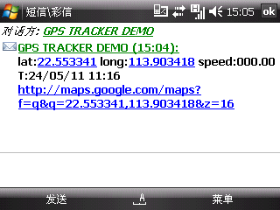
* Tracking location, when no GPS signal, the SMS includes the last valid latitude & longitude as well as the LAC code of current position, the LAC code can be input in the column of “manual track” menu of web platform to check the location.

Auto track continuously

Track with limited times upon time interval:
Send SMS command “fix030s005n +password” to the tracker device, it will report the latitude & longitude at intervals of 30 seconds for 5 times. (s:second, m:minute, h:hour). This command set must be in 3 digits and the maximum value is 255.

6.16.2 Track with unlimited times upon time interval:
Send SMS “fix030s***n+password” to the tracker device, it will reply the latitude & longitude continuously at interval of 30 seconds.
Note: the interval must not less than 20s.

Smart track upon time and distance interval:
Please set "track with unlimited times upon time interval" before this function, and send "distance+password+space+distance", tracker will reply "Distance ok", and then tracker will locate upon both the pre-set time and distance.
E.G: Send "distance123456 0050", it means distance is 50 meters; the number must be 4 digits Arabic numbers.
Set this function on web server: Set time interval first and then distance interval, tracker will locate upon the time and distance.

Cancel
Send SMS “nofix+password” to the tracker device to cancel the “auto track”.

Automatic update positions of vehicle turns
The tracker will update the positions automatically to web server once the vehicle changing driving direction over pre set angle value to form a smooth trajectory consistent with the actual road, this function is only effective in GPRS mode.
Send "angle+password+space+angle" to tracker, it will reply" angle ok".
The angle must be 3 digits Arabic numbers, default angle value is 30 degree.

GPS drift suppression
This function is deactivated as default, send "suppress+password" to tracker, it will reply" suppress drift ok". The GPS data stop updating if vehicle is not driving (ACC is OFF) and latitude and longitude always keep same, and GPS data updates automatically when vehicle is moving.
Cancel: send "nosuppress+password" to tracker, it will reply" nosuppress ok ".

Location based service (LBS) / Cell-ID locating
If the tracker cannot establish a solid GPS Fix, it will calculate its location using Cell-id GSM locating, location reports will include the GPS coordinates of the last known position as well as a LAC code, Entering the LAC code to the "Manual Track" menu of web tracking platform will enable you see the tracker’s current location, you can also send command “address+password" to the tracker to request exact address. Tracker will automatically switch to tracking by LBS in GPRS mode. Accuracy of LBS also known as Cell-id Tracking depends on the GSM signal reception.
Note: This feature can be used normally in most areas according to the signal of GSM network. It may not be available in some areas.

Exact street address by SMS
You must set up the APN of your local GSM network for the SIM card in tracker first before using this function, if there is user name and password for GPRS login, Please refer to 6.36 to configure the APN, user name and password for GPRS login.
After configure the APN, send "address+password" to device, it will reply SMS including exact address. For example: No.8, Guankou 2nd Rd, Nantou, Nanshan district, Shenzhen, Guangdong, china.

Voice Monitor
The command to switch between Track and Monitor mode are “tracker” and “monitor”.
The default mode is “track” (Track mode).
Send SMS “monitor+password” to the unit, and it will reply“monitor ok!” and switch to “monitor” mode.
Send SMS “tracker+password” to the unit, it will reply “tracker ok!” and restore to “track” mode.

Data logging
Auto logging: When the tracker devices lost GSM signals or fall offline from GPRS, tracker will store the tracking position and alerts automatically upon the pre-set condition, when GSM signals get back, all the event alerts will be auto-sent to the authorized numbers or monitoring platform (server), but the stored tracking data should be loaded to the monitoring platform via SMS command.

Storage upon times: Send SMS: “save030s005n+password” to the tracker unit, it will reply “save ok”, and will store the lat, long locations every 30 seconds for 5 times. (S: second, m: minute; h: hour).
Unlimited storage：Send sms:”save030s***n+ password” to tracker device, it will reply “save ok”.
Storage Clearance: Send SMS: “clear+ password” to tracker device, it will reply “clear ok”.
Storage Volume: It depends on the capacity of the SD card inserted in the tracker device.
The stored data in SD card can be copied to computers through card reader, and then the data route can be checked by importing data in the menu “Data Import” of web platform www.gpstrackerxy.com

Data Load
Current date Load: Send SMS: “load+ password” to tracker device, it will reply: “load ok” if the device is working well under GPRS mode; if not, it will reply “load fail! Please check gprs” that means device does not work under GPRS mode. Data can only be load to monitor platform via GPRS.
Specified date Load： Send SMS: “load+ password+ space+ year month date” to tracker device, it will reply: “load ok” and load the tracking data to the monitoring platform upon the valid time you choose. For Example: send SMS: “load123456 20110425” to the tracker device, means to load the tracking data of 25th April 2011 to monitoring platform.

Alarm Functions

Low Battery Alarm
Send SMS “lowbattery+password+space+on”, it will send SMS “low battery+latitude/longitude” to authorized numbers 2 times in total at 15 minutes interval when voltage of battery is going to be about 3.55V.
This function is activated by default, send SMS “lowbattery+password+space+off” to deactivate.

External Power off alarm
Send “extpower+password+space+on” to activate, it will send SMS “power alarm+latitude/longtitude” to authorized numbers every 3 minutes when external power is cut off.
This function activates as default.
Cancel: Send SMS “extpower+password+space+off” to deactivate it.

GPS blind Spot alert
This function deactivates by default, To activate it pls send SMS “gpssignal+password+space+on”, it will send alert SMS “no gps+last valid latitude/longitude” to authorized number before lost signal
Send SMS “gpssignal+password+space+off” to deactivate.

SOS
Long Press the SOS button for 3 seconds, the tracker device will send SMS “help me!+lat./long.” to all the authorized numbers at interval of 3 minutes. It will stop sending such a SMS when any authorized number reply SMS “help me!” to the tracker.

Geo-fence
Set up a geo-fence for the tracker device to restrict its movements within a district. The unit will send SMS to the authorized numbers when it goes out of this district.

Set up: When the unit stays immobile in a place for 3-10 minutes, the user can send SMS“stockade+password+space+latitude,longitude;latitude,longitude” to unit to set the restricted district. In case of breach, it will send SMS “stockade!+ latitude & longitude” to the authorized numbers at interval of 3 minutes.

Remark: The first latitude & longitude is coordinate of the top left corner of the Geo-fence, while the second latitude & longitude is the coordinate of the bottom right corner, it will alarm at interval of 3 minutes.

Cancel: Send SMS “nostockade+password” to deactivate this function.

Multi-area management
- Set Area
Send SMS command "area+password+space+latitude,longitude+space+areaname,distanceM" to tracker(distance unit: M for meter, K for kilometer), it will reply "area01 ok".
Example: Send "area123456 22.353648,113.543678 school,800M".
Note: 5 areas at most and the distance between two points can't be less than the total distance in the 2 commands, and different areas can't cover each other.
- Delete areas
Send SMS command:"noarea+password+space+area name", tracker will reply:"noarea ok".

- Rename and set distance
Send SMS command "rename+password+space+old name;new name,distanceM" to tracker, if name is not repeated and area doesn't cover others, it will reply "rename ok!" for successful configuration.
Example: Send"rename123456 area01;school,800M", it means the new area name is "school", and covers area of a radius of 800 meters.
4. Activate multi-area management
Send SMS command "area+password+space+on" to tracker, it will reply "Area on ok!", when tracker enter the pre set area, it will send SMS "area name+latitude & longitude" to all the authorized phone number, and send same SMS when goes out of the area.
- Deactivate Multi-area management
Send SMS command "area+password+space+off" to tracker, it will reply"area off ok!

Movement alarm
Set up: when the unit stays immobile in a place for 3-10 minutes with
GPS signal reception , the user can send SMS “move+password+space+0200” to the tracker (Suppose area of a radius of 200 meters, it supports 4 digits at most. Unit: Meter). It will reply “move OK”. In case of such a movement (the default distance is 200m), it will send SMS “Move+ latitude & longitude” to the authorized numbers at interval of 3 minutes.
Cancel: Send SMS “nomove+password” to deactivate the movement alarm.

Over speed alarm
Set up: Send SMS “speed+password+space+080” to the unit (suppose the speed is 80km/h), and it will reply “speed OK!”. When the target moves exceeding 80km/h, the unit will send SMS “speed+080!+ latitude & longitude” to the authorized numbers at interval of 3 minutes.
Cancel: Send SMS “nospeed+password” to deactivate the overspeed alarm.
Note: The recommended speed should be not less than 30km/h. For below that rate, it will be effected the accuracy by GPS signals drift etc.

Set up arm/disarm by SMS
Arm
Send SMS command “arm+password” to the tracker device in the vehicle. It will reply “Tracker is activated” and enter into armed state .
Disarm
Send SMS command "disarm + password" to the tracker device in the vehicle, it will reply “Tracker is deactivated” in both armed and disarmed state and enter into disarmed state .

Alarms under Arm State

Shock sensor alarm
Shock sensor alarm is activated automatically with “ARM” command. The unit will send SMS “Sensor alarm+lat/long” to the authorized number when the sensor is triggered in arm status; send “disarm+password” to stop it.
Shock sensor sensitivity configuration:
First level: Alarm will be triggered after detect slight vibration, send command" sensitivity+password+space+1" .
Second level: Alarm will be triggered after detect 8 times vibration in 2 seconds, send command" sensitivity+password+space+2".
Third level: Alarm will be triggered after detect 25 times vibration in 5 seconds, send command" sensitivity+password+space+3".

ACC alarm
The unit will send SMS “ACC alarm+lat/long” to the authorized number in at interval of 3 minutes when the engine of the car is turned on, that is the key is rotated to ACC.ON position to start the car in arm state; send “disarm+password” to stop it.

Forward the third parties’ message
Send SMS "forward+password+space+third parties phone number" from authorized phone number, tracker will reply"forward ok", and supports 1 third parties phone numbers at most.
For example, set the phone number of the service provider of the simcard in the tracker, when charge remind message coming in, tracker will forward it to authorized phone number.
Cancel: Send SMS command "noforward+password".

Charges Inquiry
Send SMS command "balance+password+space+carrier’s phone number+space+code" to tracker, it will forward the code to carrier’s phone number and return the balance message received from carrier’s phone number.
How it works: After receive balance command, pick up the phone number sending this command, the carrier 's phone number and code in the message, and then send the code to carrier 's phone number, then forward the message get from carrier’s phone number to the phone number sending this command.

Check the Vehicle State
Send SMS command “check+password” to the tracker device in the vehicle. It will reply following SMS:
Power:ON Battery:100% External power and internal battery state
GPS:OK/NO Signal GPS signal digit
GPRS:ON/OFF line GPRS state
GSM Signal:32 GSM signal digit
Service:+15Day +500Km Maintenance Reminder：Only 15 days left for vehicle Maintenance 500Km need vehicle maintenance.
Oil:90.1% Oil digit, the vehicle need to support automatic measuring oil
DTC:P0001 Show Vehicle Malfunction Code when it has

Check IMEI
Send SMS command "imei+password" to the unit. E.g. Send SMS command "imei123456" to the tracker device, an IMEI number in 15 digits will reply to your cell phone.

Terminal (local) Time Setting
Send SMS command “time+space+zone+password+space+time” to the tracker unit, If succeed, It will reply “time OK”
For example: Send SMS “time zone123456 8”, 8 is Chinese time zone, If your country time zone is minus, send SMS “time zone123456 -8”.

TCP/UDP switch
Command: "gprs+password,0,0" switch to TCP mode, server will reply to device, this is the default mode.
Command: "gprs+password,1,0" switch to TCP mode, server will not reply to device.
Command:"gprs+password,0,1" switch to UDP mode, server will reply to device.
Command:"gprs+password,1,1" switch to UDP mode, server will not reply to device.

Reset Tracker
Send SMS “reset+password” to tracker device to reset the GSM module and GPS module of the tracker device, it will reply “reset ok”.

Sleep Mode

Sleep by time
Send SMS command "sleep+password+space+time" to tracker device, tracker will reply "sleep time ok" if none of the alarms has been set and no operations, tracker will fall asleep in 5 minutes, GPS module shuts down, LED will be off ,calling or SMS can awake the tracker. If these alarms have been set, tracker will sleep by detecting shock sensor. (This mode only works under SMS mode)
e.g. sleep123456 time

Sleep by shock sensor
Send SMS command "sleep+password+space+shock"to tracker, it will reply "sleep shock ok", and will enter sleep mode if no vibration is detected, GPS module shuts down, LED will be off . Shake or any operation can awake the tracker. (This mode only works under SMS mode.

Deep Sleep by shock sensor
Send SMS command "sleep+password+space+deepshock"to tracker to activate deep sleep by shock sensor, it will reply "sleep deepshock ok", and will enter deep sleep mode if no vibration is detected, GPS and GSM module shuts down, it will run in supper lowest power consumption mode. Vibration or any operation can’t awake the tracker. Alarms can be triggered normally, after alarm cancelled, tracker come back to deep sleep mode again.

No sleep mode
Send SMS command “sleep+password+space+off” to tracker, it will reply “sleep off ok”. Tracker won’t sleep, and GSM, GPS module keep working .This mode is the default mode.

Awake at specific time
Send "schedule+password+space+1h" to awake the tracker each hour, and location will be automatically sent after wake up.(m: minute, h: hour, d:day). The maximum time interval is 3 digits, and can’t exceed 30 days. GSM and GPS shut down, tracker runs in supper lowest power consumption, calling or sms can’t awake the tracker. Alarms can be triggered normally, after alarm cancelled, tracker come back to awake at specific time again. Wake up notification will be sent at the specific time.
Cancel: after wake up, send “noschedule+password” to deactivate this function.

GPRS Setting
User must send SMS via cell phone to set up APN, IP and port before starting tracking by GPRS.

Configure APN
APN standards for Access Point Name and differs from country to country. For more information about your local APN, please inquire with your local GPRS network operator.
Text the tracker a SMS “APN+password + Space + your local APN” via a cell phone and if succeeded, the tracker will return the message “APN OK”.
E.g. Send SMS command “APN123456 CMNET”. If succeeded, “APN OK” is returned by the tracker in SMS.
Notes: 123456 refer to password of tracker and CMNET is the APN of one of china GPRS Network Operator (China mobile).

GPRS User Name and password Setup
In most countries, the user name and password involving GPRS login are not compulsorily necessary, therefore, the entry can be skipped. For those countries requiring user name and password, please configure as following:
Send SMS “up+password+space+user+space+password”If succeeded, “user, password ok!” is returned by the tracker in SMS.
For instance, send SMS “up123456 jonnes 666666” to the tracker, and if succeeded, the tracker returns “user, password OK”
Note: 123456 is tracker device password, jonnes is the user name for GPRS login, 666666 is the password for GPRS login.

IP and Port Setup
Send SMS as below via a cell phone: adminip+password+Space+IPAddress+Space+Port Number. If succeeded, “adminip OK” is returned by the device in SMS.
E.g. Send SMS command “adminip123456 202.104.150.75 9000” to the tracker device, If succeeded, “adminip OK” is returned by the device in SMS. ( 123456 is default password，202.104.150.75 is IP，9000 is port).

Less GPRS traffic
6.37.1 Tracker will change to less GPRS traffic mode after parking 5 minutes, GPRS disconnect and connect again when alarm being triggered or vehicle starts driving.
6.37.2 Activate this function: Send "less gprs123456 on", tracker will reply "less gprs on ok".
6.37.3“Less gprs off ok” Deactivate this function: Send "less gprs123456 off", tracker will reply" less gprs off ok".
Note: 123456 is the password of tracker, and replace it with the new if you have changed.

Modes Switch between “SMS” and “GPRS”
The default mode is “SMS”
Send SMS “GPRS+password” to the unit, and it will reply “GPRS ok!” it means tracker device has switched to “GPRS” mode.
Send SMS “SMS+password” to the unit, it will reply “SMS ok!” and restore to “SMS” mode.

Web platform and PC installation tracking software user manual
Web based platform www.gpstrackerxy.com. Configuration IP: 202.104.150.75 Port: 9000. Please check “software platform user manual” included in the CD for detailed operation information.
PC based installation tracking software user manual included in the CD in package.

Cautions
Please comply with the instructions to extend the unit life:
1. Keep the unit dry. Any liquid, i.e. rain, moisture, may destroy or damage the inside circuitry.
2. Don’t use & store the unit in dusty places.
3. Don’t put the unit in overheated or overcooled places.
4. Handle carefully. Don’t vibrate or shake it violently.
5. Don’t disassemble or refit the unit.
6. Please read the user manual carefully before installation and operation.

Faults & the Solutions
Faults | Solution
Fail to turn on | Check the battery and see if it is fully charged or external power connector is connect well.
No GSM Signal | Please make sure SIM Card is GSM Net and installed correctly; also call display should be on; but no call transfer and PIN code off. Check power voltage if it is normal.
No GPS Signal | Please make sure to get the GPS signal, then connect device to vehicle.
SMS reply fail | Password incorrect or wrong SMS commands format
Call without SMS reply or cannot receive alarm SMS | Authorized number is wrong or without setting any authorized number

