COMP 7005

Assignment 2
Network Sockets

Wei Zhang
A00996514
Feb 8th 2025

Purpose 3
Data Types 3
Arguments 3
Settings 3
Context 3
Functions 4
States 4
State Table 4
State Transition Diagram 6
Pseudocode 7
parse_arguments 7
Parameters 7
Return 7
Pseudo Code 7
handle_arguments 7
Parameters 7
Return 8
Pseudo Code 8
usage 8
Parameters 8
Return 8
Pseudo Code 8
display_messages 9
Parameters 9
Return 9
Pseudo Code 9
display_message 9
Parameters 9
Return 9
Pseudo Code 9
cleanup 9
Parameters 9
Return 10
Pseudo Code 10

Purpose
Develop a client/server application using network sockets for inter-process
communication. Use Vigenère cipher encryption to encrypt file contents from server.

Data Types

Arguments
Purpose: To hold the unparsed command-line argument information

Field | Type | Description
String[] args | Array | Command line arguments
ip | String | IP address
filename | String | Name of file
port | int | Port number

Functions
Function | Description
parse_arguments | Parse the command line arguments

State Transition Diagram
Client then Server
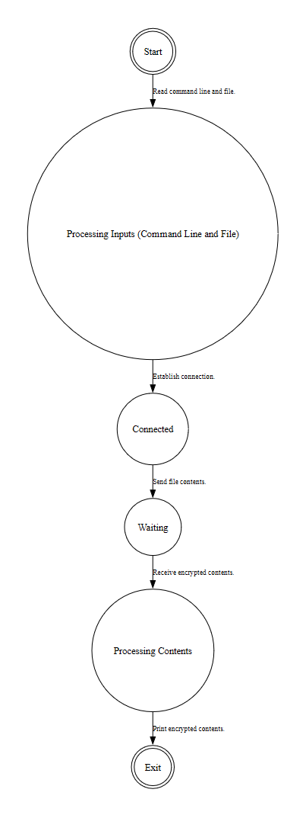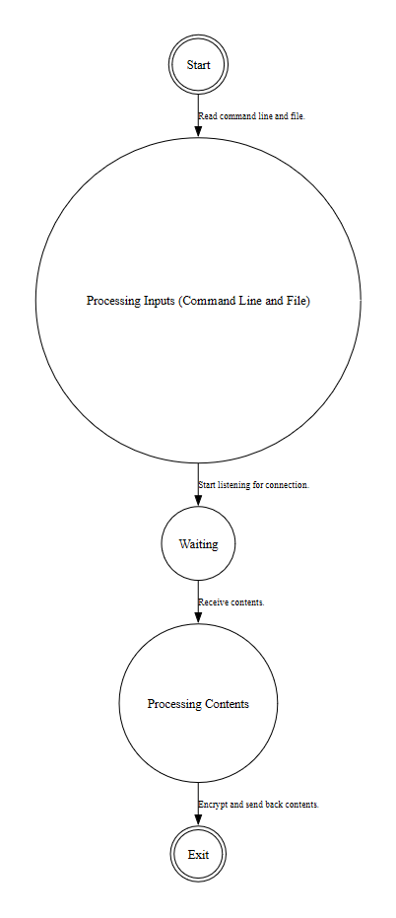

Pseudocode

parseArgs (client)

Parameters
Parameter | Type | Description
args | Array | Arguments

Return

Pseudo Code
If there are not exactly 3 arguments then exit early
Set argument 0 as filename
Set argument 1 as ip
Set argument 2 as port

readFile

Parameters
Parameter | Type | Description
filename | String | Name of file

Return
Message contained in file

Pseudo Code
If filename is empty return early
Open the file and read its contents

encryptMsg

Parameters
Parameter | Type | Description
msg | String | Message to send
ip | String | IP address
port | int | Port number

Return
Encrypted message from server

Pseudo Code
Make connection with given IP address and port number.
Send message to server.
Wait for encrypted message back from server.
If ten seconds pass without response timeout and exit

parseArgs //server

Parameters
Parameter | Type | Description
args | Array | Arguments

Return

Pseudo Code
If there are not exactly 1 argument then exit
Set argument 0 as port number

encryptMsg //server

Parameters
Parameter | Type | Description
port | int | port number

Return

Pseudo Code
Wait on a connection with given port number.
Receive a message and keyword from client.
Encrypt message with Vigenère cipher with given keyword.
Send encrypted message back to client.

vigCipher

Parameters
Parameter | Type | Description
msg | String | Message to be encrypted.
keyword | String | Keyword for the cipher.

Return
Encrypted message.

Pseudo Code
Loop for each character in message
If the character is alphabetical then shift it by index value of the character in same position.
Add character to new message to form encrypted message.
Return encrypted message.

