COMP 7005

Assignment 2

Testing

Wei Zhang
A00996514
Feb 8th 2025

Tests 4
Test 1 4
Test 2 5
Test 3 5
Test 4 6
Test 5 6
Test 6 7
Test 7 7
Test 8 8
Test 9 8
Test 10 9
Test 11 9
Test 12 10
Test 13 10

Test | Expected | Actual | Screenshot
No arguments | fail | fail | Test 1
-h | pass | pass | Test 2
-x | fail | fail | Test 3
Empty message | fail | fail | Test 4
Empty count | fail | fail | Test 5
Non-integer count | fail | fail | Test 6
Negative count | fail | fail | Test 7
Count of 0 | fail | fail | Test 8
Too many arguments | fail | fail | Test 9
Message, no count | pass | pass | Test 10
Message, 1 | pass | pass | Test 11
Message, 2 | pass | pass | Test 12
Message, 10 | pass | pass | Test 13

Tests

Test 1
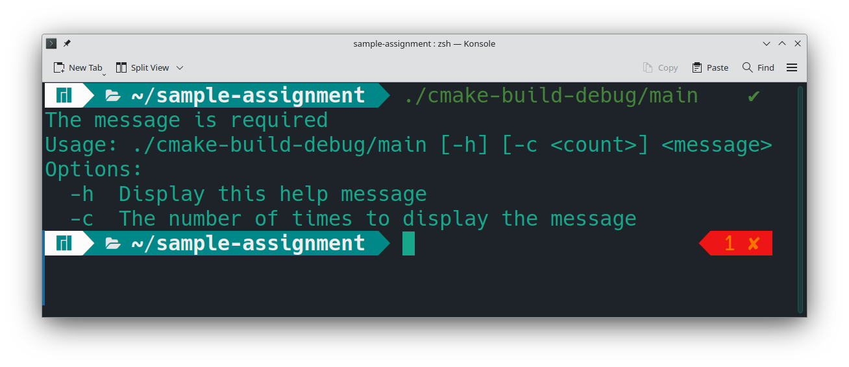

Test 2

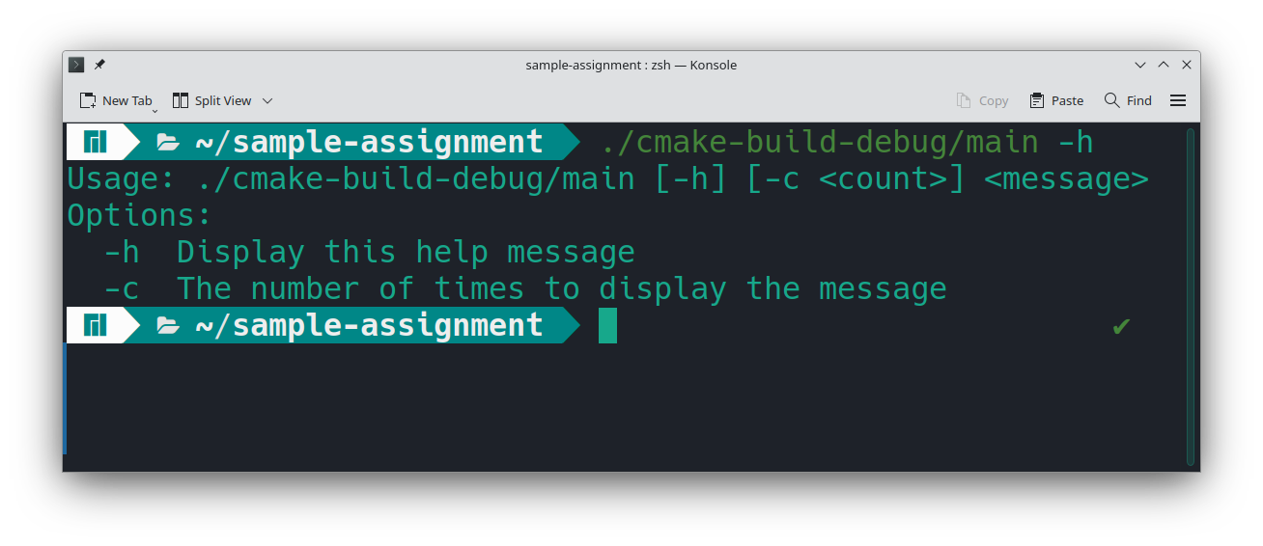Test 3
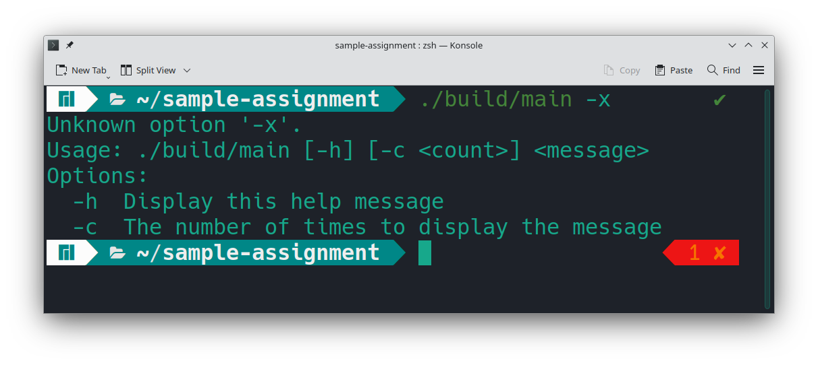

Test 4
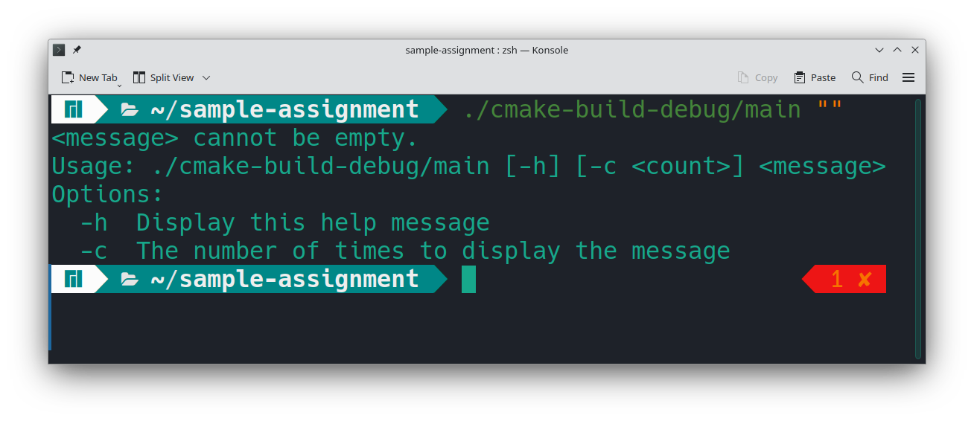

Test 5
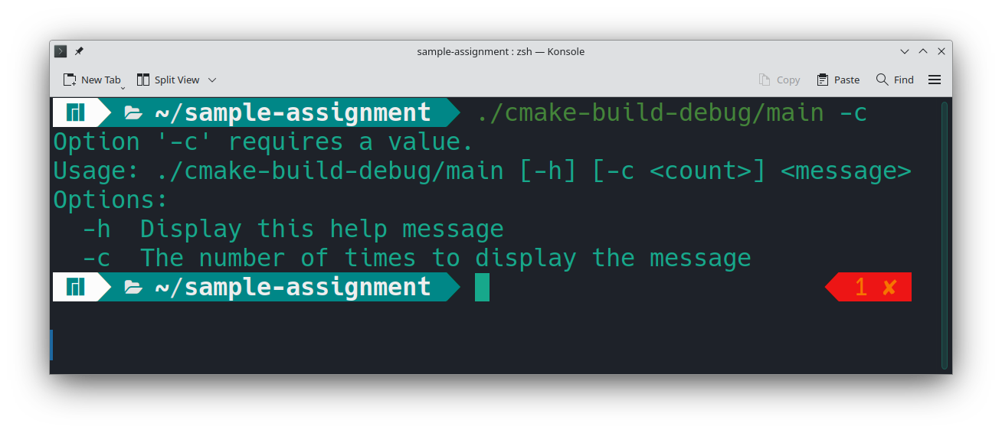

Test 6
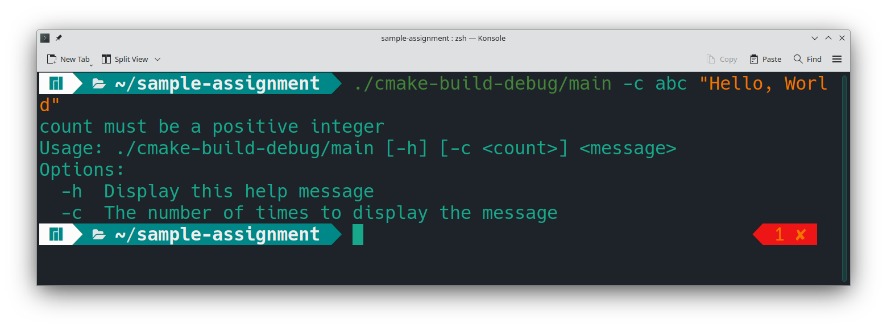

Test 7
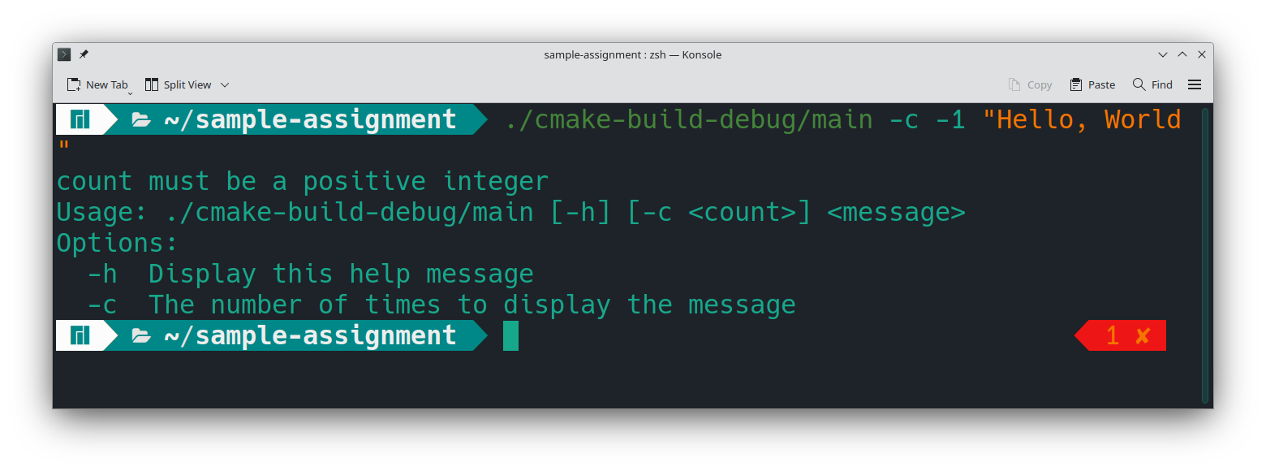

Test 8
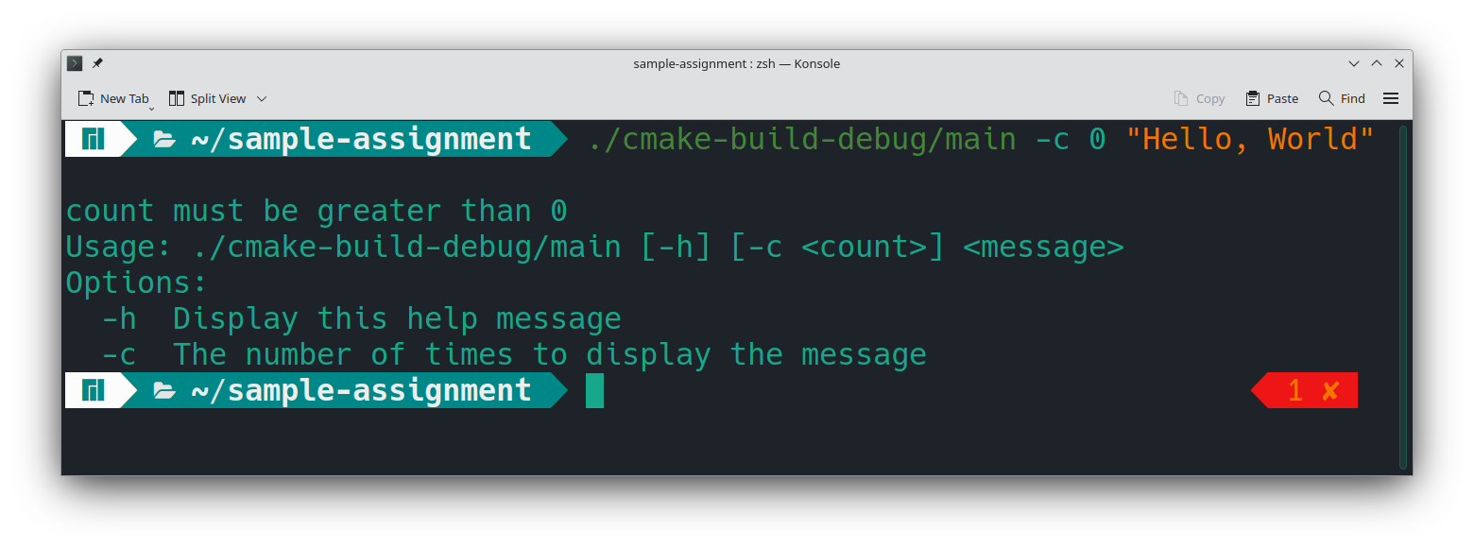

Test 9
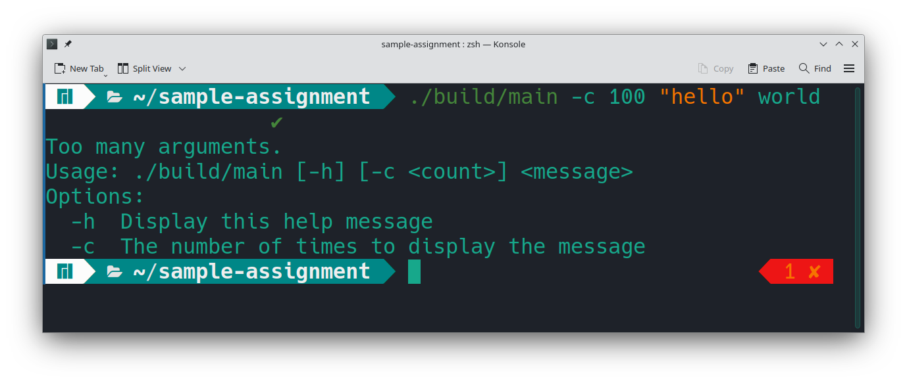

Test 10
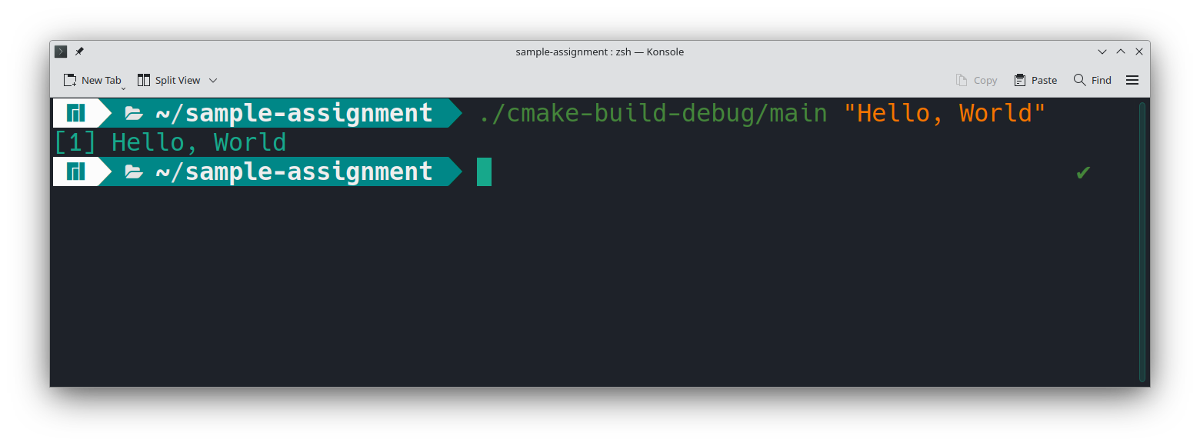

Test 11
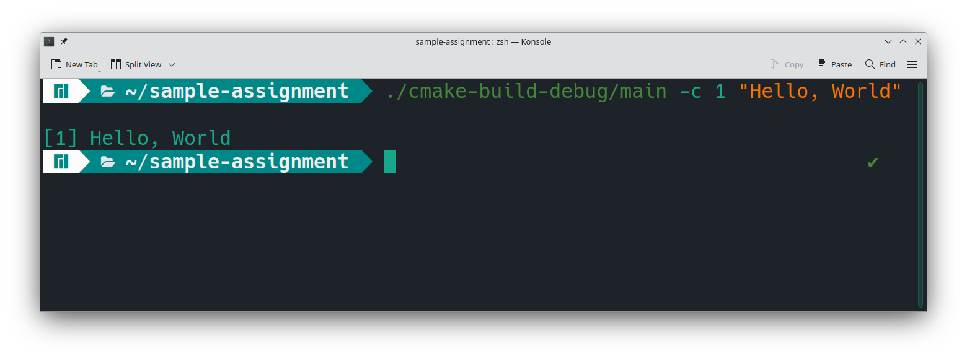

Test 12
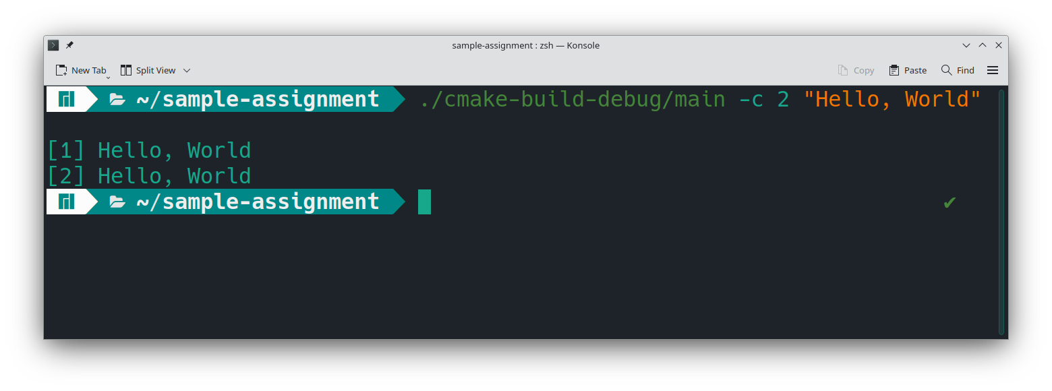

Test 13
