Game Design Document

Fill up the following document

1. Write the title of your project.

Planet saver.

1. What is the goal of the game?

To stop the astoriods from hitting the Earth.

1. Write a brief story of your game.

You are a renowned pilot of the nova thruster, a unique ship. You were living your life like any other. That is, until you receive an emergency call from NASA. There is a massive meotor shower on its way to Earth. You must go forward and save the planet as the pilot of the nova thurster. This spacecraft is outfitted with blasters.

1. Which are the playing characters of this game?

* Playing characters are the ones who respond to the user based on the input from the user.
* Cars, monkeys, dinos, wizards, etc., are the playing characters in the game.

|  |  |  |
| --- | --- | --- |
| Number | Character Name | What can this character do? |
| 1 | The Blue ship | This character can move on the X and Y axis. It can also shoot blasts that can blow up meotors. |
| 2 |  |  |
| 3 |  |  |
| 4 |  |  |
| 5 |  |  |
| 6 |  |  |
| 7 |  |  |
| 8 |  |  |

1. Which are the Non-Playing Characters of this game?

* Non-Playing characters are the ones that don't have an action or behavior when the user interacts with the game.
* Hurdles, stones, bananas, coins, etc., are non-playing characters in the game.

|  |  |  |
| --- | --- | --- |
| Number | Character Name | What can this character do? |
| 1 | Big meotor | It can damage the player if not shot up in time. This character is very big |
| 2 | meotor | It can damage the player if not shot up in time. |
| 3 | Small meotor | It can damage the player if not shot up in time. This character is very small |
| 4 | Power up | The charecter can make the ship’s blast radius much larger |
| 5 |  |  |
| 6 |  |  |
| 7 |  |  |
| 8 |  |  |

Draw your imagination of this game. What does this game look like?

* Draw the game either on your computer or on paper.

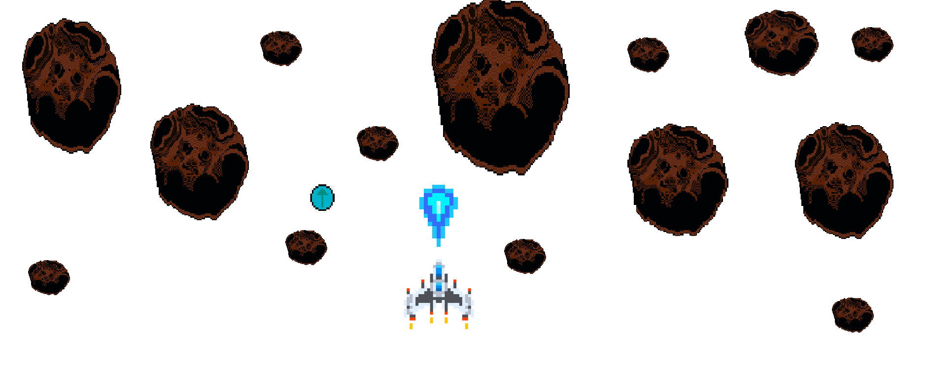

* Add images of the game scenes to show each of the playing and non-playing characters at least once.



How do you plan to make your game engaging?

I intend to make my game more entertaining by incorporating music and noises. Giving a prize at the end of the level is the finest approach to keep any player interested. Such, throughout this level, I'd make it so that each metor you end up firing adds 5 points to your total. The score will be displayed at the end of the level. If the score is more than 50. Then you've done an excellent job. I'll also include noises in the game. Because noises increase the game's relasism. The audience will get more involved.