**Firmware Update**

From time to time Vescent will issue new releases of firmware for the SLICE products. Below are instructions on upgrading the SLICE firmware. Please follow these instructions carefully.

|  |  |
| --- | --- |
|  | For SLICE-QT firmware versions 1.38 and lower, updating the firmware will reset all stored parameters (PID loop parameters, etc.). Before beginning a firmware update, manually record all settings for all channels. Versions 1.50 and higher will automatically store this information. |

1. Create the following folder on your PC   
   **C:\Vescent\SLICE\UPGRADE**
2. Copy the latest Upgrade Package from the GitHub website  
   <https://github.com/Vescent>   
   1. Select the appropriate SLICE model’s Firmware-Upgrade link  
      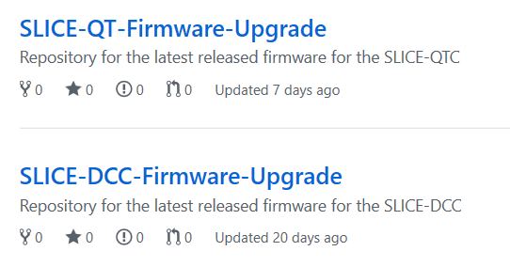
   2. Left click on the SLICE-mmm_Sv.v_mmmv.v.zip file  
      
   3. Select [ Download] to download the file  
      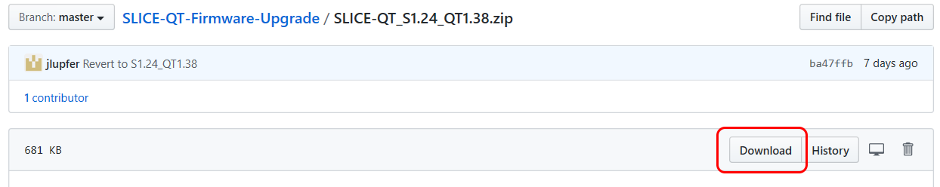
3. Unzip the Upgrade Package into the folder created in step 1. There will be two files in the zip file.
   1. One will be named SystemController-x-x.dfu where ***x-x*** will be the version number of the firmware.
   2. The other file will be named 90-0000*m*-upgrade-x-x.hex   
      Where :  
      ***m*** is the model number of the ICE2 card in the SLICE (1 = QTC, 4 = DCC, 5 = DHV)  
      ***x-x*** is the version number of the firmware.  
      **NOTE**: **DO NOT RENAME THESE FILES!!**
4. Extract the **SLICE_Firmware_Upgrader.exe** file from the **SLICE_Firmware_Upgrade_Utility-x.x-WIN.zip** file to a location of your choice on your PC
5. Connect a USB cable (type B) from the back of the SLICE unit to your PC
6. Do this step only the first time you use a new PC to do the upgrade:
   1. Power OFF the SLICE
   2. Depress and hold the blue button within the access hole on the lower left front side of the SLICE case, located just behind the red bezel.  
      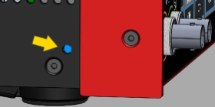
   3. While holding the blue button, power on the SLICE. You should see a blank white screen on the display.
   4. Windows will acknowledge the new USB device found.  
      Watch the lower right of your PC’s display for a brief message indicating that Windows is installing drivers for the new device.  
      Watch the lower right of your PC’s display for a second brief message indicating successful installation of the drivers.
   5. Power Off the SLICE
7. Power On the SLICE  
   **NOTE:** Make sure that only one SLICE Device is connected to the PC during the upgrade.
8. Open Windows File Explorer and navigate to the folder where the **SLICE_Firmware_Upgrader.exe** was placed earlier



Please follow firmware update instructions

carefully.

During the upgrade, do not turn off,

disconnect, or unplug the SLICE.

1. Launch the **SLICE_Firmware_Upgrader.exe** application.**Note: The first time the upgrade utility is run, it needs to install a Device Driver to communicate with the SLICE in the Upgrade Mode.**Therefore, the **SLICE_Firmware_Upgrader**.**exe** application must be launched as **administrator**.  
   Right click on the **SLICE_Firmware_Upgrader**.**exe** application in Windows File Manager and   
   select “**Run as administrator”**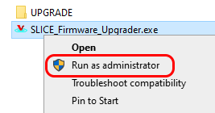  
   Subsequent operation of the **SLICE_Firmware_Upgrader.exe** application can be launched in regular user mode by simply double clicking on the filename in Windows File Explorer.
2. Follow the prompts in the **SLICE_Firmware_Upgrader** application to complete the upgrade process.
   1. Verify that the upgrade files are placed in the **C:\Vescent\SLICE\UPGRADE** folder and press Any Key to continue.  
      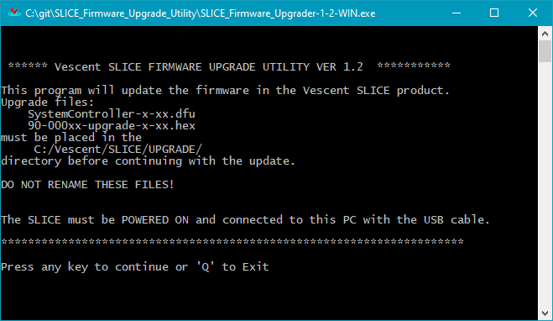
   2. The Upgrader will scan the com ports on the PC to find the attached SLICE device.  
      It will present the following instruction screen.  
      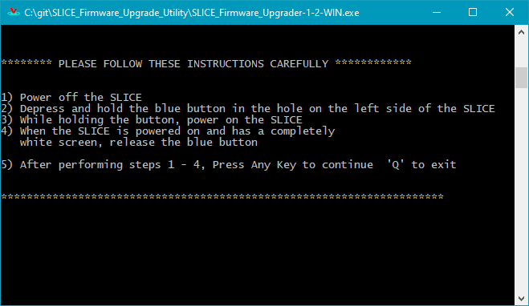
   3. **Before continuing:**
      1. Power off the SLICE
      2. Depress and hold the blue button in the hole on the left side of the SLICE  
         
      3. While holding the button, power on the SLICE
      4. When the SLICE is powered on and has a completely white screen, release the blue button.
      5. After performing steps i – iv, press any key to continue the process
   4. Driver Installation --A firmware upgrade support driver needs to be installed on the PC used for upgrades. This will be detected the first time the SLICE_Firmware_Upgrader is used.  
       **NOTE:** If the SLICE_Firmware_Upgrader was launched in normal user (Non-Administrator) mode, the following message will appear.  
       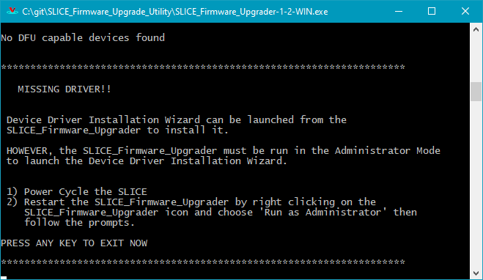  
       Follow the steps given and restart the SLICE_Firmware_Upgrader in Administrator mode.  
       Repeat steps 1 and 2 to get back to this point.  
        
        
      When this screen message appears, press any key to launch the Device Driver Installation Wizard which will install the library.  
      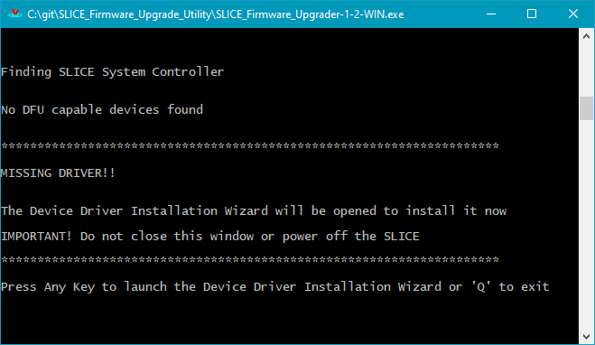
      1. Click [Next>] on this screen  
         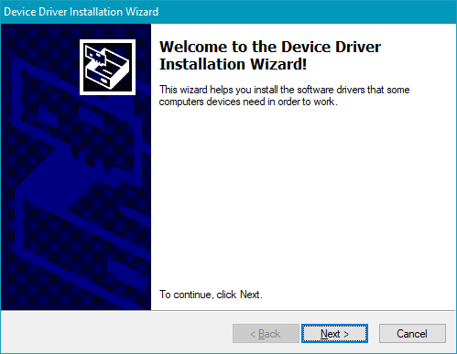
      2. Wait for the Installation to complete then press [Finish]  
          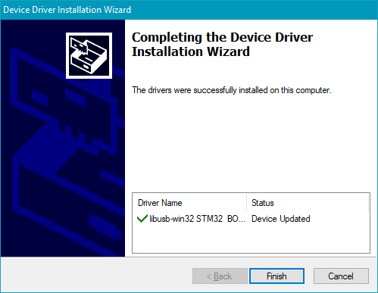
3. The upgrade will now continue.
   1. The System Controller firmware will be upgraded First  
      **DO NOT turn off power on the SLICE or touch the touchscreen during this process.**  
      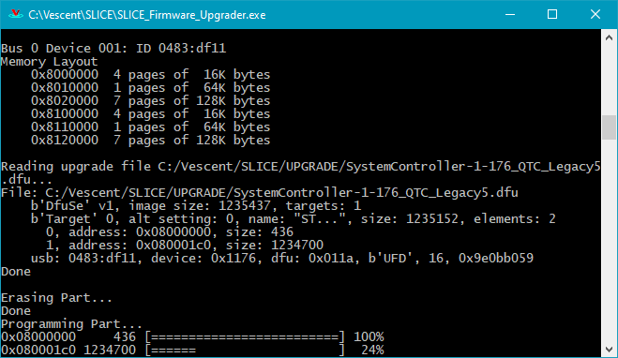
   2. When the System Controller Firmware upgrade finishes, the SLICE will Reboot.  
      **DO NOT cycle power on the SLICE or touch the touchscreen during this process.**  
      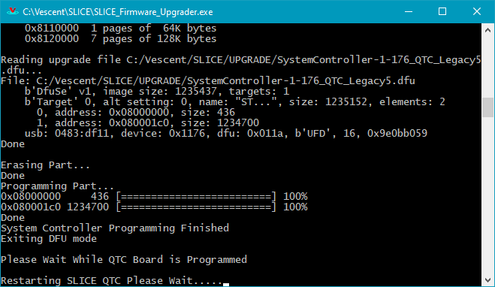During this half of the process, the following message will appear on the SLICE touchscreen.  
      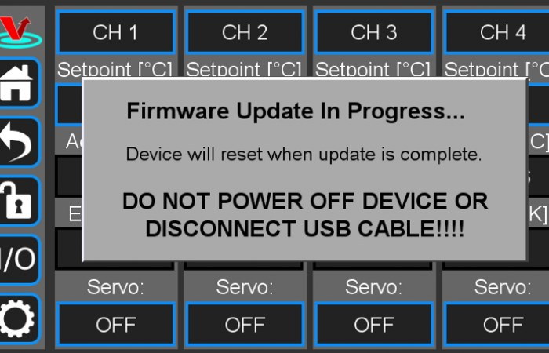
4. The Upgrade is finished when the **SLICE_Firmware_Upgrader** application closes and the SLICE reboots.