# Lab: Multidimensional Lists

Problems for in-class lab for the [Python Advanced Course @SoftUni](https://softuni.bg/courses/python-advanced). Submit your solutions in the SoftUni judge system at <https://judge.softuni.bg/Contests/1834>

## Sum Matrix Elements

Write a program that **reads a matrix** from the console and prints:

* The sum of all **matrix elements**
* The **matrix itself**

On the first line, you will get matrix sizes in format **"{rows}, {columns}"**

### Examples

|  |  |
| --- | --- |
| **Input** | **Output** |
| 3, 6  7, 1, 3, 3, 2, 1 1, 3, 9, 8, 5, 6 4, 6, 7, 9, 1, 0 | 76  [[7, 1, 3, 3, 2, 1], [1, 3, 9, 8, 5, 6], [4, 6, 7, 9, 1, 0]] |

## Sum Matrix Columns

Write a program that **reads a matrix** from the console and prints the sum for each column. On the first line, you will get the matrix's **rows**. On the next **rows**, you will get elements for each column separated with a space.

### Examples

|  |  |
| --- | --- |
| **Input** | **Output** |
| 3, 6  7 1 3 3 2 1  1 3 9 8 5 6  4 6 7 9 1 0 | 12  10  19  20  8  7 |
| 3, 3  1 2 3  4 5 6  7 8 9 | 12  15  18 |

### Hints

* **Read** matrix **sizes**.
* On the next row lines, **read** the **columns**.
* **Traverse** the matrix and **sum** all elements in **each** column.
* Print the **sum** and **continue** with the other columns.

## Primary Diagonal

Write a program that finds the **sum of matrix primary diagonal**.

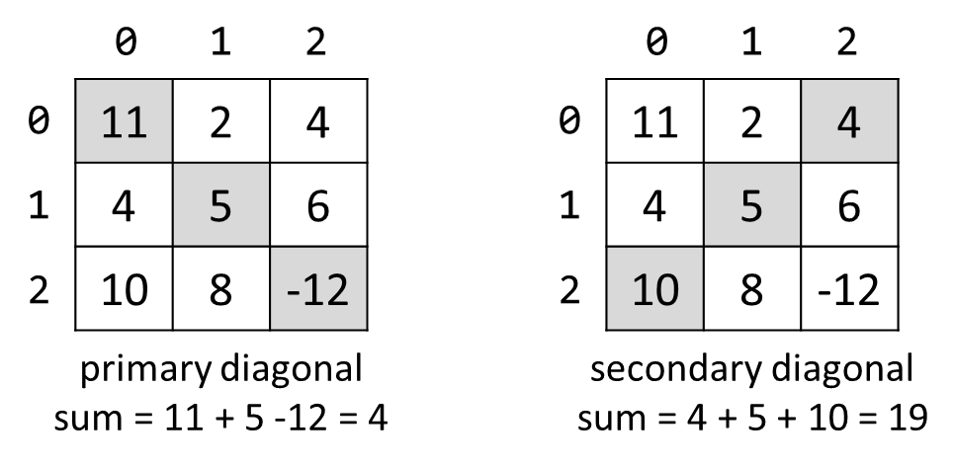

### Input

* On the **first line**, you are given the integer **N** – the size of the square matrix
* The next N **lines** holds the values for **every row** – N numbers separated by a space

### Examples

|  |  |
| --- | --- |
| **Input** | **Output** |
| 3  11 2 4  4 5 6  10 8 -12 | 4 |
| 3  1 2 3  4 5 6  7 8 9 | 15 |

## Symbol in Matrix

Write a program that reads **N**, a number representing the **rows** and **cols** of a **matrix**. On the next **N** lines, you will receive rows of the matrix. Each row consists of ASCII characters. After that, you will receive a symbol. Find the **first occurrence**,starting from the **top left,** of that symbol in the matrix and print its position in the format: "({row}, {col})". If there is no such symbol print an error message "{symbol} does not occur in the matrix"

### Examples

|  |  |
| --- | --- |
| **Input** | **Output** |
| 3  ABC  DEF  X!@  ! | (2, 1) |
| 4  asdd  xczc  qwee  qefw  4 | 4 does not occur in the matrix |

## Square with Maximum Sum

Write a program that **read a matrix** from console. Find biggest sum of **2x2 submatrix** and print it to console.

### Input

On first line you will get matrix sizes in format **rows, columns.**

One next **rows** lines you will get elements for each **column** separated with coma.

### Output

Print **biggest top-left** square, which you find and sum of its elements.

### Examples

|  |  |
| --- | --- |
| **Input** | **Output** |
| 3, 6  7, 1, 3, 3, 2, 1 1, 3, 9, 8, 5, 6 4, 6, 7, 9, 1, 0 | 9 8  7 9  33 |
| 2, 4  10, 11, 12, 13  14, 15, 16, 17 | 12 13  16 17  58 |

### Hints

* Be aware of **IndexError**
* If you find more than one max square, print the top-left one