**Veselin Ivanov**

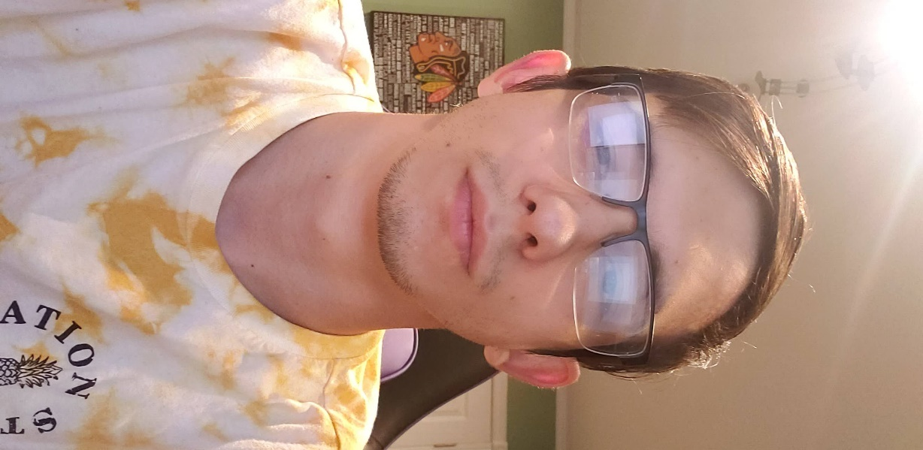

Values and beliefs:

* Hard work
* Science
* Honesty
* Friendship
* Sleep
* I believe that everything falls into place eventually and if you work hard and do what you like then one day it will become your life

Interests:

* Sports
  + Volleyball is my favorite sport and I love playing and watching it
* Fishing
  + It provides me with a way of clearing my head and it is also a good hobby to have that I share with my grandpa
* Cars
  + I like cars especially JDM which is Japanese domestic market cars and I like how they are cheap and can be modified to anyone’s liking
* Computers
  + I like computers because they are our future and by learning and playing around with building and configuring them I can learn new ideas and ways that they work.
* Sleep
  + I like sleep because it is a way of me to escape reality and rest
* Games
  + Games are a way for me to play and meet a lot of people and to be in a whole different world where racism and bulling is not usual

What I want to do for a career:

* I want to be a Cyber Security officer or have my own IT company someday

What I hope to learn from this course:

* I hope to learn the basics and more in dept concepts of Object-Oriented Programming and C++. I want to be able to come out after this course and say that I am more educated and experienced in Computer Science. I want to learn a lot from this course