**Nathasya Pernidya Ashari**

**2327250063**

**IF3B**

1. Pengujian POSTMAN API GET DAN POST

2. Tabel phpMyAdmin Clever Cloud

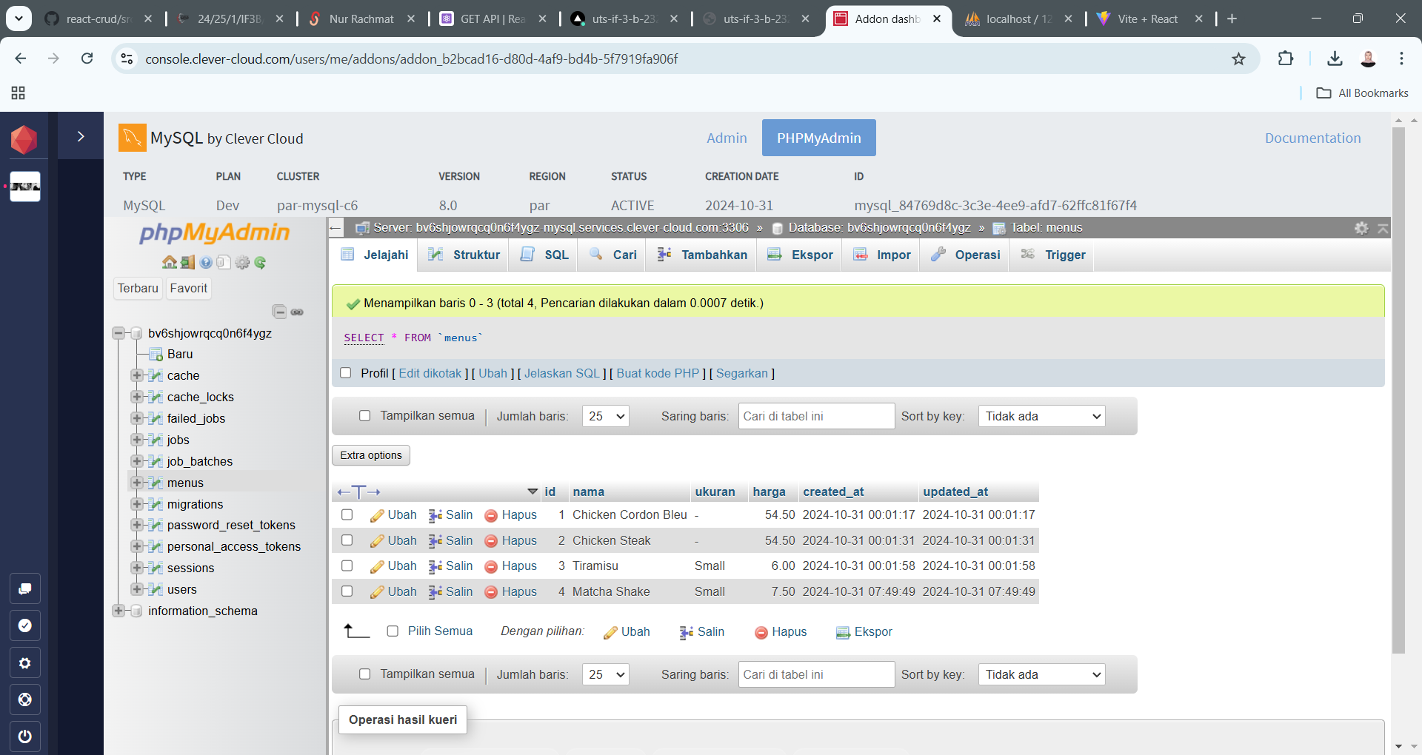

3. Vercel React (belum selesai)