Goals
Submit your work by the deadline listed in the email you received or your application will be voided. To submit, create a google drive folder titled <NAME>_<TRACK> to put your work into then reply to the email with a link that allows anybody to view. While we are looking for success, success does not mean completion of all goals. We are more interested in how clearly you articulate your progress through this challenge. You may submit other work that demonstrates your ability to perform the following goals. Use of generative AI is allowed but must be addressed with a copy of the prompts used at the bottom of the document submitted.

Background: The Robotics & Sim team is developing simulation to real pipelines for VLA to embody hardware systems with the accuracy and precision to perform laboratory research. The challenge is not the quantity of the data, but the quality. As it is the laboratory is notoriously known for having messy environments with scattered objects of varying age, precision, and usage.

Goal 1: In a preferred simulation software with a 3D engine set-up a virtual box on a table.
Goal 2: Create a second box.
Goal 3: Push the first block against the 2nd to move the 2nd block to either the corner of the table.
Goal 4: Create a barrier between the left and right side of the table at ⅓ the height of an imported 6-DOF arm, pick up a block and move it onto the other side of the barrier
Goal 5: Incorporate collection of sensor data that can realistically be used (RGB, tactile, IMU, joint-state, etc.).
Goal 6: Perform the next step of this challenge. The next most important step to making this training data for a VLA model.

Initialization and Understanding the Question
First, I wanted to understand what the question was asking me to do as well as starting to set up the environment and my workplace for that. I first took a read over the IsaacSim documentation, my choice of simulation for this question. Reading through the documentation, I developed an initial plan below that I plan on editing later as I actually do it.
First, in the documentation, I found the quickstart instructions. I realized that this tutorial pretty much accomplishes the entirety of the first two goals. Once I initialize my workspace and then create the two boxes, I can also extrapolate these instructions to make a crude floating plane that would act as my table.
This IS documentation also included on how to add a robot to the sim which I plan on using to address goals 4 and 5. In particular, this tutorial seems exceedingly useful for getting my robot to move as well as adding sensors.

Github repo: https://github.com/Vespacian/corvinus-technical

Process
First created a new conda env and installed CUDA (torch 2.7.0 tv 0.22.0), isaacsim 5.0.0 with the full bundle, and python 3.11. Specifically, I asked AI to set this up for me with this prompt [1]. Then I started work on the first Goal.

Goal 1
For goal 1, as specified in the previous section, I followed IS’s quickstart documentation in the “Extensions” tab. For full code, see scripts/goal1.py in the github.
Something I noticed is some of the code in the quickstart documentation is outdated so I had to read over the updated documentation like this to fix the imports:
- https://docs.isaacsim.omniverse.nvidia.com/latest/py/source/deprecated/isaacsim.core.api/docs/api.html?highlight=ground%2520plane#isaacsim.core.api.objects.GroundPlane

Then I used this prompt [2] to convert the code that I had into the updated core.api version that was more stable. As shown below, I now have a cube on a table
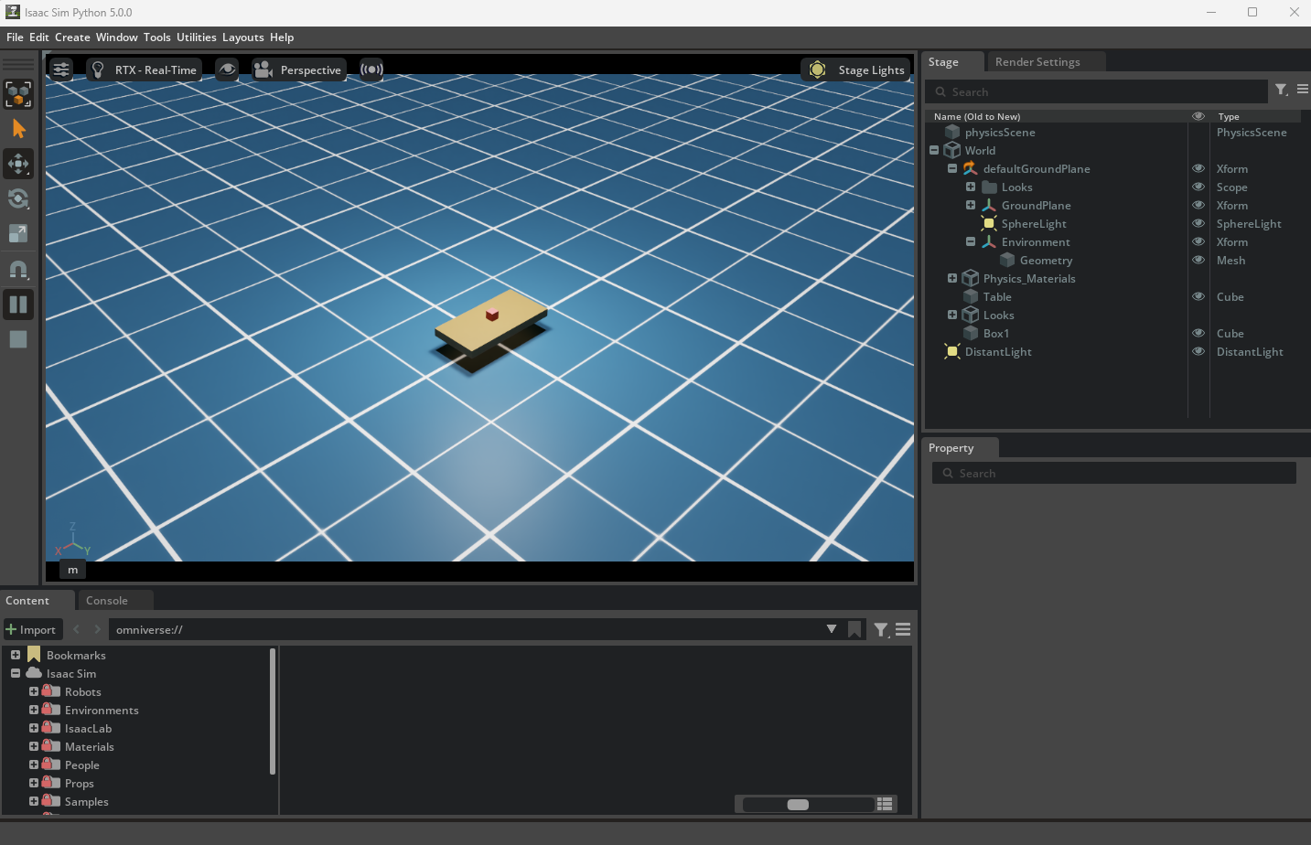

Goal 2
Was trivial to do. Just added another box
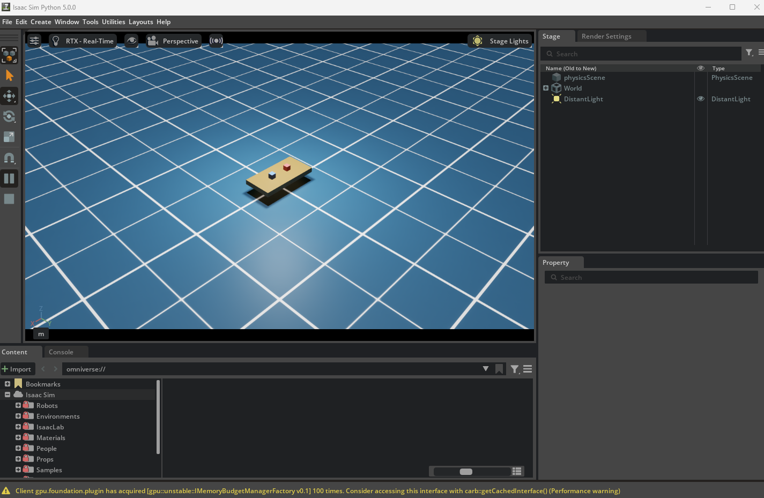

Goal 3
To accomplish goal 3, I took my goal 2 code and asked AI to add in some physics by providing some documentation first [3]. With that I was able to see how the AI adjusted the physics and then reported bugs to the AI to get it to fix. The final form of the code was saved to the github and I also uploaded a video of the cube pushing to the google folder titled “Goal 3”

Goal 4
I did something similar to Goal 4 and used my goal 3 code as the starter code. I searched up what robot arm is already available in IS and decided to use franka panda. This task was significantly more difficult compared to the previous tasks because of the addition of the robot arm. For this one in particular, I had multiple troubles.
First trouble that I ran into was the arm I chose wasn’t loading in at all. Whenever I loaded the scene in, I would only see the table, barrier, and the cube. I then discovered that I needed to download the arm model locally so I proceeded to create a download script that would take care of that and the arm was able to appear correctly.
Now that the scene was created, I looked into different ways to get the arm moving and tried hardcoding joint angle waypoints. However, I quickly realized just how inaccurate this method was. Not only was it frustrating to try to readjust the numbers little by little, it was just not practical at all with the level of accuracy the arm needed to be in order to move correctly towards the arm. It was also not intuitive to use because the 3D space we as humans were used to were very different from the space the simulation offers (e.g. the arm would go opposite ways and xyz with camera positioning wasn’t always where you might expect it to go). Due to these limitations, I ditched this plan and looked further into the documentation to find a better solution.
While I was reading over the IS example code, I found out they use a KinematicSolver which was a lot more intuitive to use. With the documentation, I used AI to replace my hardcoded motion logic with the new system [4].
Immediately, another problem I ran into was the actual process of picking up the cube. I didn’t account for the size of the cube nor the size of the grippers. I also didn’t consider the strength and friction necessary to actually pick up the cube. So tackled each problem one by one by first searching up the Franka Panda arm’s model and dimensions and then scaling the cube to be around the middle of the gripper range so the cube can be comfortably picked up. Even with that the cube was slipping out of the grippers hands so I made a friction function that allowed the grippers to hold the cube properly and also increased the grip strength.
With those adjustments (which did take a while to fine tune), I added a video titled “Goal 4” in the google folder that shows the full simulation of the arm picking up the cube.

Goal 5
For goal 5, I decided to take a closer look into joint-state. As I was debugging and working on Goal 4 with motion logic, I already had a pipeline implemented that would look at the joint state so I built off that first [5].
In my goal5.py code, I added a helper function that would log each joint state at every phase. It would pick up the joint positions and velocities. This data can be used for debugging as well as more information on how the robot actually works. I also had it automatically create a json within the path in /logs .
Please refer to the /logs folder and /scripts/goal5.py for more information

Goal 6
For this goal in particular, I had to plan out designing the VLA model. I originally wanted to use HDF5 library to store the data but I found from experimental testing that IS and HDF5 didn’t work that well together. Finding this out, I decided to switch over to built-in .npz instead and that worked fine for data storage.
As for actually storing the information, I decided to store the image of the scene, instruction, and action. Because I already had a pipeline with join-state data being logged in goals 4 and 5, this part wasn’t as hard to accomplish. The only thing I was missing was the image of the scene so I added a fixed RBG camera that’ll take an image every 5 timesteps.
With this, I saved a .npz file within my /logs folder of the github that stores all this information. I also used this prompt to help me accomplish this after planning [6].

AI Prompts
[1] I am setting up NVIDIA Isaac Sim 5.0 for a robotics simulation challenge. I need to create a new conda environment with Python 3.11, install CUDA-enabled PyTorch (torch 2.7.0, torchvision 0.22.0), and install Isaac Sim 5.0.0 via pip. Please give me the exact terminal commands to do this

[2] I am working on Goal 1 of a robotics simulation challenge in IS 5.0 using standalone python scripts in vscode. I have the following code that was written for the IS using the isaacsim.core.experimental api from the quickstart tutorial. can you convert it to use the stable isaacsim.core.api library instead, so it avoids bugs from the experimental api. Here is the original code.

[3] Can you use my goal 2 code that I provided to push the red box into the blue box so the blue box slides to the corner of the table? Please use your search engine tools to read over these docs first before adding the push mechanic. use set_linear_velocity() and have the boxes be directly on the table before pushing. then add friction between the boxes in the function set_friction() so the first box can push the second box.
https://docs.isaacsim.omniverse.nvidia.com/latest/introduction/quickstart_isaacsim.html
https://docs.isaacsim.omniverse.nvidia.com/5.0.0/physics/simulation_fundamentals.html

[4] I'm using the Franka Panda arm to have it pick up a cube on the table on the other side of the barrier and then put it on the same side as the robot. However, I found that my current code (insert code) is not very accurate. I found documentation for KinematicsSolver which I want you to use your search engine capabilities to read first. Then please edit my current code to write motion logic instead of my hardcoded joint waypoints to pick up the red cube.

[5] Here is my goal 4 code, please use it as the starter code and I want you to add joint state logging collection. My system already takes in account of joint states so I want you to create a helper method that logs the joint state after each phase end into a .json file. please save this in the folder /logs

[6] The next goal is to take a step toward making this simulation produce training data for a VLA model. Here is my previous Goal 5 code and I want to use this as a starter. Here I already have joint state logging and need to save data every x amount of timesteps, maybe 5. I want to use HDF5 to save my data. First determine how we can save data then add in a RGB camera and save the image of the scene, the instructions at that timestep and the action

