# Exercises: Unit Testing Arrays

Submit your solutions here: <https://alpha.judge.softuni.org/contests/unit-testing-arrays-exercise/5092>

## Unit Test Array: Reverser

Test a given method which takes in an **array of strings** and **reverses** each string in thearray.

The method is found in the Reverser.cs file:

In the **test** **file** ReverserTests.cs you are given **1 finished test**, **1 partially finished test**, and **2 empty tests**. Finish them and run them:

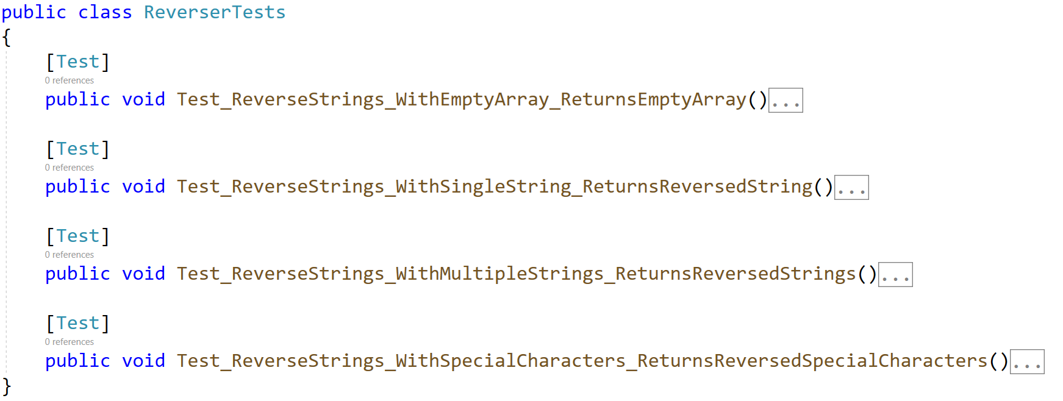

## Unit Test Array: Duplicates

Test a given method which takes in an **array of integers** and **removes all duplicate numbers**.

The method is found in the Duplicates.cs file:

In the **test** **file** DuplicatesTests.cs you are given **2 partially finished test**, and **2 empty tests**. Finish them and run them:

## Unit Test Array: Fake

Test a given method which takes in an **array of characters** and **removes all characters which are numbers and not letters.**

The method is found in the Fake.cs file:

Notice the method throws ArgumentException if the array is **null**.

In the **test** **file** FakeTests.cs you are given **3 empty tests**:

## Unit Test Array: Pattern

Test a given method which takes in an **array of integers** that **removes all duplicates** and **sorts** the list in a zig-zag pattern.

Example: If we have an array 1 2 1 3 4 10 12 15 the sorted array would be: 1 15 2 12 3 10 4.

The method is found in the Pattern.cs file:

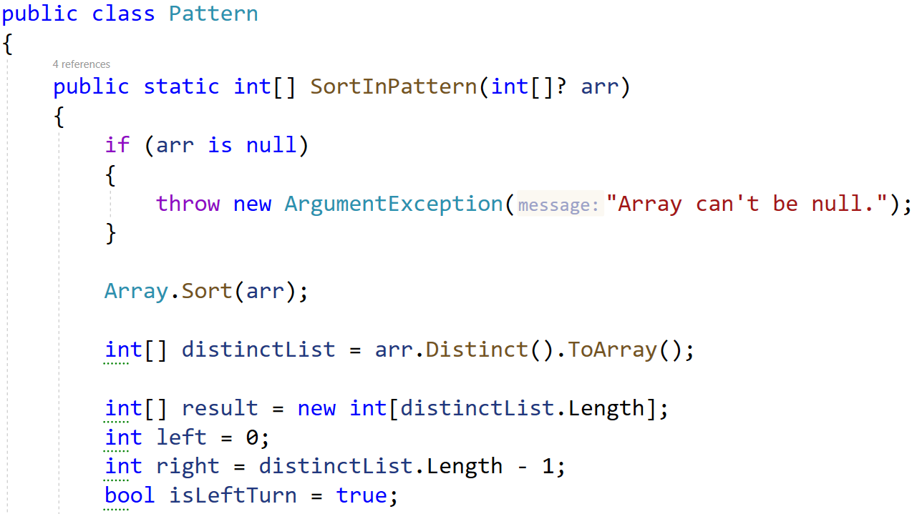

In the **test** **file** PatternTests.cs you are given **tests**:

## Unit Test Array: Top Integer

Test a method that **takes in an array of integers** and **returns string of top integers**, **separated by single space**. A top integer is an **integer that is greater than all the elements to its right**.

**Note:** The method is not static. You need to call it in a different way.

### Examples

|  |  |
| --- | --- |
| **Input** | **Output** |
| 4 3 2 | 4 3 2 |
| 10 | 10 |
| 14 24 3 19 15 17 | 24 19 17 |

The method is found in the TopIntegers.cs file:

Картина, която съдържа текст, екранна снимка, Шрифт, номер

Описанието е генерирано автоматично

You are given a test file TopIntegersTests.cs containing **4 empty tests:**

Картина, която съдържа текст, екранна снимка, Шрифт, линия

Описанието е генерирано автоматично

When you are ready make sure your **tests run:**

Картина, която съдържа текст, екранна снимка, Шрифт

Описанието е генерирано автоматично

## Unit Test Array: Majority

Test a method that takes in an array of integers and returns:

* Positive integer, if even numbers are majority.
* Negative integer, if odd numbers are majority.
* Zero if even and odd numbers are equal.

The method is found in the Majority.cs file:

Картина, която съдържа текст, екранна снимка, номер, Шрифт

Описанието е генерирано автоматично

You are given a test file MajorityTests.cs containing **5 empty tests:**

Картина, която съдържа текст, екранна снимка, Шрифт, номер

Описанието е генерирано автоматично

When you are ready make sure your **tests run:**

Картина, която съдържа текст, екранна снимка, Шрифт

Описанието е генерирано автоматично

## Unit Test Array: First Repeating Element

Test a method that takes in an array of integers and returns the first element that repeats. If no repeating elements are found, return -1.

The method is found in the RepeatingChecker.cs file:

Картина, която съдържа текст, екранна снимка, Шрифт, номер

Описанието е генерирано автоматично

You are given a test file RepeatingChecker_FirstReapeatingElementTests.cs containing **6 empty tests:**

Картина, която съдържа текст, екранна снимка, Шрифт

Описанието е генерирано автоматично

When you are ready make sure your **tests run:**

Картина, която съдържа текст, Шрифт, екранна снимка, линия

Описанието е генерирано автоматично

## Unit Test Array: Last Repeating Element

Test a method that takes in an array of integers and returns the last element that repeats. If no repeating elements are found, return -1.

The method is found in the RepeatingChecker.cs file:

Картина, която съдържа текст, екранна снимка, софтуер, Шрифт

Описанието е генерирано автоматично

You are given a test file RepeatingChecker_LastReapeatingElementTests.cs containing **6 empty tests:**

Картина, която съдържа текст, екранна снимка, Шрифт, номер

Описанието е генерирано автоматично

When you are ready make sure your **tests run:**

Картина, която съдържа текст, екранна снимка, Шрифт, номер

Описанието е генерирано автоматично