# Exercises: Unit Testing Lists

Submit your solutions here: <https://alpha.judge.softuni.org/contests/unit-testing-lists-exercise/5093>

## Unit Test List: Number Processor

Test a given method which takes in a **list of integers** and adds each number in a new list following these principles:

* If the number is **even**, it **squares** it.
* If the number is **odd**, it **square** **roots** it**.**

The method is found in the NumberProcessor.cs file:

In the **test** **file** NumberProcessorTest.cs you are given **tests**. Finish them and run them:

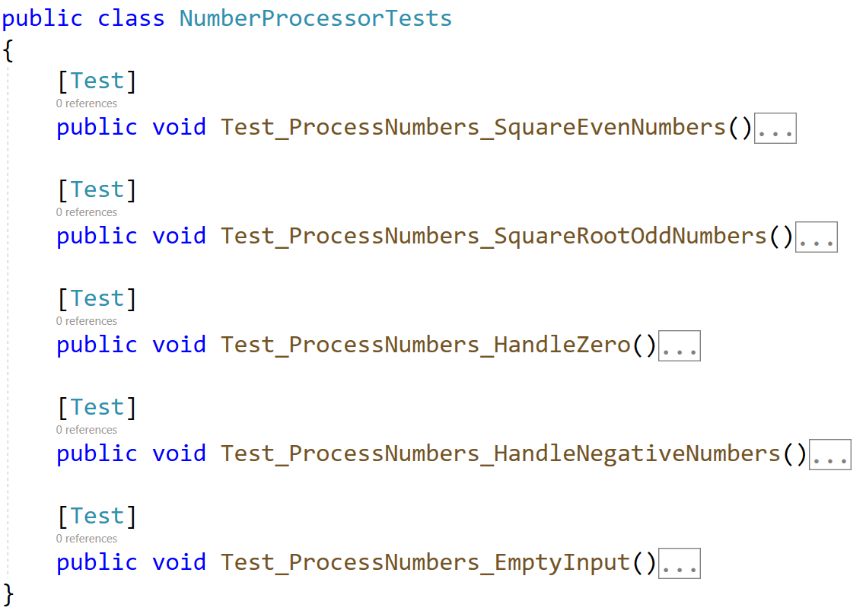

## Unit Test List: Palindrome

Test a given method which takes in a **list of strings** and checks if every word in the list is a **palindrome**.

The method is found in the Palindrome.cs file:

In the **test** **file** PalindromeTests.cs you are given **2 partially finished test**, and **3 empty tests**. Finish them and run them:

## Unit Test List: Matrix

Test a given method which takes in **2** **lists of list of integers (matrix)** that performs **matrix addition** on them.

The method is found in the Matrix.cs file:

Notice the method throws ArgumentException if the matrices are **not the** **same length**.

In the **test** **file** MatrixTests.cs you are given **2 partially finished test**, and **3 empty tests**:

Check the tests run successfully:

## Unit Test List: Find Same Values

Test a method that takes **two lists of integers as input** and **returns a new list containing the unique integers that are present in both input lists**. The method ensures that **each value in the result appears only once, even if it appears multiple times in the input lists**.

The method is found in the SameValues.cs file:

Картина, която съдържа текст, Шрифт, линия, екранна снимка

Описанието е генерирано автоматично

Картина, която съдържа текст, Шрифт, линия, екранна снимка

Описанието е генерирано автоматично

You are given a test file TopIntegersTests.cs containing **4 empty tests:**

Картина, която съдържа текст, екранна снимка, Шрифт, номер

Описанието е генерирано автоматично

When you are ready make sure your **tests run:**

Картина, която съдържа текст, екранна снимка, Шрифт

Описанието е генерирано автоматично

## Unit Test List: Remove Greater Than Threshold

Test a method that takes in **a list of integers and an integer threshold**. The method should **return a new list that contains only the integers from the original list that are less than or equal to the threshold**.

The method is found in the ListRemover.cs file:

Картина, която съдържа текст, екранна снимка, Шрифт

Описанието е генерирано автоматично

You are given a test file ListRemover_RemoveGreaterThanTests.cs containing **4 empty tests:**

Картина, която съдържа текст, линия, Шрифт, екранна снимка

Описанието е генерирано автоматично

When you are ready make sure your **tests run:**

Картина, която съдържа текст, Шрифт, линия, екранна снимка

Описанието е генерирано автоматично

## Unit Test List: Remove Less Than or Equal to Threshold

Test a method that takes in **a list of integers and an integer threshold**. The method should **return a new list that contains only the integers from the original list that are greater than the threshold**.

The method is found in the ListRemover.cs file:

Картина, която съдържа текст, екранна снимка, софтуер, дисплей

Описанието е генерирано автоматично

You are given a test file ListRemover_RemoveLessThanOrEqualToTests.cs containing **4 empty tests:**

Картина, която съдържа текст, екранна снимка, Шрифт, линия

Описанието е генерирано автоматично

When you are ready make sure your **tests run:**

Картина, която съдържа текст, Шрифт, линия, екранна снимка

Описанието е генерирано автоматично

## Unit Test List: List Splitter

Test a method that takes in **a list of integers and splits it into two separate lists**: one containing all even numbers and the other containing all odd numbers.

Note: The method's return type is **(List<int> evens, List<int> odds)**, which is **a tuple** consisting of two List<int> objects.

The method is found in the ListSplitter.cs file:

Картина, която съдържа текст, екранна снимка, Шрифт, номер

Описанието е генерирано автоматично

You are given a test file ListSplitterTests.cs containing **4 empty tests:**

Картина, която съдържа текст, екранна снимка, Шрифт, номер

Описанието е генерирано автоматично

When you are ready make sure your **tests run:**

Картина, която съдържа текст, екранна снимка, Шрифт, линия

Описанието е генерирано автоматично