# Exercises: Unit Testing Methods

Submit your solutions here: <https://alpha.judge.softuni.org/contests/unit-testing-methods-exercise/4682>

## Unit Test Method: Fibonacci

The method takes in an **integer** , and calculates the **Fibonacci** **number**:

Then, look at the tests inside the FibonacciTests.cs class:

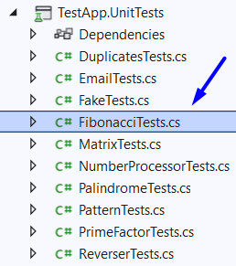

The first test if **finished** so you have a **reference**, the rest of the tests are **empty,** and your task is to finish them. The tests should run when you're finished:

## Unit Test Method: Email

Test a given method which takes in a **string representing an email address** and finds if the given email is indeed **a valid email or not**.

The method is found in the Email.cs file:

You are given again a **test** **file** EmailTests.cs which contains **3 tests**. One of them has been **finished partially**, and **two** are **empty** for you to finish:

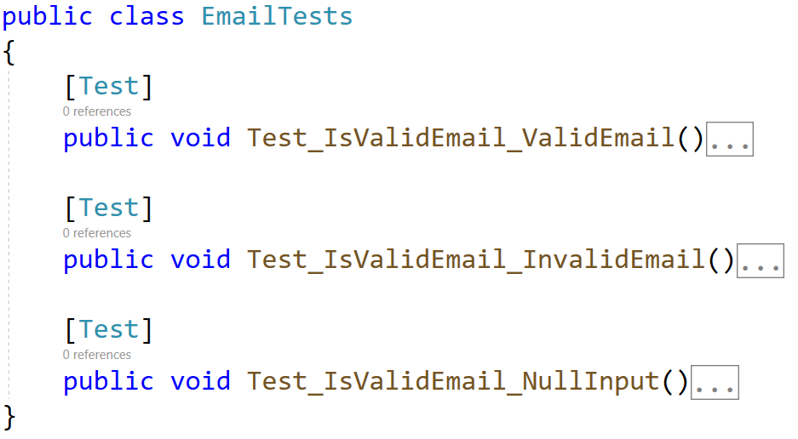

When you are ready make sure your **tests run:**

## Unit Test Method: Prime Factor

Test a given method which takes in a **long number** and finds the largest prime factor of the given number.

The method is found in the PrimeFactor.cs file:

In the **test** **file** PrimeFactorTests.cs you are given **3 empty tests**. Finish them and run them:

## Unit Test Method: Sign of Integer Number

Test a method that takes in a **string**, **parse it to integer** and **checks if the given number is positive, negative, or zero**. The method **returns the following string as result**:

* For positive number: **"The number {number} is positive."**
* For negative number: **"The number {number} is negative."**
* For zero number: **"The number {number} is zero."**
* If not an integer: **"The input is not an integer!"**

The method is found in the **SignOfIntegerNumbers.cs** file:

Картина, която съдържа текст, екранна снимка, Шрифт, номер

Описанието е генерирано автоматично

You are given a test file **SignOfIntegerNumbersTests.cs** containing **4 empty tests:**

Картина, която съдържа текст, екранна снимка, Шрифт, номер

Описанието е генерирано автоматично

When you are ready make sure your **tests run:**

Картина, която съдържа текст, екранна снимка, Шрифт, линия

Описанието е генерирано автоматично

## Unit Test Method: Average Grade Definition

Test a method that takes in **list of double values**, **calculate the average** and **returns the corresponding grade definition as string**:

* 2.00 – 2.99 - **"Fail"**
* 3.00 – 3.49 - **"Poor"**
* 3.50 – 4.49 - **"Good"**
* 4.50 – 5.49 - **"Very good"**
* 6.00 - **"Excellent"**

The method is found in the **AverageGrade.cs** file:

Картина, която съдържа текст, екранна снимка, Шрифт, номер

Описанието е генерирано автоматично

You are given a test file **AverageGradeTests.cs** containing **7 empty tests:**

Картина, която съдържа текст, екранна снимка, Шрифт, номер

Описанието е генерирано автоматично

When you are ready make sure your **tests run:**

Картина, която съдържа текст, екранна снимка, Шрифт

Описанието е генерирано автоматично

## Unit Test Method: Middle Characters

Test a method that **takes in a single string** and **returns a string with the middle character of the input**. If **the length of the string is even**, there are **two middle characters**.

The method is found in the **MiddleCharacters.cs** file:

You are given a test file **MiddleCharactersTests.cs** containing **5 empty tests:**

Картина, която съдържа текст, екранна снимка, Шрифт, номер

Описанието е генерирано автоматично

When you are ready make sure your **tests run:**

Картина, която съдържа текст, екранна снимка, Шрифт

Описанието е генерирано автоматично

## Unit Test Method: Palindrome Integers

Test a method that **takes in a list of integers** and **returns a list of palindrome integers**. A **palindrome** is a **number that reads the same backward as forward**, such as 323 or 1001.

**Note:** The method is not static. You need to call it in a different way.

The method is found in the **PalindromeIntegers.cs** file:

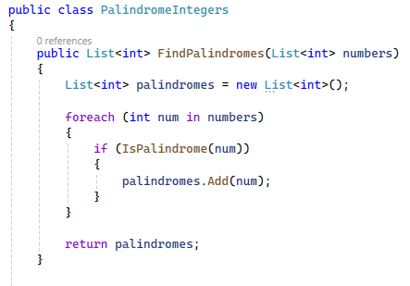

There is **one helper method** to find if the integer is palindrome:

Картина, която съдържа текст, екранна снимка, Шрифт, линия

Описанието е генерирано автоматично

You are given a test file **PalindromeIntegersTests.cs** containing **5 empty tests:**

Картина, която съдържа текст, екранна снимка, Шрифт, номер

Описанието е генерирано автоматично

When you are ready make sure your **tests run:**

Картина, която съдържа текст, екранна снимка, Шрифт

Описанието е генерирано автоматично