**MINISTERUL EDUCAŢIEI ȘI CERCETĂRII AL REPUBLICII MOLDOVA UNIVERSITATEA TEHNICĂ A MOLDOVEI FACULTATEA CALCULATOARE, INFORMATICĂ ŞI MICROELECTRONICĂ DEPARTAMENTUL INFORMATICĂ ȘI INGINERIEA SISTEMELOR**

**Raport**

**Lucrarea de laborator nr. 2**

**la disciplina “Programarea aplicațiilor mobile”**

**A efectuat: Pintilii Vadim,**

**IA-222**

**Chișinău 2024**

### **Sarcină:**



**Realizarea:**

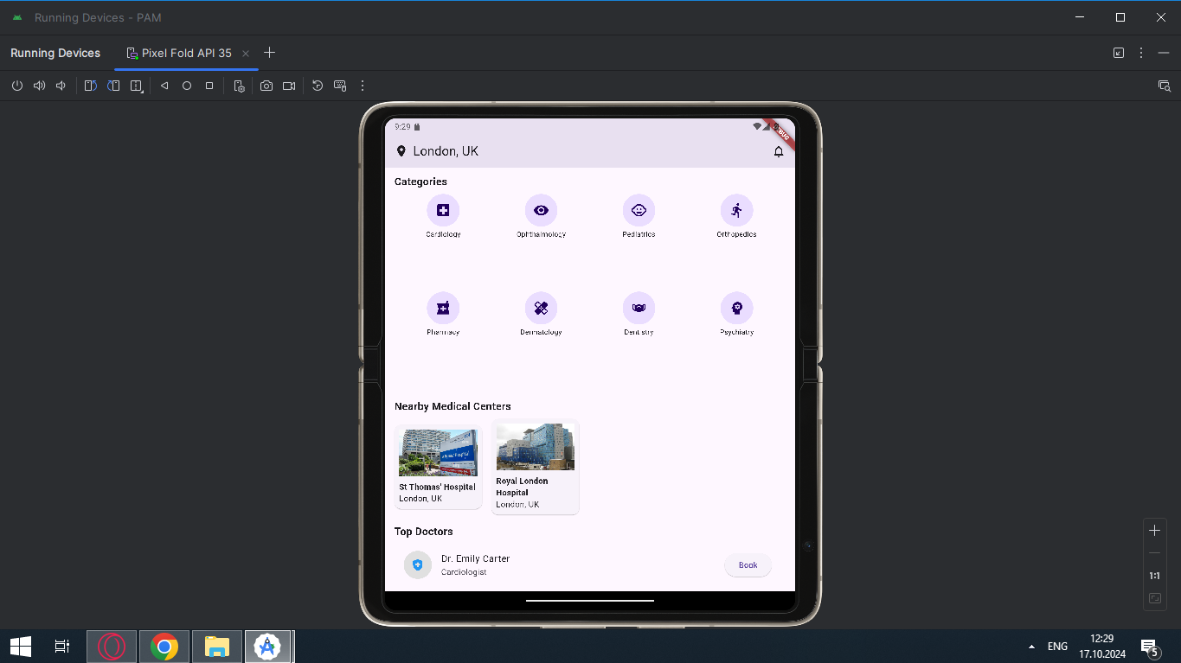

**Codul:**

import 'package:flutter/material.dart';  
  
void main() {  
 runApp(DoctorFinderApp());  
}  
  
class DoctorFinderApp extends StatelessWidget {  
 @override  
 Widget build(BuildContext context) {  
 return MaterialApp(  
 title: 'Doctor Finder',  
 theme: ThemeData(  
 primarySwatch: Colors.*blue*,  
 ),  
 home: DoctorFinderHomePage(),  
 );  
 }  
}  
  
class DoctorFinderHomePage extends StatelessWidget {  
 @override  
 Widget build(BuildContext context) {  
 return Scaffold(  
 appBar: AppBar(  
 title: Row(  
 children: [  
 Icon(Icons.*location_on*),  
 SizedBox(width: 8),  
 Text('London, UK'),  
 Spacer(),  
 Icon(Icons.*notifications_none*),  
 ],  
 ),  
 ),  
 body: SingleChildScrollView(  
 padding: EdgeInsets.all(16),  
 child: Column(  
 crossAxisAlignment: CrossAxisAlignment.start,  
 children: <Widget>[  
 SearchBar(),  
 SizedBox(height: 16),  
 CategoriesSection(),  
 SizedBox(height: 16),  
 NearbyMedicalCentersSection(),  
 SizedBox(height: 16),  
 DoctorListSection(),  
 ],  
 ),  
 ),  
 );  
 }  
}  
  
class SearchBar extends StatelessWidget {  
 @override  
 Widget build(BuildContext context) {  
 return TextField(  
 decoration: InputDecoration(  
 hintText: 'Search specialist doctors...',  
 prefixIcon: Icon(Icons.*search*),  
 border: OutlineInputBorder(  
 borderRadius: BorderRadius.circular(10),  
 ),  
 ),  
 );  
 }  
}  
  
class CategoriesSection extends StatelessWidget {  
 @override  
 Widget build(BuildContext context) {  
 return Column(  
 crossAxisAlignment: CrossAxisAlignment.start,  
 children: [  
 Text(  
 'Categories',  
 style: TextStyle(fontSize: 18, fontWeight: FontWeight.*bold*),  
 ),  
 SizedBox(height: 8),  
 GridView.count(  
 crossAxisCount: 4,  
 shrinkWrap: true,  
 physics: NeverScrollableScrollPhysics(),  
 children: [  
 CategoryIcon(icon: Icons.*local_hospital*, label: 'Cardiology'),  
 CategoryIcon(icon: Icons.*visibility*, label: 'Ophthalmology'),  
 CategoryIcon(icon: Icons.*child_care*, label: 'Pediatrics'),  
 CategoryIcon(icon: Icons.*directions_run*, label: 'Orthopedics'),  
 CategoryIcon(icon: Icons.*local_pharmacy*, label: 'Pharmacy'),  
 CategoryIcon(icon: Icons.*healing*, label: 'Dermatology'),  
 CategoryIcon(icon: Icons.*masks*, label: 'Dentistry'),  
 CategoryIcon(icon: Icons.*psychology*, label: 'Psychiatry'),  
 ],  
 ),  
 ],  
 );  
 }  
}  
  
class CategoryIcon extends StatelessWidget {  
 final IconData icon;  
 final String label;  
  
 CategoryIcon({required this.icon, required this.label});  
  
 @override  
 Widget build(BuildContext context) {  
 return Column(  
 children: [  
 CircleAvatar(  
 radius: 28,  
 child: Icon(icon, size: 28),  
 ),  
 SizedBox(height: 4),  
 Text(label, textAlign: TextAlign.center, style: TextStyle(fontSize: 12)),  
 ],  
 );  
 }  
}  
  
class NearbyMedicalCentersSection extends StatelessWidget {  
 @override  
 Widget build(BuildContext context) {  
 return Column(  
 crossAxisAlignment: CrossAxisAlignment.start,  
 children: [  
 Text(  
 'Nearby Medical Centers',  
 style: TextStyle(fontSize: 18, fontWeight: FontWeight.*bold*),  
 ),  
 SizedBox(height: 8),  
 SingleChildScrollView(  
 scrollDirection: Axis.horizontal,  
 child: Row(  
 children: [  
 NearbyMedicalCenterCard(  
 location: 'St Thomas\' Hospital',  
 imagePath: 'assets/images/st-thomas-hospital.jpg',  
 ),  
 NearbyMedicalCenterCard(  
 location: 'Royal London Hospital',  
 imagePath: 'assets/images/Royal_London_Hospital.jpg',  
 ),  
 ],  
 ),  
 ),  
 ],  
 );  
 }  
}  
  
class NearbyMedicalCenterCard extends StatelessWidget {  
 final String location;  
 final String imagePath;  
  
 NearbyMedicalCenterCard({required this.location, required this.imagePath});  
  
 @override  
 Widget build(BuildContext context) {  
 return Card(  
 margin: EdgeInsets.only(right: 16),  
 child: Container(  
 width: 150,  
 padding: EdgeInsets.all(8),  
 child: Column(  
 crossAxisAlignment: CrossAxisAlignment.start,  
 children: [  
 Image.asset(  
 imagePath,  
 height: 80,  
 width: double.*infinity*,  
 fit: BoxFit.cover,  
 ),  
 SizedBox(height: 8),  
 Text(location, style: TextStyle(fontWeight: FontWeight.*bold*)),  
 Text('London, UK'),  
 ],  
 ),  
 ),  
 );  
 }  
}  
  
class DoctorListSection extends StatelessWidget {  
 @override  
 Widget build(BuildContext context) {  
 return Column(  
 crossAxisAlignment: CrossAxisAlignment.start,  
 children: [  
 Text(  
 'Top Doctors',  
 style: TextStyle(fontSize: 18, fontWeight: FontWeight.*bold*),  
 ),  
 SizedBox(height: 8),  
 ListView.builder(  
 shrinkWrap: true,  
 physics: NeverScrollableScrollPhysics(),  
 itemCount: 5,  
 itemBuilder: (context, index) {  
 return DoctorListTile(doctorName: doctorNames[index], specialty: doctorSpecialties[index]);  
 },  
 ),  
 ],  
 );  
 }  
}  
  
class DoctorListTile extends StatelessWidget {  
 final String doctorName;  
 final String specialty;  
  
 DoctorListTile({required this.doctorName, required this.specialty});  
  
 @override  
 Widget build(BuildContext context) {  
 return ListTile(  
 leading: CircleAvatar(  
 radius: 24,  
 backgroundColor: Colors.*grey*[300],  
 child: Icon(Icons.*health_and_safety*, color: Colors.*blue*), // Icon pentru doctor  
 ),  
 title: Text(doctorName),  
 subtitle: Text(specialty),  
 trailing: ElevatedButton(  
 onPressed: () {},  
 child: Text('Book'),  
 ),  
 );  
 }  
}  
  
final List<String> doctorNames = [  
 'Dr. Emily Carter',  
 'Dr. James Wilson',  
 'Dr. Olivia Smith',  
 'Dr. William Johnson',  
 'Dr. Ava Brown'  
];  
  
final List<String> doctorSpecialties = [  
 'Cardiologist',  
 'Pediatrician',  
 'Dermatologist',  
 'Orthopedic Surgeon',  
 'Psychiatrist'  
];

**Concluzii:**

Lucrarea a oferit o oportunitate practică de a aplica conceptele de dezvoltare a aplicațiilor mobile, îmbunătățind abilitățile de utilizare a Flutter și a limbajului Dart pentru interacțiuni cu interfețele grafice și manipularea datelor de intrare. Aceasta a fost o experiență valoroasă pentru înțelegerea aprofundată a dezvoltării aplicațiilor mobile.