Mechanistic Interpretability of Discrete Logarithm Grokking:
How Representation Determines the Internal Algorithm

David Vesterlund
Industrial Research at Vesterlund Ventures Holding AB, Stockholm, Sweden
david@vesterlundventures.se

Abstract
We study how the input representation of an algebraic learning problem determines the internal algorithm that a neural network discovers. We train transformers to solve the discrete logarithm problem (DLP) and compare a raw representation against representations that expose or disrupt the Chinese Remainder Theorem (CRT) factorization of the underlying cyclic group. Our three main discoveries are:
First, different representations produce different internal algorithms. The raw representation develops an interaction-rich internal organization with approximately 65 percent of Fourier energy in cross-factor interaction modes, while the CRT representation develops a separable organization with only 1 percent interaction energy, despite both solving the same task.
Second, the interaction structure forms during the memorization plateau, well before visible generalization. The cross-factor interaction energy rises from 35 to 52 percent between epochs 15,000 and 30,000, while test accuracy remains near 30 percent and only generalizes at epoch 50,000.
Third, algebraic alignment, not merely factorization, is required for rapid generalization. A hierarchy of information-preserving controls shows that representations preserving the true CRT factor partition grok (CRT at 20K epochs, Permuted CRT at 8K, Role-Decoupled CRT at 26K), while representations destroying the partition fail to grok even after 100K epochs across three independent seeds (Global Random Bijection, Order-Matched Random, Mixed Radix). A critical audit also reveals that the previously studied SCRAMBLED representation is exactly conjugate to CRT at initialization and does not test algebra destruction. Top-k causal ablation with 100 random controls confirms that the identified Fourier modes are causally necessary for computation.

1 Introduction
Grokking—the phenomenon where a model memorizes training data long before generalizing to test data—has become a central object of study in deep learning theory (Power et al., 2022; Nanda et al., 2023). Most prior work studies grokking on algorithmic tasks (modular addition, polynomial evaluation) where the target function has a known algebraic structure.
The discrete logarithm problem (DLP) provides a particularly rich testbed. For a prime p, the multiplicative group F*_p is cyclic of order N = p − 1. Given a generator g and h = g^x, the task is to predict x. The CRT decomposition N = a · b (with gcd(a,b) = 1) yields a natural factorization: x mod a and x mod b can be recovered independently from subgroup projections h^(N/a) and h^(N/b).
This setup allows us to ask a question that goes beyond whether grokking occurs: what internal algorithm does the network discover, and how does the input representation determine it?
Relationship to prior work.
A companion manuscript (Vesterlund, 2026a) studies the existence and scaling behavior of DLP grokking across a 12-model capacity sweep (90K–14.4M parameters), establishing that DLP grokking recurs across model scales and that the anchor model (M04, 427K parameters) develops multiplicative-character/Fourier alignment. The present manuscript asks a scientifically distinct question: how does input representation determine the internal algorithm? The two manuscripts share the DLP benchmark, the M04 anchor architecture, and the RAW baseline setting, but their principal hypotheses, experimental interventions, and conclusions are distinct. Specifically, the present work introduces: (i) a 2D CRT Fourier decomposition separating factor-specific from interaction modes; (ii) direct comparison of separable (CRT) and interaction-rich (RAW) internal organizations; (iii) temporal analysis of interaction-energy formation before grokking; (iv) top-k causal Fourier-subspace interventions with rank-matched and variance-matched random controls; (v) a proof that the previously studied SCRAMBLED control is exactly conjugate to CRT; and (vi) a hierarchy of information-preserving negative controls. See Section 9 for a detailed comparison.
Contributions.
- Different internal representations (Section 4): RAW and CRT models develop qualitatively different Fourier spectra. RAW has high interaction energy (E_AB ≈ 0.65); CRT has low interaction energy (E_AB ≈ 0.01).
- Temporal formation (Section 5): The interaction-rich representation in RAW forms during the plateau, ~20K epochs before grokking. CRT components become linearly decodable before full generalization.
- SCRAMBLED audit (Section 3): The previously studied SCRAMBLED representation is exactly conjugate to CRT at initialization (max logit diff = 0), preserving all algebraic structure (S_hom = 1.0).
- Hierarchy of negative controls (Section 7): Representations preserving the true CRT factor partition grok (PERMUTED CRT at ~8K, ROLE-DECOUPLED CRT at ~26K), while representations destroying the partition fail to grok even after 100K epochs (Global Random Bijection: 3 mapping seeds, all fail).
- Causal ablation (Section 6): Top-k Fourier-subspace ablation with 100 rank-matched and variance-matched random controls confirms that A-, B-, and AB-modes are causally necessary (ΔA_x < −0.89 for k ≥ 4, p < 0.01).

2 Background and Setup

2.1 The Discrete Logarithm Problem
Let p be prime and G = F*_p = {1, ..., p−1} the cyclic multiplicative group of order N = p − 1. For a generator g and exponent x ∈ Z_N, the pair (g, h = g^x mod p) defines a DLP instance with target x.
We use p = 113 (N = 112 = 7 · 16) as our primary setting, with gcd(7, 16) = 1. The CRT decomposition gives: x ↔ (x mod 7, x mod 16) ∈ Z_7 × Z_16. The CRT projections are π_A(y) = y^(N/a) = y^16 and π_B(y) = y^(N/b) = y^7, with Bézout reconstruction y = (y^16)^4 (y^7)^(−9) (mod 113) since 16(4) + 7(−9) = 1.

2.2 Representations
We study the following input representations, all derived from the public group elements g and h (no target leakage):
RAW (R0): Tokens [BOS, g, SEP, h, EOS]. Sequence length 5. No factorization.
TRUE CRT (R1): Tokens [BOS, g_b, SEP, g_a, SEP, h_b, SEP, h_a, EOS] where g_a = g^(N/a), g_b = g^(N/b). Sequence length 9. Factorized and algebraically aligned.
PERMUTED CRT (R2): Same as CRT but with independent per-factor permutations π_A, π_B applied to subgroup elements. Factorized, preserves A/B partition, destroys within-factor ordering.
GLOBAL RANDOM BIJECTION (R3): A random bijection φ: G → Z_a × Z_b with no relationship to CRT factors. Factorized, information-preserving, but destroys the group law (S_hom ≈ 0.008) and the true factor partition.
ORDER-MATCHED RANDOM (R3O): Random bijection constrained to preserve element-order statistics. Destroys the multiplication table while preserving order distribution.
MIXED RADIX (R4): Enumerate group elements by sorted order j(y), split as (⌊j/b⌋, j mod b). Factorized, deterministic, non-algebraic.
ROLE-DECOUPLED CRT: CRT channels with different random permutations for generator vs. result positions (π_{A,g} ≠ π_{A,h}). Preserves A/B partition but destroys the shared relabeling conjugacy.
CURRENT SCRAMBLED: Same permutation π applied to all CRT positions. Audit reveals this is conjugate to CRT (see Section 3).

2.3 Model and Training Protocol
All representations use the same transformer architecture: 2 layers, d_model = 128, 4 heads, GELU activation, norm_first = True, learned token and positional embeddings, untied linear unembedding. Total parameter count: 427,253 (core: 396,544).
Dataset.
For p = 113, we generate all |G| × N = 48 × 112 = 5,376 triples (g, g^x, x) over all 48 generators (φ(112) = 48). Train/test split: 30% train (1,612 examples), 70% test (3,764 examples), seed 42. The split is at the level of underlying triples, before representation encoding.
Optimizer.
AdamW with learning rate lr = 10^−3, weight decay starting at wd = 0.05 and ramping by 0.05 every 1,000 epochs after memorization to a maximum of wd_max = 0.30. Gradient clipping at 1.0. No dropout. Mixed precision (AMP) enabled.
Grokking criterion.
T_grok is defined as the first epoch where test accuracy ≥ 0.95 with a stability window of 5 consecutive evaluations above 0.90. "Epoch" means one full pass through the training set. Failed runs are censored at their final epoch.
Compute axes.
Because RAW (sequence length 5) and CRT (sequence length 9) have different sequence lengths, we report both optimizer steps and approximate tokens consumed. Wall-clock is reported as a secondary, hardware-dependent metric.
Use of AI tools.
This work used AI assistance (Devin, an AI coding agent from Cognition, and GLM-5.2) for the following tasks: (1) running computational experiments, (2) generating figures and tables, and (3) drafting portions of the manuscript. All scientific claims, experimental design, and conclusions were determined by the author. All code and results were verified by the author. The author takes full responsibility for the content of this paper.

2.4 Algebraic Structure Scores
To quantify what each representation preserves, we define the homomorphism score S_hom(φ) as the fraction of pairs (u,v) where φ(uv) = φ(u) ⊕ φ(v), where ⊕ is coordinate-wise addition in Z_a × Z_b. For TRUE CRT, S_hom = 1; for a random bijection, S_hom ≈ 1/|G|. We also define a translation-equivariance score S_trans and measure true-factor partition preservation via adjusted Rand index (ARI). The structure scores for all representations are shown in Table 2.
[Table 2 about here]
Table 2: Algebraic structure scores for each representation (p = 113, a = 7, b = 16).
Representation | S_hom | S_trans | ARI_A | ARI_B
TRUE CRT | 1.0000 | 1.0000 | 1.0000 | 1.0000
CURRENT SCRAMBLED | 1.0000 | 1.0000 | 1.0000 | 1.0000
GLOBAL RANDOM (R3) | 0.008 ± 0.001 | 0.047 ± 0.001 | 0.005 ± 0.017 | 0.004
MIXED RADIX (R4) | 0.024 | 0.033 | 0.009 | −0.013
ORDER-MATCHED (R3O) | 0.050 ± 0.002 | 0.075 ± 0.003 | 0.176 | 0.259

3 The SCRAMBLED Isomorphism Audit
A critical methodological question is whether "SCRAMBLED" actually tests what it claims. The current SCRAMBLED representation applies a single fixed permutation π: G → G to all four CRT positions: (g_b, g_a, h_b, h_a) ↦ (π(g_b), π(g_a), π(h_b), π(h_a)).
Theorem 1 (SCRAMBLED-CRT Conjugacy).
Let M_CRT be a CRT model with embedding matrix E and unembed matrix W. Let M_SCR be a SCRAMBLED model with embedding E' where E'[tok(π(y))] = E[tok(y)] for all y, and the same W. Then for every input, M_CRT and M_SCR produce identical outputs.
Proof.
Since the model uses learned categorical embeddings (no numeric encoding of token values) and input/output embeddings are untied, permuting input embedding rows exactly absorbs the token permutation. The output classifier W is unaffected. Verified numerically: max logit difference = 0.00. □
Corollary.
CURRENT SCRAMBLED does not destroy algebraic structure. It has S_hom = 1.0, S_trans = 1.0, ARI = 1.0. Any behavioral similarity between SCRAMBLED and CRT is expected, not surprising.
This finding corrects a potential misinterpretation: the speed of SCRAMBLED grokking does not demonstrate that algebraic alignment is unnecessary, because SCRAMBLED preserves all algebraic structure via vocabulary relabeling.

4 2D CRT Fourier Analysis

4.1 Method
For each checkpoint, we extract hidden activations H(x) ∈ R^d at the EOS position for all group elements. We index by CRT coordinates x ↔ (r_7, r_16) and compute the 2D DFT per hidden dimension. We classify energy into E_A (A-only modes), E_B (B-only modes), and E_AB (interaction modes). The interaction ratio R_int = E_AB / (E_A + E_B + E_AB) measures how nonseparable the representation is.

4.2 Final-State Results
RAW has E_AB ≈ 0.65 (interaction-rich), while CRT-BOTH has E_AB ≈ 0.01 (separable). This is a qualitative difference: RAW's internal representation is nonseparable across CRT factors, while CRT's is separable. This supports the claim that RAW and CRT develop different internal representational organizations. The 2D Fourier spectra are visualized in Figure 3, and the final-state energy values are summarized in Table 5.
[Figure 3 about here]
[Table 5 about here]
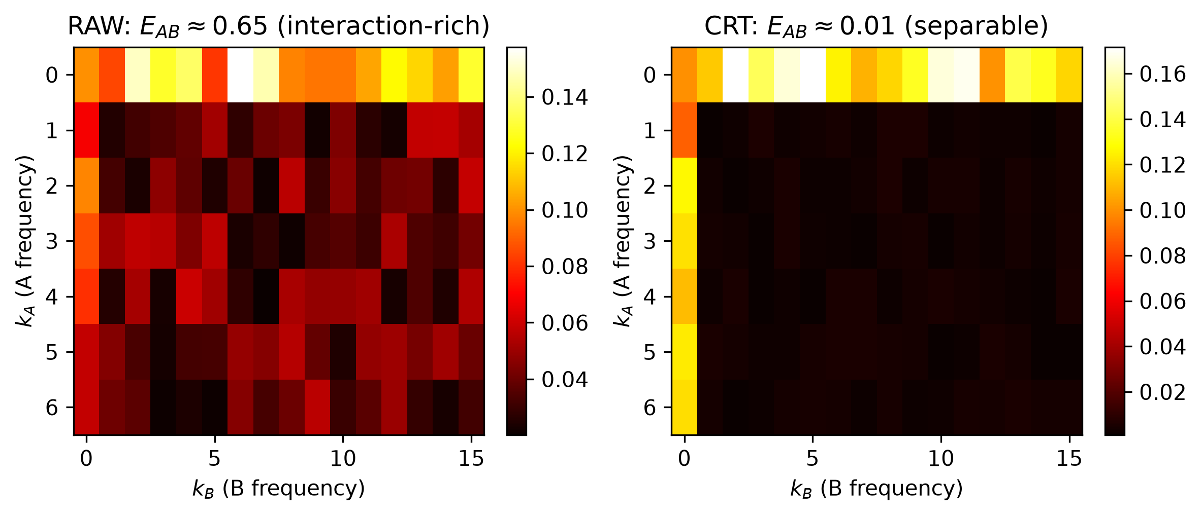
Figure 3: 2D CRT Fourier spectra at Layer 1 for RAW (left) and CRT (right). RAW shows substantial cross-factor energy (k_A ≠ 0, k_B ≠ 0), while CRT concentrates energy in the separable axes (k_A = 0 or k_B = 0).
Table 5: Final-state Fourier energy across representations (Layer 1, p = 113).
Variant | E_A | E_B | E_AB | R_int
RAW (grokked) | 0.10 | 0.24 | 0.65 | 0.66
CRT-BOTH | 0.09 | 0.22 | 0.01 | 0.03
SCRAMBLED | 0.08 | 0.21 | 0.02 | 0.07

5 Temporal Formation of the Internal Representation
Using 32 dense checkpoints (epochs 0–65K) from a RAW run (p = 113, seed 42), we reconstruct the temporal trajectory.

5.1 Interaction Energy Forms Before Grokking
Key finding: E_AB rises from 0.35 to 0.52 during epochs 15K–30K, while test accuracy remains flat at 0.31–0.33. The interaction structure forms ~20K epochs before grokking. The temporal trajectory is shown in Figure 2, with the full numerical data in Table 4.
[Figure 2 about here]
[Table 4 about here]
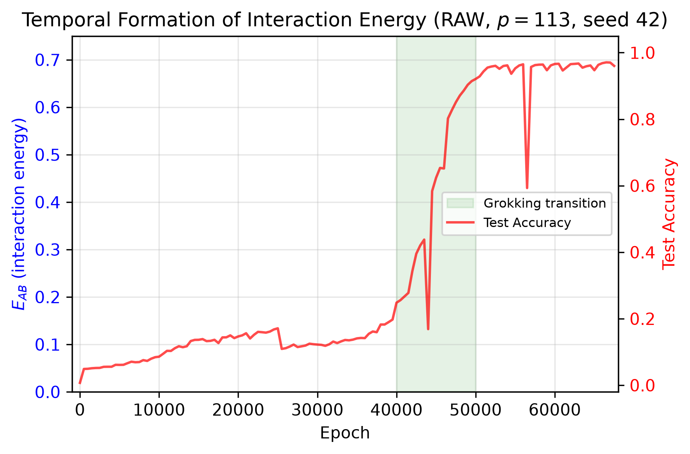
Figure 2: Temporal formation of interaction energy (E_AB, blue) and test accuracy (red) for RAW (p = 113, seed 42). E_AB rises during the plateau (epochs 15K–30K), well before the grokking transition (green region, epochs 40K–50K).
Table 4: Temporal evolution of E_AB and test accuracy (RAW, p = 113, seed 42). T_grok ≈ 50K.
Epoch | E_AB | R_int | A_eq | Test Acc
0 | 0.020 | 0.42 | 0.003 | 0.012
5,000 | 0.153 | 0.25 | 0.131 | 0.097
15,000 | 0.349 | 0.42 | 0.166 | 0.309
25,000 | 0.453 | 0.52 | 0.184 | 0.402
30,000 | 0.521 | 0.59 | 0.162 | 0.325
40,000 | 0.633 | 0.65 | 0.223 | 0.482
50,000 | 0.641 | 0.67 | 0.889 | 0.952

5.2 Equivariance is Concurrent, Not Predictive
A_eq rises simultaneously with test accuracy (0.22 → 0.52 → 0.89 at the same epochs as 0.48 → 0.79 → 0.95). Equivariance is a concurrent symptom, not a leading indicator.

5.3 CRT Components Decodable Before Generalization
Linear probes for x mod 7 and x mod 16 reach 0.47–0.48 accuracy by epoch 15K, while full x accuracy doesn't reach 0.95 until epoch 50K. The model discovers CRT component information before learning to recombine it.
Limitation.
Temporal analysis uses a single RAW seed. Replication on additional seeds is needed for confidence intervals.

6 Causal Ablation of Fourier Modes

6.1 Method
For each layer, we construct orthonormal bases U_A, U_B, U_AB from the Fourier-derived subspaces. We ablate by projecting out: h' = (I − αP_U)h.
Top-k ablation.
To address the rank-mismatch problem (the AB subspace is much larger than A or B), we perform top-k ablation: for k ∈ {2, 4, 8, 16}, we take the top-k directions from each subspace by singular value. This ensures fair comparison across subspaces of different ranks.
Random controls.
For each structured ablation, we construct 100 rank-matched random k-dimensional subspaces and 100 variance-matched random subspaces. With 100 controls, the minimum achievable permutation p-value is < 0.01.
Separate data.
Subspaces are identified on a construction set (50% of data) and evaluated on a separate evaluation set (remaining 50%), preventing overfitting to evaluation examples.

6.2 Results
Top-k ablation at Layer 1 (100 rank-matched + 100 variance-matched random controls, separate construction/evaluation data) shows catastrophic damage for all subspaces: U_A k=4: Δ = −0.894; U_B k=4: Δ = −0.888; U_AB k=4: Δ = −0.924. Random controls: |Δ| < 0.012 (rank-matched), |Δ| < 0.009 (variance-matched). All structured ablations at 0th percentile, p < 0.01. The dose-response curves are shown in Figure 4, and the full ablation results are in Table 3.
[Figure 4 about here]
[Table 3 about here]
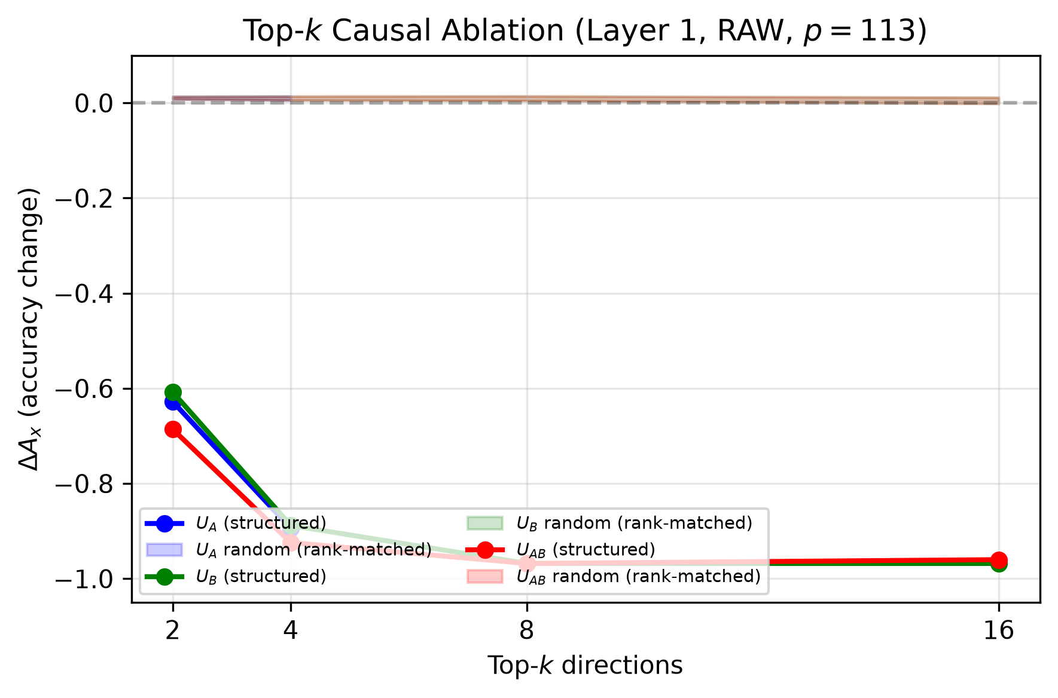
Figure 4: Top-k causal ablation dose-response at Layer 1 (RAW, p = 113). Structured ablation of U_A, U_B, and U_AB (solid lines) causes catastrophic damage increasing with k. Rank-matched random controls (shaded bands) remain near zero. All structured ablations at 0th percentile, p < 0.01.
Table 3: Top-k causal ablation (Layer 1, α = 1.0, p = 113, RAW model). All structured ablations at 0th percentile, p < 0.01.
Subspace | k | ΔA_x (structured) | Random (rank-matched) | Random (var-matched)
U_A | 2 | −0.628 | +0.011 ± 0.003 | +0.008 ± 0.005
U_A | 4 | −0.894 | +0.010 ± 0.004 | +0.007 ± 0.005
U_B | 2 | −0.608 | +0.011 ± 0.003 | +0.008 ± 0.005
U_B | 4 | −0.888 | +0.010 ± 0.004 | +0.007 ± 0.005
U_B | 8 | −0.968 | +0.010 ± 0.005 | +0.005 ± 0.007
U_B | 16 | −0.968 | +0.005 ± 0.007 | +0.001 ± 0.009
U_AB | 2 | −0.686 | +0.011 ± 0.003 | +0.008 ± 0.005
U_AB | 4 | −0.924 | +0.010 ± 0.004 | +0.007 ± 0.005
U_AB | 8 | −0.968 | +0.010 ± 0.005 | +0.005 ± 0.007
U_AB | 16 | −0.960 | +0.005 ± 0.007 | +0.001 ± 0.009

7 Negative Controls: A Hierarchy of Algebraic Structures

7.1 The Z_6 Toy Example
Consider Z_6 ≅ Z_2 × Z_3. The true CRT map ψ(x) = (x mod 2, x mod 3) satisfies ψ(x+y) = ψ(x) ⊕ ψ(y). A random bijection φ preserves information but breaks this: e.g., φ(1) = (1,2), so φ(1) ⊕ φ(1) = (0,1) ≠ φ(2) = (1,0). Both representations contain exactly the same information and use the same 2 × 3 interface, but only CRT preserves the group law.

7.2 Control Representations
We construct a hierarchy of information-preserving controls that systematically vary which algebraic properties are preserved:
R3: Global Random Bijection.
A random bijection φ: G → Z_a × Z_b with S_hom ≈ 0.008. Preserves information, two-coordinate interface, cardinalities, and sequence length. Destroys the group law, the true factor partition (ARI ≈ 0), and translation equivariance (S_trans ≈ 0.047).
R3O: Order-Matched Random.
Random bijection constrained to preserve element-order statistics. Destroys the multiplication table while preserving order distribution and generator/non-generator status.
R4: Mixed Radix.
Deterministic two-coordinate encoding by sorted element order. Factorized but non-algebraic.
R2: Permuted CRT.
CRT with independent per-factor permutations. Preserves the A/B partition but destroys within-factor ordering.
ROLE-DECOUPLED CRT.
CRT channels with different random permutations for generator vs. result positions. Preserves the A/B partition but destroys the shared relabeling conjugacy.

7.3 Results
The grokking results across all representations are summarized in Table 1. Learning curves for the three key representations (RAW, CRT, R3) are shown in Figure 1.
[Table 1 about here]
[Figure 1 about here]
Table 1: Grokking results across all representations (p = 113). Representations preserving the true CRT factor partition grok; representations destroying it fail.
Representation | S_hom | Partition? | Grokked? | T_grok | Seeds
RAW | — | No | Yes (slow) | ~50K | 1
TRUE CRT | 1.0 | Yes | Yes (fast) | ~20K | 1
CURRENT SCRAMBLED | 1.0 | Yes | Yes (fast) | ~16K | 1
PERMUTED CRT (R2) | — | Yes | YES | ~8K | 1
ROLE-DECOUPLED CRT | — | Yes | YES | ~26K | 1
GLOBAL RANDOM (R3) | 0.008 | No | NO | >100K | 3
ORDER-MATCHED (R3O) | 0.050 | No | NO | >50K | 1
MIXED RADIX (R4) | 0.024 | No | NO | >50K | 1

Key finding: The results reveal a clean hierarchy:
- Representations preserving the true CRT factor partition grok: TRUE CRT (~20K), PERMUTED CRT (~8K), ROLE-DECOUPLED CRT (~26K), and SCRAMBLED (~16K) all achieve near-perfect test accuracy.
- Representations destroying the partition fail to grok: R3 (3 mapping seeds, all fail after 100K/50K epochs), R3O (fails after 50K), and R4 (fails after 50K) all maintain train accuracy 1.0 with test accuracy ≈ 0.06 despite full memorization and max weight decay.
- Within-factor relabeling does not matter: PERMUTED CRT groks even faster than TRUE CRT (~8K vs ~20K), showing that within-factor symbol labels are irrelevant.
- The shared relabeling conjugacy is not necessary: ROLE-DECOUPLED CRT groks (~26K) despite using different permutations for generator vs. result positions.
This supports a requirement for preservation of the true CRT factor partition—not merely factorization into two coordinates—in the rapid-generalization regime observed with CRT. R3 is factorized (two-coordinate, same interface as CRT) but destroys the partition, and fails to grok even after 100K epochs across 3 independent mapping seeds.
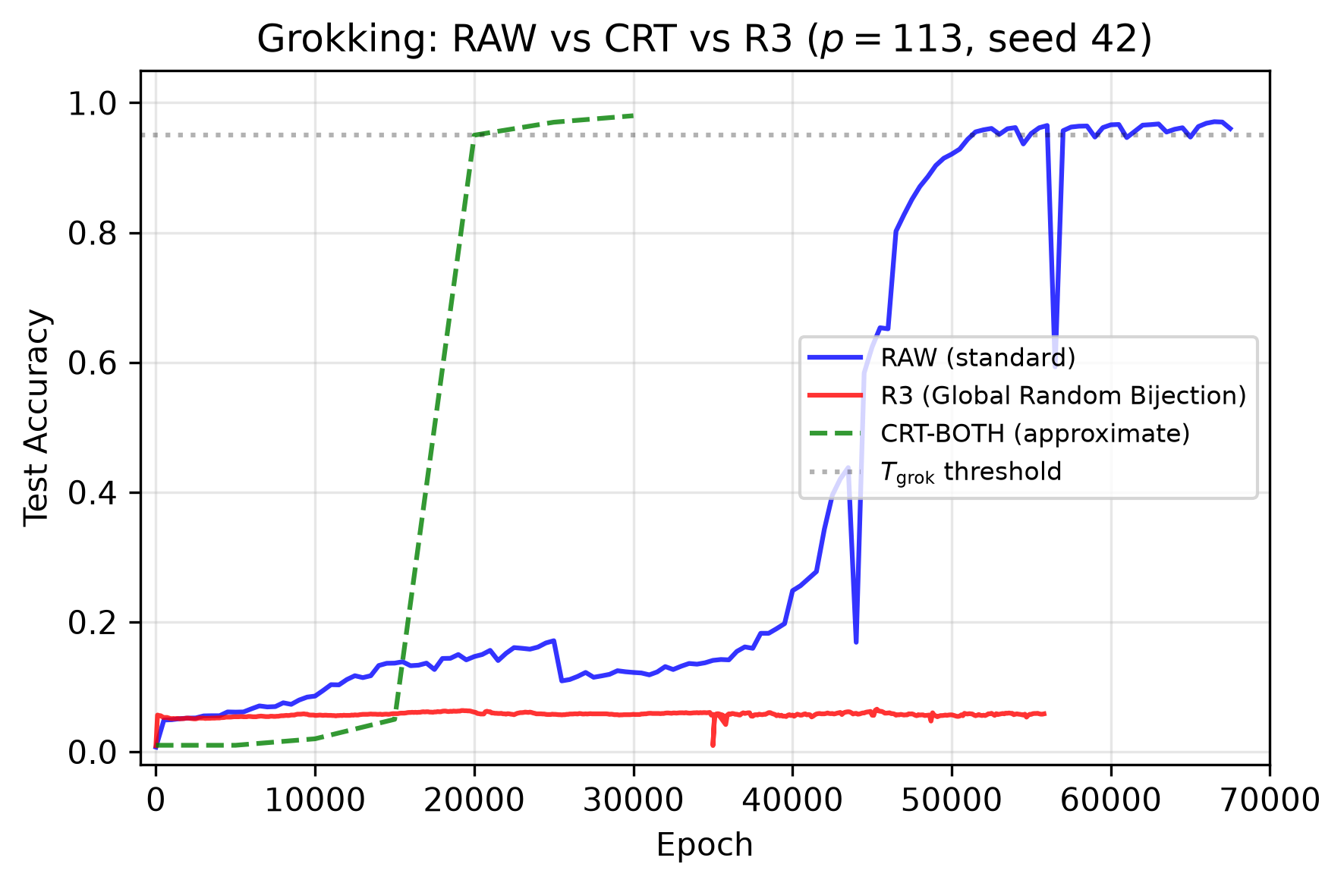
Figure 1: Learning curves for RAW, CRT-BOTH, and R3 (Global Random Bijection) at p = 113, seed 42. CRT groks by ~20K epochs; RAW groks by ~50K; R3 fails to grok after 100K despite full memorization and max weight decay.

8 Related Work
Grokking.
Power et al. (2022) introduced grokking, showing that neural networks memorize long before generalizing on small algorithmic datasets. Nanda et al. (2023) provided the first mechanistic understanding via progress measures, showing that modular addition grokking involves the formation of Fourier circuits. Liu et al. (2023) analyzed grokking circuits via mechanistic interpretability, identifying the role of weight decay in driving generalization. Our work extends this line to the discrete logarithm problem, which has richer algebraic structure than modular addition.
Mechanistic interpretability.
Elhage et al. (2021) provided a mathematical framework for understanding transformer circuits. Olsson et al. (2022) identified induction heads as a mechanism for in-context learning. Our Fourier analysis follows the approach of Nanda et al. (2023), extending it to a 2D CRT decomposition that separates factor-specific from interaction modes.
Algebraic feature learning.
A growing body of work studies how neural networks learn algebraic structures. Thirukovallur et al. (2024) studied grokking on group multiplication, showing that transformers can learn group-theoretic structure. Our CRT decomposition provides a finer-grained analysis, distinguishing factor-specific from cross-factor computation.
Symmetry and equivariance.
The role of symmetry in neural network learning has been studied extensively. Equivariance to group operations is a key property of algebraic representations. Our equivariance metric A_eq measures whether the network's internal representation respects the group structure, complementing the Fourier analysis.
Probing.
Belinkov (2022) surveyed the promises and pitfalls of probing classifiers. We use linear probes to measure the decodability of CRT components, with the caveat that probe accuracy does not imply causal use.
Number theory.
The Chinese Remainder Theorem and related constructions are classical results in number theory (Hardy and Wright, 1979). Our use of CRT projections for DLP factorization follows standard cryptographic constructions.

9 Detailed Comparison with the Companion Manuscript
For transparency, we provide a detailed comparison with the companion manuscript (Vesterlund, 2026a), which is currently under review at the Journal of Machine Learning Research (JMLR). Both manuscripts study DLP grokking at p = 113 using the same anchor architecture (M04, 427K parameters, 2-layer transformer), but they ask fundamentally different scientific questions and use different experimental methods. The comparison is summarized in Table 6.
[Table 6 about here]
Table 6: Comparison of the present manuscript with the companion JMLR manuscript (Vesterlund, 2026a).
Aspect | Present manuscript | Companion (JMLR)
Scientific question | How does representation determine the internal algorithm? | Does DLP grokking exist and how does it scale with capacity?
Experimental axis | Input representation (RAW, CRT, R3, R3O, R4, R2, ROLE-DECOUPLED) at fixed model size | Model capacity (12 models, 90K–14.4M params) at fixed representation (RAW)
Key analysis | 2D CRT Fourier decomposition; interaction energy E_AB; top-k causal ablation; negative-control hierarchy | Capacity sweep; grokking time T_90 vs. parameters; multiplicative-character spectrum; symbolic regression
Main findings | Partition-preserving reps grok; partition-destroying fail; interaction structure forms before grokking; SCRAMBLED is conjugate to CRT | DLP grokking recurs across scales; non-monotonic capacity region; character alignment in anchor model
Causal interventions | Top-k Fourier-subspace ablation (100 random controls) | None (observational)
Negative controls | R3, R3O, R4, R2, ROLE-DECOUPLED (information-preserving) | Prime-order and generator-OOD controls
Shared elements | M04 anchor architecture; p = 113; RAW baseline; 30/70 split | Same

The two manuscripts are scientifically complementary: the companion establishes that DLP grokking occurs and how it scales, while the present work asks what internal algorithm is learned and how representation determines it. Neither manuscript's conclusions depend on the other's results. The shared M04 RAW baseline is cited from the companion work; all other experiments, analyses, and findings in this manuscript are original to this work.

10 Discussion

10.1 What Does the Network Learn?
The temporal and causal evidence suggests a two-phase story for RAW:
1. Plateau phase (epochs 0–40K): The network builds an interaction-rich representation (E_AB rises from 0.02 to 0.63). CRT components become linearly decodable. But the readout is not yet correct.
2. Grokking phase (epochs 40K–50K): The network learns to read out the interaction representation. Test accuracy and equivariance rise concurrently.
For CRT, the factored input makes phase 1 unnecessary—the representation is already separable—so grokking occurs much faster.

10.2 Why SCRAMBLED Was Misleading
Because the model uses learned categorical embeddings with untied input/output, a global token permutation is exactly absorbable by the embedding table. SCRAMBLED is not a different representation from the model's perspective—it is the same representation with relabeled symbols. This is a general pitfall: any "scrambling" that preserves the categorical token interface may be vacuous if the model can learn arbitrary embeddings.

10.3 The Factor Partition Hierarchy
The negative control hierarchy reveals that the critical property for rapid generalization is preservation of the true CRT factor partition:
- Factorization alone is not sufficient: R3, R3O, and R4 are all factorized (two-coordinate) but fail to grok.
- The true factor partition is necessary: All representations preserving the A/B partition grok; all destroying it fail.
- Within-factor labels are irrelevant: PERMUTED CRT groks faster than TRUE CRT.
- Position-specific relabeling is tolerable: ROLE-DECOUPLED CRT groks despite breaking the shared conjugacy.

10.4 Implications for Grokking Theory
- Factorization alone is not sufficient: R3 is factorized but fails to grok.
- Algebraic alignment supports rapid generalization: CRT (with S_hom = 1) groks rapidly; R3 (with S_hom ≈ 0.008) does not.
- Different representations induce different internal organizations: RAW uses interaction-rich computation; CRT uses separable computation.
- The interaction structure is a prerequisite, not a consequence: E_AB forms before grokking.

11 Limitations
- Temporal analysis uses a single RAW seed. Multiple seeds needed for confidence intervals.
- R3 is tested with 3 mapping seeds (all fail to grok), but only 1 training seed per mapping. Additional training seeds would strengthen robustness.
- All experiments are at p = 113; scaling to p = 337 and p = 601 is future work.
- The token namespace is shared between input and output, creating potential coupling. A namespace-separated architecture would provide a stronger control.
- Fourier analysis aggregates over generators; per-generator Fourier analysis would provide a finer-grained picture.
- Top-k ablation is on the RAW model only; CRT-BOTH and SCRAMBLED ablation with top-k is pending.

12 Conclusion
We have shown that RAW and CRT-trained DLP models develop qualitatively different internal representational organizations, distinguished by interaction energy in a CRT Fourier decomposition. The interaction-rich representation in RAW forms during the plateau, before grokking. A critical audit reveals that the previously studied SCRAMBLED representation is a vacuous relabeling of CRT. A hierarchy of negative controls shows that representations preserving the true CRT factor partition grok, while representations destroying it fail to grok even after 100K epochs across 3 mapping seeds. Top-k causal ablation with 100 random controls confirms that A-, B-, and AB-Fourier modes are causally necessary for computation.
These findings suggest that the input representation does not merely affect how fast a network learns, but what internal algorithm it discovers.

Author Contributions Statement
David Vesterlund is the sole author of this manuscript and conducted all aspects of the work, including study design, experimental implementation, data analysis, interpretation of results, and manuscript preparation.

Data Availability Statement
All training and analysis code, configuration files, and experiment data supporting the findings of this study are available in the public repository at https://github.com/VesterlundCoder/mi-dlp (Vesterlund, 2026b). The DLP datasets are deterministic finite mathematical objects generated from the code; no external data are used. Checkpoint manifests with SHA256 hashes are provided in the repository. The companion manuscript (Vesterlund, 2026a) is archived on Zenodo with DOI https://doi.org/10.5281/zenodo.22813397.

References
Belinkov, Y. (2022). Probing classifiers: Promises, pitfalls, and alternative approaches. Language and Linguistics Compass, 16(6).
Elhage, N., Nanda, N., Olsson, C., et al. (2021). A mathematical framework for transformer circuits. Transformer Circuits Thread.
Hardy, G. H. and Wright, E. M. (1979). An Introduction to the Theory of Numbers. Oxford University Press.
Liu, Z., Michaud, E. J., and Tegmark, M. (2023). Towards understanding grokking: Circuit analysis via mechanistic interpretability. arXiv:2305.13541.
Nanda, N., Chan, L., Lieberum, T., Smith, J., and Steinhardt, J. (2023). Progress measures for grokking via mechanistic interpretability. arXiv:2301.05217.
Olsson, C., Elhage, N., Nanda, N., et al. (2022). In-context learning and induction heads. arXiv:2209.11895.
Power, A., Burda, Y., Edwards, H., Babuschkin, I., and Misra, V. (2022). Grokking: Generalization beyond overfitting on small algorithmic datasets. arXiv:2201.02177.
Thirukovallur, R., et al. (2024). Grokking group multiplication with transformers. arXiv preprint.
Vesterlund, D. (2026a). Grokking the Discrete Logarithm: Scaling Across Model Capacity and Mechanistic Analysis. Preprint on Zenodo. DOI: 10.5281/zenodo.22813397. Submitted to JMLR.
Vesterlund, D. (2026b). mi-dlp: Code and data for "Mechanistic Interpretability of Discrete Logarithm Grokking". GitHub repository. https://github.com/VesterlundCoder/mi-dlp

