CS 255 System Design Document: DriverPass

UML Diagrams

UML Use Case Diagram
The use case diagram summarizes who uses DriverPass and what they can do. Students register, log in, take practice tests, view progress, and schedule lessons. Office staff can help schedule or adjust lessons, instructors can view student progress and notes, and administrators manage users, packages, reporting, and test content. The DMV system is shown as an external source for updates.
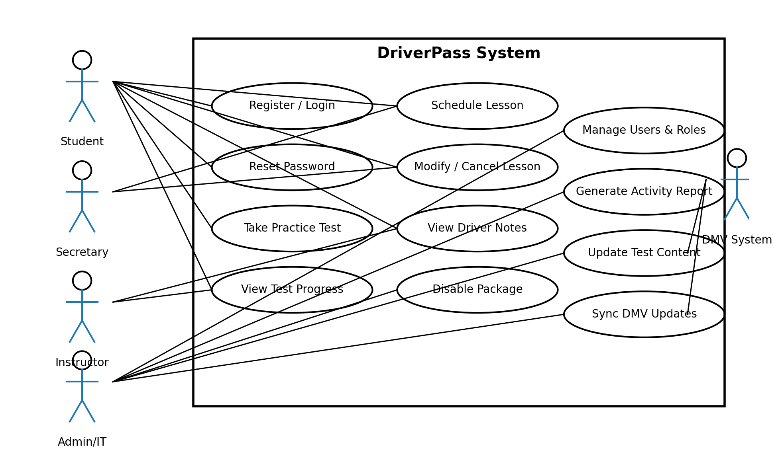

Two activity diagrams are included to show the step-by-step flow for key actions in the system. These workflows help confirm that the process is complete and that the system handles common decision points, like picking a new time when a lesson slot is not available.
Activity Diagram 1: Schedule Driving Lesson
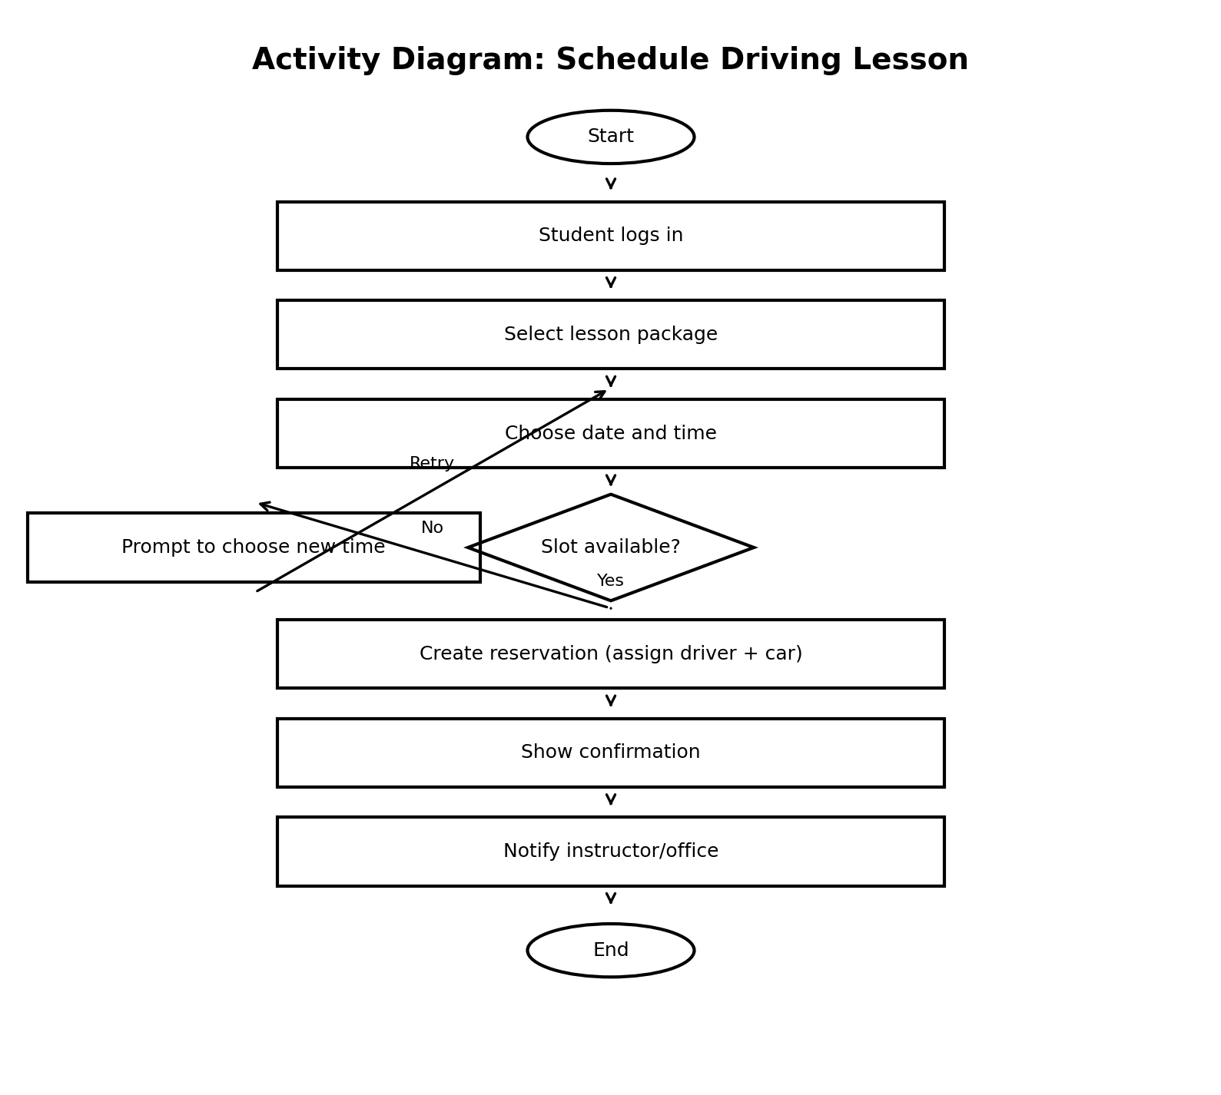
The sequence diagram focuses on scheduling a driving lesson. It shows the order of messages between the student, the DriverPass application, the scheduling database, and the office/instructor notification step.
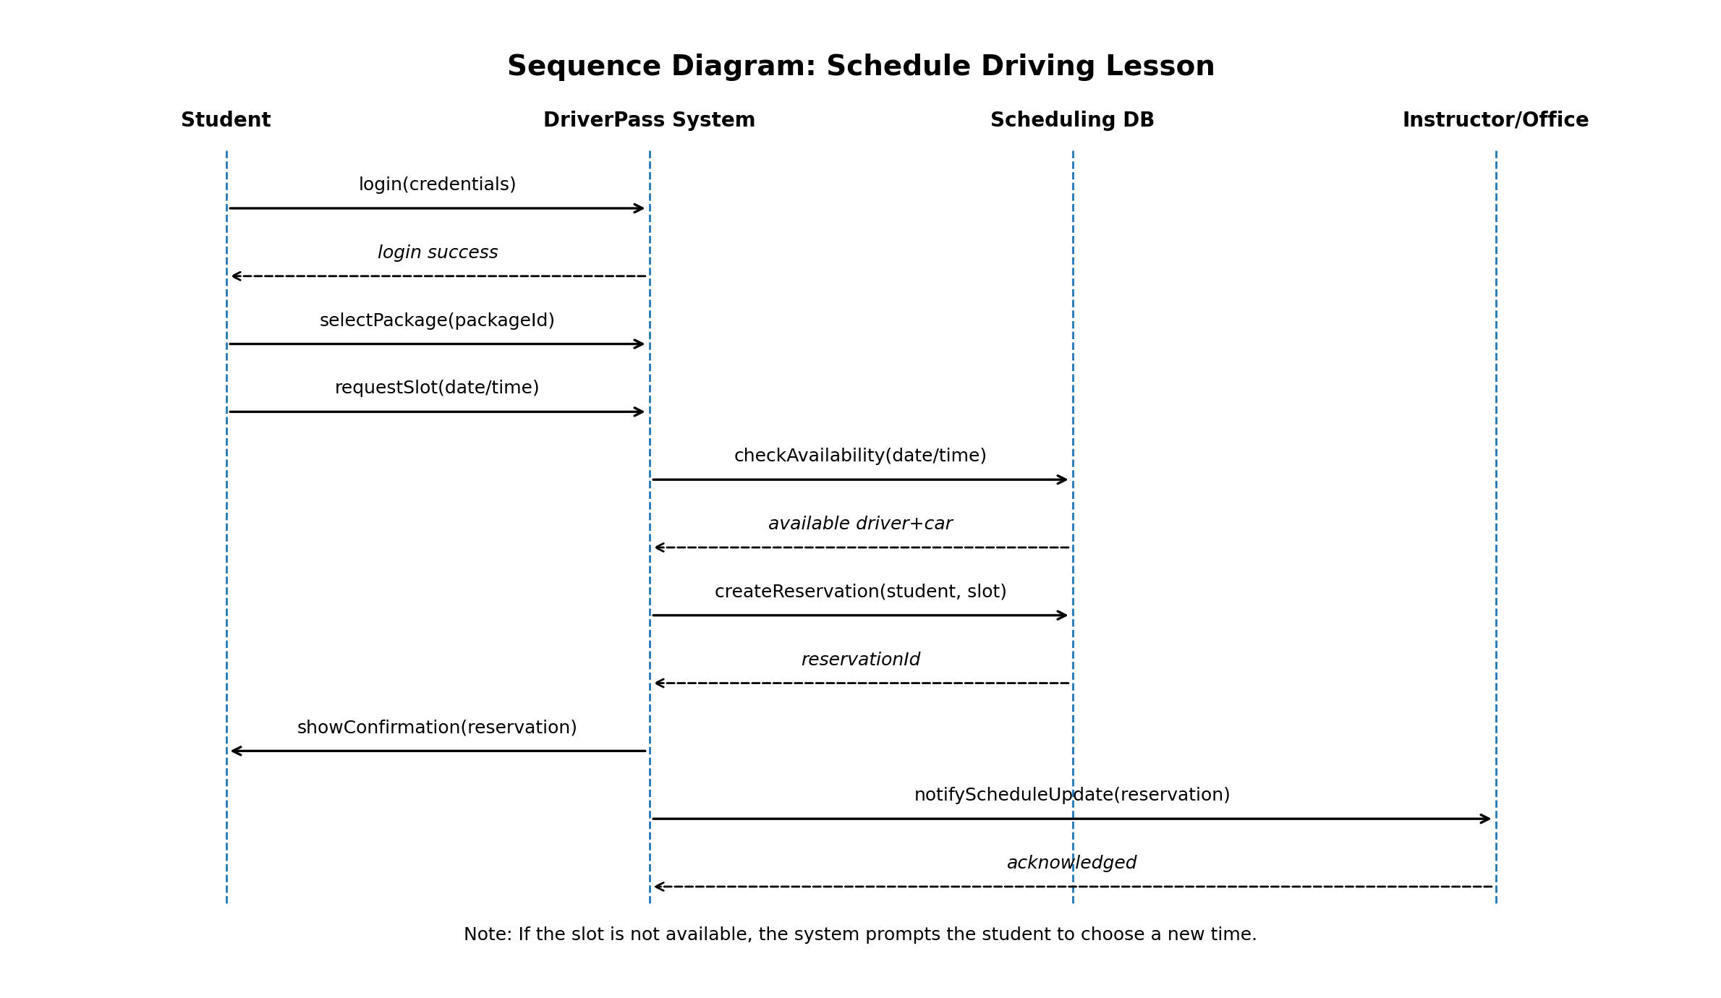
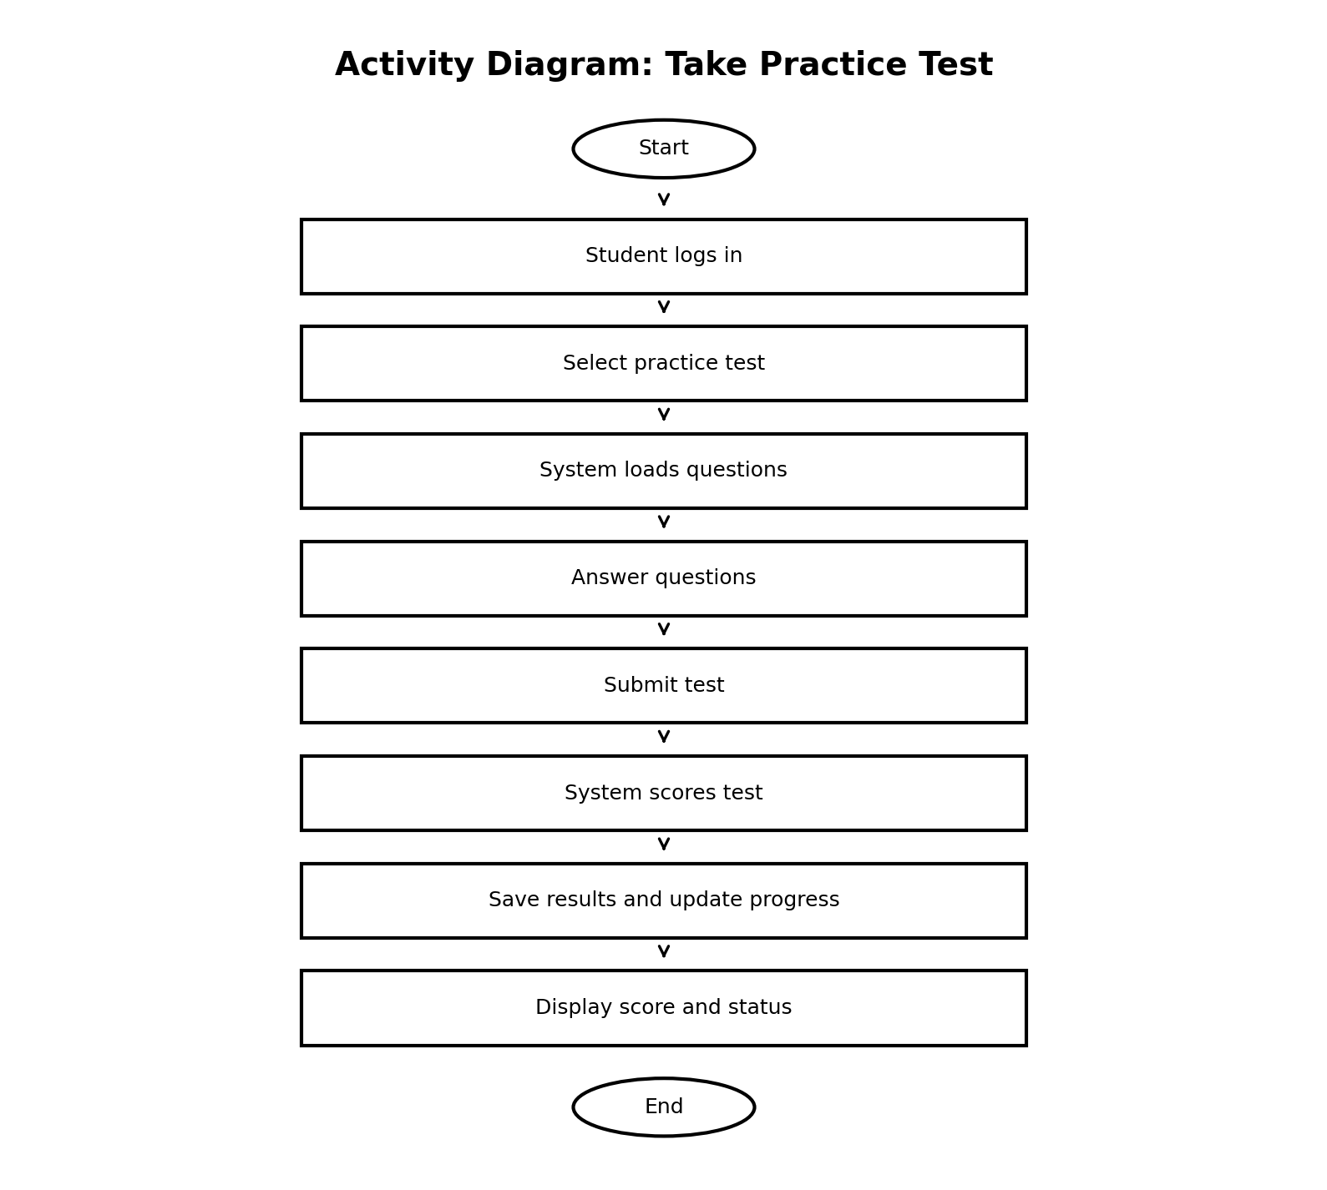
The class diagram shows the main data structures needed to support DriverPass. It includes users and roles, lesson scheduling, packages, practice tests and attempts, vehicles, and activity logging. Attributes are listed to show what information needs to be stored for each class.
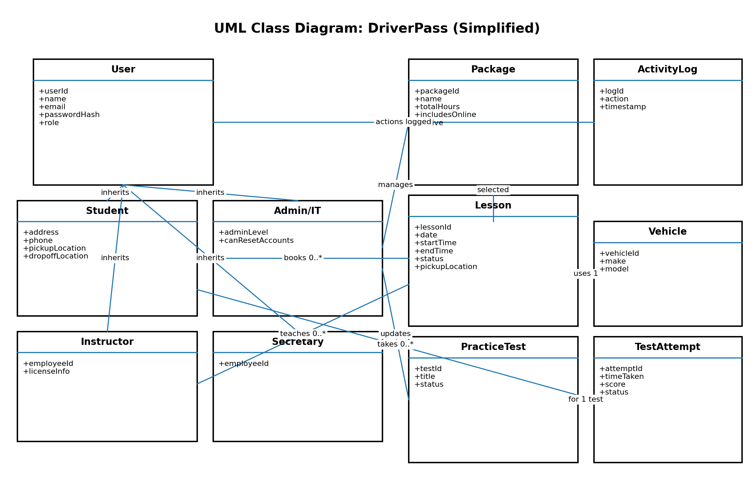

Hardware
- Cloud-hosted servers to run the web application and database
- End-user devices: desktop, laptop, tablet, or smartphone with a modern browser
Software
- Web application (student, instructor, secretary, and admin portals)
- Relational database for accounts, lessons, packages, practice tests, and progress
- Notification service for email/text reminders and confirmations
Infrastructure and Security
- HTTPS for all traffic and encryption for sensitive data at rest
- Role-based access control so each user only sees what they are allowed to access
- Audit logging for key actions (logins, schedule changes, admin updates)
- Backups and recovery plan for the database and application configuration

