sudo apt update

sudo apt upgrade

python3 –version

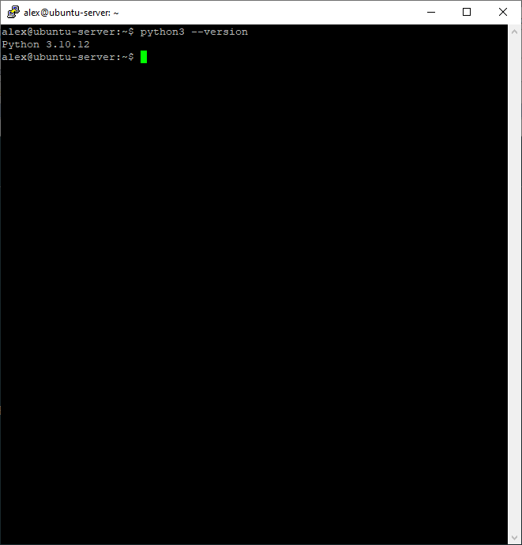

python3 -m pip –version

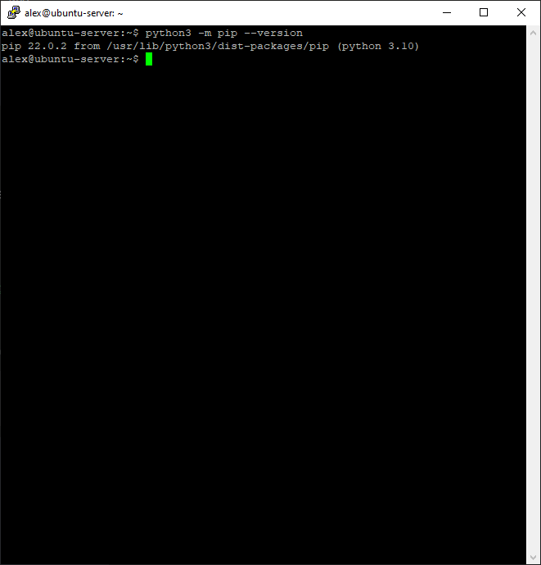

(install pip : sudo apt install python3-pip)

pip install poetry

export PATH="$HOME/.local/bin:$PATH"

poetry -V

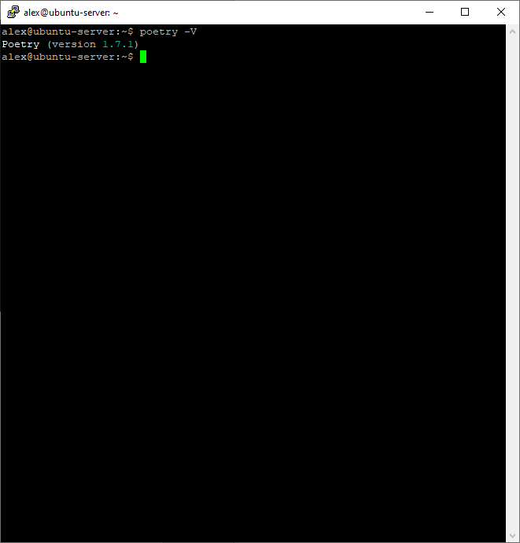

poetry install

poetry update

------------------------------------------

sudo apt-get install ffmpeg

sudo apt-get install cifs-utils