Activity 1 - Difficulty Rate: Low -- star painting
- Open Greenfoot

Departmental → Computing → Greenfoot
Open the Asteroid Scenario – click -- save the file → unzip → scenario → open

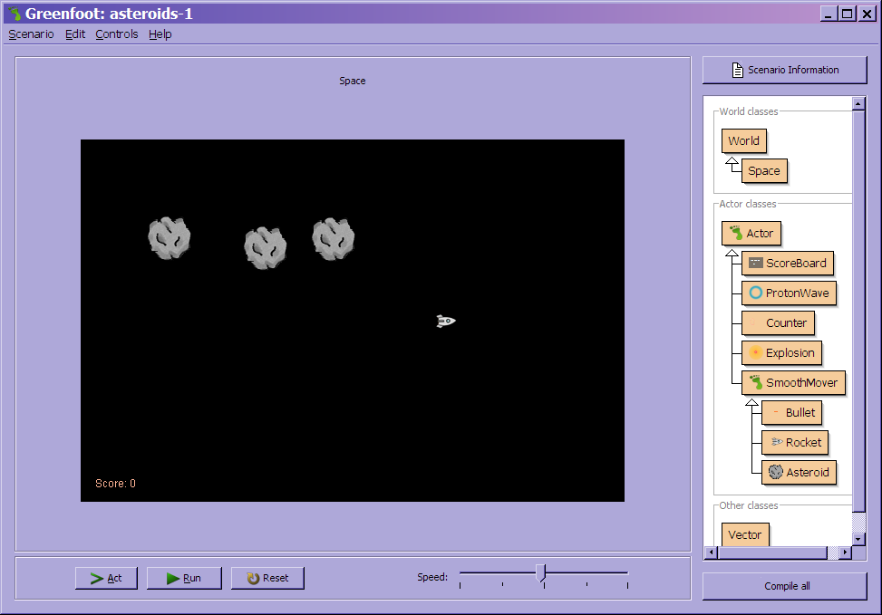

Task 1:
- Can you identify which keyboard key is used to fire the bullet?
- Run the programme – whilst the programme is running place an explosion on the world and see what happens.

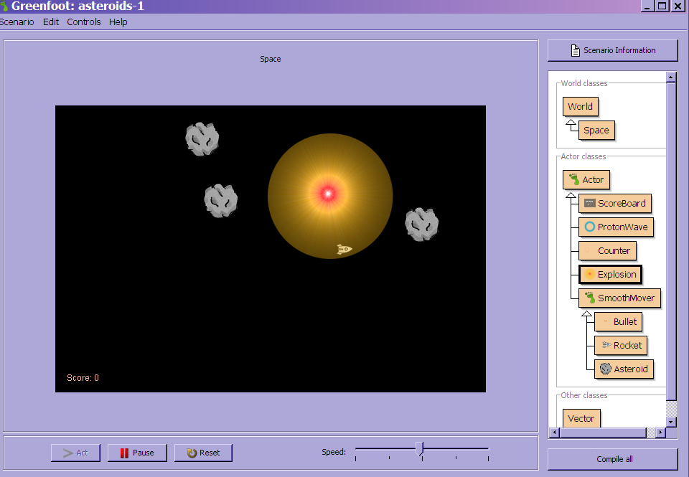

If you place a proton wave on the system: Whilst it is running:

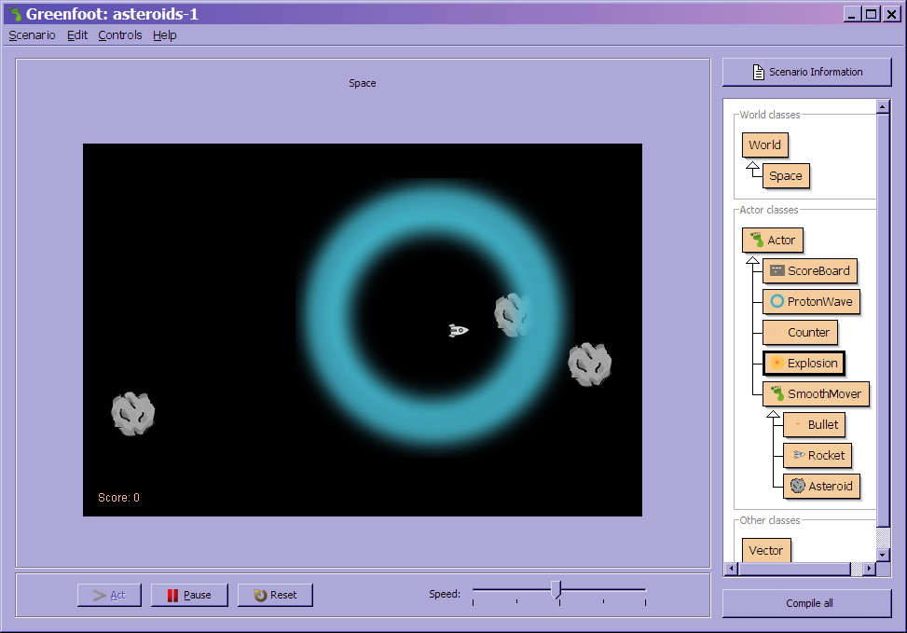

PROBLEMS:

- The rocket does not move, it cannot turn nor can it move forward.
- Nothing happens when an asteroid collides with the rocket – which means you cannot loose.
- The scoreboard, explosion and protonwave do not seem to feature in the scenario.

GOAL OF GAME:
- Clear the game of asteroids without the rocket getting hit

WORK TO DO:
- Movement of rocket -- move forward and turn
- Rocket explodes when hit an asteroid.
- When rocket explodes we put the scoreboard on the display
- Release a proton wave -- it starts small around the rocket and then gradually spread out destroying asteroids when it hits them
- Paint some stars

- Open the ‘space’ editor
Create a new method called createStars that receives and integer value for how many stars – before the last closing bracket }
public void createStar(int number)
{
}

Within the method – create oval shapes and random positioning on the X & Y axis
Making sure the background colour is still set as black:
public void createStar(int number)
{
GreenfootImage background = getBackground();
for (int i = 0; i < number; i++)
{
int x = Greenfoot.getRandomNumber( getWidth() );
int y = Greenfoot.getRandomNumber( getHeight() );
int color = 120 - Greenfoot.getRandomNumber(100);
background.setColor(new Color(color,color,color));
background.fillOval(x, y, 2, 2);
}
}
Within the space() method after the background is created call the new method with 300 stars randomly placed
createStar(300);

Compile code – compile all --- there should now be stars on the background:
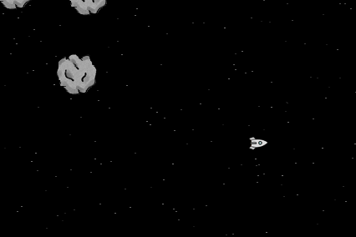

Activity 2 - Difficulty Rate: Low/Medium -- rocket moving
- Open the ‘rocket’ class in edit mode -- create turn using the arrow keys
Create a method checkKeypress() before the last closing bracket } -- there is a method within Actor called setRotation and getRotation
public void checkKeypress()
{
if (Greenfoot.isKeyDown("left"))
{
setRotation(-5);
}
}
Call the checkKeypress(); within the act()

When this is run the rocket moves once only -- need to use the getRotation() then subtract 5 – then set a new rotation:
setRotation(getRotation() – 5);
Compile code then compile All - now when you run the rocket will now rotate to the left
As you fire at the asteroids (space bar) they reduce in size until they disappear.
Task 2:
Create within the checkKeypress() create the right turn

- Making the rocket move forward
Within the act() of the rocket class add the call for move()
The act() should now look like this:
public void act()
{
checkKeys();
reloadDelayCount++;
checkKeypress();
move();
}
This does not actually do anything until we alter the vector as this currently set to zero – using the addForce method from within SmoothMover we can set some movement:
Within public Rocket() within the Rocket class call the addForce method
addForce(new Vector(13, 0.3));

Should look like this:
public Rocket()
{
reloadDelayCount = 5;
addForce(new Vector(13, 0.3));
}
This movement creates drift within space – we need to add rocket boosters:
Create a method ignite before the last closing bracket – this receives a true or false answer --- this will be called from the “up” keypress
We set an image with booster
private void ignite(boolean boosterOn)
{
if (boosterOn)
{
setImage (rocketWithThrust);
addForce (new Vector(getRotation(), 0.3));
}
else
{
setImage(rocket);
}
}
Within the checkKeypress() call the ignite method
Ignite (Greenfoot.isKeyDown("up"));

Compile code – compile All and RUN

Activity 3 - Difficulty Rate: Low/Medium -- End Game

- Collision with asteroid ends the game
Within the rocket class we need to create a checkCollision method this will call the gameOver method within the World class.
private void checkCollision()
{
// talk about the asteroid that collides
Actor a = getOneIntersectingObject(Asteroid.class);
if (a!= null)
{
//create a copy of the world – making sure we say which one
Space space = (Space)getWorld();
//show an explosion
space.addObject(new Explosion(),getX(),getY());
//remove the rocket
space.removeObject(this);
//call game over method which currently does nothing
space.gameOver();
}
}

Within the act() method make sure you call this method
checkCollision();

Compile code -- Compile All Run and see if when rocket collides with asteroid it explodes and disappears.

Within the space class --- inside the gameOver() method we need to create and object of scoreboard:

addObject(new ScoreBoard(999), getWidth()/2, getHeight()/2);

adding points completed later ……………..

