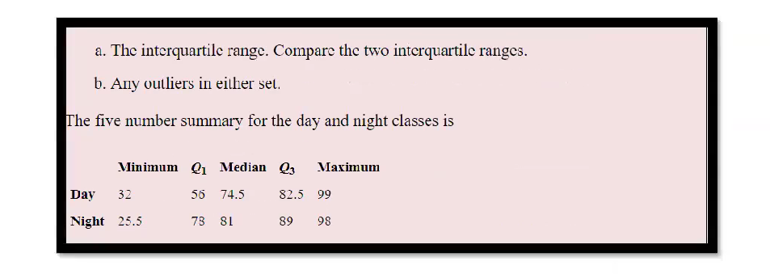

**Day class:**

**IQR = Q3-Q1=** 82.5 - 56 = 26.5

**Lesser Outlier Range** = **Q1 - (1.5 * IQR)** = 56 – (1.5 * 26.5) = 56 – 39.75 = 16.25

**Greater Outlier Range** = **Q3 + (1.5 * IQR) =** 82.5 + (1.5 * 26.5) = 82.5 + 39.75 = 122.25

**Night class:**

**IQR = Q3-Q1=** 89 - 78 = 11

**Lesser Outlier Range** = **Q1 - (1.5 * IQR)** = 78 – (1.5 * 11) = 56 – 16.5 = 61.5

**Greater Outlier Range** = **Q3 + (1.5 * IQR) =** 89 + (1.5 * 11) = 82.5 + 16.5 = 105.5

**INSIGHT:**

* **IQR**  of class day is grater than night ,so day class have more spread of data in 50% that is balanced data.
* In day class , there is no potential outliers since minimum and maximum of that class in the range.
* In night class, there is less outlier , since minimum is 25.5 which is lesser that less Outlier range(61.5).So there is potential outlier in this class.