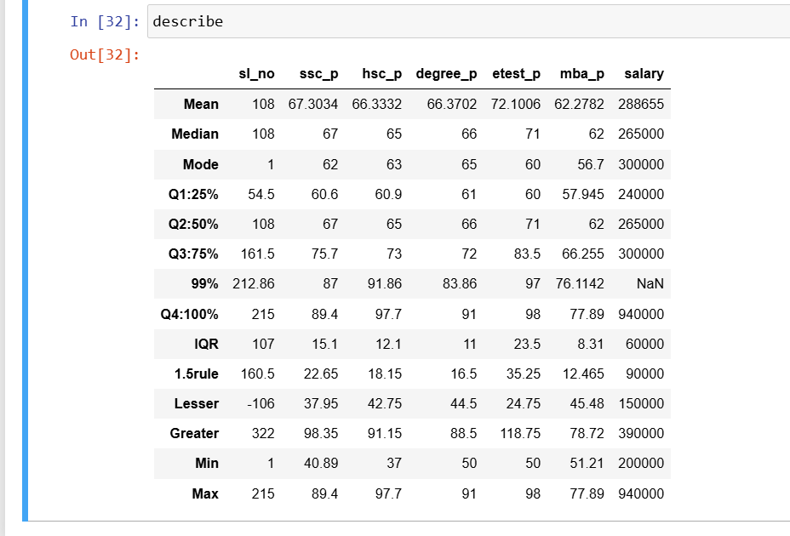

**Insights:**

* In column ssc_p, the IQR is 15.1 and lesser outlier is 37.95 and greater outlier is 98.35. It has no potential outliers.
* In column hsc_p, the IQR is 12.1 and lesser outlier is 42.75 and greater outlier is 91.15. It has both greater and lesser outlier since max and min values are out of outlier range.
* In column degree_p, the IQR is 11, lesser outlier is 44.5 and greater outlier is 88.5. It has greater outlier, since max is greater than greater outlier range.
* In column etest_p, the IQR is 23.5, lesser outlier is 24.75 and greater outlier is 118.75. It has no potential outliers.
* In column mba_p, the IQR is 8.31, lesser outlier is 45.48 and grater outlier is 78.72. It has no potential outliers.
* In salary coumn, the IQR is 60000, lesser outlier is 150000 and grater outlier is 390000. It has greater outlier since the max is out of range of greater outlier range.