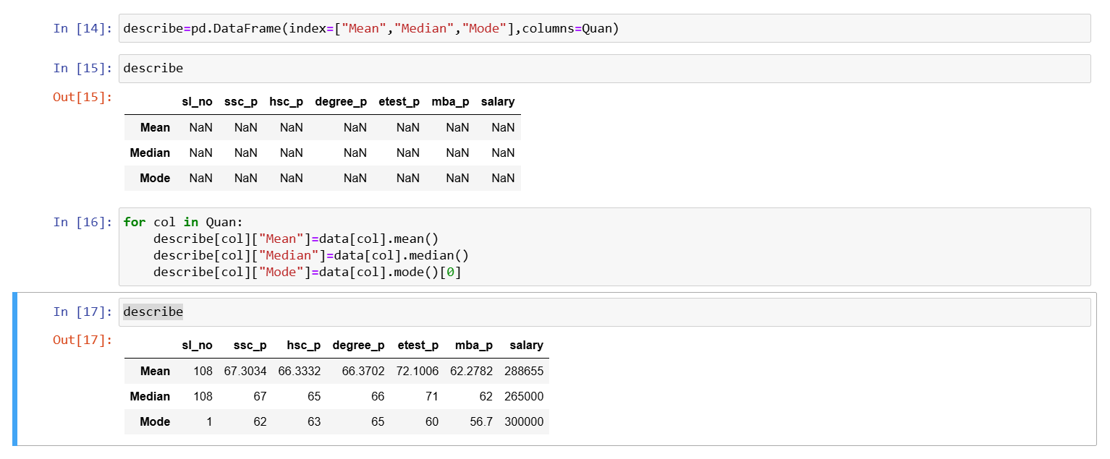

Insights from the above data:

* The Students have scored marks in range of 60`s in their 10th,12th,degree,mba but scored in range of 70`s in their entrance test .
* From the above point, we can also consider that students may weak in their theoretical side but may good in understanding
* From the mode in the above DataFrame , we can see that many got 62 in their 10th,63 in their 12th,65 in their degree,60 in their entrance, 56.7 in their mba
* From comparing mean and median, There is no larger difference in the columns ssc_p, hsc_p, degree_p, etest_p, mba_p. But There is difference in salary.So we need to consider median for salary since median leave outliers.