Take insights from the below table:

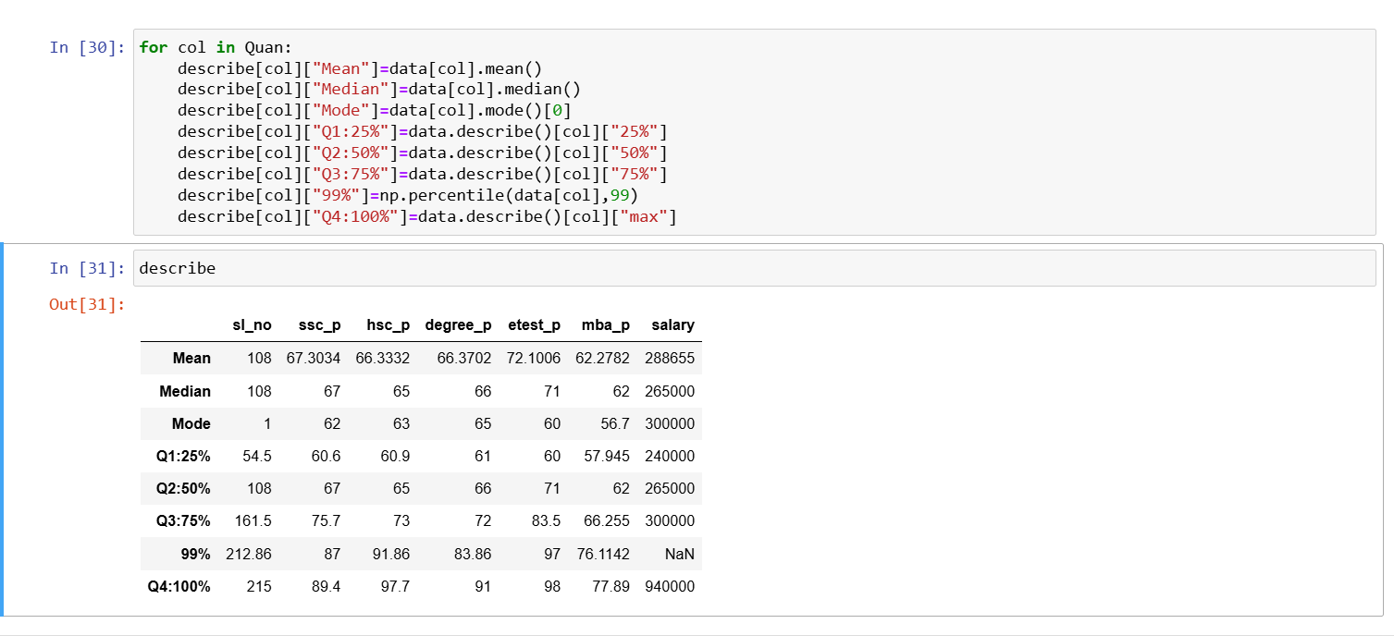

Insights from this:

* The table has info like mean,median,mode,Q1,Q2,Q3,Q4 for each columns.
* In ssc_p column, the Q1 is 60.6 and Q2 is 67 , thus there is only 7% increase in the 25% of data added to Q2. Q3 is 75 , thus there is only 8% increase in the 25% of data added to Q3. 99% is 87, thus there is only 12% increase in the 24% of data added to 99.But there is only 2% increase in Q4
* In hsc_p column, the Q1 is 60.9 and Q2 is 65 , thus there is only 5% increase in the 25% of data added to Q2. Q3 is 73 , thus there is only 8% increase in the 25% of data added to Q3. 99% is 91.86, thus there is only 18% increase in the 24% of data added to 99.But there is only 6% increase in Q4
* In degree_p column, the Q1 is 61 and Q2 is 66 , thus there is only 5% increase in the 25% of data added to Q2. Q3 is 72 , thus there is only 6% increase in the 25% of data added to Q3. 99% is 83.86, thus there is only 11% increase in the 24% of data added to 99.But there is only 8% increase in Q4
* In etest_p column, the Q1 is 57.945 and Q2 is 62 , thus there is only 11% increase in the 25% of data added to Q2. Q3 is 83.5 , thus there is only 12% increase in the 25% of data added to Q3. 99% is 97, thus there is only 14% increase in the 24% of data added to 99.But there is only 1% increase in Q4
* In mba_p column, the Q1 is 60 and Q2 is 71 , thus there is only 5% increase in the 25% of data added to Q2. Q3 is 66 , thus there is only 5% increase in the 25% of data added to Q3. 99% is 76, thus there is only 10% increase in the 24% of data added to 99.But there is only 1% increase in Q4