Daily returns have approx. Normal distribution, therefore:

**Return (t) = mean + x * standard deviation**

Where x * standard deviation is stochastic -> Central limit theorem

Stock price S(t) can be described by a random walk W(t)

W(t) has continuous sample path

W(t) has independent and normally distributed increments

What does this mean? Tomorrows asset price approx. normal distribution

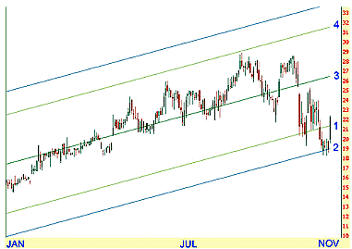

The stock price will be generally be **within mean + 1 * std dev**

# Wiener-process

W(t) has independent increments: future W(t+dt) – W(t) increments are independent of past values

W(t) has Gaussian increments: W(t+dt) – W(t) is normally distributed with mean 0 and variance dt

**W(t+dt) – W(t) ~ N(0,dt)**

Wiener-process W(t) follow a continuous path

**dS = μSdt + σSdX**

**Change in stock price = deterministic part “drift” + stochastic part**

**E(dX) = 0 and E(dX2) = dt**

**dX = random variable with N(0,dt)**

# Stochastic calculus

Ordinary functions with deterministic variables. Example with x2 derivated = 2x. This is NOT true for stochastic random variables

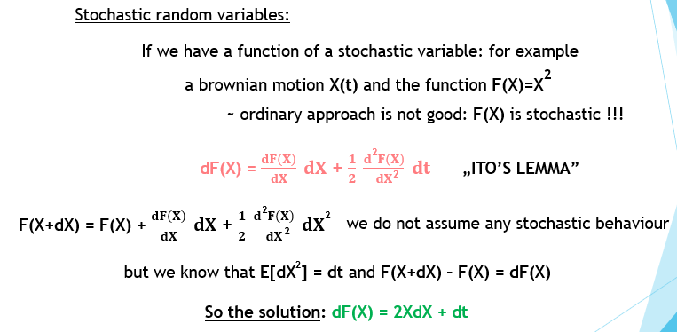

Random stochastic variable stock price S(t), we can use wiener-process as a model.

**dS(t) = a(S,t) dt + b(S,t) dX**

If we have another variable V(S,t) (eg price of a call option) depending on **S(t)**, what stochastic equation describes change in V(S,t) value? **HIGHER DIMENSIONAL ITO’S FORMULA IS NEEDED**

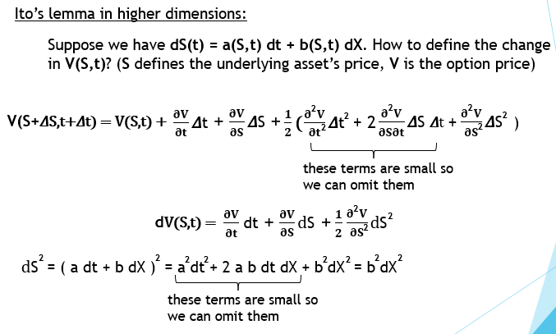

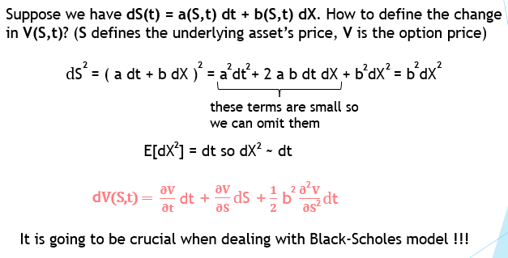

# Black-Scholes delta hedging portfolio

Portfolio π = V(S,t) – dS = long position – short position

From earlier: **dS = μSdt + σSdX**

What about the change in the portfolios value? From time t to (t+dt)

**d π = dV(S,t) – ddS**

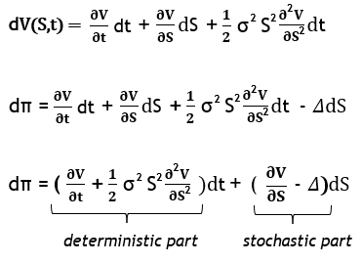

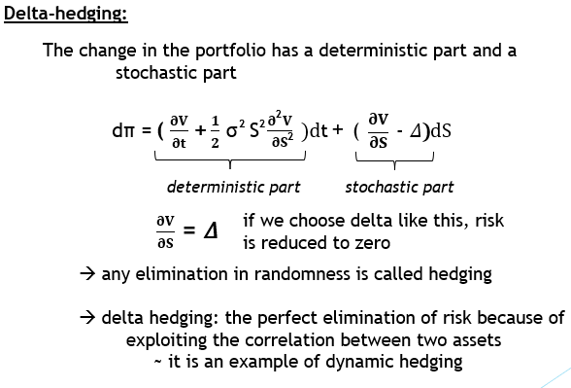

# Black scholes – No arbitrage principle

We can use dynamic hedging to eliminate all the risk, we just have the deterministic part



This change is completely riskless, but risk-free asset has something to do with the risk-free rate.

The risk-free d π change must be the same as the growth we would get if we lend the same amount to the bank.

**d π = r* π*dt**

**“No arbitrage principle”**

# Value at risk (VaR)

Maximum loss given a confidence level

**Variance method: assumes returns are normally distributed**

Density of normal distribution function is important.

We want to make sure loss is not greater than a predefined value.



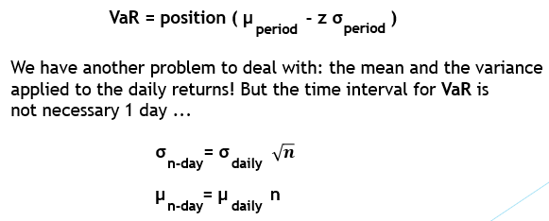

We end up with this equation:

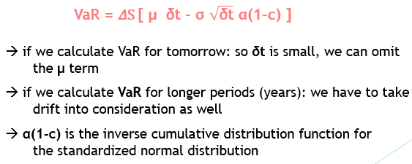

# Machine learning for finance

* No hardcoded algorithms -> Machine finds

Features -> lead to target variable

**Logistic regression**

Features: lagged percentage returns

Dependent variable: up or down

P(Up | L1,L2,L3)