Experiment 1 : Create Table with Constraints

A. NOT NULL
Ensures a column cannot have NULL (empty) values.

B. UNIQUE
Ensures all values in a column are different.

C. PRIMARY KEY
Uniquely identifies each record in a table (NOT NULL + UNIQUE)

D. FOREIGN KEY
Links one table to another using a referenced key.

E. CHECK
Ensures that all values in a column satisfy a specific condition.

F. DEFAULT
Assigns a default value to a column if no value is provided.

G. CREATE INDEX
Improves the speed of data retrieval from a table.

Experiments:
A. NOT NULL
Code:
create table student(id int not null,name varchar2(50) not null);
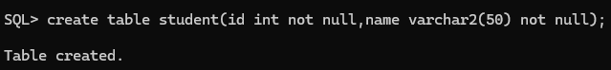

Output:
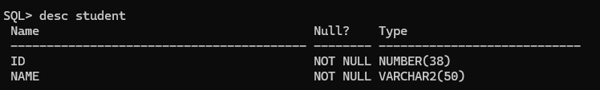

B. UNIQUE
Code:
create table student_uni(roll_no int unique,email varchar2(100) unique);
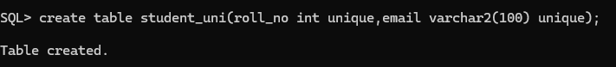
Output:
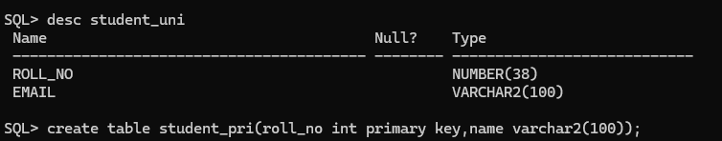

C. PRIMARY KEY
Code:
create table student_pri(roll_no int primary key,name varchar2(100));
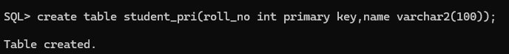

Output:
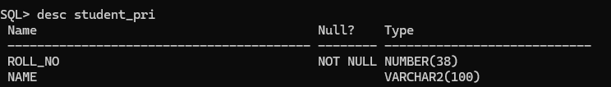

D. FOREIGN KEY
Code:
create table dept(dept_id int primary key,dept_name varchar2(100));
create table student_fore(roll_no int primary key,dept_id int,foreign key (dept_id) references dept(dept_id));
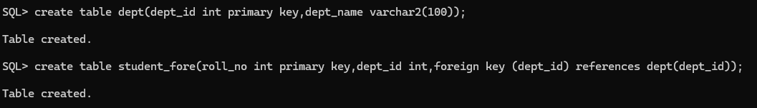

Output:
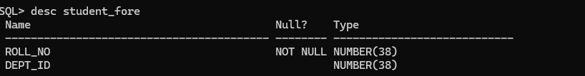

E. CHECK
Code:
create table student_check(id int primary key,age int check(age>=18));
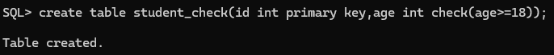

Output:
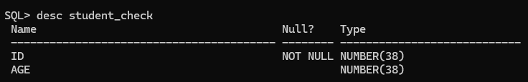

F. DEFAULT
Code:
create table student_default(id int primary key,city varchar2(50) default 'kadiri');

Output: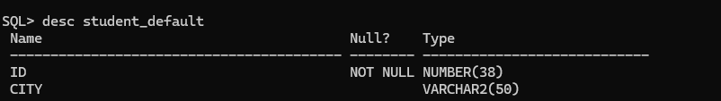

G. CREATE INDEX
Code:
create index idx_name on student_pri(name);
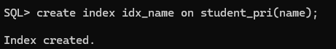

Output: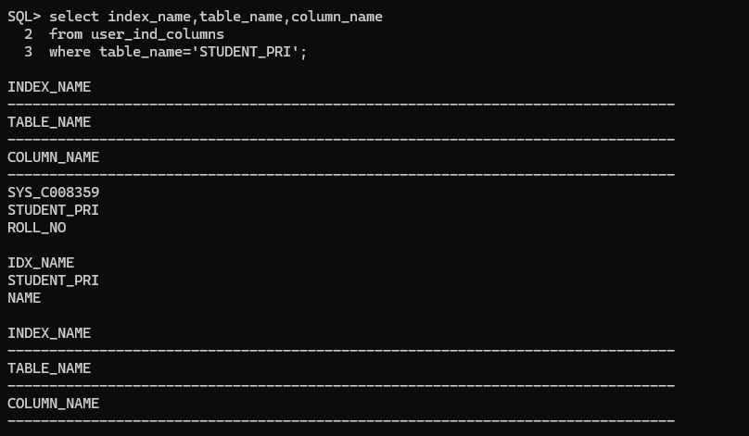

Experiment 2 : INSERT Command
1. Insert values with single entry
2. Insert values with multiple entires
3. ALTER Table Structure
4. VIEW Table structure
5. UPDATE table
6. DELETE Rows in table
Source Code:

-- =========================================
-- EXPERIMENT 2: INSERT COMMAND
-- =========================================

-- Step 1: Create and use database
CREATE DATABASE IF NOT EXISTS DBMS_Experiments;
USE DBMS_Experiments;

-- Step 2: Create necessary tables (so INSERT has targets)
CREATE TABLE IF NOT EXISTS Students (
StudentID INT PRIMARY KEY,
FirstName VARCHAR(50) NOT NULL,
LastName VARCHAR(50),
Email VARCHAR(100) UNIQUE,
Age INT CHECK (Age >= 18),
City VARCHAR(50) DEFAULT 'Unknown'
);

CREATE TABLE IF NOT EXISTS Courses (
CourseID INT PRIMARY KEY,
CourseName VARCHAR(100) NOT NULL
);

CREATE TABLE IF NOT EXISTS Enrollments (
EnrollmentID INT PRIMARY KEY,
StudentID INT,
CourseID INT,
FOREIGN KEY (StudentID) REFERENCES Students(StudentID),
FOREIGN KEY (CourseID) REFERENCES Courses(CourseID)
);

-- =========================================
-- INSERT COMMANDS
-- =========================================

-- 1️⃣ Insert values with single entry
INSERT INTO Students (StudentID, FirstName, LastName, Email, Age, City)
VALUES (1, 'John', 'Doe', 'john.doe@example.com', 20, 'New York');

-- 2️⃣ Insert values with multiple entries
INSERT INTO Students (StudentID, FirstName, LastName, Email, Age, City)
VALUES
(2, 'Alice', 'Smith', 'alice.smith@example.com', 22, 'Boston'),
(3, 'Bob', 'Brown', 'bob.brown@example.com', 21, 'Chicago'),
(4, 'Mary', 'Johnson', 'mary.johnson@example.com', 19, DEFAULT);

-- 3️⃣ Insert into Courses table
INSERT INTO Courses (CourseID, CourseName)
VALUES
(101, 'Database Systems'),
(102, 'Operating Systems'),
(103, 'Computer Networks');

-- 4️⃣ Insert into Enrollments table
INSERT INTO Enrollments (EnrollmentID, StudentID, CourseID)
VALUES
(1, 1, 101),
(2, 2, 102),
(3, 3, 103),
(4, 4, 101);

-- =========================================
-- VIEW INSERTED DATA
-- =========================================
SELECT * FROM Students;
SELECT * FROM Courses;
SELECT * FROM Enrollments;

Program:

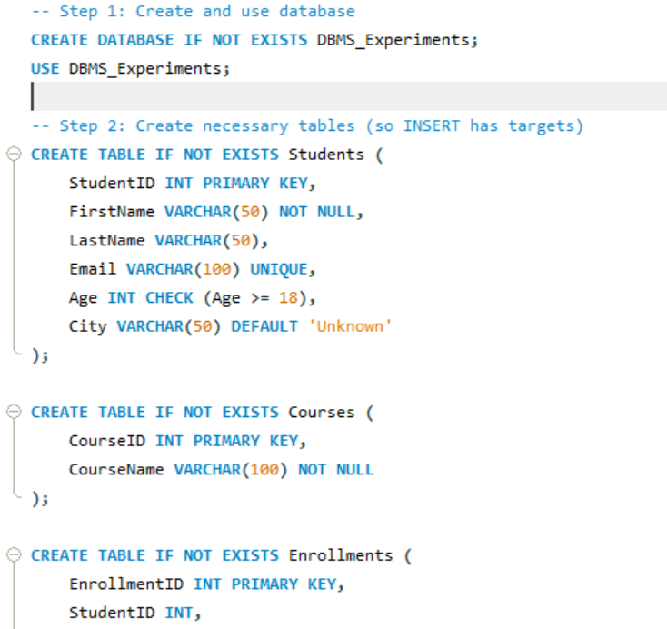

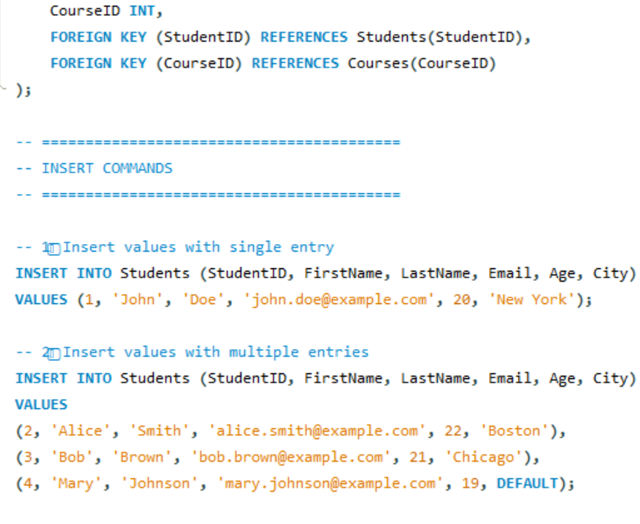
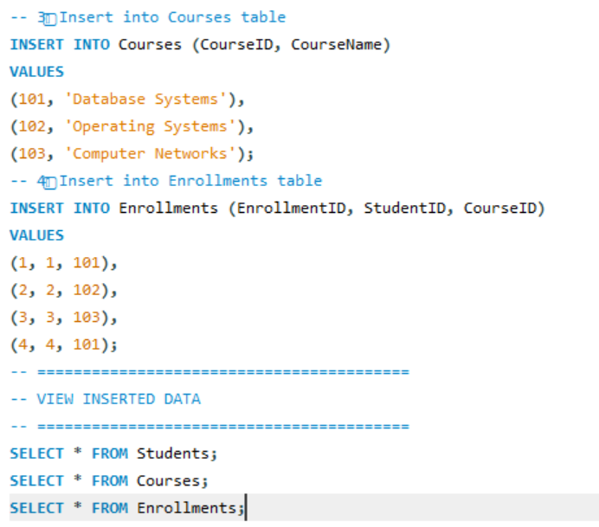

Output:

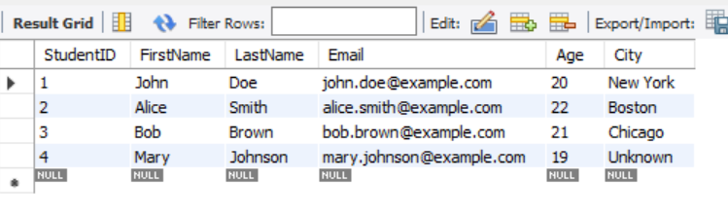
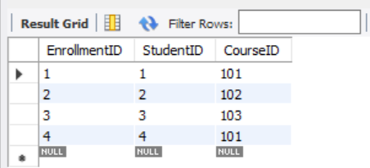
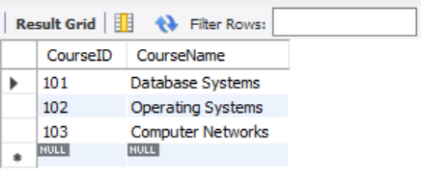

Experiment 3 :Aggregate Functions

Source Code:

DROP DATABASE IF EXISTS college;
CREATE DATABASE college;
USE college;

-- Create table
CREATE TABLE marks (
student_name VARCHAR(50),
subject VARCHAR(50),
score INT
);

-- Insert sample data
INSERT INTO marks VALUES
('Manasa', 'DBMS', 90),
('Ravi', 'DBMS', 80),
('Priya', 'Math', 95),
('Kiran', 'Math', 65),
('Meena', 'Math', 60);

-- Display all records
SELECT * FROM marks;

-- Aggregate functions demonstration
SELECT
MIN(score) AS min_score,
MAX(score) AS max_score,
COUNT(*) AS total_students,
SUM(score) AS total_score,
AVG(score) AS avg_score
FROM marks;

Program:

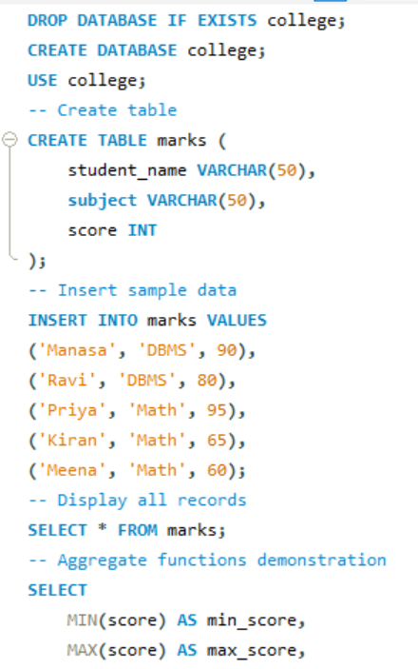
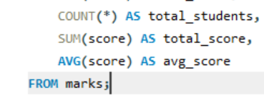

Output:

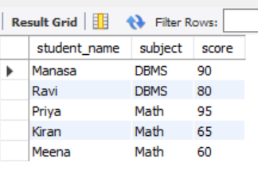

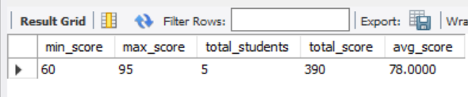

Experiment 4 :Group By and Order By

Source Code:

DROP DATABASE IF EXISTS college;
CREATE DATABASE college;
USE college;
CREATE TABLE marks (
student_name VARCHAR(50),
subject VARCHAR(50),
score INT
);
INSERT INTO marks VALUES
('Manasa', 'DBMS', 90),
('Ravi', 'DBMS', 80),
('Priya', 'Math', 95),
('Kiran', 'Math', 65),
('Meena', 'Math', 60);
-- Average score per subject
SELECT subject, AVG(score) AS avg_score
FROM marks
GROUP BY subject;
-- Order students by score descending
SELECT student_name, score
FROM marks
ORDER BY score DESC;

Program:

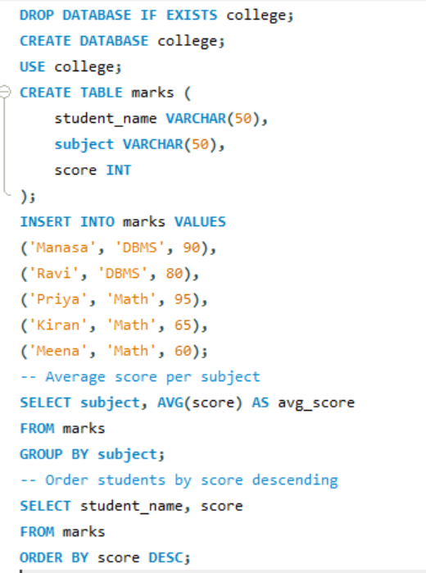

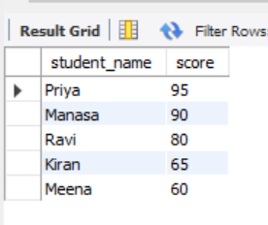
Output:

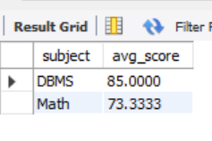

Experiment 5 : Ascending, Descending
Source Code:

-- Create database
CREATE DATABASE IF NOT EXISTS college;
USE college;

-- Create table
DROP TABLE IF EXISTS student;
CREATE TABLE student (
id INT PRIMARY KEY,
name VARCHAR(30),
age INT,
branch VARCHAR(10)
);

-- Insert sample data
INSERT INTO student VALUES
(1, 'Manasa', 20, 'CSE'),
(2, 'Ravi', 22, 'ECE'),
(3, 'Kiran', 21, 'CSE'),
(4, 'Priya', 19, 'EEE'),
(5, 'Arjun', 23, 'MECH');

-- View all records
SELECT * FROM student;

-- Ascending order by name
SELECT * FROM student
ORDER BY name ASC;

-- Descending order by age
SELECT * FROM student
ORDER BY age DESC;

Program:

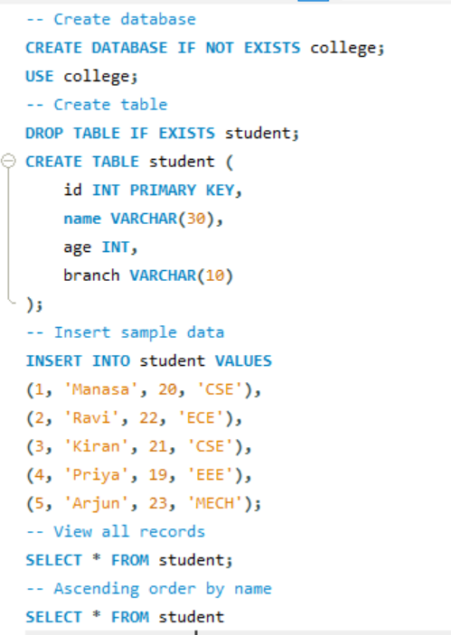
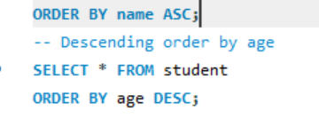

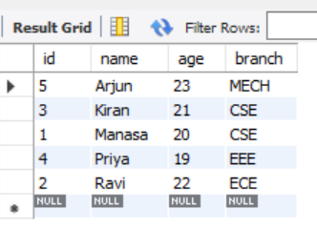
Output:

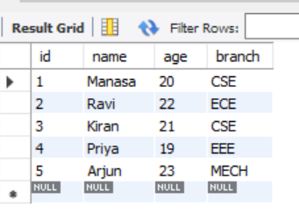
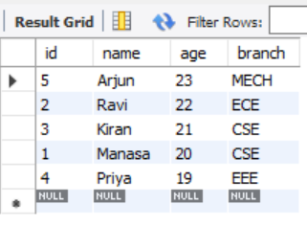

Experiment 6 :SQL Operators
1. Like operator (%,-)
2. Between & or
Source Code:

DROP DATABASE IF EXISTS college;
CREATE DATABASE college;
USE college;
CREATE TABLE student (
student_id INT PRIMARY KEY,
name VARCHAR(50),
age INT,
dept_id INT
);
INSERT INTO student VALUES
(101, 'Manasa', 20, 1),
(102, 'Ravi', 21, 2),
(103, 'Priya', 19, 1),
(104, 'Kiran', 22, 1),
(105, 'Meena', 20, 3);
-- LIKE operator
SELECT * FROM student WHERE name LIKE 'M%';
SELECT * FROM student WHERE name LIKE '%an%';
-- BETWEEN operator
SELECT * FROM student WHERE age BETWEEN 19 AND 21;
-- IN operator
SELECT * FROM student WHERE dept_id IN (1, 3);

Program:

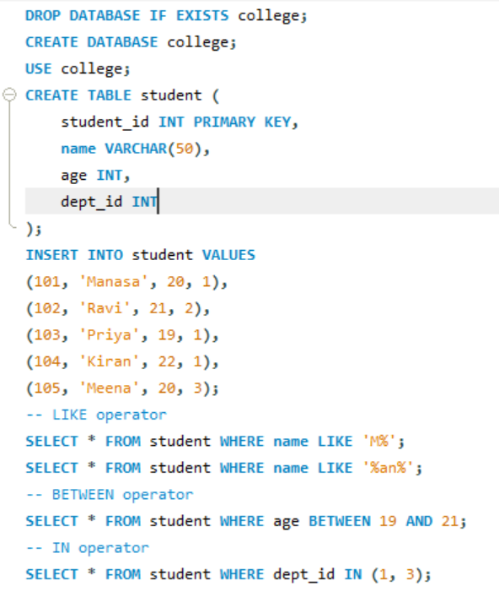

Output:
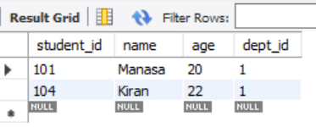
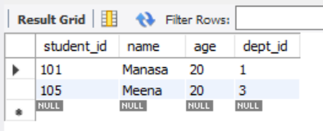

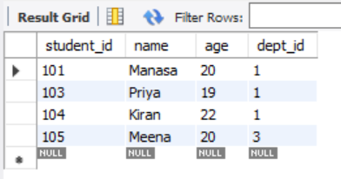
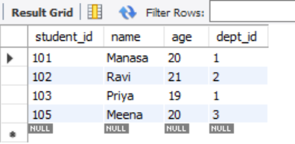

Experiment 7 : SQL Joins
1. Inner Join
2. Left Join
3. Right Join
4. Outer Join
5. Left Join exclude Inner Join
6. Right Join exclude Inner Join
7. Outer Join exclude Inner Jain
Source Code:

-- Create tables
DROP TABLE IF EXISTS Students;
DROP TABLE IF EXISTS Courses;
CREATE TABLE Students (
StudentID INT,
Name VARCHAR(50),
CourseID INT
);

CREATE TABLE Courses (
CourseID INT,
CourseName VARCHAR(50)
);

-- Insert data
INSERT INTO Students VALUES
(1, 'John', 101),
(2, 'Emma', 102),
(3, 'Raj', 103),
(4, 'Sara', NULL);

INSERT INTO Courses VALUES
(101, 'Math'),
(102, 'Science'),
(104, 'History');

-- 1. INNER JOIN
SELECT s.Name, c.CourseName
FROM Students s
INNER JOIN Courses c ON s.CourseID = c.CourseID;

-- 2. LEFT JOIN
SELECT s.Name, c.CourseName
FROM Students s
LEFT JOIN Courses c ON s.CourseID = c.CourseID;

-- 3. RIGHT JOIN
SELECT s.Name, c.CourseName
FROM Students s
RIGHT JOIN Courses c ON s.CourseID = c.CourseID;

-- 4. FULL OUTER JOIN (some databases: use UNION of LEFT + RIGHT)
SELECT s.Name, c.CourseName
FROM Students s
LEFT JOIN Courses c ON s.CourseID = c.CourseID
UNION
SELECT s.Name, c.CourseName
FROM Students s
RIGHT JOIN Courses c ON s.CourseID = c.CourseID;

-- 5. LEFT JOIN EXCLUDING INNER JOIN
SELECT s.Name, c.CourseName
FROM Students s
LEFT JOIN Courses c ON s.CourseID = c.CourseID
WHERE c.CourseID IS NULL;

-- 6. RIGHT JOIN EXCLUDING INNER JOIN
SELECT s.Name, c.CourseName
FROM Students s
RIGHT JOIN Courses c ON s.CourseID = c.CourseID
WHERE s.CourseID IS NULL;

Program:

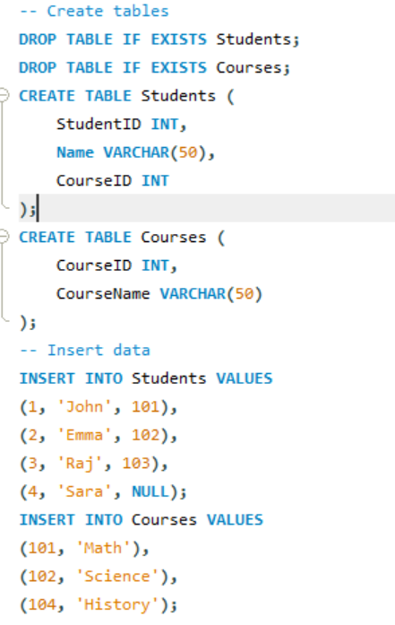
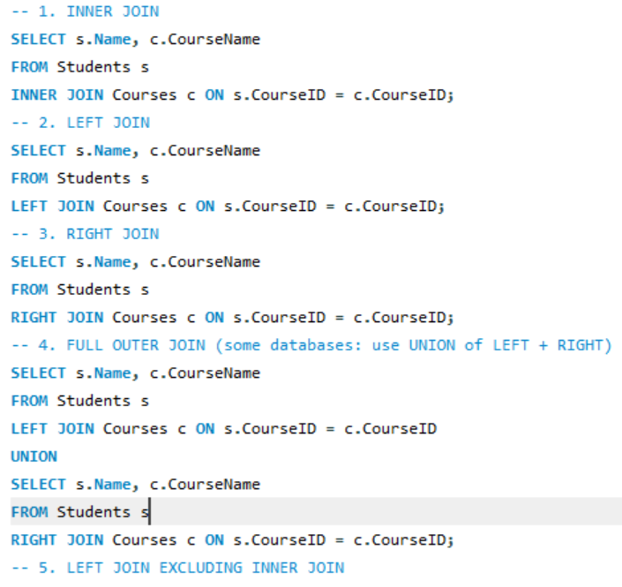
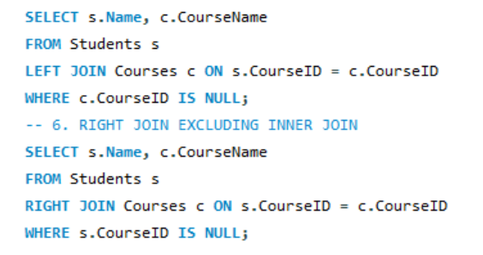

Output:

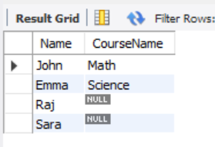
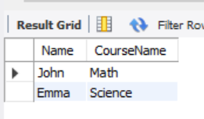

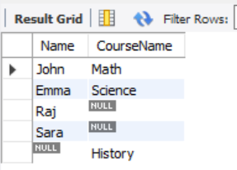
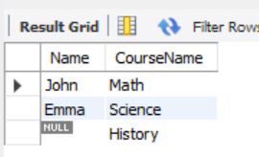

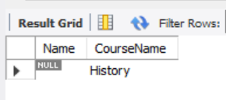
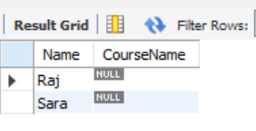

Experiment 8 : Normal Forms
1. INF
Source Code:
DROP DATABASE IF EXISTS normalforms;
CREATE DATABASE normalforms;
USE normalforms;

CREATE TABLE orders_1nf (
order_id INT,
customer_name VARCHAR(30),
product VARCHAR(30),
quantity INT
);

INSERT INTO orders_1nf VALUES
(1, 'Manasa', 'Pen', 10),
(1, 'Manasa', 'Book', 2),
(2, 'Ravi', 'Pencil', 5);
SELECT * FROM orders_1nf;

Program:
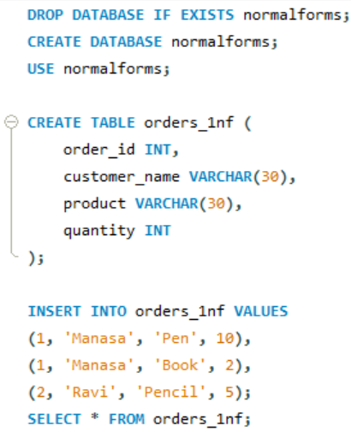

Output:
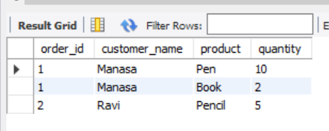

2. 2NF
Source Code:
-- Clean safely (drop children first)
DROP TABLE IF EXISTS items;
DROP TABLE IF EXISTS orders_2nf;
DROP TABLE IF EXISTS customer;
-- Recreate tables
CREATE TABLE customer (
cust_id INT PRIMARY KEY,
cust_name VARCHAR(30)
);
CREATE TABLE orders_2nf (
order_id INT PRIMARY KEY,
cust_id INT,
FOREIGN KEY (cust_id) REFERENCES customer(cust_id)
);
CREATE TABLE items (
item_id INT PRIMARY KEY,
order_id INT,
product VARCHAR(30),
quantity INT,
FOREIGN KEY (order_id) REFERENCES orders_2nf(order_id)
);
-- Insert data
INSERT INTO customer VALUES (1, 'Manasa'), (2, 'Ravi');
INSERT INTO orders_2nf VALUES (101, 1), (102, 2);
INSERT INTO items VALUES
(1, 101, 'Pen', 10),
(2, 101, 'Book', 2),
(3, 102, 'Pencil', 5);
-- Verify
SELECT o.order_id, c.cust_name, i.product, i.quantity
FROM orders_2nf o
JOIN customer c ON o.cust_id = c.cust_id
JOIN items i ON o.order_id = i.order_id;
Program:

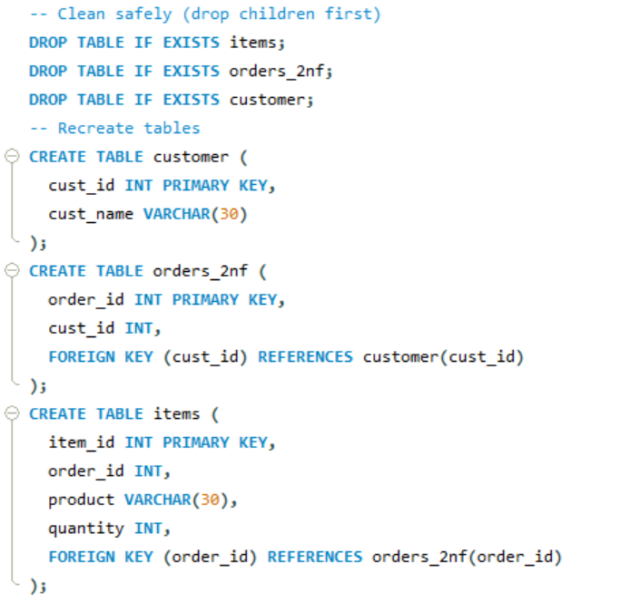
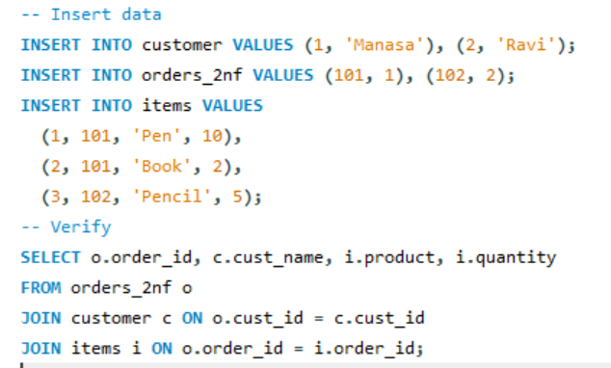

Output:
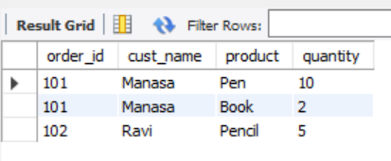
3. 3NF
Source Code:
-- Create database
CREATE DATABASE normalforms3;
USE normalforms3;
-- Tables for 3NF
CREATE TABLE city (
city_name VARCHAR(30) PRIMARY KEY,
state VARCHAR(30)
);
CREATE TABLE customer (
cust_id INT PRIMARY KEY,
cust_name VARCHAR(30),
city_name VARCHAR(30),
FOREIGN KEY (city_name) REFERENCES city(city_name)
);
CREATE TABLE orders (
order_id INT PRIMARY KEY,
cust_id INT,
product VARCHAR(30),
quantity INT,
FOREIGN KEY (cust_id) REFERENCES customer(cust_id)
);
-- Insert data
INSERT INTO city VALUES
('Vijayawada', 'Andhra Pradesh'),
('Hyderabad', 'Telangana');
INSERT INTO customer VALUES
(1, 'Manasa', 'Vijayawada'),
(2, 'Ravi', 'Hyderabad');
INSERT INTO orders VALUES
(101, 1, 'Pen', 10),
(102, 1, 'Book', 5),
(103, 2, 'Pencil', 6);
-- Display result
SELECT o.order_id, c.cust_name, c.city_name, ci.state, o.product, o.quantity
FROM orders o
JOIN customer c ON o.cust_id = c.cust_id
JOIN city ci ON c.city_name = ci.city_name;

Program:

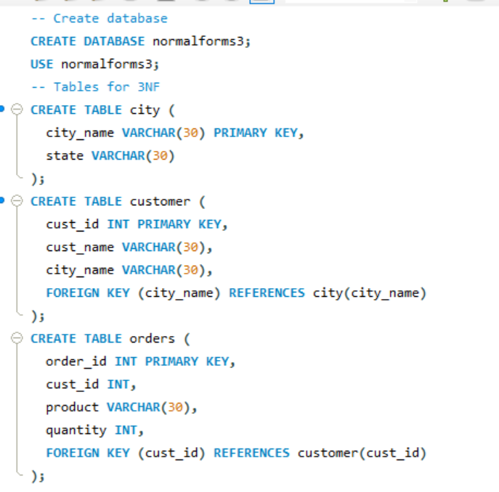
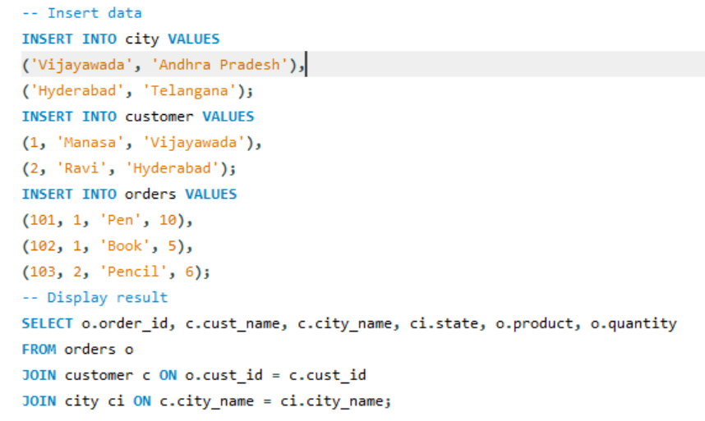

Output:

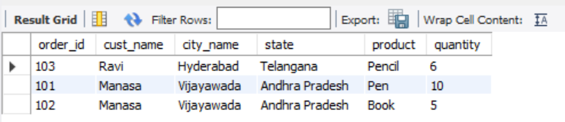

Experiment 9 :Nested Queries Using select across two tables
Source Code:
CREATE TABLE department (
dept_id INT PRIMARY KEY,
dept_name VARCHAR(20)
);
CREATE TABLE student (
stu_id INT PRIMARY KEY,
stu_name VARCHAR(20),
dept_id INT,
FOREIGN KEY (dept_id) REFERENCES department(dept_id)
);
INSERT INTO department VALUES (1, 'CSE'), (2, 'ECE');
INSERT INTO student VALUES
(101, 'Manasa', 1),
(102, 'Ravi', 2),
(103, 'Priya', 1);
SELECT stu_name
FROM student
WHERE dept_id = (SELECT dept_id FROM department WHERE dept_name = 'CSE');

Program:

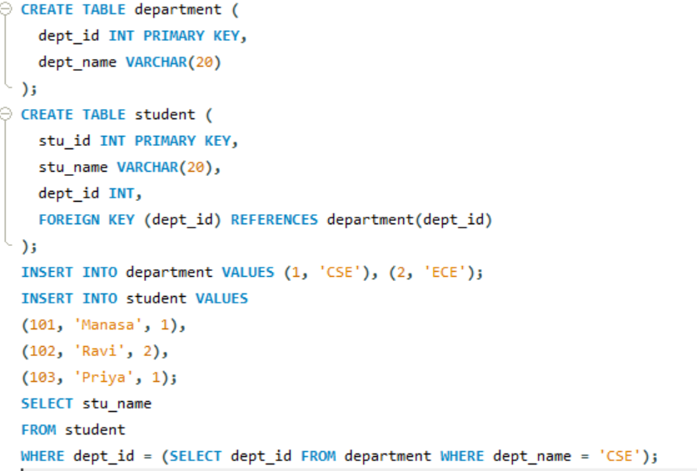

Output:
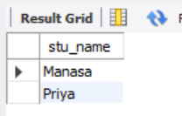

Experiment 10 :SQL wild card characters
Source Code:
DROP TABLE IF EXISTS student;
CREATE TABLE student (
id INT,
name VARCHAR(30)
);
INSERT INTO student (id, name) VALUES
(1, 'Manasa'),
(2, 'Ravi'),
(3, 'Manoj'),
(4, 'Priya'),
(5, 'Kiran');
-- Names starting with 'Ma'
SELECT name
FROM student
WHERE name LIKE 'Ma%';
-- Names containing 'ri' (case-insensitive)
SELECT name
FROM student
WHERE LOWER(name) LIKE '%ri%';

Program:
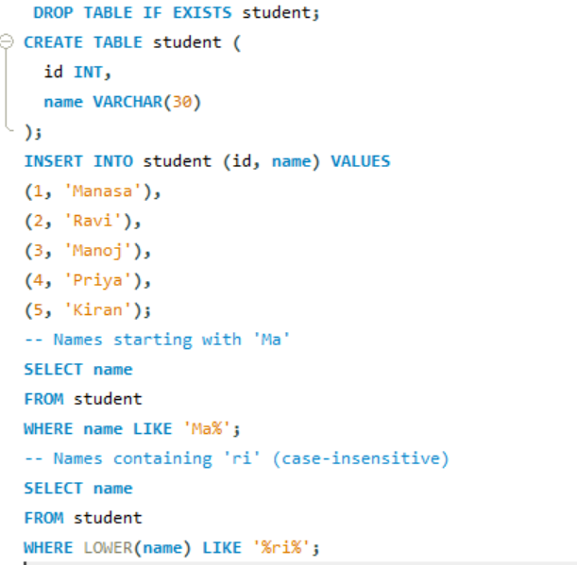

Output:
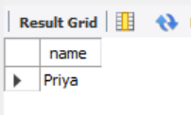
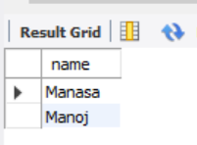

Experiment 11 :Retrieve Database using SELECT with Comparison operator ( = , > . <. >= , <= )
Source Code:
DROP TABLE IF EXISTS student;
CREATE TABLE student (
id INT,
name VARCHAR(30),
marks INT
);
INSERT INTO student (id, name, marks) VALUES
(1, 'Manasa', 85),
(2, 'Ravi', 72),
(3, 'Manoj', 90),
(4, 'Priya', 78),
(5, 'Kiran', 60);
-- Single query showing all comparison operators
SELECT
name,
marks,
CASE
WHEN marks = 78 THEN 'Equal to 78'
WHEN marks > 80 THEN 'Greater than 80'
WHEN marks < 75 THEN 'Less than 75'
WHEN marks >= 78 THEN 'Greater than or equal to 78'
WHEN marks <= 72 THEN 'Less than or equal to 72'
ELSE 'Other'
END AS `Condition`
FROM student;

Program:

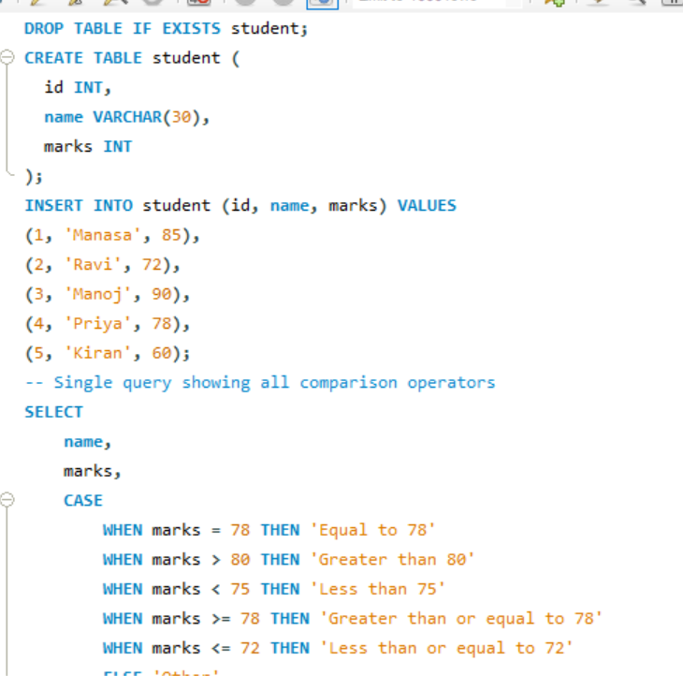
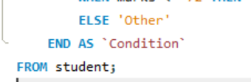

Output:
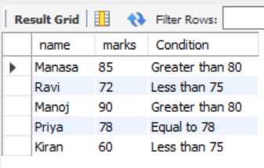

Experiment 12 : Working on Local Host XAMPP Server
1. Exploring Server Variables.( Servername. User, pwd, DBname)
Source Code:
-- Get the current MySQL user
SELECT USER();

-- Get the current selected database
SELECT DATABASE();

-- Get the hostname (server name)
SHOW VARIABLES LIKE 'hostname';

-- Get the MySQL version
SELECT VERSION();
Program:
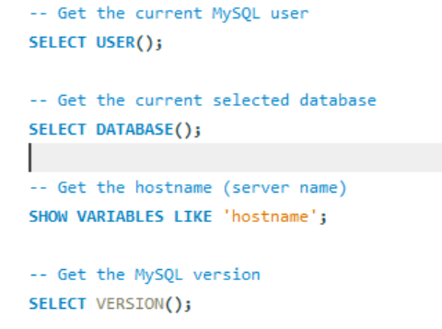
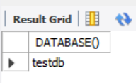
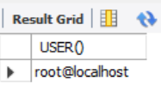
Output:

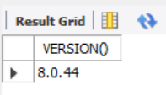
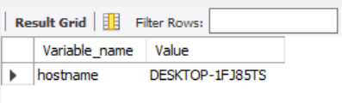

2. Exploring Create hierarchical user access with privileges
Source Code:
-- Check if the database exists and then drop it
DROP DATABASE IF EXISTS testdb;
CREATE DATABASE testdb;
USE testdb;
CREATE TABLE students (id INT PRIMARY KEY, name VARCHAR(50), age INT);
Program:
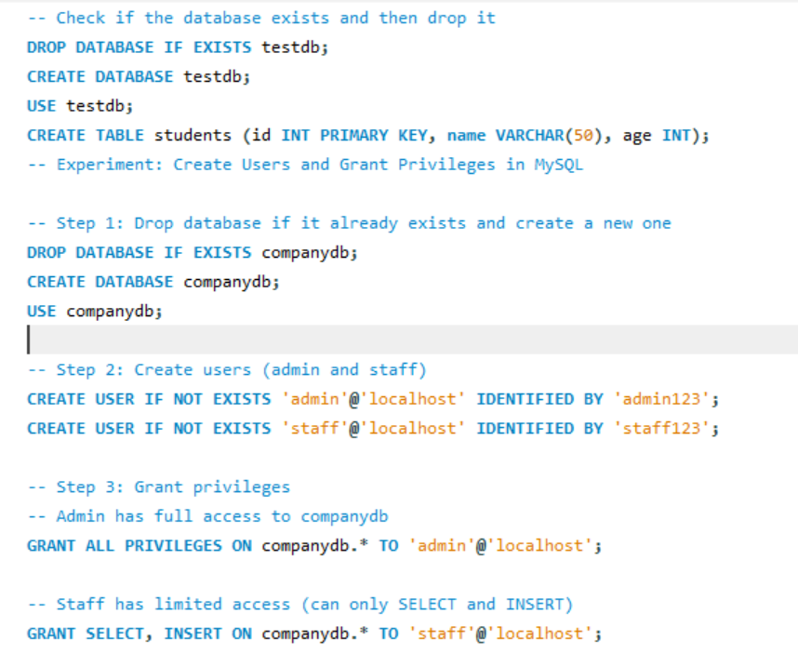
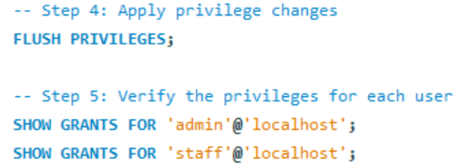
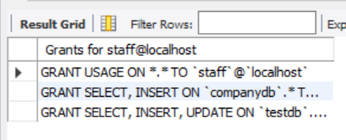
Output:
