 SiteMorph | SITE INTELLIGENCE & CLIMATE DESIGN

SiteMorph geospatial intelligence
SITE INTELLIGENCE REPORT
SiteMorph - Site Intelligence & Climate Design Report
FortyGuard historical evidence + Autodesk Forma design-performance validation
South Phoenix Logistics Campus
South Phoenix, AZ | 359,376 ft2 | 8.25 acres
Requested concept: Climate-controlled logistics / storage | 85,000 ft2
Generated Aug 25, 2026, 2:32 PM | Concept-stage evidence-to-design workflow
Key signal | Current finding
Hot-season exposure | HIGH
Summer persistence | MODERATE
Thermal zoning confidence | LOW
Design status | Building not generated
Next required action
Generate one building in Forma, run native Sun and Rapid Wind, and export again to complete the spatial design evidence.

1. Site overview
Project | South Phoenix Logistics Campus
Location | South Phoenix, AZ
Proposal | Warehouse Study - Baseline
Selected Site Limit | Site Limit 01
Site area | 359,376 ft2 / 8.25 acres
Analysis basis | Real Forma Site Limit + FortyGuard historical/site evidence
Planning status | Zoning, entitlement, utilities, access engineering and market feasibility are not connected

2. Climate history
Metric | Observed value | Meaning
Hot-season mean | 39.2 C | Historical thermal burden
Hot-season maximum | 46.8 C | Peak sampled condition
Mean exceedance above 35 C | 612 h | Mean exceedance duration
Maximum continuous persistence | 7 h | Longest continuous episode
Peak thermal hour | 9:00 PM MST | 04:00 UTC
FortyGuard TCM heat model

3. Climate Design Brief
Thermal zoning confidence: LOW
The parcel should use site-wide heat constraints while Forma validates massing, sun, wind, and microclimate performance.
Priority | Level | Evidence-based reason
Cooling resilience | Critical | Hot-season exposure is high.
Impervious-surface reduction | High | Impervious cover is 72%.
Canopy and shading intervention | High | Canopy and vegetation cover is 12%.
Outdoor worker heat mitigation | High | Loading and worker areas need shade and cooling.

Site-wide constraints
- Do not spatially zone the building from FortyGuard alone.
- Shade loading and worker areas.
- Reduce exposed pavement.

4. Environmental and site intelligence

Environmental parameters
Relative humidity | 22%
Wet-bulb temperature | 23.8 C
Apparent temperature | 42.3 C
Heat index | 41.1 C
US AQI | 72
Cloud cover | 14%
Precipitation | 2.6 mm

Satellite - What is around the site?
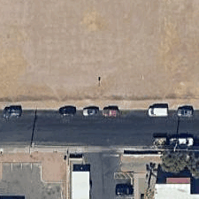  Satellite context | 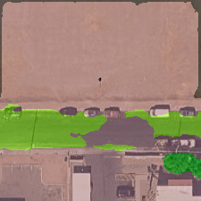  FortyGuard surface segmentation
Finding: 72% impervious surface and 12% canopy/vegetation in the sampled context. These values drive paving reduction and shade priorities.

Street view - What does the access edge look like?
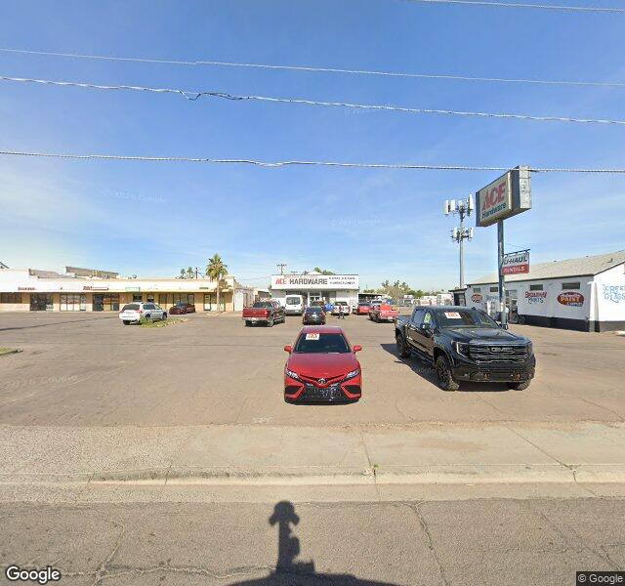  Archived street view - North access edge - captured 23 Aug 2026 | 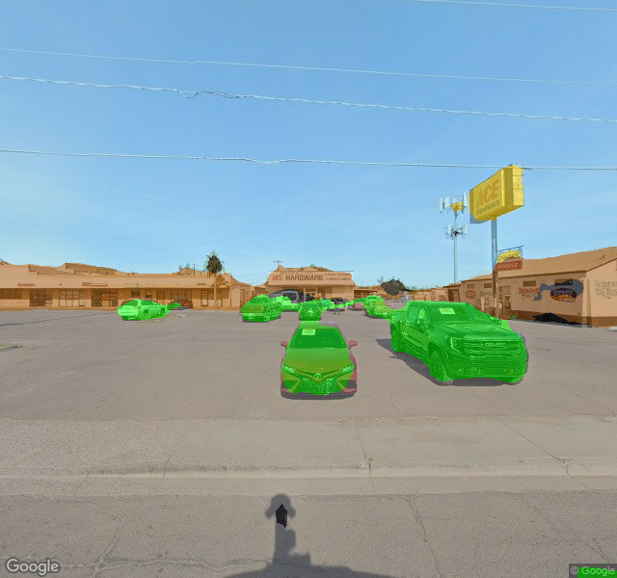  Archived FortyGuard street segmentation - supporting context
Archived evidence: earlier north access-edge source and segmentation imagery are supporting context. No new Street View activity was submitted.

5. What could fit here?
Preliminary climate-and-area compatibility only. Planning and commercial due diligence remain required.
Typology | Preliminary fit | Reason
Warehouse / logistics | Area-compatible; planning unverified | Large-footprint development remains subject to setbacks, access, parking, utilities, zoning and entitlement verification. Site-wide heat requires roof, envelope, yard and worker controls.
Cold-chain distribution | Area-compatible with climate penalty | Historical cooling burden makes resilience, envelope, refrigeration energy and backup strategy critical.
Light industrial + office | Potentially compatible; planning unverified | Keep occupied program compact and validate sun, wind, daylight, noise, energy and microclimate in Forma.
Residential / heat-sensitive outdoor use | Undetermined | High hot-season exposure and missing zoning, market, amenity, access and entitlement evidence prevent a responsible recommendation.

6. Generated Forma proposal
No generated Forma building was present when this report was exported. Generate and evaluate a building, then export the report again.

7. Forma validation
Forma validation will appear after a building is generated.

8. SiteMorph revision
No autonomous geometry revision has been completed.

9. SiteMorph Recommendation
Complete the generated Forma proposal before a design recommendation
Confidence: Preliminary
Primary constraint: Persistent hot-season thermal load
Next decision: Generate, analyze and revise one requirements-driven building.

10. Evidence trail

FortyGuard heat activities
Date | TCM | Persistence | Exceedance | Peak time
Primary | fg_act_9c2a14d8
Site context | Archived South Phoenix satellite, surface and street imagery - captured 23 Aug 2026 - no new FortyGuard activity
Forma analyses | None recorded - building not generated
SiteMorph decision | Generate and validate one Forma building: Historical evidence is ready; native spatial validation is the next step.

Limitations
FortyGuard supplies historical thermal and site context. Forma remains responsible for native sun, wind, daylight, microclimate, energy, noise, solar and carbon validation. Archived imagery is labeled separately and is not presented as part of the current thermal run. This document is a concept-stage intelligence and design report, not a zoning determination, engineering certification, environmental-impact statement, financial feasibility study or permit document.

