

**REAL-TIME COMMUNICATION SYSTEM POWERED BY AI FOR SPECIALLY ABLED**

**TEAM ID** - **PNT2022TMID45510**

|  |  |  |
| --- | --- | --- |
| S.No. | TEAM MEMBERS | REGISTER NUMBER |
| 1 | VISHNU N (TL) | 812619205024 |
| 2 | RIYAS AHAMED M | 812619205019 |
| 3 | LAYONAL JENISTON J | 812619205019 |
| 4 | VAISHNAVI R | 81261920501 |

DSG

M.A.M COLLEGE OF ENGINEERING ,

TRICHIRAPPALI,

TRICHY-CHENNAI TRUNK ROAD ,SIRUGANUR

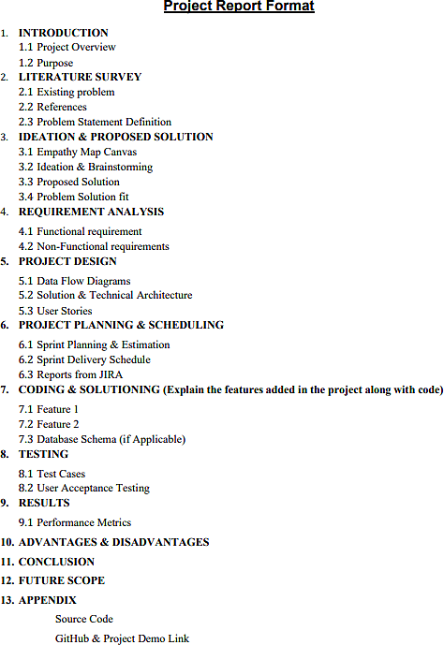

# INTRODUCTION

1.1 Project Overview

The goal of this project was to build a neural network able to classify which letter of the American Sign Language(ASL) alphabet is being signed, given an image of a signing hand. This project is a first step towards building a possible sign language translator, which can take communications in sign language and translate them into written and oral language. Such a translator would greatly lower the barrier for many deaf and mute individuals to be able to better communicate with others in day to day interactions.

This goal is further motivated by the isolation that is felt within the deaf community. Loneliness and depression exists in higher rates among the deaf population, especially when they are immersed in a hearing world . Large barriers that profoundly affect life quality stem from the communication disconnect between the deaf and the hearing. Some examples are information deprivation, limitation of social connections, and difficulty integrating in society.

Most research implementations for this task have used depth maps generated by depth camera and high resolution images. The objective of this project was to see if neural networks are able to classify signed ASL letters using simple images of hands taken with a personal device such as a laptop webcam. This is in alignment with the motivation as this would make a future implementation of a real time ASL-to-oral/written language translator practical in an everyday situation.

1.2 Purpose

In our society, we have people with disabilities. The technology is developing day by day but no significant developments are undertaken for the betterment of these people. Communications between deaf-mute and a normal person has always been a challenging task. It is very difficult for mute people to convey their message to normal people. Since normal people are not trained on hand sign language. In emergency times conveying their message is very difficult. The human hand has remained a popular choice to convey information in situations where other forms like speech cannot be used. Voice Conversion System with Hand Gesture Recognition and translation will be very useful to have a proper conversation between a normal person and an impaired person in any language.

The project aims to develop a system that converts the sign language into a human hearing voice in the desired language to convey a message to normal people, as well as convert speech into understandable sign language for the deaf and dumb. We are making use of a convolution neural network to create a model that is trained on different hand gestures. An app is built which uses this model. This app enables deaf and dumb people to convey their information using signs which get converted to human-understandable language and speech is given as output.

# LITERATURE SURVEY

**Literature survey:**

A literature survey or a literature review in a project report is that section which shows the various analyses and research made in the field of your interest and the results already published, taking into account the various parameters of the project and the extent of the project. It is the most important part of your report as it gives you a direction in the area of your research. It helps you set a goal for your analysis - thus giving you your problem statement.

2.1 Existing Problem

In our society, we have people with disabilities. The technology is developing day by day but no significant developments are undertaken for the betterment of these people. Communications between deaf-mute and a normal person has always been a challenging task. It is very difficult for mute people to convey their message to normal people. Since normal people are not trained on hand sign language. In emergency times conveying their message is very difficult. The human hand has remained a popular choice to convey information in situations where other forms like speech cannot be used. Voice Conversion System with Hand Gesture Recognition and translation will be very useful to have a proper conversation between a normal person and an impaired person in any language.

2.2 References

TITLE: Innovative study of an AI voice based smart device to assist deaf people AUTHOR: Dhaya Sindhu Battina

YEAR: 2021

Assistive technology consists of a wide range of hardware and software tools that enable a person to receive information in the format that suits their needs best. These Various technology may be available to the deaf.many items, including cochlear implants, loop systems,accessibility,FM technology and assistive listening devices,visual warning systems, videophones, and much more . Recognizing the worth and boundaries of different assistive devices can be advantageous for both.Artificial intelligence (AI) enables computers to learn from existing experiences, adapt to new information, and perform tasks that are similar to those carried out by humans . The vast majority of artificial intelligence applications that users know of today – ranging from chess playing robots to self-driving vehicles – are primarily reliant on deep learning and computational linguistics.Computers may be taught to do particular jobs by

processing huge quantities of data and detecting trends in the data. This is accomplished via the use of various technologies.

TITLE:Communication system for deaf and dumb people AUTHOR: Shraddha R. Ghorpade, Prof. Surendra K. Waghmare2 YEAR: 2019

People with disabilities are having a difficult time keeping up with the rapidly evolving technology, which is one of the major issues that our society is dealing with. For those with disabilities, having access to communication tools has become crucial. typically deaf and stupid people use sign language to communicate, but they struggle to do so with non-sign language users language. Information is the main topic of communication between normal and deaf individuals using sign language, which is expressive and natural. So that we can converse with them and comprehend what they're saying, we need a translation. A language translation technology converts common sign language into voice, enabling regular people to communicate with one another. When it comes to communicating with other people,sign language (SL) is the primary method of communication for hearing-impaired individuals and other groups. It is conveyed via both manual (body and hand movements) and non-manual (face expressions) characteristics. All of these characteristics are combined to create utterances that communicate the meaning of words or statements.

TITLE: Educational Status of Differently Abled Persons and Developed Policies in India AUTHOR: Chiranjit Majumder

YEAR: 2019 April

One of the socially created phenomenon is basically Disability. The fact is that many children and adults suffered from disabilities excluded from mainstream education benefits. Disabled persons are segregated from education system because of social negligence and absence of support system in the home and inadequacy of sufficient facilities in schools particularly. However, education is the most important medium for social, economic and political transformation. Socialization of children with disabilities (CWD) through education receives an unremarkably important roles in societies such as India where social exclusion of Physically Challenged Persons (PCPs) is significant. Indisputably, the literacy level of Physically Challenged Persons (PCPs) is very low in India. Very poor educational outcomes for children with disabilities remain in developing countries specially. Most of disabled persons do not getfx the full benefits of education. However, some policies in India has started to display some concern for Physically Challenged students. Education is utmost significant to lift up the socio-

economic status of PCPs. But education of disabled persons has not received adequate intentness and resources that it requires. Physically Challenged Persons (PCPs), few who are enrolled in schools are not given equal opportunity for middle secondary and higher education levels. Many Disabled persons are educated but they do not get any work for earning in our society.

2.3 Problem Statement Deﬁnition

Communication is the only medium by which we can share our thoughts or convey the message but communications between deaf-mute and a normal person has always ben a challenging task. It is very difficult for mute people to convey their message to normal people. Since normal people are not trained on hand sign language.

In emergency times conveying their message is very difficult.

Problem:

Vedha has difficulty in hearing. He uses sign language to **communicate** with others. But he can’t able to communicate with normal people who don’t understand sign language.

Solution:

To develop a system that converts the sign language into a human hearing voice in the

desired language to convey a message to normal people, as well as convert speech into

**understandable** sign language for the deaf ,the system enhances the user friendly experience.

Problem**:**

Ram is a dumb by birth. He uses sign language to communicate with others. But he can’t able to communicate with normal people who don’t understand sign language.

Solution:

To create a app for understanding sign language and convert into Speech signal as output for normal people.

# IDEATION AND PROPOSED SOLUTION

3.1 Empathy Map Canvas

#### Definition:

An empathy map canvas is a more in-depth version of the original empathy map, which helps identify and describe the user’s needs and pain points. And this is valuable information for improving the user experience.

An empathy map canvas helps brands provide a better experience for users by helping teams understand the perspectives and mindset of their customers. Using a template to create an empathy map canvas reduces the preparation time and standardizes the process so you create empathy map canvases of similar quality.

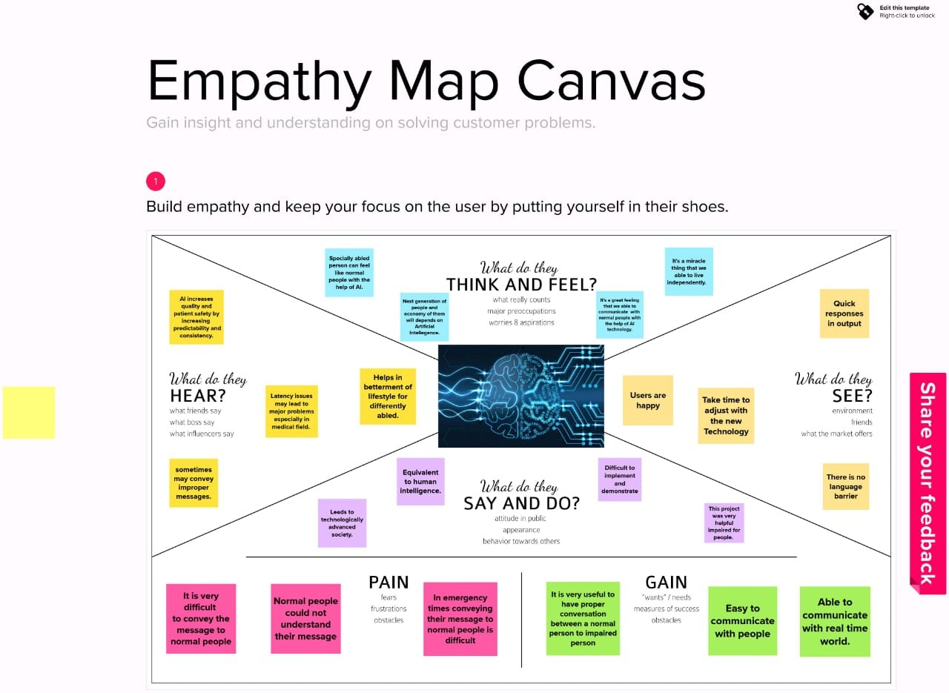

3.2 Ideation & Brainstorming

Definition:

Brainstorming provides a free and open environment that encourages everyone within a team to participate in the creative thinking process that leads to problem solving. Prioritizing volume over value, out-of-the-box ideas are welcome and built upon, and all participants are encouraged to collaborate, helping each other develop a rich number of creative solutions.

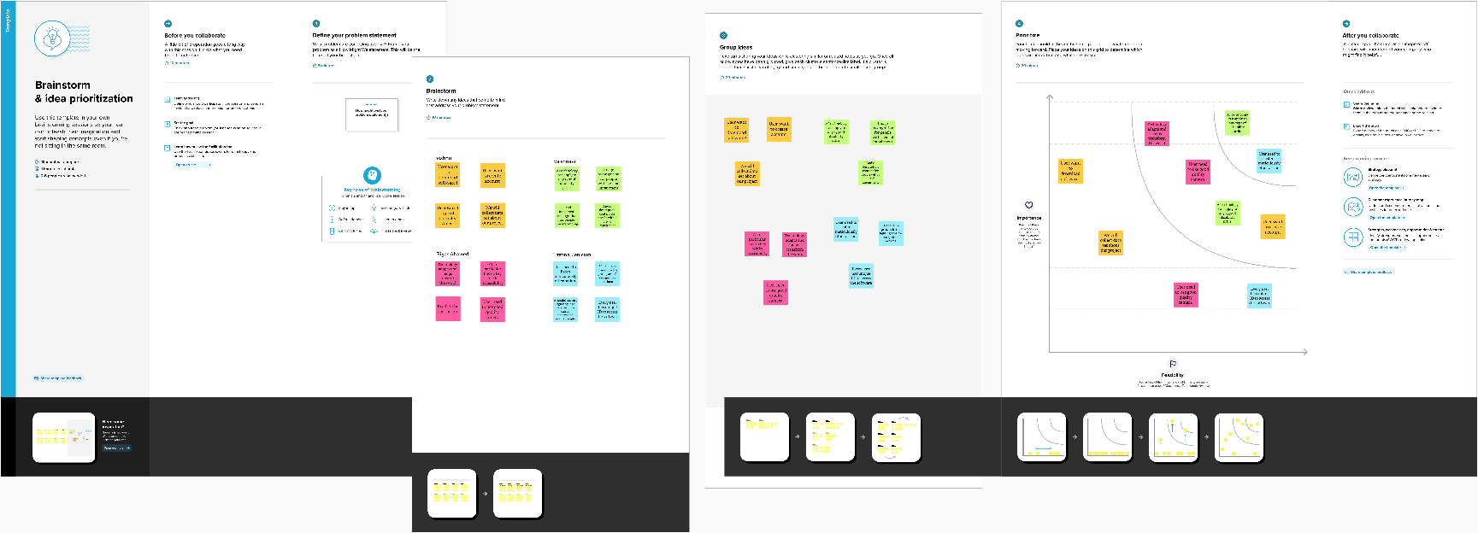

3.3 proposed Solution

|  |  |  |
| --- | --- | --- |
| S.No | Parameter | Description |
| 1. | Problem Statement (Problem to be solved) | Deaf and dumb people couldn’t able to communicate with the normal people easily. |
| 2. | Idea/Solution description | A real time ML based system is built for the real time sign language detection with a Tensor Flow object detection |
| 3. | Novelty/Uniqueness | This model using SSD ML algorithm recognizing the signs as words instead of old traditional translators, that are very slow and take too much since every  alphabet as to be recognized to form the  whole statement in old methods. |
| 4. | Social Impact/Customer satisfaction | It drastically reduce communication difference gap between normal people and specially abled people with the help of AI.So they can live their life  independently. |
| 5. | Business Model (Revenue Model) | We use freemium business revenue model for making revenue. In our device, we give most of the basic features for free of charge but they have to pay  if they need more advanced features. |
| 6. | Scalability of the Solution | The model which is TensorFlow model that has been used can be replaced with  another model as well.  The same system can be implemented for different sign languages by substituting the  dataset. |

3.4 Problem Solution Fit

#### Definition:

The Problem-Solution Fit simply means that you have found a problem with your customer and that the solution you have realized for it actually solves the customer's problem.

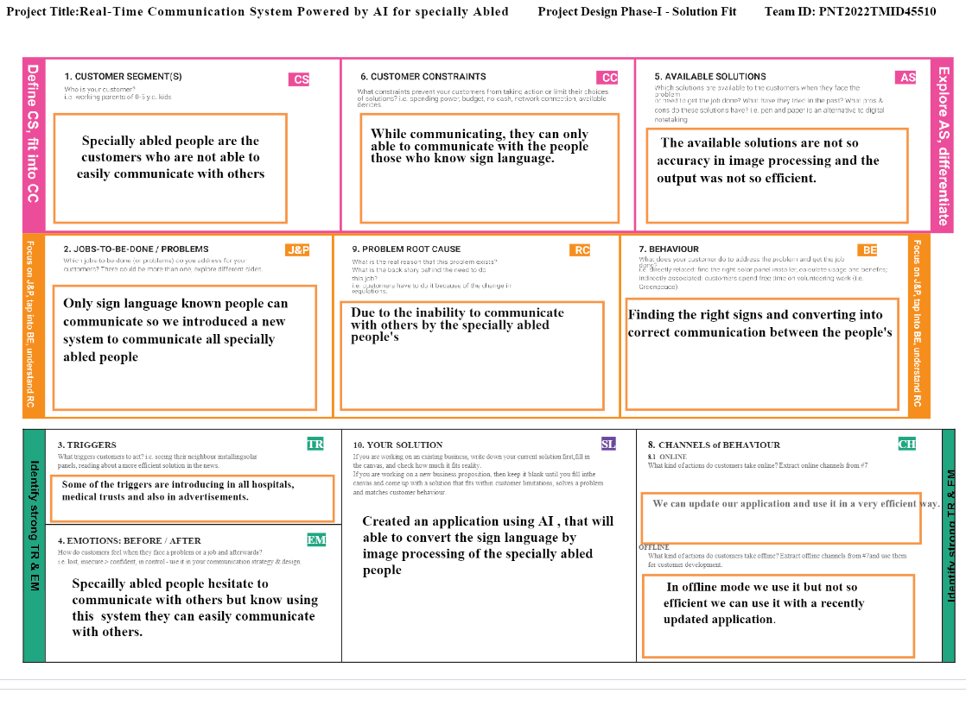

# REQUIREMENT ANALYSIS

4.1 Functional Requirements

|  |  |  |
| --- | --- | --- |
| **FR No.** | **Functional Requirement** | **Sub Requirements** |
| FR-1 | **User Registration** | Registration throughForm  Registration through Gmail. |
| FR-2 | **User confirmation** | Confirmation via Email  Confirmation via OTP |
| FR-3 | **System** | Desktop with high resolution camera |
| FR-4 | **Authorization Levels** | There are two levelsof authorization namelystandard  access level and advanced accesslevel. |
| FR-5 | **External interface** | Ethernet, Wi-Fi,USB to provideinternet facility to  access the resources with real timecommunication. |
| FR-6 | **Reporting** | If anyissues found in the application, automatically it  will be notified to the developer. |

4.2 Non-Functional Requirements

|  |  |  |
| --- | --- | --- |
| **FR No.** | **Non-Functional Requirement** | **Description** |
| NFR-1 | **Usability** | To convey a message to normal people, as well as convert speechinto understandable sign language  for the deaf and dumb people. |
| NFR-2 | **Security** | Converted information using signs intospeech is  accessed only by the user. |
| NFR-3 | **Reliability** | Provides insight into potential issues for desktop  applications on managed devices. |
| NFR-4 | **Performance** | The timefor converting signsinto speech shouldbe  faster for the real time communication. |
| NFR-5 | **Availability** | Provides automatic recovery as muchas possible. |
| NFR-6 | **Scalability** | This app enables deaf and dumb people to convey their information using signs which get converted to human-understandable language and speechis  given as output. |

# PROJECT DESIGN

**5.1 Data Flow Diagram**

A Data Flow Diagram (DFD) is a traditional visual representation of the information flows within a system. A neat and clear DFD can depict the right amount of the system requirement graphically. It shows how data enters and leaves the system, what changes the information, and where data is stored.

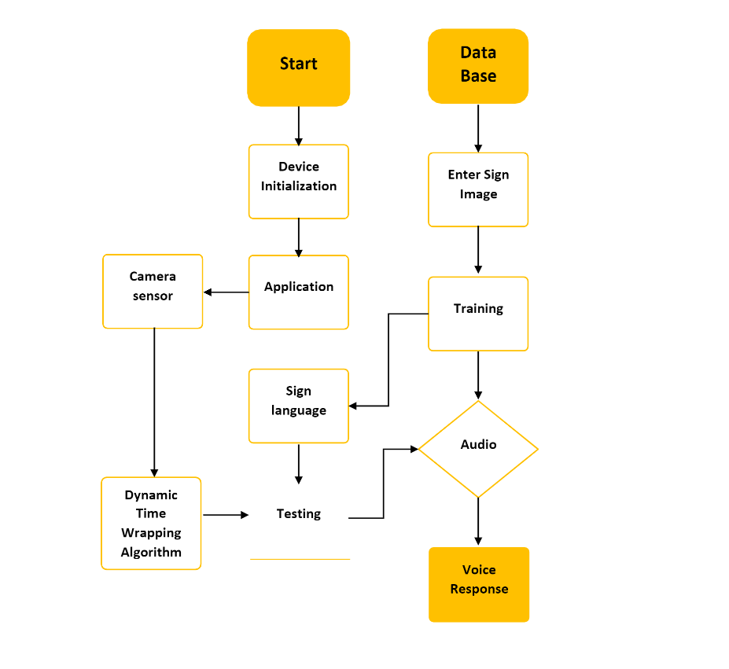

**5.2 Solution & Technical Architecture**

Solution architecture is a complex process – with many sub-processes – that bridges the gap between business problems and technology solutions. Its goals are to:

1. Find the best tech solution to solve existing business problems.
2. Describe the structure, characteristics, behaviour, and other aspects of the software to project stakeholders.
3. Define features, development phases, and solution requirements.
4. Provide specifications according to which the solution is defined, managed, and delivered.

**Solution Architecture Diagram :**

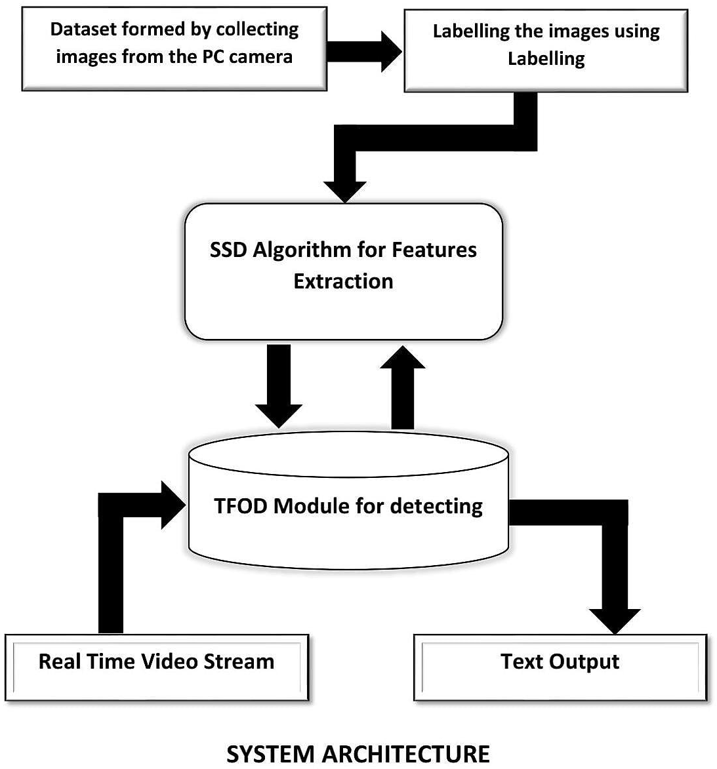

**Technology Stack (Architecture & Stack):**

**Technical Architecture:**

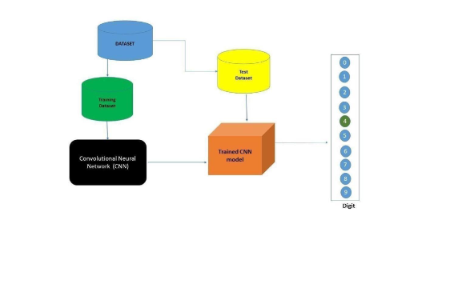

**Table-1 Components and Technologies:**

|  |  |  |  |
| --- | --- | --- | --- |
| **S.NO** | **Component** | **Description** | **Technology** |
| 1. | User Interface | Customer have to login through their respectivewebsite or phone number.  Then interaction will happen withthe  User interface. | javascript, CSS,HTML |
| 2. | Application Logic-1 | It requires various types libraries, frameworks todevelop the project | Java / Python |
| 3. | Application Logic-2 | Helps to converting the human gestures/actionsinto written words. | Machine learning |
| 4. | Application Logic-3 | Provides helpful,feasible answers afterrecognising the human gestures. | ANN,CNN |
| 5. | Database | Data couldbe numbers or words. | MySQL, Rational  database |
| 6. | Cloud Database | Providing customer to use hostdatabase withoutbuyingadditional hardware.. | Deep learning and neural networks |
| 7. | File Storage | File storagecould be fast,reliable and  flexible.. | Local filesystem |
| 8. | External API-1 | Used to access the information in the  cloud | Weather API |
| 9. | External API-2 | Used to access the information for data drivendecision making... | Aadhar API |
| 10. | Machine Learning Model | Machine learning interact with variousalgorithmsthat are required for  implementation. | Image acquisation |
| 11. | Infrastructure (Server / Cloud) | Application deployment on local system /localcloud serverconfiguration.  Install the windows version and  execute theinstaller.. | Local, Cloud Foundry, Kubernetes, etc. |

**Table-2: Application Characteristics:**

|  |  |  |  |
| --- | --- | --- | --- |
| **S.No** | **Characteristics** | **Description** | **Technology** |
| 1. | Open-Source Frameworks | The framework which are used. | Tensor flow, Theano,  RNN, PyTorch |
| 2. | Security Implementations | Security controls which can implemented by usingfirewall.. | Firewall and some security related  softwares.. |
| 3. | Scalable Architecture | The architecture will be scalable  (Micro services). | Data, models, speedand  consistency.. |
| 4. | Availability | The availablity of application ( use of loadbalancers, distributed servers  etc) | Image recognition, sign/gestures recognition, text recognition & real time  captioning.. |
| 5. | Performance | Design aspects for the performance of application ( number of requests per second, use of cacheetc.., | Using Convolutional neural network, maching learning for conversation and improve the sensivity of  the performance.. |

**5.3 User Stories**

|  |  |  |  |  |  |  |
| --- | --- | --- | --- | --- | --- | --- |
| **User Type** | **Functional Requirement (Epic)** | **User Story**  **Number** | **User Story / Task** | **Acceptance criteria** | **Priority** | **Release** |
| Customer (Mobile user) | Registration | USN-1 | As customer, I couldable to register for theapp by entering my E-mail and proper  password. | I could able to access myregistered account. | High | Sprint 1 |
|  |  | USN-2 | As a user, I'll get the acknowledgement verification emailonce after my registrationhasbeen done for theapp | I can get verification emailand clickok to confirm it.. | High | Sprint 1 |
|  |  | USN-3 | As a customer, I could able to register for application via their official websites and  social media. | I could able to register and access my account by usingtheirwebsite & socialmedia. | Medim | Sprint 2 |
|  |  | USN-4 | As a customer, I could able to register for application  through Gmail | via some thirdparties link | Low | Sprint 2 |
|  | Login | USN-5 | As a customer, I could able to login into application by entering alreadyregistered email and  password | I can type manually and alsocan used saved login credentials | High | Sprint 1 |

|  |  |  |  |  |  |  |
| --- | --- | --- | --- | --- | --- | --- |
|  | Dashboard | USN- 6 | As a customer,I can get all services andhelp in dashboard | I can access my dashboard and change profile | Medium | Sprint 2 |
| Customer (Webuser) | Registration | USN- 7 | As a customer, I could able to login throughregistered phone numberby using otp instead of Gmail | I could able to register & login via phone numberto access my account | High | Sprint 2 |
| Customer Care Executive | Service | USN- 8 | Can avail the service by calling customer care or reaching through E-mail. | Can avail the service by calling customer care or reaching throughE-mail. | Medium | Sprint 1 |
| Administrator |  | USN- 9 | Respective personin the companyshould take care all of this. | All the requirements arethere. | High | Sprint 2 |
|  | Sign up | USN- 10 | Customer have to sign-up to use thesethings andall | Have to enter validcredentials. | High | Sprint 2 |

|  |  |  |  |  |  |  |
| --- | --- | --- | --- | --- | --- | --- |
| **User Type** | **Functional Requirement (Epic)** | **User Story Number** | **User Story / Task** | **Acceptance criteria** | **Priority** | **Release** |
|  | Wish list | USN-11 | Customer's desired choices to availthese services. | As a customer can review and choose theirservices ashe want/preferred. | Medium | Sprint 1 |
|  | Enrollment | USN-12 | Now, customer can avail all services oncehe/she enrolled. | As a customer, it'squiteenchanting | Medium | Sprint 2 |

# PROJECT PLANNING & SCHEDULING

**6.1 Sprint Planning & Estimation**

### Product Backlog, Sprint Schedule, and Estimation:

|  |  |  |  |  |  |  |
| --- | --- | --- | --- | --- | --- | --- |
| **Sprint** | **Function al Requirem**  **ent(Epic)** | **User Story Number** | **User Story / Task** | **Story Points** | **Priority** | **Team Members** |
| Sprint-1 | Data Collection | USN-1 | Collect Dataset. | 9 | High | VISHNU, RIYAS AHAMED |
| Sprint-1 |  | USN-2 | Image preprocessing | 8 | Medium | VAISHNAVI , LYONAL JENISTON |
| Sprint-2 | Model Building | USN-3 | Import the required libraries, add the necessary layers and compile the model | 10 | High | RIYAS AHAMED, VAISHNAVI |
| Sprint-2 |  | USN-4 | Training the image classification  modelusingCNN | 7 | Medium | VISHNU, LYONAL JENISTON |
| Sprint-3 | Training and Testing | USN-5 | Training the model and testing the  model’s performance | 9 | High | RIYAS AHAMED, LYONAL JENISTO |
| Sprint-4 | Implementati on ofthe application | USN-6 | Converting the input sign language images into Englishalphab ets | 8 | Medium | VISHNU, VAISHNAVI. |

**6.2 Sprint Delivery Schedule**

**Project Tracker,Velocity & BurndownChart:**

|  |  |  |  |  |  |  |
| --- | --- | --- | --- | --- | --- | --- |
| **Sprint** | **Total Story Points** | **Duration** | **Sprint Start Date** | **Sprint End Date (Planned)** | **Story Points Completed (as on PlannedEnd Date)** | **Sprint Release Date(Actual)** |
| Sprint-1 | 10 | 6 Days | 24 Oct  2022 | 29 Oct 2022 | 8 | 29 Oct 2022 |
| Sprint-2 | 10 | 6 Days | 31 Oct  2022 | 04 Nov 2022 | 5 | 04 Nov 2022 |
| Sprint-3 | 10 | 6 Days | 07 Nov  2022 | 11 Nov 2022 | 7 | 11 Nov 2022 |
| Sprint-4 | 10 | 6 Days | 14 Nov  2022 | 18 Nov 2022 | 5 | 18 Nov 2022 |

**Velocity:**

**AV = 6/10 = 0.6**

**Burndown chart:**

A burn down chart is a graphical representation of work left to do versus time. It is often used in agile software development methodologiessuch as Scrum. However, burn down chartscan be applied to any project containing measurable progress over time.

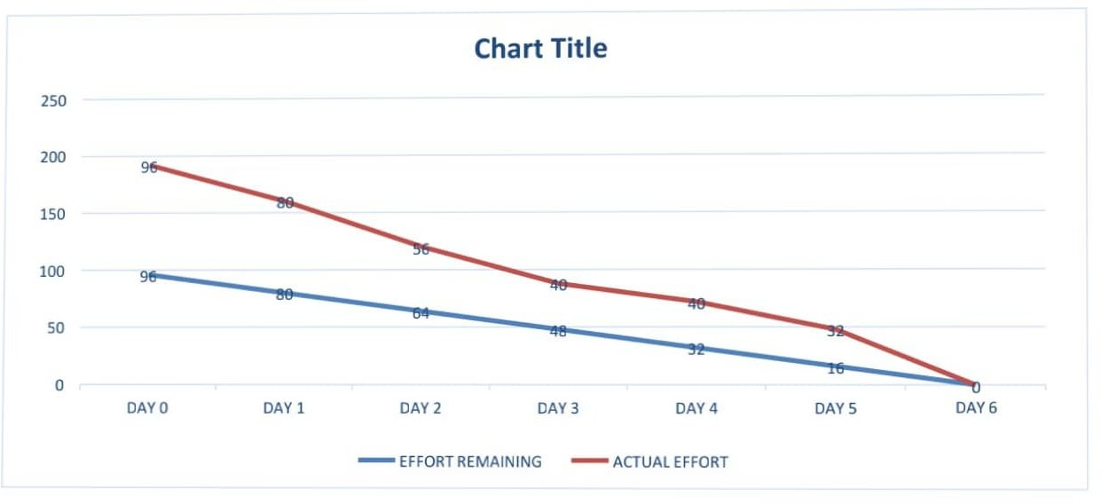

**6.3 Reports from JIRA**

**Jira helps teams plan, assign, track, report, and manage work and brings teams together for everything from agile software development and customer support to start-ups and enterprises. Software teams build better with Jira Software, the #1 tool for agile teams. As a Jira administrator, you can create project categories so your team can view work across related projects in one place. Your team can use categories in advanced search, filters, reports, and more.**

**Reports from JIRA:**



# CODING & SOLUTIONING

**(Explain the features added in the project along with code)**

The user can choose which sign language to read based on the different sign language standards that exist.

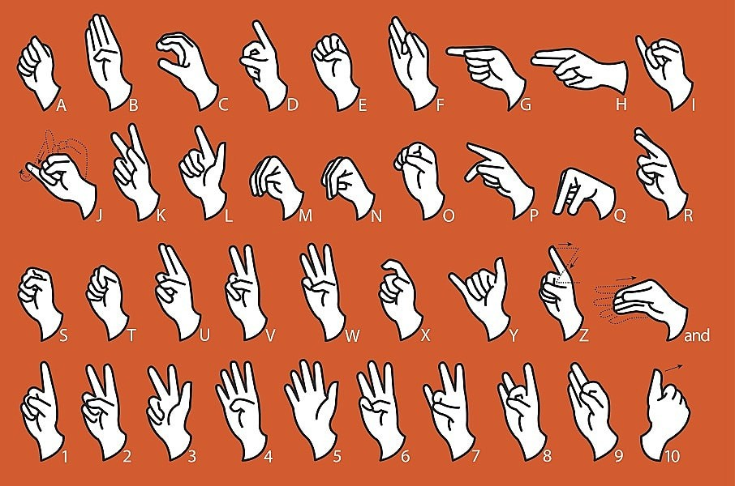

MODEL BUILDING

**from** keras.models **import** Sequential

**from** keras.layers **import** Dense

**from** keras.layers **import** Convolution2D

**from** tensorflow.keras.layers **import** Conv2D, MaxPooling2D

**from** keras.layers **import** Dropout

**from** keras.layers **import** Flatten

*#Creating the model*

model**=**Sequential()

*#Adding the layers*

model**.**add(Convolution2D(32,(3,3), input_shape**=**(64,64,1), activation **=** 'relu')) model**.**add(MaxPooling2D(pool_size**=**(2,2)))

model**.**add(Flatten())

*#adding hidden layers* model**.**add(Dense(400, activation**=**'relu')) model**.**add(Dense(200, activation**=**'relu')) model**.**add(Dense(100, activation**=**'relu'))

*#Adding the output layer*

model**.**add(Dense(9, activation**=**'softmax')) model**.**compile(loss**=**'categorical_crossentropy', optimizer**=**'adam', metrics**=**['accuracy'])

model**.**fit_generator(x_train, steps_per_epoch**=**30, epochs**=**10, validation_data**=**x_test,validation_steps**=**50)

Epoch 1/10

/usr/local/lib/python3.7/dist-packages/ipykernel_launcher.py:1: UserWarning:

`Model.fit_generator` is deprecated and will be removed in a future version. Please use

`Model.fit`, which supports generators.

"""Entry point for launching an IPython kernel.

In [102]:

In [157]:

30/30 [==============================] - ETA: 0s - loss: 0.0083 - accuracy: 0.9957

WARNING:tensorflow:Your input ran out of data; interrupting training. Make sure that your dataset or generator can generate at least `steps_per_epoch * epochs` batches (in this case, 50 batches). You may need to use the repeat() function when building your dataset.

30/30 [==============================] - 18s 587ms/step - loss: 0.0083 - accuracy:

0.9957 - val_loss: 0.2910 - val_accuracy: 0.9693 Epoch 2/10

30/30 [==============================] - 12s 402ms/step - loss: 0.0081 - accuracy:

0.9980

Epoch 3/10

30/30 [==============================] - 12s 400ms/step - loss: 0.0102 - accuracy:

0.9963

Epoch 4/10

30/30 [==============================] - 12s 402ms/step - loss: 0.0049 - accuracy:

0.9993

Epoch 5/10

30/30 [==============================] - 12s 402ms/step - loss: 0.0030 - accuracy:

0.9997

Epoch 6/10

30/30 [==============================] - 12s 394ms/step - loss: 0.0019 - accuracy:

0.9997

Epoch 7/10

30/30 [==============================] - 12s 401ms/step - loss: 0.0081 - accuracy:

0.9973

Epoch 8/10

30/30 [==============================] - 12s 402ms/step - loss: 0.0124 - accuracy:

0.9960

Epoch 9/10

30/30 [==============================] - 12s 401ms/step - loss: 0.0070 - accuracy:

0.9987

Epoch 10/10

30/30 [==============================] - 12s 399ms/step - loss: 0.0089 - accuracy:

0.9973

model**.**save('Real_time.h5')

TEST THE MODEL

**from** tensorflow.keras.models **import** load_model **from** tensorflow.keras.preprocessing **import** image **import** numpy **as** np

**import** cv2

model **=** load_model('/content/Real_time.h5')

In [105]:

In [151]:

img **=** image**.**load_img('/content/Dataset/test_set/H/107.png',target_size **=** (100,100))img



**from** skimage.transform **import** resize

**def** detect(frame): img**=**image**.**img_to_array(frame) img **=** resize(img,(64,64,1))

img **=** np**.**expand_dims(img,axis**=**0) pred**=**np**.**argmax(model**.**predict(img)) op**=**['A','B','C','D','E','F','G','H','I']

print("THE PREDICTED LETTER IS ",op[pred])

img**=**image**.**load_img("/content/Dataset/test_set/H/107.png") detect(img)

1/1 [==============================] - 0s 28ms/step THE PREDICTED LETTER IS H

img **=** image**.**load_img('/content/Dataset/test_set/A/110.png') pred**=**detect(img)

1/1 [==============================] - 0s 26ms/step THE PREDICTED LETTER IS A

img**=**image**.**load_img('/content/Dataset/test_set/E/111.png') detect(img)

1/1 [==============================] - 0s 30ms/step THE PREDICTED LETTER IS E

In [150]:

In [155]:

In [158]:

**7.2 Feature 2**

The communication gap between deaf and dumb people and the general public can be bridged with a mobile application.

**Mobile App:**

from flask import Flask, Response, render_template from camera import Video

app = Flask(_name_) @app.route('/')

def index():

return render_template('index.html')

def gen(camera):

while True:

frame = camera.get_frame() yield(b'--frame\r\n'

b'Content-Type: image/jpeg\r\n\r\n' + frame + b'\r\n\r\n')

@app.route('/video_feed') def video_feed():

video = Video()

return Response(gen(video), mimetype='multipart/x-mixed-replace; boundary = frame')

if _name_ == '_main_': app.run()

# TESTING

**8.1 Test cases**

#### Our code was tested on various angle to check whether it gives the correct output.

* To satisfy the customer’s expectations we tested it fully

**8.2 User Acceptance Testing**

**Our project was tested by an end user to verify that it has working correctly.**

|  |  |  |  |
| --- | --- | --- | --- |
| **S.No.** | **Parameter** | **Values** | **Screenshot** |
| 1 | Model Summary |  |  |
| 2 | Accuracy | Training Accuracy  –99.6%  Validation Accuracy  –98.3% |  |

# RESULTS

**9.1 Performance Metrics**

* + **The proposed procedure was implemented and tested on a set of images.**
  + **The training database consists of 15750 images of Alphabets from "A" to "I", while the testing database consists of 2250 images of Alphabets from "A" to "I".**
  + **Once the gesture is recognized the equivalent alphabet is shown on the screen.**

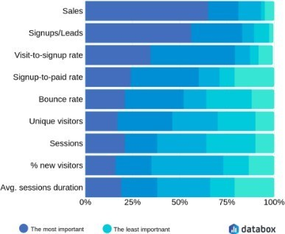

# ADVANTAGES & DISADVANTAES

### Advantages:

* The speech is converted to sign language very quick to provide greater and faster understanding to specially-abled people.
* The user interface is convenient and simple for both people.

### Disadvantages:

* The number of images and pixels for the model to train in the dataset is not high so accuracy is moderate level.
* It will be improved by changing the dataset.
* Currently, we have deployed a dataset in the model for the alphabets A to I only.

# CONCLUSION

## CONCLUSION:

It aims to bridge the communication gap between deaf people and the rest of society. The proposed methodology translates sign language into English alphabets that are understandable to humans. This system sends hand gestures to the model, who recognizes them and displays the equivalent.

# FUTURE SCOPE

## FUTURE OF SCOPE:

With the introduction of gesture recognition, the web app can easily be expanded to recognize letters beyond 'I', digits, and other symbols plus gesture recognition can also allow controlling of software/hardware interfaces. Having a technology that can translate hand sign language to its corresponding alphabet is a game changer in the field of communication and Ai for specially-abled people such as thosedeaf or dumb.

# APPENDIX

## APPENDIX:

#### Source code: Flask:

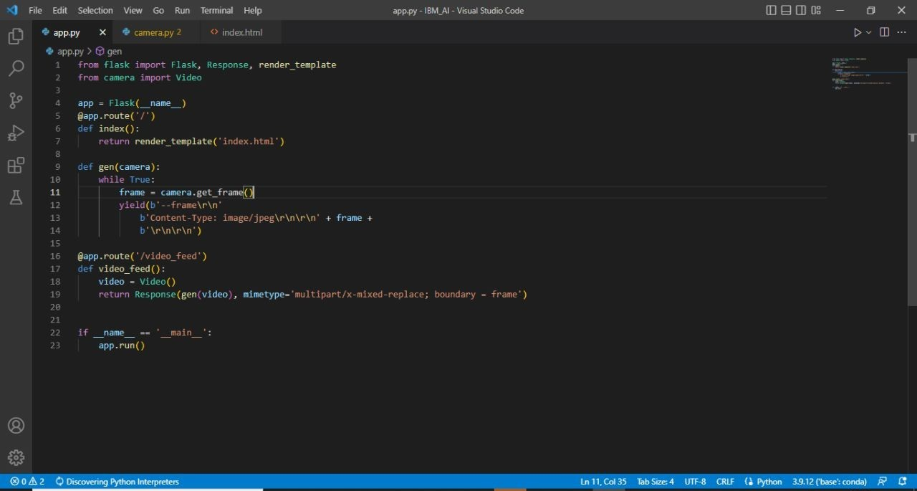

HTML:

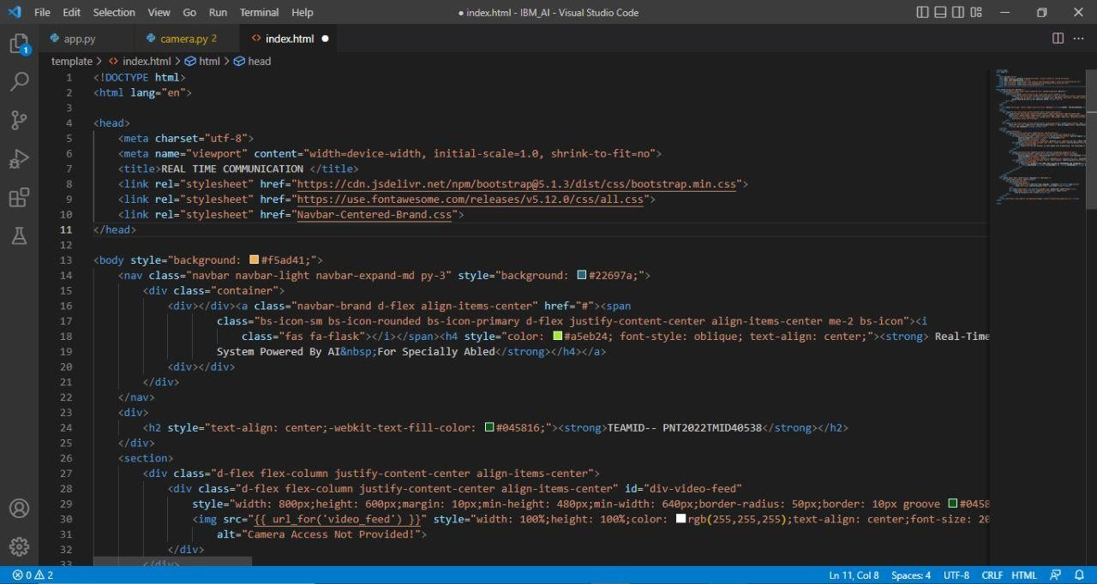

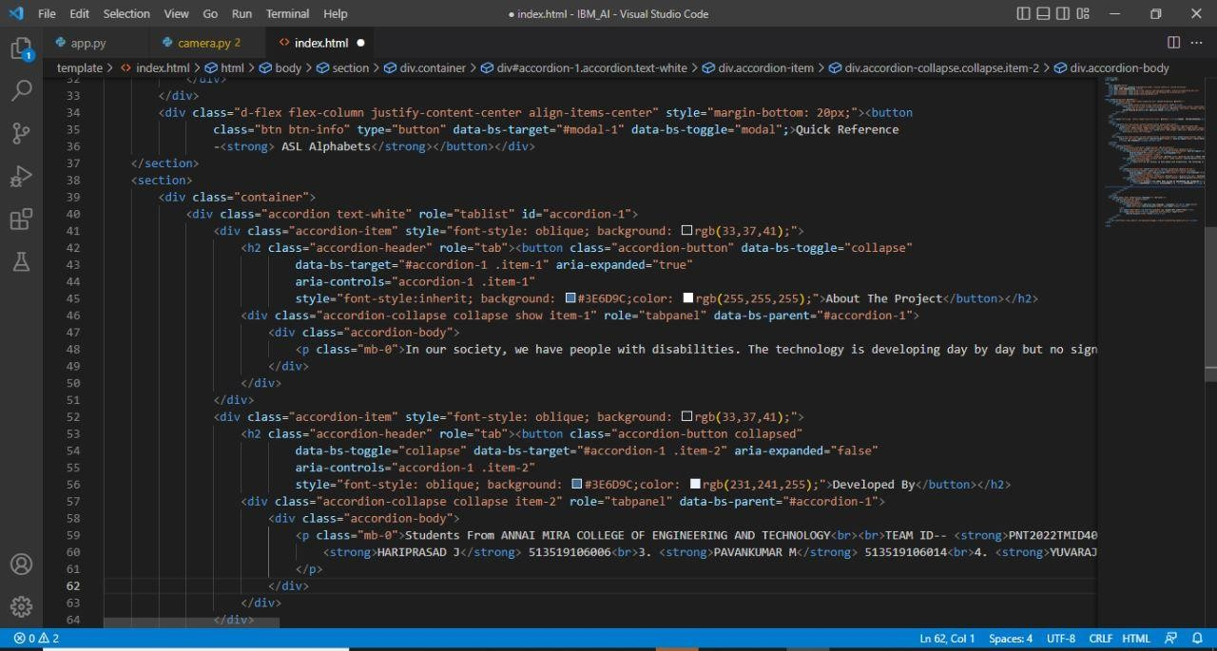

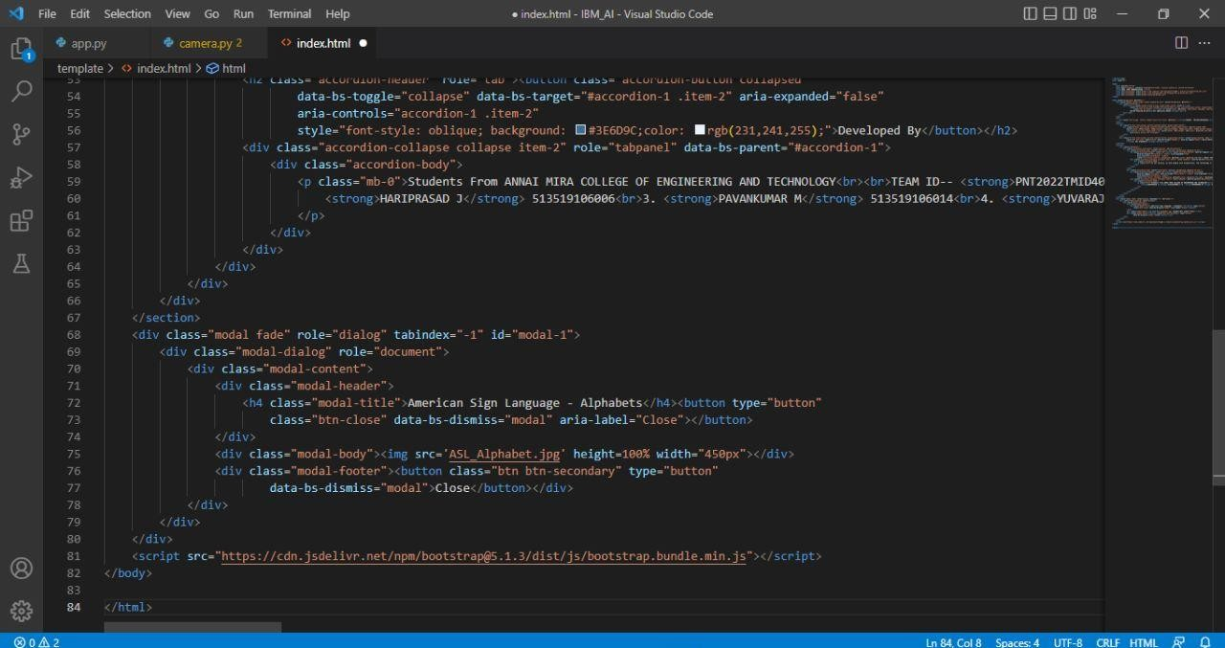

#### Camera**:**

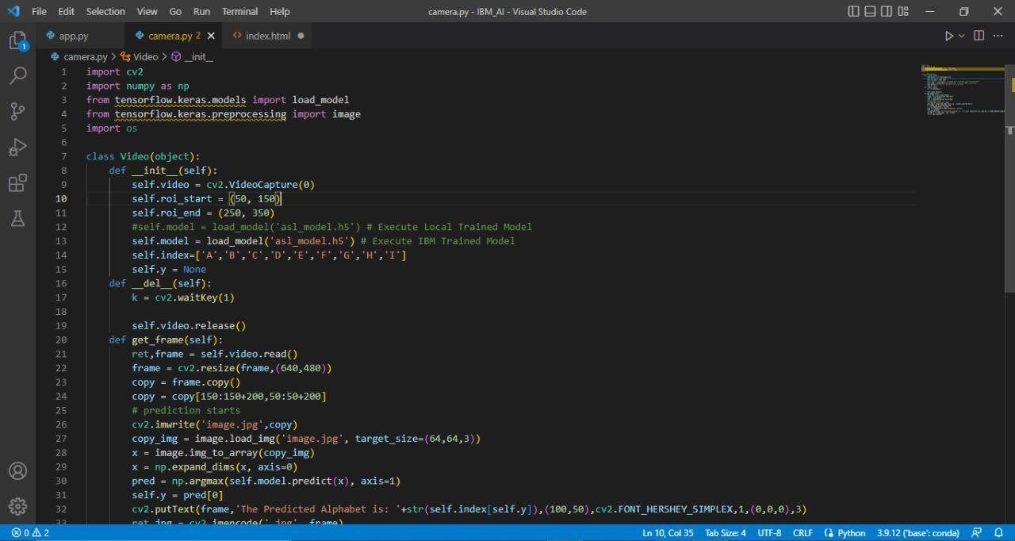

Main:

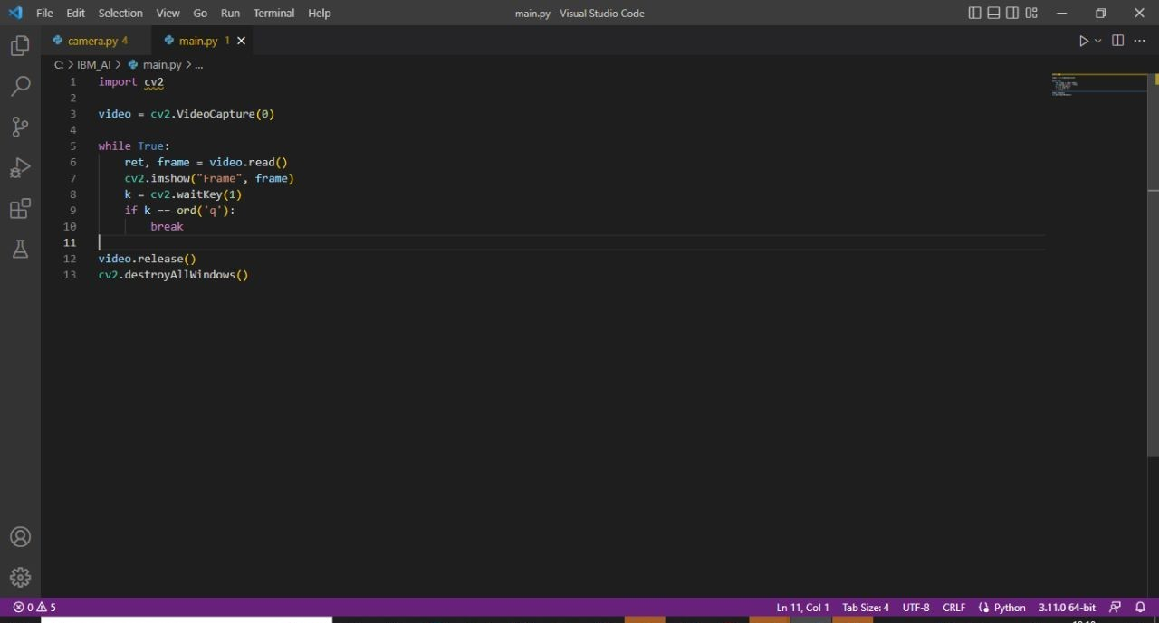

#### Trained Model:

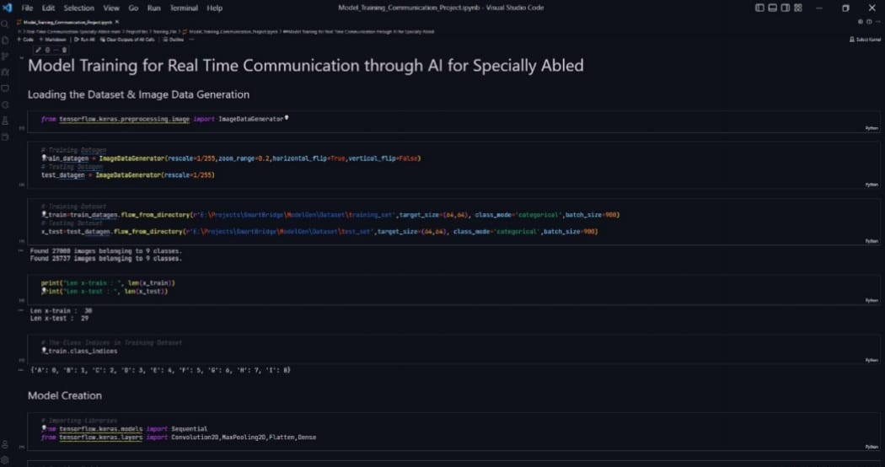

**GitHub Repository**: https://github.com/IBM-EPBL/IBM-Project-19605-1659702440

**Project Demonstration Link**: