BATTERY CHARGERS IN IC 741

OBJECTIVE:

The objective of using an IC 741 in a battery charger circuit could be to provide accurate voltage regulation, current limiting, or temperature sensing to ensure safe and efficient charging of the battery. The IC 741 can be used in various configurations, such as a voltage follower or an integrator, to achieve these objectives.

CONTEXT:

The IC 741 is an operational amplifier, which is not designed specifically for use as a battery charger. However, it is possible to use an operational amplifier like the 741 to build a battery charger circuit, but additional components such as transistors, diodes, and resistors may be required to achieve the desired functionality.

TECHNICAL ASPECTS:

Reference voltage level:

The IC 741 can be used as a voltage comparator to compare the battery voltage with a reference voltage level set by a potentiometer. This reference voltage level should be set based on the battery's charging voltage limit.

Current limiting:

To prevent overcharging and damage to the battery, it is important to limit the charging current. This can be done by using a resistor or current sensing circuit to limit the current flow to the battery. The IC 741 can be used to control a transistor or MOSFET that acts as a switch to regulate the charging current.

Thermal considerations:

When charging a battery, there is a risk of overheating, which can damage the battery or other components in the circuit. It is important to design the circuit with thermal considerations in mind, including selecting components that can handle the expected power dissipation and providing adequate ventilation.

Battery type:

Different types of batteries have different charging characteristics, such as voltage and current limits. It is important to choose a charging circuit that is appropriate for the specific type of battery being charged.

Safety features:

To ensure safe operation, it is important to incorporate safety features such as overvoltage and overcurrent protection into the charging circuit. This can help prevent damage to the battery and other components in the circuit in the event of a fault

CIRCUIT DIAGRAM:

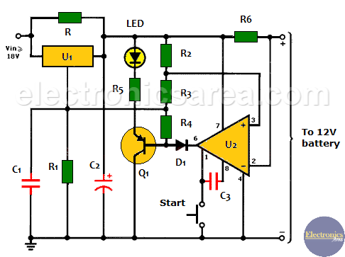

MERGING TRENS IN BATTERY CHARGER IC 741:

Fast charging:

There is a growing demand for fast charging solutions that can charge batteries quickly and efficiently. This has led to the development of new charging technologies such as Qualcomm's Quick Charge and USB Power Deliver..

Wireless charging:

With the increasing popularity of wireless devices, there is a growing demand for wireless charging solutions that can charge batteries without the need for cables or connectors. This has led to the development of wireless charging ICs that can regulate the charging process using electromagnetic induction or resonance.

Battery management systems:

Battery management systems (BMS) are becoming increasingly important for the safe and efficient operation of batteries. BMS can monitor the battery's state of charge, temperature, and other parameters to ensure safe and optimal operation.

Conclusion:

It can be used in combination with other components to regulate the charging voltage and current. When designing a battery charging circuit using the IC 741, it is important to consider technical aspects such as the reference voltage level, current limiting, thermal considerations, battery type, and safety features.

PO MAPPING:

PO 12-LIFELONG LEARNING

The 741 is not a battery charger IC, but rather an operational amplifier (op-amp) that has been widely used in electronic circuits for many years. Nevertheless, I can provide some general information on lifelong learning for electronics and battery charging