**MEASURE ENERGY CONSUMPTION USING MACHINE LEARNING.**

**Phase 4 submission document.**

**Project title: Measure energy consumption**

**Phase 4: Development part 2**

**Topic: Energy consumption data creating and visualization.**

**Abstract:**

Interactive data visualization tools for residential energy data are instrumental indicators for analyzing end user behaviour. These visualizations can be used as continuous home feedback systems and can be accessed from mobile devices using touch-based applications. Visualizations have to be carefully selected in order for them to partake in the behavioural transformation that end users are encouraged to adopt. In this paper, six energy data visualizations are evaluated in a randomized controlled trial fashion to determine the optimal data visualization tool. Conventional visualizations, namely bar, line, and stacked area, are compared against enhanced charts, namely spiral, heatmap, and stacked bar, in terms of effectiveness, aesthetic, understandability, and three analysis questions. The study is conducted through a questionnaire in a mobile application. The application, created through React Native, is circulated to participants in multiple countries, collecting 133 responses. From the received responses, conventional plots scored higher understandability (by 22.74%), effectiveness (by 13.44%), and aesthetic (by 10.54%) when compared with the enhanced visualizations. On the flipside, enhanced plots generated higher correct analysis questions’ responses by 8% compared to the conventional counterparts. From the 133 collected responses, and after applying the unpaired t-test, conventional energy data visualization plots are considered superior in terms of understandability, effectiveness, and aesthetic.

**Introduction:**

In modern society, excessive domestic energy consumption is an issue surpassing all other dilemmas despite the increasing awareness of existing environmental problems (Ouyang and Hokao, 2009). For instance, global heating and cooling energy consumption is expected to grow by 84% by 2030, according to Ürge-Vorsatz et al. (2015). Paz et al. (2012) emphasizes that it is of the utmost importance that future leaders, scientists, and engineers be more aware about the current and future problems related to environmental sustainability. Consequently, recent research has focused on controlling household energy usage for better efficiency in energy consumption either by studying the acceptability of energy-saving measures with different physical characteristics as in Poortinga et al. (2003), increasing the energy consumption understanding by initiating a large-scale energy monitoring campaign as Almeida et al. (2011) did, or analyzing the residential power consumption trends in the world in a certain period of time as the work of Pablo-Romero et al. (2017).

Creating data visualizations is a powerful way to represent and communicate information effectively. These visual representations can help you understand trends, patterns, and insights within your data that might not be immediately apparent when looking at raw numbers or text. Whether you're working with sales figures, survey data, scientific measurements, or any other dataset, data visualizations can simplify complex information and make it more accessible to a broader audience.

In this process, you'll learn to choose the right type of visualization for your data, select appropriate tools or software, and effectively design and present your visualizations to convey meaningful insights. Whether it's a simple bar chart or a complex interactive dashboard, data visualization is a valuable skill for decision-making, storytelling, and enhancing data-driven communication.

The type of chart you use to visualise your energy consumption is important and depends on both who you are communicating to and the type of data that you have. Some useful charts include:

**Bar Charts:**

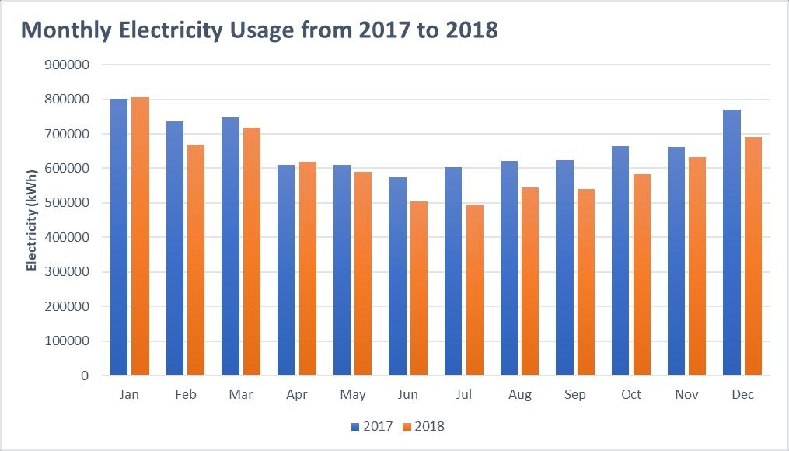

Bar charts are perfect for comparing energy consumption and are one of the most common ways to visualise data. Monthly energy consumption over two or three years can be plotted on a bar chart to compare your energy consumption between the months of the calendar year, or to the previous months in other years.

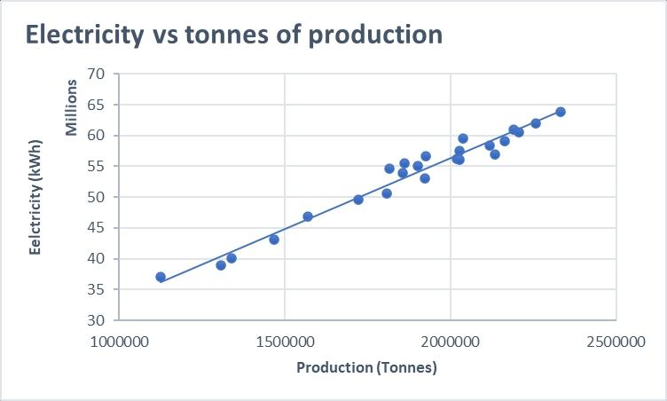**Scatter Plots:**

Scatter plots are useful when there are many different data points and you want to point out similarities in the data set. They can also be used to highlight outliers in the data set and give you an understanding of the data’s distribution. One way to use scatter plots is to plot your electricity consumption against your production to determine if there is a relationship between these two factors of your business. A trendline can also be created to obtain an equation which defines the relationship between energy usage and your production.

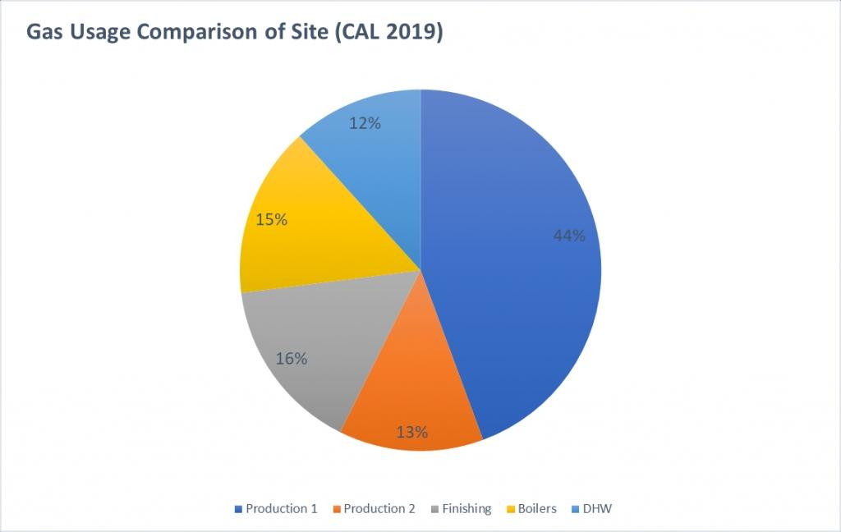**Pie Charts:**

Pie charts will be useful in comparing the energy consumption of different departments of your business, where the sum of each part will equal to a whole. They are easy to read and with a quick scan of the chart, you can understand which area of your site uses the most energy and which area uses the least.

It is also good practice to ensure you include percentage labels, as the portions of the chart might not be immediately obvious to some stakeholders.

**Indicators:**

Indicators are great to use if your business has set targets in your energy usage, as they can then be used to track your current energy usage. They are easy to read and understand from a simple glance and can be expressed either as a gauge or ticker to create greater visual impact. You can also compare your performance to the previous time period to show whether your usage has gone up or down.

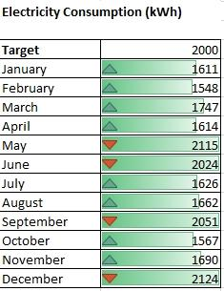

The charts described above are just a number of ways that you could visualise your site’s energy usage. The choice of what chart to use depends on what type of data you have and who you will be presenting these charts to.

To create a visualization of energy consumption data, you can use tools like Microsoft Excel, Google Sheets, or specialized data visualization software like Tableau or Power BI. Here’s a general guide on how to create a simple visualization:

**1.Data Collection:** Ensure you have your energy consumption data in a structured format, typically with columns for date/time and energy consumption values.

**2.Select a Visualization Type:** Choose the most suitable chart type for your data. Common options include line charts for trends over time, bar charts for comparisons, and pie charts for showing the composition of consumption by category.

**3.Data Formatting:** Organize your data in a way that the software can understand. Typically, you’ll need to specify the X-axis (e.g., time) and the Y-axis (e.g., energy consumption values).

**4.Create the Visualization:** In Excel or Google Sheets, select your data and insert a chart.In specialized tools like Tableau or Power BI, import your data, and use their interface to create the visualization. Customize and Label: Add titles, labels, and legends to make the visualization clear and understandable.

**5.Color and Style:** Choose appropriate colors and styles for your visualization to enhance its aesthetics and readability.

**6.Analyze and Interpret:** Once you have your visualization, analyze the trends, patterns, and insights present in the data.

**7.Save and Share:** Save the visualization as an image or share it directly through your chosen software or platform. Remember that the choice of visualization type and design should depend on the specific goals and audience for your energy consumption data presentation.

**●Popular Energy Consumption and visualization:**

Data visualization study on domestic energy data is conducted. Conventional visualizations, namely bar, line, and stacked area charts, are compared against enhanced charts, namely spiral, heatmap, and stacked bar charts, in terms of effectiveness, aesthetic, and understandability. The study is conducted through a mobile application circulated to participants in multiple countries. From the 133 responses, conventional data visualizations can be considered superior in terms of effectiveness, aesthetic, and understandability against the enhanced plots, however, lacking when it comes to the analysis questions. From the received responses, conventional plots outperformed enhanced plots by 22.74% in understandability, by 13.44% in effectiveness, and by 10.54% in aesthetic. Enhanced plots, on the other hand, generated higher correct analysis questions’ responses by 8%. From the 133 collected responses, and after applying the multivariate unpaired t-test, conventional energy data visualization plots are considered superior in terms of understandability, effectiveness, and aesthetic.

Certainly, I can guide you through creating a basic data visualization. Please provide the type of data you want to visualize, and let me know if you have a preference for the type of visualization (e.g., bar chart, line chart, pie chart). Additionally, if you have sample data or specific data points you’d like to use, please share that information, and I’ll provide more detailed instructions based on your input.

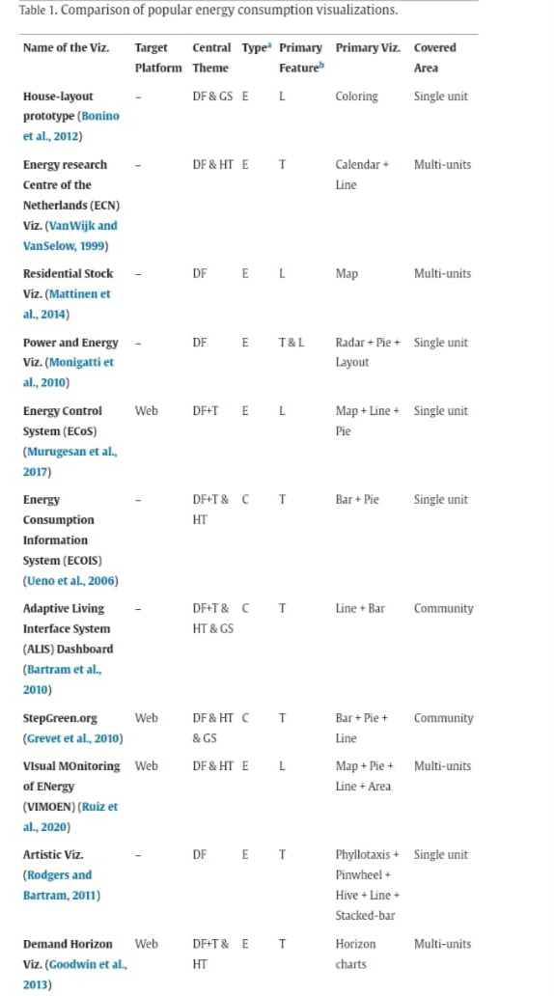**●Comparison of Popular Energy Consumption and visualization:**

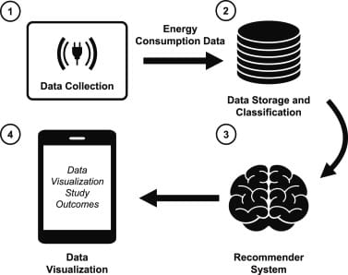**Over view of the frame work:**

The remainder of this paper is organized as follows. Section 2 summarizes recent work in energy data visualizations. Section 3 discusses the study methodology. Section 4 presents the obtained sample size and the employed enhanced and conventional data visualizations.

**PROGRAM:**

import matplotlib.pyplot as plt

import pandas as pd

# Sample energy consumption data (replace with your dataset)

data = {

'Date': ['2023-01-01', '2023-01-02', '2023-01-03', '2023-01-04', '2023-01-05'],

'Energy Consumption (kWh)': [100, 110, 95, 120, 105]

}

# Create a DataFrame from the data

df = pd.DataFrame(data)

# Convert the 'Date' column to datetime

df['Date'] = pd.to_datetime(df['Date'])

# Create the line chart

plt.figure(figsize=(10, 5))

plt.plot(df['Date'], df['Energy Consumption (kWh)'], marker='o', linestyle='-')

# Add labels and title

plt.xlabel('Date')

plt.ylabel('Energy Consumption (kWh)')

plt.title('Energy Consumption Over Time')

# Show the chart

plt.grid(True)

plt.xticks(rotation=45)

plt.tight_layout()

plt.show()

To create a visualization for energy consumption data, let’s assume you have a simple dataset with two columns: one for dates/times and another for energy consumption values. Here’s a step-by-step guide using Python and the Matplotlib library to create a line chart:

●**Conclusion:**

In this paper, a data visualization study on domestic energy data is conducted. Conventional visualizations, namely bar, line, and stacked area charts, are compared against enhanced charts, namely spiral, heatmap, and stacked bar charts, in terms of effectiveness, aesthetic, and understandability. The study is conducted through a mobile application circulated to participants in multiple countries. From the 133 responses, conventional data visualizations can be considered superior in terms of effectiveness, aesthetic, and understandability against the enhanced plots,