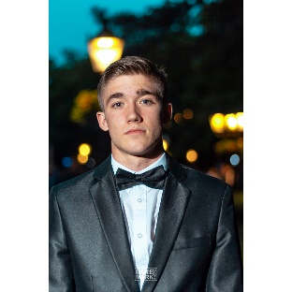**Vetstein Tamás**

realmadrid.vetstein@gmail.com | [Vetstein Tamás (vetsteintamas.github.io)](https://vetsteintamas.github.io/Advanced-Eportfolio/)

+36/204057749

# Professional Summary

An experienced and highly motivated frontend developer with a strong passion for learning and building websites that provide a great user experience.

# Education

**Bachelor’s Degree in Computer Science In Progress ( Last semester )**

University of Szeged

# Experience ­­­

## ICB Tech July 2021 – August 2021

Trainee Frontend Software Engineer

# Engineered scalable, responsive, multi-platform and SEO friendly websites for learning reasons using HTML5, CSS3 + JavaScript ES6+ and Angular best practises

# Connected to backend API’s through CRUD HTTP requests

# ­

# Personal Projects

## E-Portfolio

[Vetstein Tamás (vetsteintamas.github.io)](https://vetsteintamas.github.io/Advanced-Eportfolio/)

# Designed, developed and hosted my personal e-portfolio using semantic HTML5 and CSS3 (+BEM) best practises

# Included every single project I done with working links.

# Included responsive and multi-platform support to enable the portfolio to be viewed on any platform and device

## Library app in React

<https://vetsteintamas.github.io/Library-app-in-React>

(Make sure you click on the Home button because GitHub Pages may show an empty page)

# Created this website in 7 days using HTML5, CSS3 (+BEM), React and JavaScript best practises

# This was the first time I implemented my React knowledge with Router and Hooks.

# Improved this website performance by compressing, caching and lazy loading images and components

# Included SEO, responsive and multi-platform support, enabling this website to be viewed by any user in the world

# 

# Technical Skills

**Proficient:** Html5, CSS3 (BEM), JavaScript ES6+, npm, Git, GitHub

**Familiar:** React (+hooks), Firebase

# Language skills:

* Hungarian ( Native or bilingual proficiency )
* English ( Intermediate, communication level )
* Serbian (Intermediate, communication level )