Task 4: Feature Importance and Interpretation

Feature Importance (Models)
We computed coefficients from Logistic Regression and impurity-based importance from Random Forest on the engineered team–year dataset.
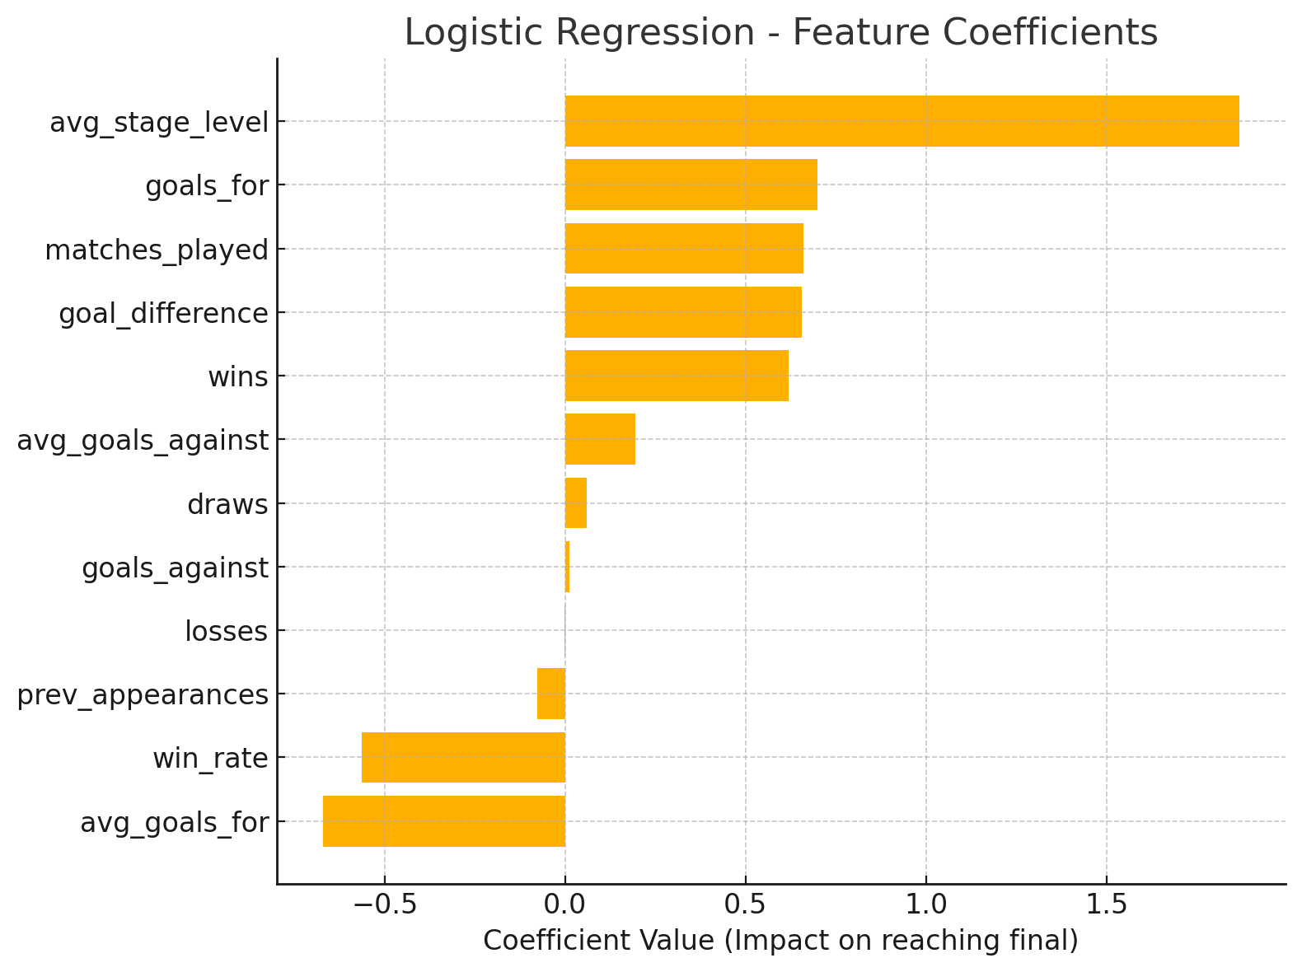
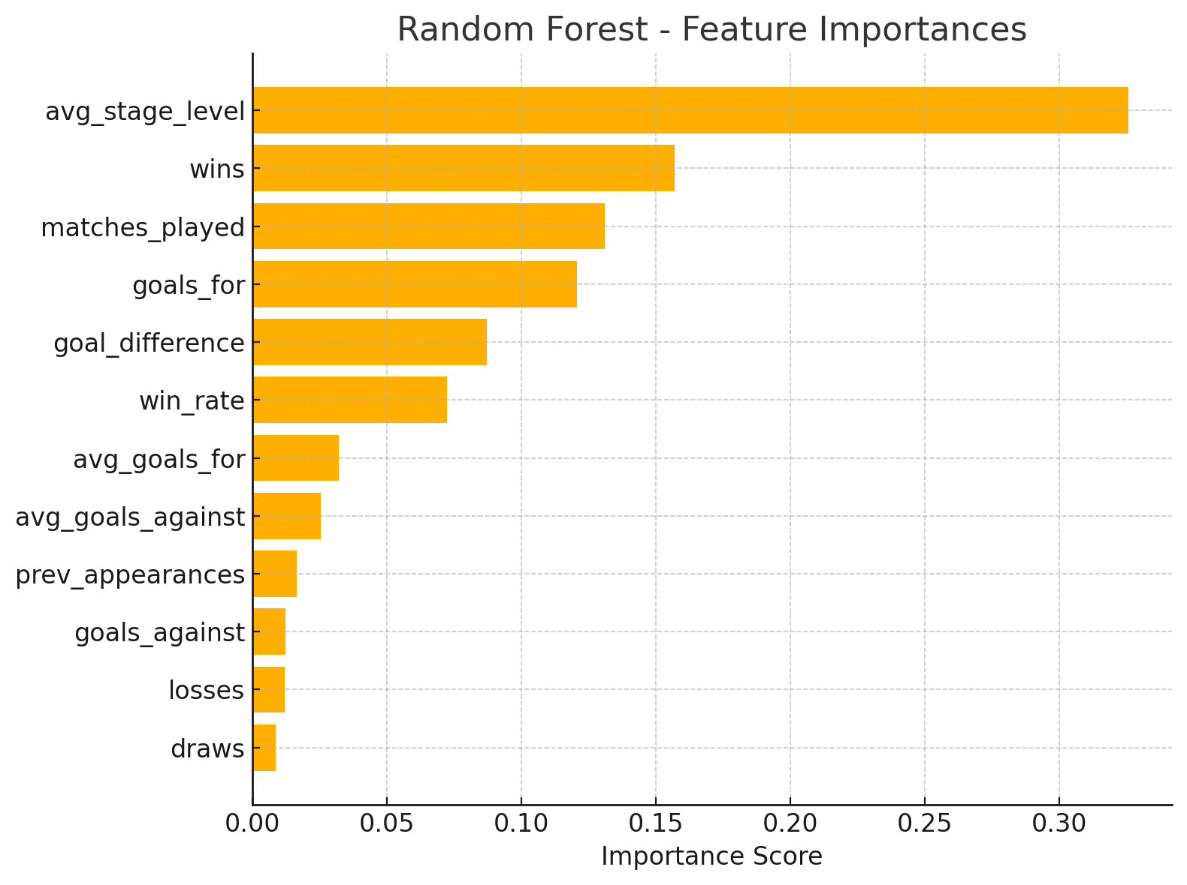

Interpretation (Football Context)
• Goal Difference — Captures combined attacking and defensive dominance; finalists usually maintain a strong positive margin.
• Win Rate — Reflects consistent match control across group and knockout phases.
• Goals For — High scoring sides convert chances and are more likely to advance in knockouts.
• Average Stage Level — Proxy for strength of opposition and round difficulty handled throughout the run.
• Previous Appearances — Institutional experience and tournament know‑how reduce variance under pressure.

Surprising Insights & Bias Checks
• Some features (e.g., matches_played) can act as proxies for progress—careful to avoid label leakage by excluding the exact final stage variable.
• Era effects: older tournaments had different formats and goal environments; results may favor historically dominant teams.
• Class imbalance: finalists are few; we used class_weight='balanced' to mitigate bias.

Conclusion
Random Forest ranks goal_difference and win_rate as top drivers; Logistic Regression supports the same pattern with positive coefficients. These align with domain knowledge: balanced, consistent, high‑scoring teams most often reach the Final.

