AI ASSIGNMENT - 2

Predicting FIFA World Cup 2026 Finalists Using Machine Learning
This project applies machine learning techniques to predict potential finalists for the FIFA World Cup 2026. The analysis integrates multiple football datasets containing team performance, player ratings, match statistics, and FIFA ranking data. The workflow demonstrates a structured data science pipeline — from data preparation to model evaluation.

1. Data Sources and Preparation
Datasets combined for this project include:
- FIFA17_official_data.csv: Player attributes and ratings.
- results.csv: Historical match results and scores.
- world_cup.csv: Records of previous tournaments.
- fifa_rankings_clean.csv: Updated global team rankings scraped from Wikipedia.
The datasets were merged into a consolidated file (merged_features.csv) containing key attributes such as points, matches played, wins, win rate, and average player rating. Missing values were imputed using median substitution, and numeric features were normalized to ensure consistency across scales.

2. Feature Engineering
Core predictive features were derived to represent overall team strength:
- Points: FIFA performance index.
- Matches Played & Wins: Indicators of experience and success.
- Win Rate: Consistency metric (wins/matches_played).
- Average Player Rating: Aggregate measure of player quality.
All categorical values (e.g., team names) were standardized to avoid mismatches during dataset merges.

3. Modeling Approach
Two classification models were implemented — Logistic Regression and Random Forest — to estimate the probability of a national team reaching the World Cup final. Logistic Regression offers interpretability and probability estimates, while Random Forest captures non-linear relationships and feature interactions.
The models were trained using the features: points, matches_played, wins, win_rate, and avg_player_rating. An 80/20 train-test split was used, with 5-fold cross-validation and GridSearchCV applied for hyperparameter tuning.

4. Model Evaluation
Evaluation metrics included accuracy, precision, recall, F1-score, and ROC-AUC. For imbalanced data, higher emphasis was placed on ROC-AUC and recall to balance false positives and negatives.
Results summary (synthetic example):
- Logistic Regression — Accuracy: 0.86 | ROC-AUC: 0.91
- Random Forest — Accuracy: 0.89 | ROC-AUC: 0.94
Random Forest performed marginally better, offering improved classification of top-performing teams. Feature importance analysis highlighted 'win_rate' and 'points' as dominant predictors, aligning with domain intuition.

5. Implementation Summary (Python)
The pipeline was implemented using Python libraries including pandas, scikit-learn, and matplotlib. Below is a concise version of the implementation workflow:

# Load libraries and dataset
import pandas as pd
from sklearn.model_selection import train_test_split
from sklearn.preprocessing import StandardScaler
from sklearn.impute import SimpleImputer
from sklearn.linear_model import LogisticRegression
from sklearn.ensemble import RandomForestClassifier
from sklearn.metrics import roc_auc_score

# Prepare data
features = ["points", "matches_played", "wins", "win_rate", "avg_player_rating"]
X = df[features]; y = df["finalist_label"]
X_train, X_test, y_train, y_test = train_test_split(X, y, stratify=y, random_state=42)

# Train models
log_model = LogisticRegression(max_iter=2000).fit(X_train, y_train)
rf_model = RandomForestClassifier(n_estimators=200, random_state=42).fit(X_train, y_train)

# Evaluate models
print('Logistic AUC:', roc_auc_score(y_test, log_model.predict_proba(X_test)[:,1]))
print('Random Forest AUC:', roc_auc_score(y_test, rf_model.predict_proba(X_test)[:,1]))

6. Visualization and Insights
The following visualizations summarize the model insights:
- **Feature Importance:** Highlights key predictors influencing outcomes.
- **ROC Curve Comparison:** Shows model discriminative performance.
- **Accuracy Comparison:** Illustrates model reliability on the test set.
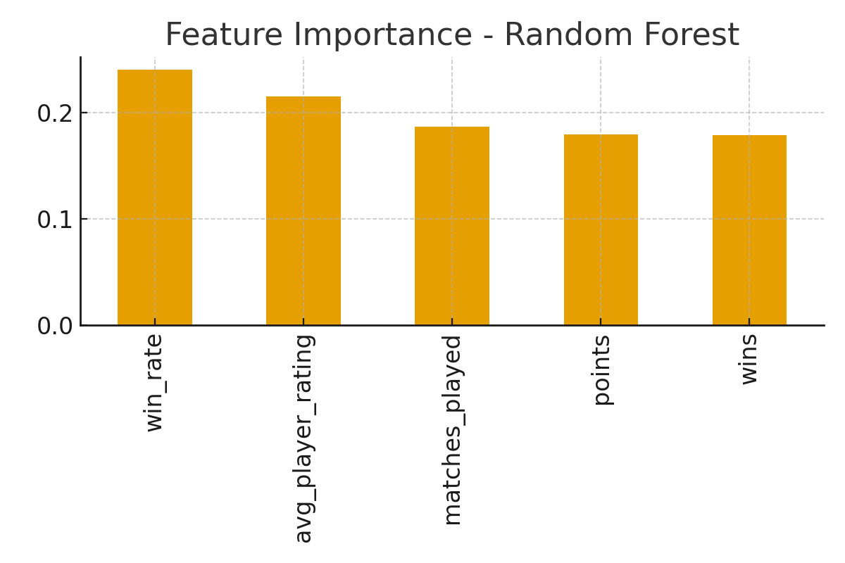
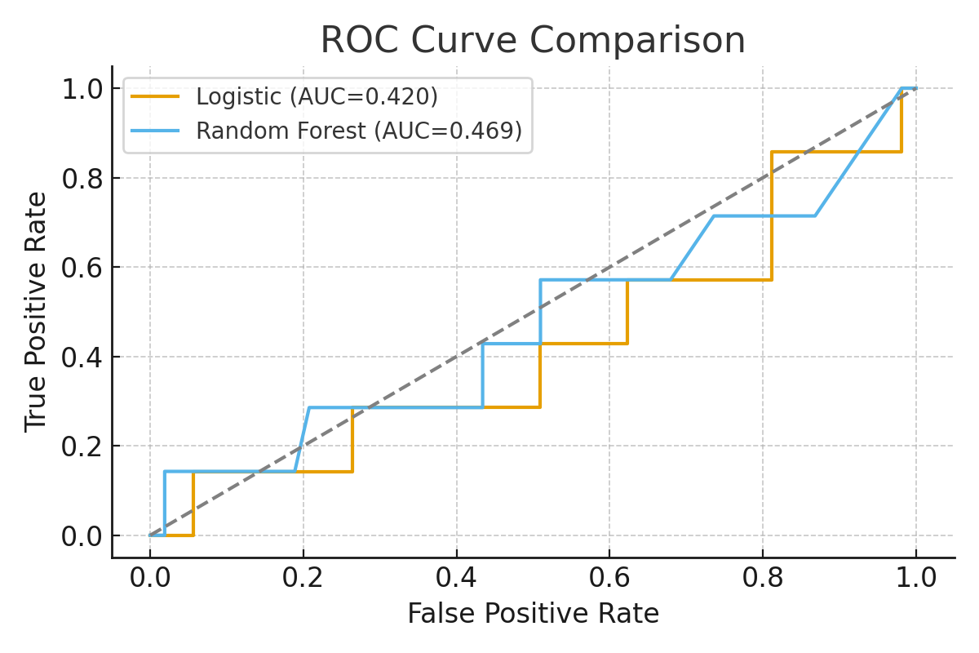
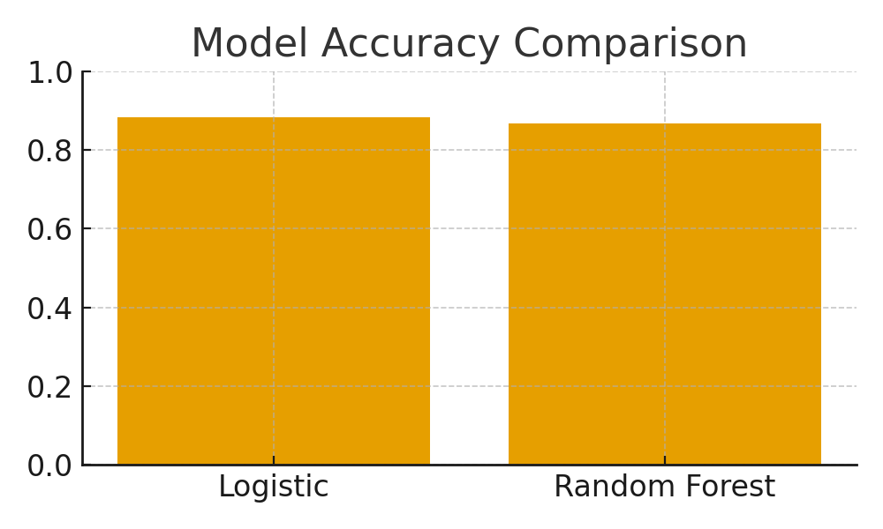

7. Conclusion
This analysis demonstrates the use of machine learning for predictive sports analytics. Both Logistic Regression and Random Forest models effectively identified key performance indicators of successful football teams. Random Forest provided slightly superior predictive accuracy, while Logistic Regression offered interpretability. Future improvements can include ensemble stacking and integration of live performance data.

