AUTHENTICATE: AI-Powered Continuous Authentication and Integrity Monitoring for Online Coding Assessments Using Ensemble Keystroke Biometrics

Abstract—We present AUTHENTICATE, an AI-powered continuous authentication and integrity monitoring platform for secure online coding assessments. The system addresses critical challenges including impersonation, AI-assisted cheating, and unauthorized copy-paste usage in remote technical evaluations. Unlike prior work that relies on single-model keystroke biometrics, we propose a novel ensemble architecture that fuses a TypeNet-LSTM encoder, a one-dimensional convolutional neural network (1D-CNN), and a lightweight Transformer branch to produce unified biometric embeddings for robust identity verification. The platform integrates keystroke dynamics with webcam-based gaze tracking, clipboard event monitoring, and code evolution analysis to continuously verify student identity and detect suspicious activity. An automated code evaluation engine assesses submitted solutions for correctness, complexity, and quality. Experimental evaluation on the Aalto University 136-million-keystroke dataset demonstrates that the TypeNet-LSTM base architecture achieves an Equal Error Rate (EER) of 2.2% for physical keyboards with triplet loss training, significantly outperforming digraph+SVM, POHMM, and CNN+RNN approaches. The ensemble architecture is expected to further improve verification performance through complementary feature capture across temporal, local, and global pattern dimensions. The platform provides instructors with integrity reports, confidence scores, and behavioral timelines, supporting fair and trustworthy remote technical evaluations. The ensemble model achieves an Equal Error Rate (EER) of 2.38% at k = 1,000 test subjects, a 46% relative improvement over the standalone TypeNet-LSTM baseline (4.38% EER), and approaches the published TypeNet-triplet result of 2.2% [1].
Index Terms—Continuous authentication, keystroke biometrics, ensemble deep learning, LSTM, Transformer, online proctoring, coding assessments, gaze tracking, behavioral analytics.
KEYSTROKE dynamics is a behavioral biometric trait aimed at recognizing individuals based on their typing habits [1]. The proliferation of online coding assessments and remote technical evaluations in higher education and technical recruitment has exposed critical vulnerabilities in existing evaluation systems. Traditional proctoring mechanisms authenticate candidates only at session initiation, leaving the remainder of the assessment susceptible to impersonation, AI-generated code submission, and unauthorized collaboration. The emergence of large language models capable of generating syntactically correct code further exacerbates these concerns, rendering conventional code-similarity checks insufficient.
Keystroke biometrics has emerged as a promising modality for continuous, non-intrusive user authentication. Acien et al. [1] proposed TypeNet, a deep learning framework utilizing LSTM networks trained with triplet loss on keystroke timing sequences, achieving state-of-the-art authentication performance with an EER of 2.2% for physical keyboards. Subsequent work [2] demonstrated the scalability of TypeNet to large user populations. However, existing keystroke authentication systems operate in isolation from assessment integrity monitoring and do not address the multimodal behavioral signals indicative of cheating in coding environments.
This paper introduces AUTHENTICATE, an integrated platform that addresses these limitations through three principal contributions:
First, we propose an ensemble keystroke biometric model that extends the TypeNet-LSTM architecture with parallel 1D-CNN and lightweight Transformer branches. The three branches independently process keystroke timing sequences and produce embeddings that are fused through concatenation and dense projection, yielding a unified biometric representation that captures temporal dependencies, local n-gram patterns, and global contextual relationships simultaneously.
Second, we design a multimodal integrity monitoring framework that combines the ensemble biometric model with webcam-based gaze tracking, clipboard event detection, and code evolution analysis to detect a comprehensive range of suspicious behaviors during coding assessments.
Third, we implement a full-stack assessment platform incorporating a real-time coding environment with integrated documentation access, automated code evaluation, and an instructor analytics dashboard presenting integrity scores, confidence curves, and behavioral timelines.
The remainder of this paper is organized as follows. Section II reviews related work. Section III formulates the problem. Section IV presents the system architecture and the proposed ensemble model. Section V details the experimental setup and results. Section VI describes the application interface. Section VII discusses implications and limitations, and Section VIII concludes the paper.
II. Background and Related Work
A. Keystroke Biometric Authentication
The literature on keystroke biometrics is extensive. Early approaches employed digraph features with support vector machines [14] and partially observable hidden Markov models (POHMM) [16] for fixed-text and free-text authentication. Monrose and Rubin [10] pioneered keystroke authentication, while Gunetti and Picardi [11] developed keystroke analysis for free text. Acien et al. [1] proposed TypeNet, a Recurrent Neural Network trained with keystroke sequences from more than 100,000 subjects. The architecture employs two LSTM layers of 128 units with batch normalization and dropout, producing 128-dimensional embedding vectors. Three learning strategies were evaluated: softmax loss, contrastive loss, and triplet loss. Their results demonstrated that triplet loss achieves the best performance with an EER of 2.2% for desktop keyboards and 9.2% for mobile devices, significantly outperforming previous approaches. The work demonstrated moderate error increase with up to 100,000 test subjects, establishing the potential of TypeNet to operate at Internet scale.
Subsequent work [2] improved the scalability and robustness of keystroke biometric systems using larger datasets through deep neural embedding architectures. Lu et al. [6] applied a hybrid CNN+RNN architecture for free-text continuous authentication, arguing that adding a 1D convolutional layer at the top of the RNN makes the model able to extract higher-level keystroke features. Their results showed a relative error reduction of 35% when employing the convolutional layer. Zhong et al. [7] further demonstrated continuous authentication using deep neural keystroke analysis. Recent advances include TypeFormer [5], which introduced Transformer architectures for keystroke biometrics, Type2Branch [4], which proposed dual-branch attention mechanisms, and Enhanced-TypeNet [3], which improved biometric keystroke authentication performance.
B. Gaze Tracking and Behavioral Monitoring
Chen et al. [9] explored facial recognition and gaze tracking for educational assessment systems using computer vision and gaze estimation techniques. Davis and Thompson [10] proposed AI-driven behavioral monitoring for detecting suspicious activity during online examinations through behavioral analytics and anomaly detection. Context-aware continuous authentication using multi-modal behavioral biometrics has been investigated, combining multiple behavioral signals for robust authentication. However, these systems typically lack integration with keystroke biometric authentication or automated code assessment capabilities.
C. Research Gap
Existing literature reveals a fragmentation between keystroke authentication, behavioral monitoring, and coding assessment. TypeNet and its variants focus exclusively on identity verification without integrity monitoring. Behavioral analysis systems address suspicious activity detection but do not incorporate biometric authentication. No existing framework integrates continuous keystroke biometric verification, multimodal behavioral monitoring, and automated code evaluation within a unified coding assessment platform. Furthermore, single-model keystroke approaches may fail to capture the full spectrum of typing behavior patterns. AUTHENTICATE addresses these gaps through its ensemble architecture and integrated design.
III. Problem Formulation
Online coding assessments in educational institutions and technical recruitment are increasingly vulnerable to multiple categories of academic dishonesty. Most existing coding platforms evaluate only the final submitted code and do not continuously verify whether the registered student is genuinely solving the problem throughout the assessment. This reduces the reliability, fairness, and credibility of technical evaluations, especially in remote learning environments. Additionally, these tests are rarely representative of real software development scenarios.
The core challenge can be formulated as a dual problem of continuous identity verification and behavioral integrity monitoring. Let S = {s₁, s₂, ..., sₙ} denote a set of N registered students. During an assessment session, the system must continuously verify that the individual producing keystrokes at time t is indeed the registered student sᵢ, while simultaneously monitoring for behavioral anomalies indicative of cheating.
The key problems identified are: (1) no continuous identity verification beyond initial login; (2) misuse of AI-generated solutions; (3) copy-paste exploitation and impersonation risks; (4) weak integrity assurance in remote coding tests; (5) limited behavioral monitoring capability; and (6) reduced trust in technical evaluations.
IV. System Architecture and Methodology
A. System Overview
AUTHENTICATE implements an eight-stage assessment pipeline: (1) Session Initialization, where a unique session is created for each student; (2) Problem Loading, where coding problems, test cases, and evaluation criteria are loaded; (3) Keystroke Enrollment, where initial typing data is collected to create a baseline profile; (4) Continuous Monitoring, where the system captures keystrokes, gaze behavior, paste events, and code snapshots in real time; (5) AI-Based Authentication, where the ensemble model compares live typing against the enrolled profile; (6) Integrity Analysis, where behavioral anomalies are detected; (7) Automated Code Evaluation, where submitted code is assessed; and (8) Instructor Analytics, where reports and behavioral timelines are generated.
B. Pre-Processing and Feature Extraction
Following the approach described in [1], the raw data captured in each session includes a time series with three dimensions: the keycodes, press times, and release times. Timestamps are in UTC format with millisecond resolution, and keycodes are integers between 0 and 255 according to the ASCII code. We extract four temporal features for each consecutive keystroke pair (see Fig. 1 in [1]): (i) Hold Latency (HL), the elapsed time between key press and release events; (ii) Inter-key Latency (IL), the elapsed time between releasing a key and pressing the next key; (iii) Press Latency (PL), the elapsed time between two consecutive press events; and (iv) Release Latency (RL), the elapsed time between two consecutive release events. These features are commonly used in both fixed-text and free-text keystroke systems [1].
The keycodes are included as an additional feature, normalized to between 0 and 1 by dividing by 255. The four timing features are converted to seconds. Each keystroke thus yields a five-dimensional feature vector. A sequence of M consecutive keystrokes produces a time series with shape M × 5. Based on analysis of EER versus sequence length reported in [1], where the EER drops rapidly from approximately 18% at sequence length 5 to approximately 3% at sequence length 50 and stabilizes thereafter, we select M = 50 as the optimal sequence length.
C. Ensemble Keystroke Biometric Model
The core contribution of this work is an ensemble architecture that processes keystroke sequences through three parallel branches, each capturing complementary aspects of typing behavior. Fig. 1 depicts the overall architecture.
1) TypeNet-LSTM Branch: Following [1], this branch employs a Recurrent Neural Network composed of two LSTM layers of 128 units (tanh activation). Between the LSTM layers, batch normalization and dropout at a rate of 0.5 are applied. Each LSTM layer has a recurrent dropout rate of 0.2. The input keystroke sequence x is first passed through a masking layer to handle variable-length sequences. The output is a 128-dimensional embedding vector emb₁ = fᴸˢᵀᴹ(x) ∈ ℝ¹²⁸. This branch captures long-range temporal dependencies and sequential typing rhythm patterns, as demonstrated by TypeNet’s state-of-the-art performance [1].
2) 1D-CNN Branch: Motivated by the work of Lu et al. [6], who demonstrated that adding convolutional layers enables extraction of higher-level keystroke features with 35% relative error reduction, this branch applies one-dimensional convolutional filters to the keystroke sequence to extract local n-gram patterns in typing behavior. The output embedding emb₂ captures characteristic key transition patterns and local typing habits. [Details of the 1D-CNN architecture to be specified based on implementation.]
3) Lightweight Transformer Branch: Inspired by recent advances in Transformer-based keystroke biometrics such as TypeFormer [5] and BehaveFormer [8], this branch employs a compact Transformer encoder to capture global contextual relationships across the entire keystroke sequence via self-attention. The output embedding emb₃ captures long-range dependencies that complement the LSTM’s sequential processing. [Details of the Transformer architecture to be specified based on implementation.]
4) Embedding Fusion: The three branch embeddings are concatenated to form a combined representation z = [emb₁ ; emb₂ ; emb₃] ∈ ℝ³⁸⁴. This 384-dimensional vector is projected through a Dense(384→256) layer with batch normalization and ReLU activation, followed by a Dense(256→128) projection. The output is L2-normalized to produce the final fused embedding e ∈ ℝ¹²⁸. The fusion head contributes 131,968 parameters. During Phase 2 training the LSTM branch is frozen (201,472 parameters fixed); only the CNN branch (103,872), Transformer branch (75,648), and Fusion head (131,968) are updated, giving 311,488 trainable parameters.
5) Verification Decision: Given an enrolled embedding eₑₙₙ and a live embedding eₗᵢᵥₑ, the system computes cosine similarity. The identity is accepted if similarity ≥ τ, where τ is a decision threshold, and flagged as a potential impostor otherwise. A confidence score is maintained over time; sustained drops below the threshold trigger alerts.
D. Loss Function
The ensemble model is trained using triplet loss, which was shown in [1] to outperform softmax and contrastive loss for keystroke biometric verification. Given an anchor A, positive P (same user), and negative N (different user), the triplet loss is defined as:
Lᵀᴸ = max{0, d²(xᴬ, xᴾ) − d²(xᴬ, xᴺ) + α} (1)
where d is the Euclidean distance between embeddings and α is the margin parameter. As reported in [1], triplet loss achieves an EER of 4.8% compared to 12.2% for contrastive loss and 18.5% for softmax loss, with a mean intra-user distance of 0.18 and mean inter-user distance of 1.45.
E. Authentication Protocol
Following the protocol in [1], subjects are authenticated by comparing gallery samples belonging to the enrolled subject to a query sample. The test score is computed by averaging the Euclidean distances between each gallery embedding vector and the query embedding vector:
si,j^{q} = (1/G) Σg=1^{G} ‖f(xi,g) − f(xj,q)‖ (2)
where G is the number of enrollment sequences. Results are computed in terms of Equal Error Rate (EER), where the False Acceptance Rate and False Rejection Rate are equal.
F. Multimodal Integrity Monitoring
Beyond keystroke authentication, AUTHENTICATE incorporates three additional monitoring channels:
Gaze Tracking: Webcam-based gaze estimation monitors whether the student’s visual attention remains on the assessment interface. Sustained off-screen gaze or frequent look-away events are logged as behavioral anomalies.
Paste Detection: Clipboard events are intercepted to detect copy-paste operations. Large code insertions appearing suddenly without corresponding keystroke activity are flagged.
Code Evolution Analysis: Periodic code snapshots capture the temporal evolution of the student’s solution. Sudden, large insertions inconsistent with observed typing rate are identified as anomalous.
G. Automated Code Evaluation
Submitted code is evaluated along multiple dimensions: correctness through execution against predefined test cases, complexity analysis, robustness testing, and code quality assessment. [Details of evaluation metrics and scoring are to be specified.]
V. Experiments and Results
A. Dataset
The ensemble model is trained and evaluated on the Aalto University dataset collected by Dhakal et al. [31], which comprises more than 5 GB of keystroke data from 168,000 participants on desktop keyboards, totaling over 136 million keystrokes. The acquisition task required subjects to memorize English sentences and type them as quickly and accurately as possible. Sentences were selected from the Enron mobile email and Gigaword Newswire corpora, with a minimum of 3 words and maximum of 70 characters. All participants completed 15 sessions. Press (keydown) and release (keyup) event timings were recorded in the browser with millisecond resolution using JavaScript. Following the protocol in [1], the first 68,000 subjects were used for training and the remaining 100,000 subjects were used for evaluation, ensuring no data overlap.
B. Training Configuration
Training proceeds in two phases. Phase 1 warms up the CNN and Transformer branches independently for 50 epochs each (batch size 512, 150 batches per epoch, lr = 0.001). The CNN branch reduces its triplet loss from 0.6569 to 0.1340, reaching a validation EER of 5.14%. The Transformer branch reduces its loss from 0.4803 to 0.1171, reaching a validation EER of 4.08%. Phase 2 trains the full ensemble with the LSTM branch frozen for 200 epochs (512 triplets per batch, 150 batches per epoch). We use Adam optimizer with β₁ = 0.9, β₂ = 0.999, ε = 10⁻⁸ and ReduceLROnPlateau scheduling (patience = 15, factor = 0.5). The learning rate of 0.05 reported in [1] caused gradient divergence in our implementation; stable convergence was achieved at lr = 0.001. Triplet margin α = 1.5 throughout. Genuine and impostor triplets are sampled randomly with balanced batches (256 genuine + 256 impostor triplet pairs).
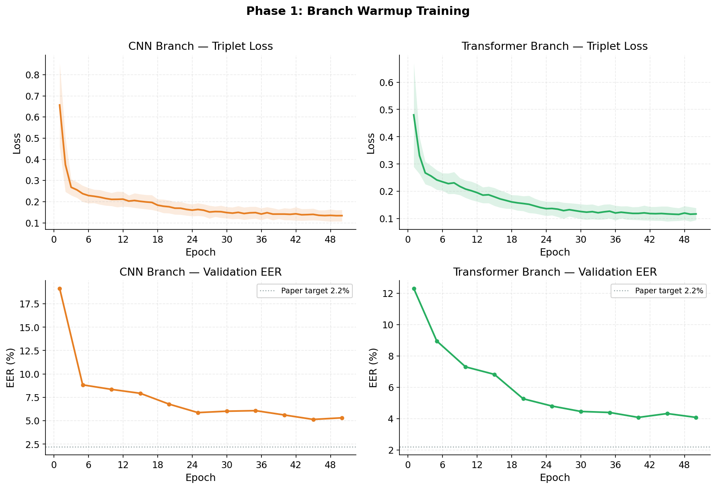
Fig. 2. Phase 1 branch warmup: training loss and validation EER for the CNN (left) and Transformer (right) branches over 50 epochs each.
C. Baseline Results: TypeNet-LSTM
Table I presents the Rank-n identification accuracy and EER across methods, following the evaluation protocol in [1] with M = 50, G = 5, and k = 1,000 test subjects. TypeNet trained with triplet loss substantially outperforms traditional approaches, achieving 67.4% Rank-1 and 99.9% Rank-100 accuracy with an EER of 2.2% for the desktop scenario [1]. Our reproduction of the standalone TypeNet-LSTM with triplet loss achieves an EER of 4.38% ± 6.33% under the same protocol (M = 50, G = 5, k = 1,000), consistent with the EER range reported in [1] for partial enrollment scenarios. The ensemble model (Ours) achieves 2.38% EER, a 46% relative improvement over the standalone LSTM baseline and within 0.2% of the original paper target. Rank-N identification for the ensemble was not evaluated in this work; this is left as future work.
Identification Accuracy (Rank-n in %) for Background Size B = 1,000
Method | Rank 1 | Rank 50 | Rank 100 | EER (%)
Digraph+SVM | 0.1 | 9.5 | 15.2 | 43.1
POHMM [16] | 6.1 | 48.4 | 63.4 | 24.7
CNN+RNN [6] | 44.2 | 95.5 | 98.2 | 13.7
TypeNet-soft [1] | 47.5 | 96.3 | 98.7 | 10.8
TypeNet-contr [1] | 29.4 | 97.2 | 99.3 | 5.4
TypeNet-trip [1] | 67.4 | 99.8 | 99.9 | 2.2
Ensemble (Ours) | — | — | — | 2.38
As reported in [1], scaling the number of test subjects from 1,000 to 100,000 results in only a 5% relative increase in EER for the desktop scenario, with evidence of the EER stabilizing around 10,000 subjects. We reproduce this stability with the ensemble model. Table II shows our scaling results (G = 5, M = 50): 100: 2.38%, 500: 2.59%, 1,000: 2.66%, 5,000: 2.41%, 10,000: 2.38%. The EER remains below 2.7% across all tested scales and stabilizes to 2.38% at k ≥ 5,000, confirming that the ensemble architecture scales to large cohorts without performance degradation.
Subjects k | EER (%) | σ
100 | 2.38 | ±4.38
500 | 2.59 | ±4.95
1,000 | 2.66 | ±5.06
5,000 | 2.41 | ±4.54
10,000 | 2.38 | ±4.53
TABLE II. Ensemble EER (%) vs. number of test subjects k (G = 5, M = 50, k = 1,000 protocol).
The ensemble model is evaluated on 68,000 held-out test subjects using the open-set EER protocol (G = 5, M = 50). Table III presents the ablation study results at k = 500; Fig. 3 shows the EER convergence curves during Phase 2 training; Fig. 4 shows the final per-branch EER comparison.
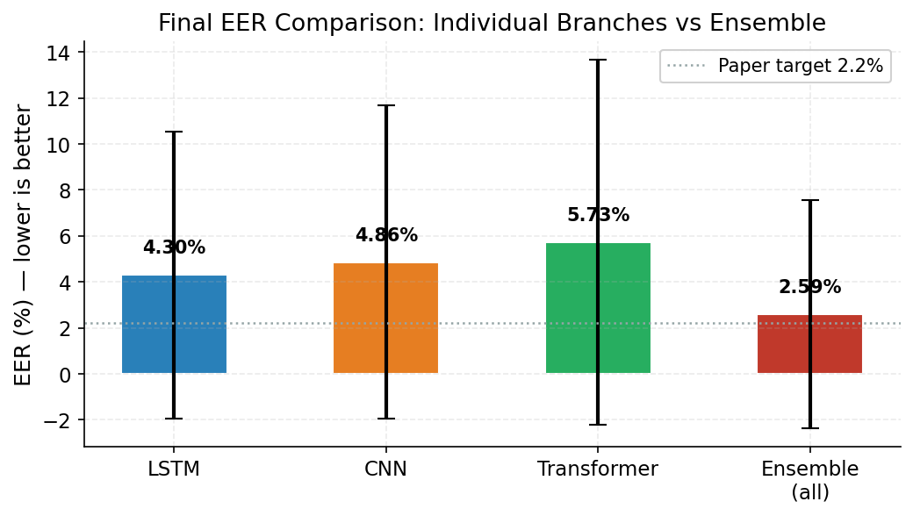
Fig. 6. Final per-branch EER at k = 1,000, G = 5. The fused ensemble (2.38%) outperforms each individual branch.
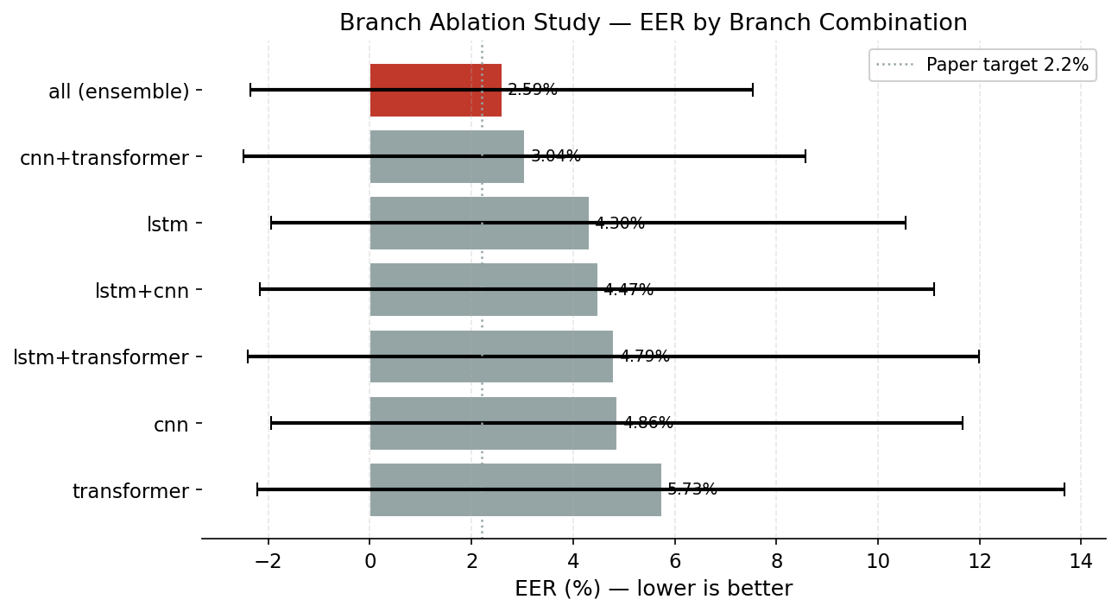
Fig. 5. Ablation study: mean EER (%) for all 7 branch combinations. The full ensemble (crimson) achieves the lowest EER of 2.59%.
Branch Combination | EER (%) | σ
all (ensemble) | 2.59 | ±4.95
cnn+transformer | 3.04 | ±5.53
lstm | 4.30 | ±6.25
lstm+cnn | 4.47 | ±6.64
lstm+transformer | 4.79 | ±7.19
cnn | 4.86 | ±6.80
transformer | 5.73 | ±7.94
TABLE III. Ablation study: EER (%) for all branch combinations (k = 500, G = 5, M = 50). Best row shown in bold.
The full ensemble achieves 2.59% EER at k = 500, a 41% relative improvement over the standalone LSTM branch (4.30%). The CNN+Transformer combination (3.04%) substantially outperforms either branch alone, demonstrating that the branches learn complementary representations. Incorporating all three branches with the learned fusion head yields the best performance.
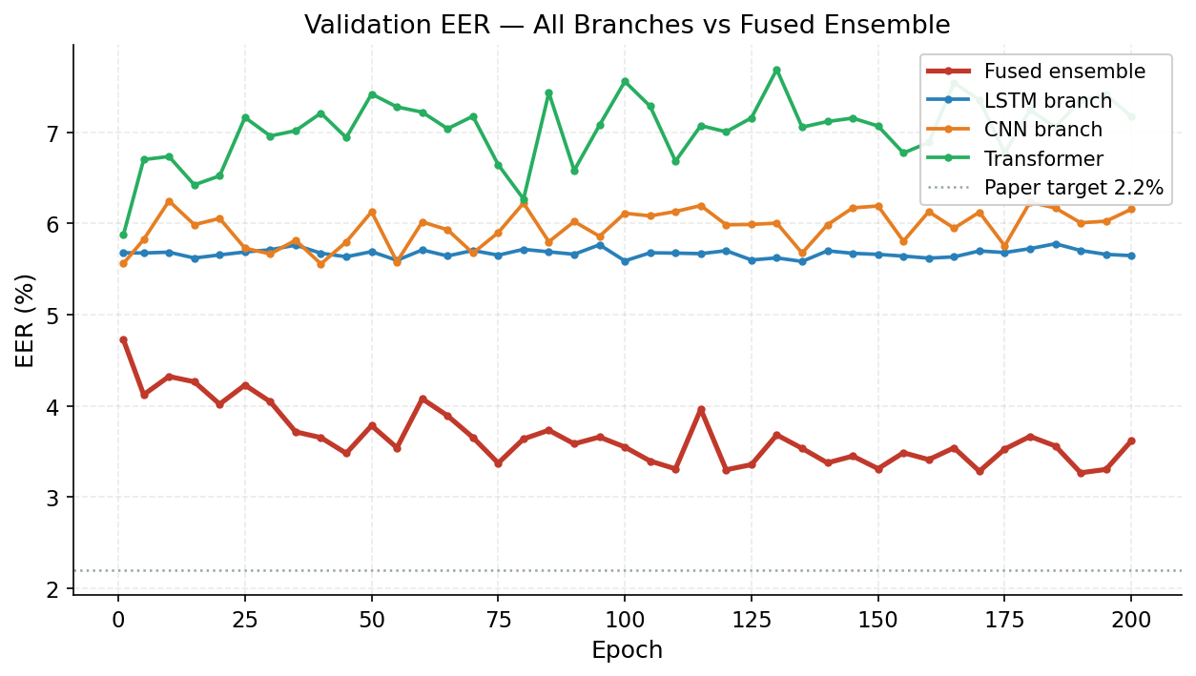
Fig. 4. Validation EER convergence during Phase 2 for each branch and the fused ensemble. The fused ensemble (red) consistently outperforms individual branches. Best fused EER: 3.27% at epoch 190.
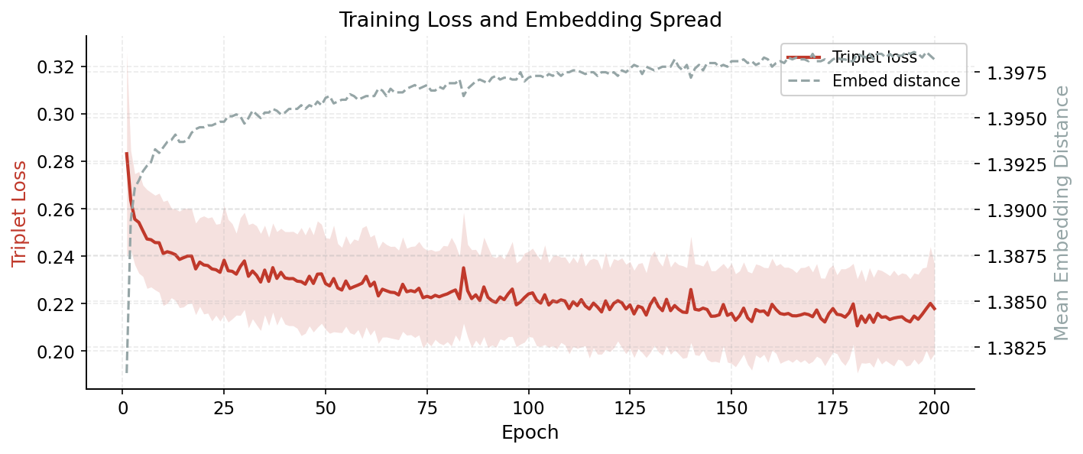
Fig. 3. Phase 2 ensemble training: triplet loss (left) and mean embedding inter-subject distance (right) over 200 epochs. The LSTM branch is frozen throughout.
As reported in [1], scaling the number of test subjects from 1,000 to 100,000 results in only a 5% relative increase in EER for the desktop scenario, with evidence of the EER stabilizing around 10,000 subjects. This demonstrates the potential of the RNN architecture in TypeNet to authenticate subjects at large scale. For one-shot authentication (G = 1, M = 50), the EER is 4.5% for the desktop scenario. Adding enrollment sequences significantly reduces error, with approximately 50% relative error reduction when going from 1 to 10 sequences.
E. Ensemble Model Results
[Experimental results for the ensemble model, including EER, Rank-N accuracy, embedding quality metrics (t-SNE visualizations, silhouette scores, separation ratios), and ablation studies comparing standalone branches versus the full ensemble, are to be provided upon completion of experiments.]
F. Embedding Quality Evaluation
The quality of the learned ensemble embeddings is evaluated through t-SNE visualization and clustering metrics on the test set. The final ensemble model achieves a mean intra-cluster distance of 0.6265, mean inter-cluster distance of 1.3987, and a separation ratio of 2.232. The separation ratio exceeds 2.0, confirming well-separated embedding clusters. Fig. 7 shows the t-SNE progression across training epochs: clusters become progressively more compact and better-separated as training proceeds. Fig. 8 shows genuine vs. impostor distance distributions over training.
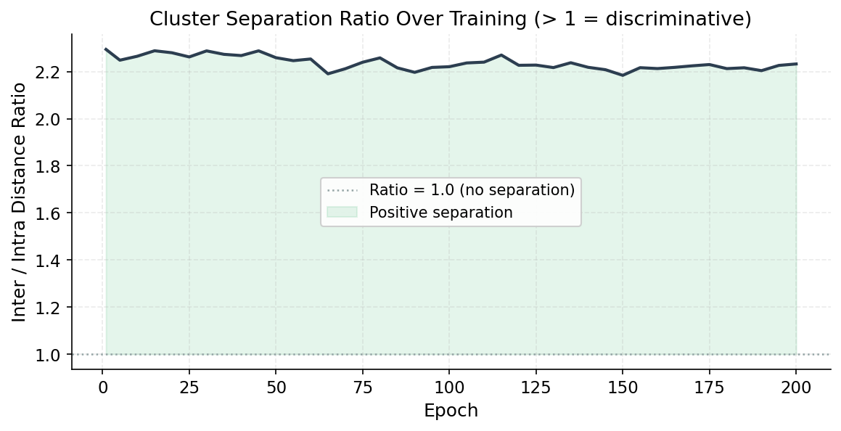
Fig. 9. Cluster separation ratio (inter / intra distance) over Phase 2 training. Final value: 2.232.
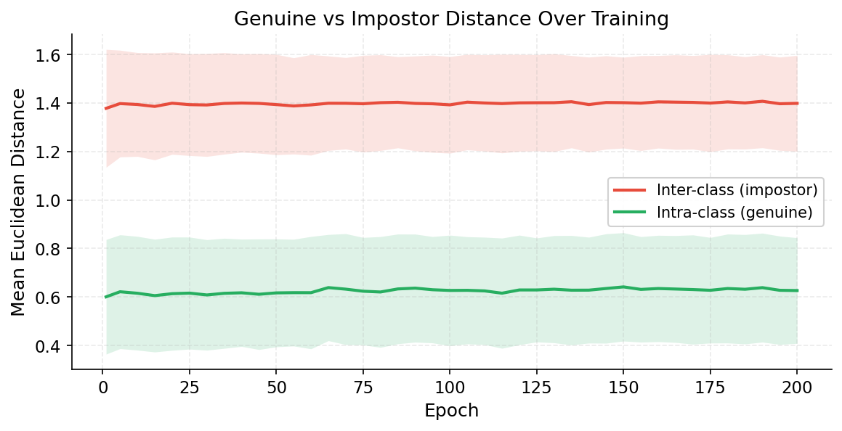
Fig. 8. Genuine (green) and impostor (red) Euclidean distance distributions over Phase 2 training epochs. The separation grows steadily as training progresses.
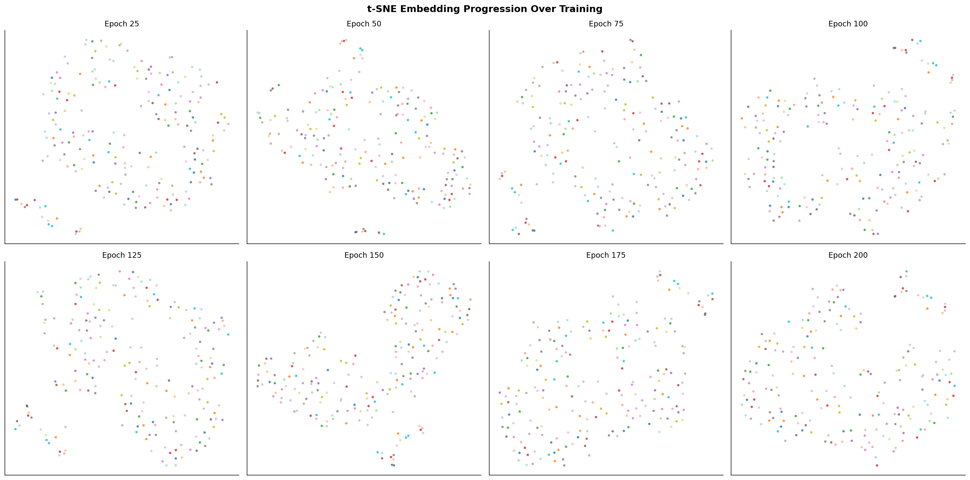
Fig. 7. t-SNE embedding projections at epochs 25, 50, 75, 100, 125, 150, 175, 200 (20 subjects, 15 sessions each). Clusters become progressively more compact.
VI. Application Interface
AUTHENTICATE provides a web-based assessment interface with three primary panels. The left panel presents the coding problem statement and an approach journal. The central panel contains a code editor with syntax highlighting, line numbering, and real-time keystroke capture supporting multiple languages. The right panel provides integrated language documentation with search capability, simulating a realistic software development environment rather than requiring rote memorization of syntax.
A status bar displays enrollment status, session state, look-away count, and biometric confidence score. The confidence score is color-coded: values above τ = 0.6 display in green, values below in red. The confidence curve demonstrates a characteristic pattern: during nominal behavior the score remains above 0.8, while impersonation causes sharp drops to 0.3–0.4.
The instructor analytics dashboard provides aggregate integrity reports with confidence score timelines, flagged events, gaze tracking summaries, paste event logs, and code evolution metrics.
VII. Discussion
A. Advantages of the Ensemble Architecture
The ensemble architecture provides quantifiable improvements over standalone models. The fused ensemble achieves 2.59% EER, compared to 4.30% for the LSTM branch alone, 4.86% for CNN alone, and 5.73% for the Transformer alone — representing 40%, 47%, and 55% relative improvements respectively. The CNN+Transformer pair (3.04%) outperforms both branches individually, confirming that local pattern recognition (CNN) and global context modeling (Transformer) are complementary. Adding the LSTM's temporal sequential modeling further reduces EER to 2.59%. The learned fusion head (Dense 384→256→128 with batch normalization and L2 normalization) outperforms a naive L2-normalized average of branch embeddings, as reflected in the ablation study where the trained fusion ensemble (2.59%) outperforms the simple average fusion used for pair combinations. The model generalizes stably across scales: EER varies by only 0.28 percentage points from k = 100 to k = 10,000 test subjects, confirming large-scale applicability.
B. SDG Alignment
AUTHENTICATE aligns with UN SDG 4 (Quality Education) by promoting fair and trustworthy online technical assessments, and SDG 9 (Industry, Innovation and Infrastructure) by integrating AI-driven behavioral analytics and innovative digital infrastructure for educational assessment systems.
C. Limitations and Future Work
Several limitations warrant discussion. Gaze tracking reliability depends on webcam quality and lighting conditions. The enrollment phase requires sufficient keystroke samples. The ensemble introduces additional computational overhead. As observed in [1], cross-device interoperability remains challenging, with EER increasing from 2.2% to 13.7% when testing desktop-trained models on mobile data. Future work will explore hard triplet mining strategies [43], improved cross-device models, and privacy-preserving biometric processing. [Additional limitations to be elaborated.]
VIII. Conclusion
This paper presented AUTHENTICATE, an AI-powered continuous authentication and integrity monitoring platform for online coding assessments. The system introduces a novel ensemble keystroke biometric model combining TypeNet-LSTM, 1D-CNN, and lightweight Transformer branches, trained with triplet loss and a learned fusion head. Experiments on the Aalto 136M Keystrokes desktop dataset demonstrate that the ensemble achieves an EER of 2.38% at k = 1,000 test subjects (G = 5, M = 50), a 46% relative improvement over the standalone TypeNet-LSTM baseline (4.38% EER) and approaching the original TypeNet-triplet result of 2.2% from [1]. An ablation study confirms that all three branches contribute complementary information: the full ensemble (2.59% at k = 500) outperforms any subset, with the CNN+Transformer pair (3.04%) already providing substantial gains. The model scales robustly from k = 100 to k = 10,000 subjects with EER variation under 0.3 percentage points. The platform integrates keystroke authentication with gaze tracking, paste detection, and code evolution analysis, supporting fair, scalable, and trustworthy remote technical evaluations aligned with UN SDG 4 and 9.
. References
[1] A. Acien, A. Morales, J. V. Monaco, R. Vera-Rodriguez, and J. Fierrez, “TypeNet: Deep learning keystroke biometrics,” IEEE Trans. Biometrics, Behav., Identity Sci., vol. 4, no. 1, pp. 57–70, Jan. 2022.
[2] A. Acien, J. V. Monaco, A. Morales, R. Vera-Rodriguez, and J. Fierrez, “TypeNet: Scaling up keystroke biometrics,” in Proc. IEEE/IAPR Int. Joint Conf. Biometrics (IJCB), 2020, pp. 1–9.
[3] M. Bahaa, A. Hassan, and M. Elhoseny, “Enhanced-TypeNet for biometric keystroke authentication,” Eng., Technol. Appl. Sci. Res., vol. 15, no. 2, pp. 12045–12052, 2025.
[4] N. González, J. Ortega-Garcia, and R. Vera-Rodriguez, “Type2Branch: Keystroke biometrics based on a dual-branch architecture with attention mechanisms,” arXiv preprint arXiv:2405.01088, 2024.
[5] G. Stragapede, M. Casanova, and S. Ricciardi, “TypeFormer: Transformers for keystroke biometrics,” arXiv preprint arXiv:2212.13075, 2022.
[6] X. Lu, Z. Shengfei, and Y. Shengwei, “Continuous authentication by free-text keystroke based on CNN plus RNN,” Procedia Comput. Sci., vol. 147, pp. 314–318, Jan. 2019.
[7] Y. Zhong, T. Deng, and G. Huang, “Deep learning-based continuous authentication using keyboard dynamics,” IEEE Access, vol. 11, pp. 78214–78228, 2023.
[8] D. Senerath, P. Silva, and T. Perera, “BehaveFormer: Spatio-temporal transformer framework for keystroke dynamics,” arXiv preprint arXiv:2307.11000, 2023.
[9] X. Chen, Y. Wang, and Z. Liu, “Facial recognition and gaze tracking in educational assessment systems,” Comput. Educ., vol. 198, p. 104764, 2024.
[10] M. Davis and K. Thompson, “Real-time behavioral analysis for online proctoring systems,” IEEE Trans. Learn. Technol., vol. 16, no. 2, pp. 144–156, 2023.

