Robotics

**\*It is recommended to read the game manual instead of below due to major changes and specifications**

**\*\*Actually ignore below the game manual is superior**

# Game

## Procedure

* Played on a 12’x12’ square field
  + 72 rings in total
    - 12 rings as preloads (6 per alliance)
      * Preloads are introduced before the game
    - 18 rings as match loads (9 per alliance)
      * Match loads are introduced during the driver-controlled period
    - 42 rings on the field
  + 7 mobile goals in total
    - 4 alliance mobile goals (2 per alliance)
    - 3 neutral mobile goals
  + 2 platforms (1 per alliance)

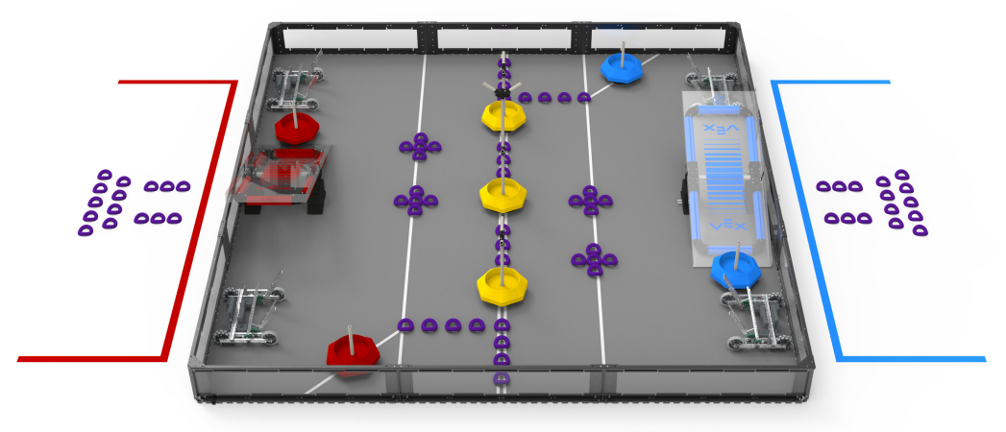

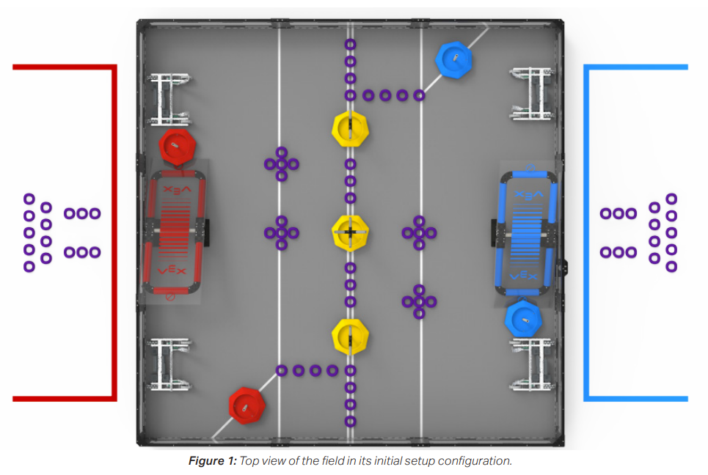

* 2 Alliances: red & blue
  + 2 teams per alliance
* Autonomous period: 15 seconds
* Driver controlled period: 1 minute & 45 seconds

## 

## Obtaining Points

* Earn an autonomous win point by…
  + Clearing the AWP line
  + Scoring 1 ring on each alliance mobile goal
* Earn an autonomous bonus by having the most points at the end of the autonomous period = 6 points or 3 points per team if tie
* Scoring a ring in a mobile goal high branch = 10 Points
* Scoring a ring in any other mobile goal branch = 3 Points
* Scoring a ring in a goal base = 1 Point
* Bringing an mobile goal into the alliance area = 20 Points
  + The alliance also receives the points scored on the goal
  + Mobile goals are in alliance areas if it is partially in it (“breaking the plane”)

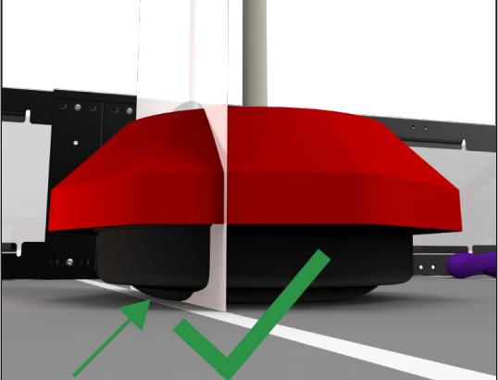

* Bringing a mobile goal onto a balanced platform = 40 Points
* Bringing a robot on the balanced platform = 30 Points
* Winning the autonomous period = 1 WP
* Winning a qualification match - 2 WP
* Tying a qualification match - 1 WP
* Losing a qualification match - 0 WP (duhhh)

## 

## Definitions

### Roles

* Alliance - Group of 2 teams
* Alliance Captain - Representative from the highest team
* Adult - Anyone who isn’t a student
* Builder - Builds the robot
* Designer - Designs the robot
* Drive Team Members - Drives the robot
* Event Partner - Coordinator for events
* Head Referee - A referee who is the head
* Programmer - Programs the robot
* Robot - A machine that is controlled by code & a robot
* Student - Someone who is working for a high school diploma & 19 or younger
* Team - Multiple students working together
* Team Representative - Student who represents the team

### Objects

* Alliance Station - Area where drive team members must stay

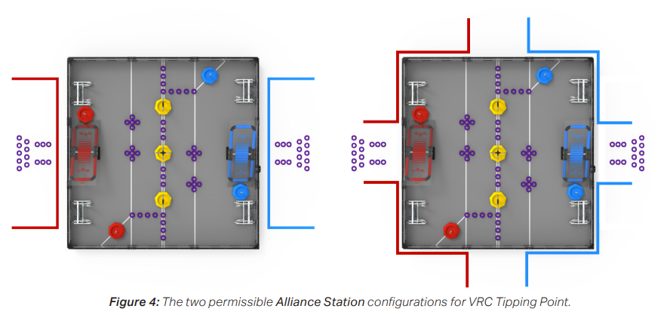

* AWP line - A line with an alliance mobile goal on it
* Alliance Home Zone - Area where robots start & neutral mobile goals can be scored

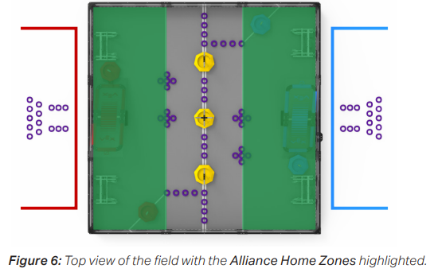

* Neutral Zone - A neutral area where 3 neutral mobile goals start
* Field Element - Foam field tiles, field perimeter, white tape, platform, and supporting structures/accessories (driver station posts, field monitors, etc)
* Platform - Object that balances
* Ring - A donut

### Penalties

* Disablement - Penalty for breaking a rule. Teams will not be able to operate their robot and must place their controllers on the ground.
* Disqualification - Penalty for breaking a rule. The team will receive 0 points and the alliance will lose the match
* Match Affecting - A rule violation status that changes the winning & losing alliance

### Statuses

* Balanced - A platform status when it is balanced, not touching the floor, and objects on it are not touching objects outside the field
* Elevated - A robot/mobile goal state when it is touching a platform, the platform is balanced, and not touching field elements

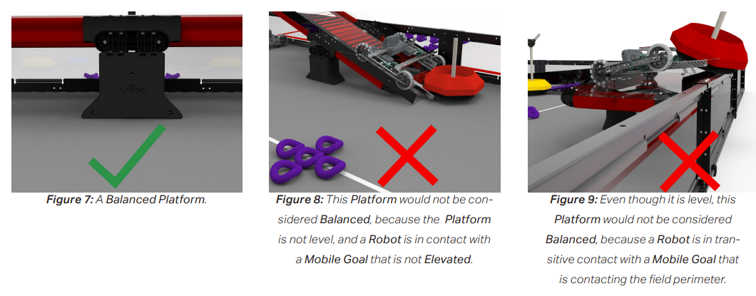

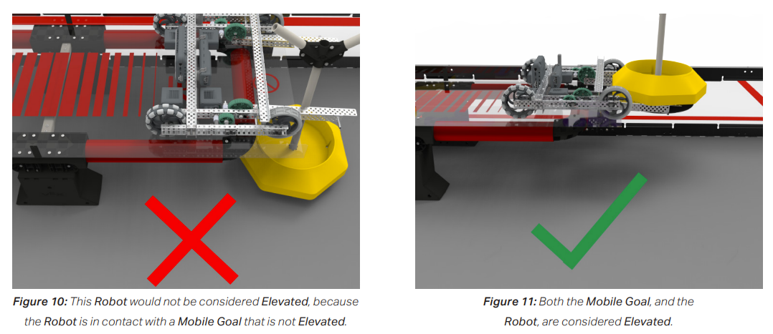

* Cleared - An alliance mobile goal when after the autonomous period, it is not touching the AWP line/neutral zone
* Entanglement - A robot status when it is entangled if it has grabbed, hooked, or attached to an opposing robot or field element
* Hoarding - A robot status when it has a mobile goal in the 2 corners of their own alliance home zone

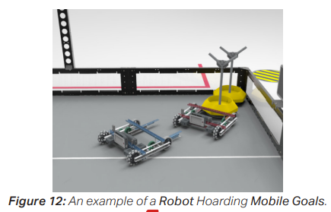

* Practice Match - A match for teams to practice using a playing field
* Qualification Match - A match used to determine the rankings for the alliance selection
* Strength of Schedule Points - Don’t know
* Timeout - 3 minute period between elimination matches
* Possession - When a robot is carrying/mobile goal or blocking an opponent’s access to mobile goals

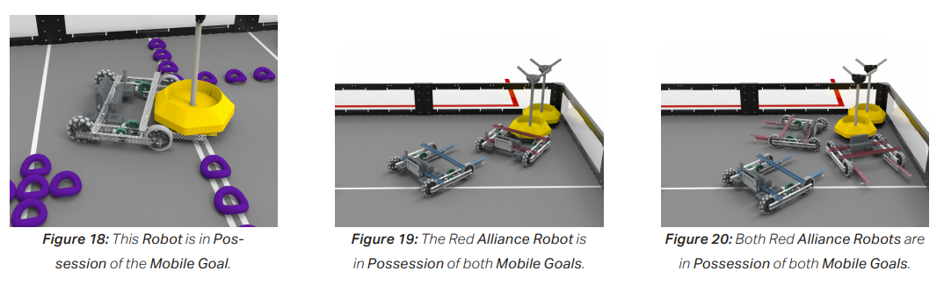

* Scored - A ring, mobile goal, robot, or platform state
* Trapping - A robot status when a robot traps another robot into a small, confined area & cannot escape

### Misc

* Alliance Selection - Process of choosing alliances
* Elimination Bracket - An elimination bracket is a bracket that is used for eliminating or having eliminations which uses brackets for eliminating
* Match - 15 second autonomous period and 1:45 minute driver control period
  + Autonomous Period - 15 second period where robots run on code & sensors
  + Driver Controlled Period - 1:45 minute period where drive team members operate the robot

## 

## Rules

### Safety Rules

S1. Be safe

S2. Robots stay in the field

S3. Drive team members must wear safety glasses/glasses

S4. Platforms are for robots, not humans

### Game Rules

G1. Respect people

G2. Adults can help but not work on robots

G3. Use common sense

G4. Robots must be 18”x18”x18”

G5. Robots cannot detect parts

G6. Robots must represent the team

G7. Only 3 drivers can be in the alliance station & cannot communicate with other members

G8. Controllers must stay connected to the field towers

G9. Don’t touch the field unless turning the robot on or off, plugging in a battery/radio, touching the screen

G10. Autonomous period means no drivers

G11. Rules apply in the autonomous period

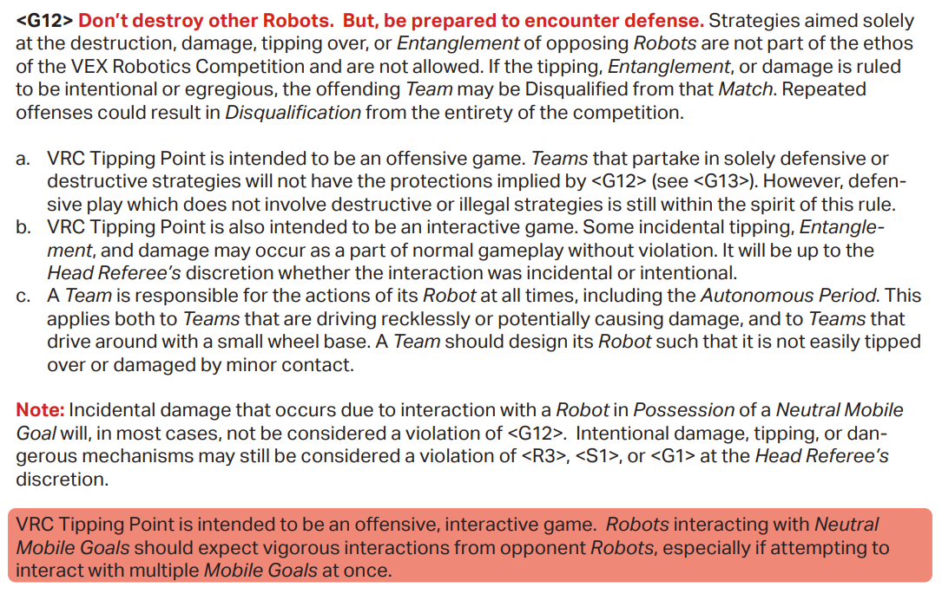

G12. Offensive robots get the “benefit of the doubt”

* A robot in possession of its own alliance mobile goal is usually offensive
* A robot in possession of an opponent’s alliance mobile goal is defensive
* A robot in possession of a neutral mobile goal is neutral

G14. You can’t force an opponent into a penalty

G15. No trapping for more than 5 seconds during the driver controlled period

G16. Don’t glamp the robot to the field

G17. Let go of scoring objects after the match

G18. It’s not over until it’s over

G19. The field may have minor changes

G20. Match replays are allowed

G21. Manual will be updated

G22. Manual has a Q&A system

### Specific Game Rules

SG1. When starting a match, the robot…

* Must be touching a grey foam field title in front of the alliance station
* Not touching other grey field titles touching white lines
* Not touching a ring except for 3 preloads
* Not touching another robot
* Not touching the platform

SG2. Robots must be less than 18”x18”x18” & can expand by 36”

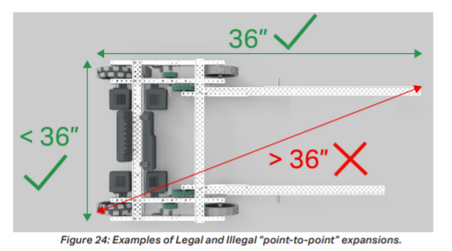

SG3. Enemies cannot touch alliance platforms in the last 30 seconds

SG4. Stay out of the enemy’s home zone during the autonomous period

SG5. Enter the neutral zone during the autonomous period at your own risk

SG6. Enemies cannot remove rings from opposing alliance mobile goals

SG7. Robots cannot hoard more than 1 mobile goal

SG8. Alliances can gently place match their load rings anytime during the autonomous & driver control period but not onto robots

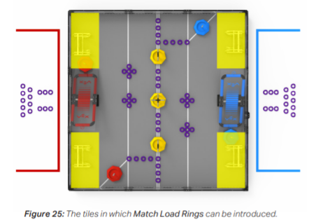

SG9. Scoring objects stay on the field

SG10. Use scoring objects to play the game

### Inspection Rules

R1. One robot per team. Teams cannot modify robots when the other is being competed. Teams cannot replace parts with other robots. Teams cannot switch robots. Multiple teams cannot use the same robot.

R2. Robots must represent the team

R3. Robots must pass inspection (functionality & built) & after large changes

R4. Robots must be safe (aka not attaching machine guns)

R5. Robots must fit in a sizing box (18”x18”x18”)

R6. Robots must be built using Vex V5 parts

R7. Vex produces come from VEX Robotics or VEX Robotics Resellers

R8. SOme non-vex parts are allowed

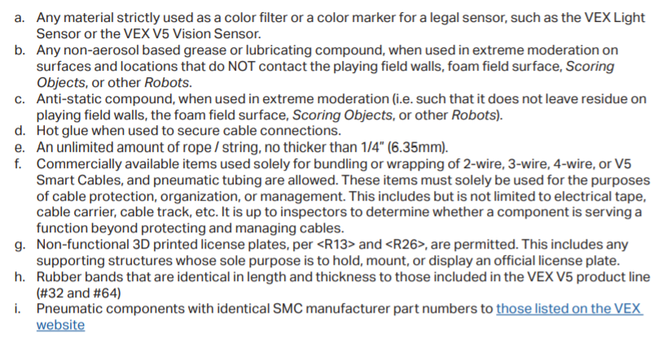

G9. Give radios safe & the symbol should not be blocked

R10. Limited amount of custom plastic is allowed

R11. Limited amount of tape is allowed

R12. Non-VEX screws, nuts, & washers are allowed

R13. Decorations are allowed (googly eyes)

R14. No WiFi

R15. New VEX parts are legal

R16. Only 1 brain

R17. Robots must use VEXnet for communication

R18. Robots can only use 1 brain & 8 motors

R19. Only use power from batteries

R20. 1-2 controllers per robot

R21. No modifications to electronic components

R22. Modifications & repairs to non-electrical components are allowed (like cutting a metal bar)

R23. Custom V5 smart cables are allowed

R24. Keep power switch accessible

R25. Pneumatics are limited

R26. Teams must be registered to compete & have colored plates for the alliance color

R27. Robots must use the competition template for programming

R26. There is a difference between accidents & not accidents

### Tournament Rules

T1. Head Referee has ultimate authority

T2. Drive team can appeal to Head Referee’s ruling

T3. The robot/drive team member should attend every match

T4, Robots at the field must be ready to play

T5. Practice matches are allowed

T6. Red alliance places their robot last

T7. Qualification matches must follow the qualification match schedule

T8. Each team will be scheduled qualification matches when in a tournament/league

T9. Team rankings are determined during qualification matches based on the the number of matches played

T10. Qualification match tiebreakers are a thing

T11. When disqualified, you get 0 win points

T12. Send a team representative to alliance selection

T13. 1 alliance per team

T14. Each alliance gets 1 time out

T15. Elimination matches can be a best of ⅓

T16. Small tournaments may have fewer alliances

T17. Fields may be raised/on the floor

T18. Students must have an adult when going to a VRC event

# 

# Planning

## Strategies

Get as many goal on the balanced platform, try to get a robot holding a goal on the platform

Ignore donuts

## 

## Videos for Everyone

[2145Z Vex Tipping Point Reveal](https://www.youtube.com/watch?v=Ly324dBBc5M)

<https://www.youtube.com/watch?v=-_vqHqtMQL8>

Robot Turtling Meta - https://www.youtube.com/watch?v=dQw4w9WgXcQ

## [GitHub](https://github.com/VexTrex87/Robotics)

## [Photo Album](https://photos.app.goo.gl/suNuc24Doa4U6d6y7)

[Google Drive](https://drive.google.com/drive/folders/1L7OUdcv5UBZgBbuVQSRwW822AvW3Y11M?usp=sharing)

# Calendar

