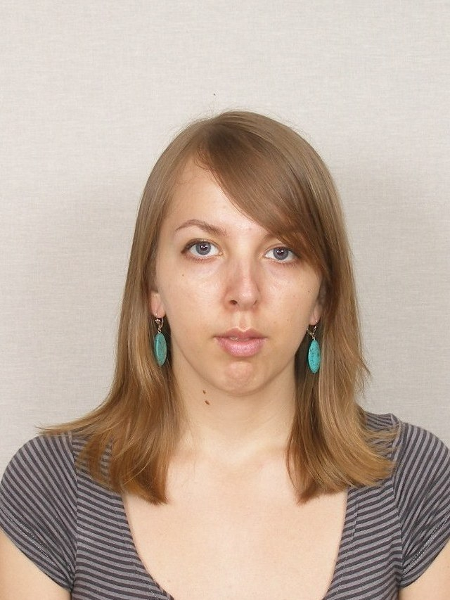
CV
Viktoriia Kovero
Personal information:
Date of birth: 26.06.1988
Place of birth: c. Ivano-Frankivsk
Place of current location: c. Ivano-Frankivsk, ready to relocation

Contact information:

Phone number:+380666758468
E-mail: bescrummaster@gmail.com

Освіта:
1995 – 2005 School № 1 with intensive course of English, c. Ivano-Frankivsk;
2005 – 2009 National university of State Tax Service of Ukraine , department of accounting and audit, bachelor;
2009-2010 National university of State Tax Service of Ukraine , department of accounting and audit, master;
01.09.2014 – 29.02.2016 National academy of Public Administration under the President of Ukraine, department of public administration, master, with honour;
24.09.2015 – 15.01.2016 Israeli-ukrainian course, common course between National academy of Public Administration under the President of Ukraine and Ariel university of Israel «Political system and system of public administration of Israel».

Work experience:
01.09.2010 – 30.04.2012 - Chief desk officer of Department of public institutions and law enforcement institutions, Control and Revision Office of city Kyiv ;
01.05.2012 – 30.11.2012 - Auditor in Department of public institutions and law enforcement institutions, State Financila inspection of Kyiv region.
01.12.2012 – 30.08.2014 - Accountant in Division of accounting, reporting and analysis of Financial department, State Financial Inspection of Ukraine
09.12.2015 – 01.04.2016 - Project manager of social project "House of veteran", Kyiv
15.04.2015 – 30.06.2016 – Technical supporter of american eCommerce webapplication, remote work
Certification: Monitoring and evaluation of programs and projects, 16-21.10.2015, Creative center CCC
Project management: instruments and methods, 06-31.10.2015, International center of education and integration
Project management of municipal and local development projects, 10.11-10.12.2015, DESPRO
Agile methodology of managing projects in IT, 29.01-29.02.2016, Educational center ITEA
HTML, CSS, Javascript Fundamentals, 05.2016-06.2016, SoftServe IT Academy
Language knowledge: English (B2 «Upper intermediate» - Cambridge Placement Test); Polish (can speak); german (basics); ukrainian (native language); russian (fluent).
Additional skills: project management, fundrising, experience in writing policy briefing and brief law amendments for supervisor and organization, basics of functioning EU institutions and european law.
Computer skills: МS Office, МS Project 2007, MS PowerPoint, Prezi, 1S:Accounting, Jira
Other activity, including public activity:
- Internship in Main department on reform introduction issue of Presidential Administration of Ukraine, 08.2015 - 11.2015.
- Project manager of Project "ATO veteran's house in Irpin, Kyiv region", 09.2015-11.2015
- Internship in Department of International Organization of Ministry of Foreign Affairs, 06.2015 - 07.2015.
- Internship in Audit Office of Poland, 12. 2014
- Volunteer for german football team during 6th European football championship between students, 2008
- Scientific work in English «Ukraine and NATO», 2006
Personal skills: open minded, self-organized, hard-working person, with analytical mind, team player.

