Eugene Chernenko

markup developer

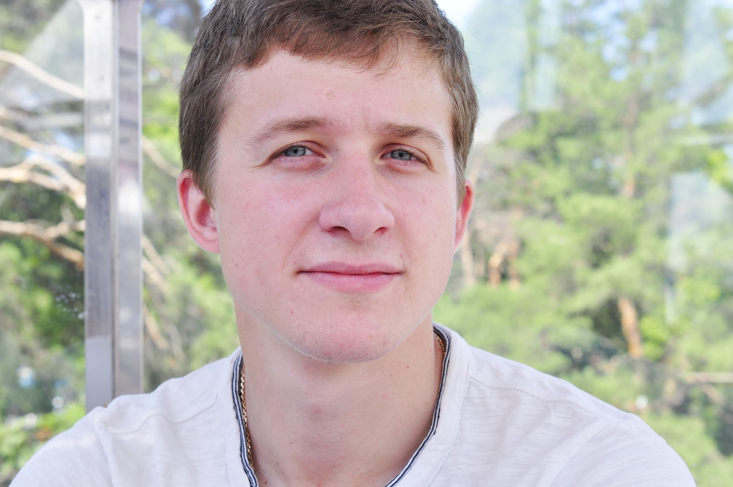


+38 093 0529 820

chernenko.ievg@gmail.com

Eugene Chernenko


www.linkedin.com/pub/eugene-chernenko/101/506/214
https://github.com/ChernenkoEugene

City: Kharkov

Objective:
To start a career of markup developer in a company, and in 5 years to grow to the teamleader.

Skills and knowledge:
Programming languages: JavaScript
Markup: HTML5, CSS3, Bootstrap (grid), LESS
Libraries & Frameworks: jQuery
Other skills: Ajax, Adobe Photoshop, Git, Autocad

Work experience:
2016-present (3 month)
markup developer at Safrasoft;

2015-2016 (3 month)
markup developer at freelance;

2012 – 2015 (3 years)
designing engineer at Ecopolymer (not IT);

Education:
2007-2012 - Kharkiv State Technical University of Construction and Architecture
The specialist degree in Water supply and sewage

Foreign languages:
English-Intermediate
French - Elementary
Russian - Advanced

Hobbies:
Sports (football, table tennis, pistol shooting), keeping home pets (a cat and a dog), cooking (grilling perfect beef or salmon).

