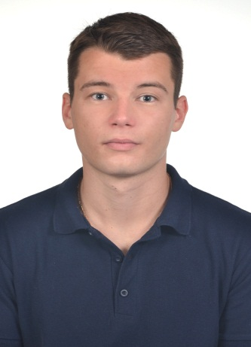
Mark Zakhozhai

Date of birth: October 28, 1992
Address: Lenina Street 28, Krasnograd, Ukraine
Phone: +38 095 60 80 630
E-mail: mark.zakhozhai@gmail.com

SKILLS
Languages: HTML, CSS, JavaScript.
Technologies: HTML5, CSS3.

EDUCATION
2009: Information Technology High School
2016: NTU «Kharkiv Politechnic Institute» , State;
Qualification: Specialist, Artificial intelligence systems, engineer of automated control
systems.

LANGUAGES
Russian: Native.
Ukrainian: Native.
English (technical): Pre-intermediate.
ABOUT ME
I have good communication skills. I'm easy learning, result-oriented person, responsible for deadlines.

I’m self-educational and self-motivated in improving my professional skills and getting new knowledge.

EXPERIENCE
https://drive.google.com/file/d/0B7O0yjJnBdvxM1V5eUVXV3p3M2M/view?usp=sharing

