Adrian Shilov  
26 years old

Ukraine, Dnipropetrovsk

e-mail: [adrianshilov@gmail.com](mailto:adrianshilov@gmail.com), mob.: 0987966588

**Objective:** getting a job as a Front-end developer  
**Desired salary:** 300$

Skills

• HTML(5)  
 • CSS(3)  
 • JavaScript, AJAX, jQuery  
 • SQL basics  
 • Node.js basics

Experience

• 2013-2015 - Leading specialist in the content creation at PrivatBank

• 2012-2013 - Curator of the project at PrivatBank

Attended courses  
 • 2016 – “JavaScript in web-development” at education center [ORT](http://ort.dp.ua/) (2 months)  
 • 2016 – online course “[Basics of Web UI development](http://courses.prometheus.org.ua:18090/downloads/edd608cbba1d48ab8c37bc1390c22232/Certificate.pdf)” via [Prometheus](http://prometheus.org.ua/) platform  
 • 2013 – “SQL basics” at [IMT academy](http://imt.academy/) (2 weeks)

Education  
 2008-2012 Dnipropetrovsk Conservatory, guitar department, bachelor  
Additionally  
 Laguages: Russian, Ukrainian – native, English - pre-intermediate  
 Driving license: category B  
Summary  
 Attentive, observant, purposeful, easily trained and self-training junior specialist, who's ready to increase his level, learn new technologies and get new skills

Portfolio (Ctrl+click on image to open link)

[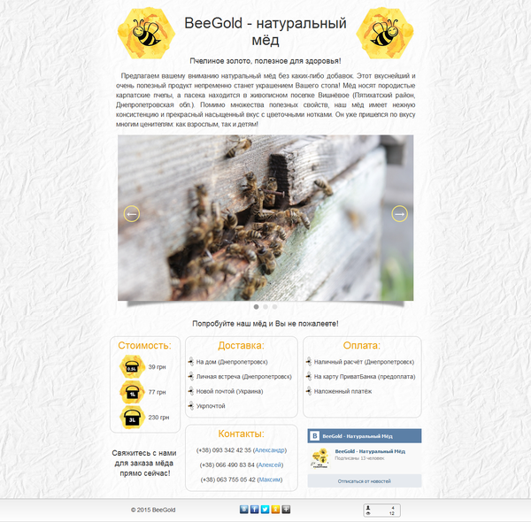](http://beegold.xyz/)[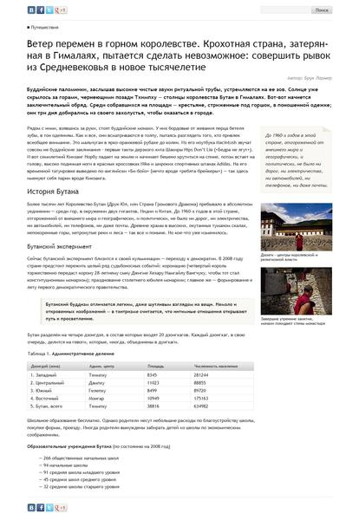](https://googledrive.com/host/0B_IWmEoDVo6ZZkZHLUJkWmRJY1k)[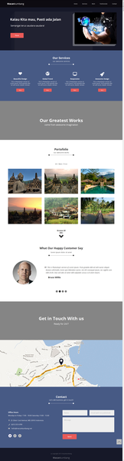](https://googledrive.com/host/0B_IWmEoDVo6ZSEVESkpyNmFBYnM)

[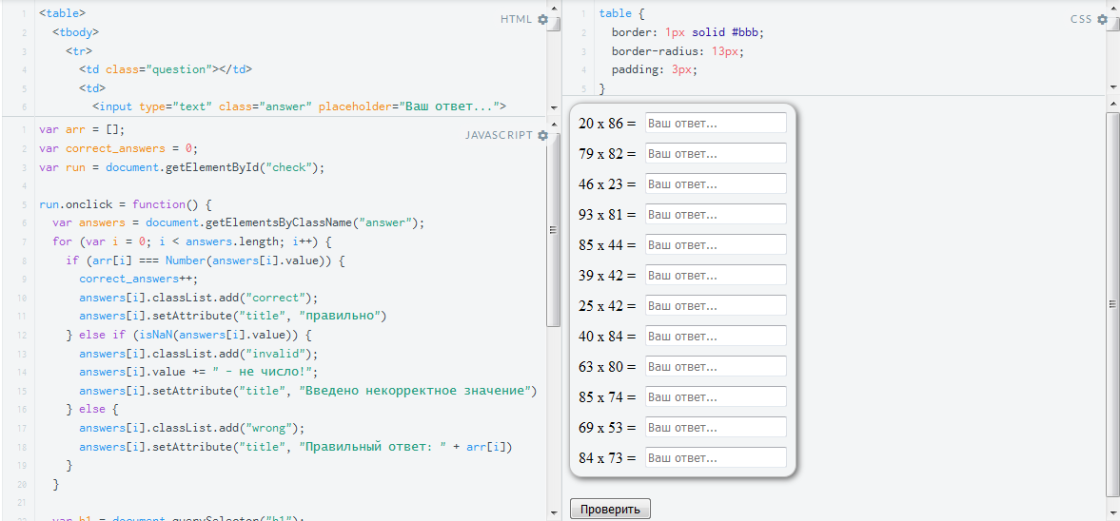](https://jsfiddle.net/Adrian_Sh/4f3hodf1/)

[](http://googledrive.com/host/0B_IWmEoDVo6ZfjhRYnp6ajViTXpwMnZrR0Y4OEpCbVA1clBwcDNLM3pjT0R2UkxhdG9MSEU)