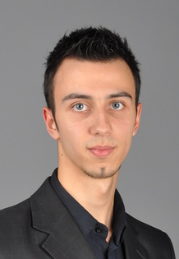**Maxim Ustich**

**Date of birth:** 02.07.1991

**Address:** Kuznetsovsk, Rivne region, Ukraine

**Phone number:** +38 (068) 017 53 55

**Email address:** ustichmaxim@gmail.com

Technical Skills

Programming languages:

* Python (Django framework)
* JavaScript (jQuery)

Operating systems:

* Windows

Other:

* HTML
* CSS
* Bootstrap
* SQL (CRUD, Join etc.)
* Git
* Linux

Languages

* Ukrainian(native)
* English(pre-intermediate)
* Russian

Education

2008 – 2013 National University "Yaroslav the Wise Law Academy of Ukraine"

Experience

2014 – 2016 Lawyer