Joel Southall

CS 234N

December 7, 2023

Project – UI

Here is the link to my Brewery UI-Project:

https://github.com/Vexmage/Brewery-MSI.git  
Here is the backup link:

https://github.com/Vexmage/BrewerySite.git

I have also decided to share some screenshots here, though you can find them in my github project. After the screenshots, I’ve written up a reflection on the process.  
  
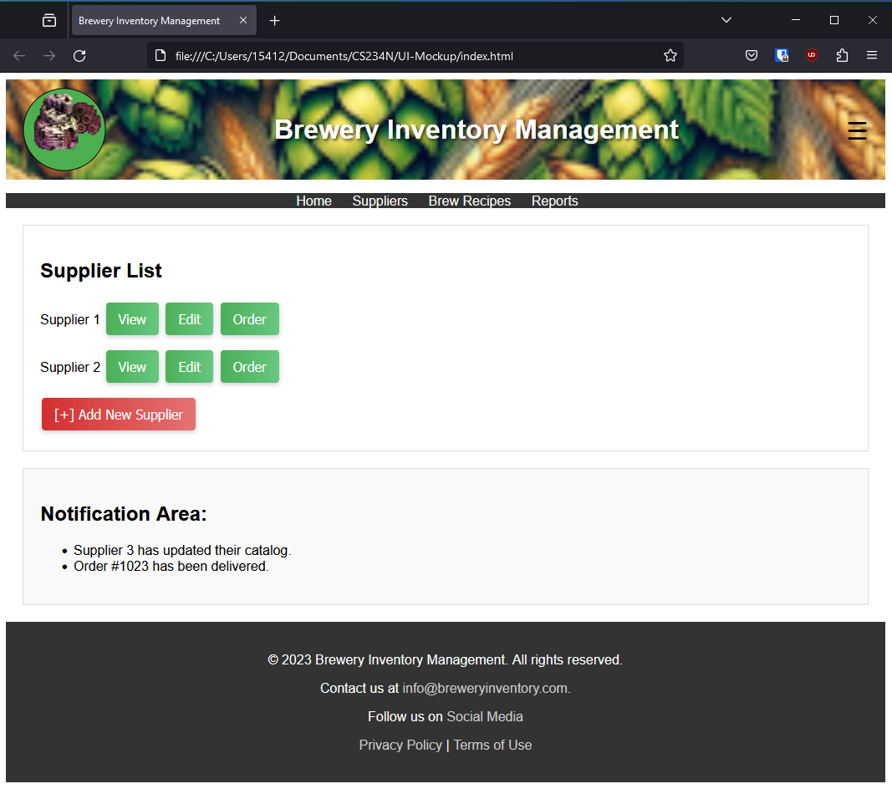.

I created modal mockups for when you press on each button:

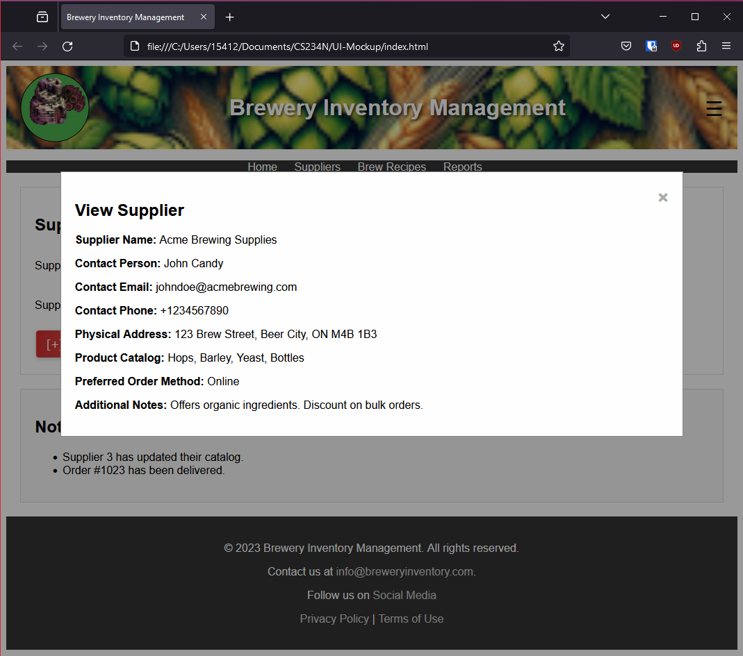

.

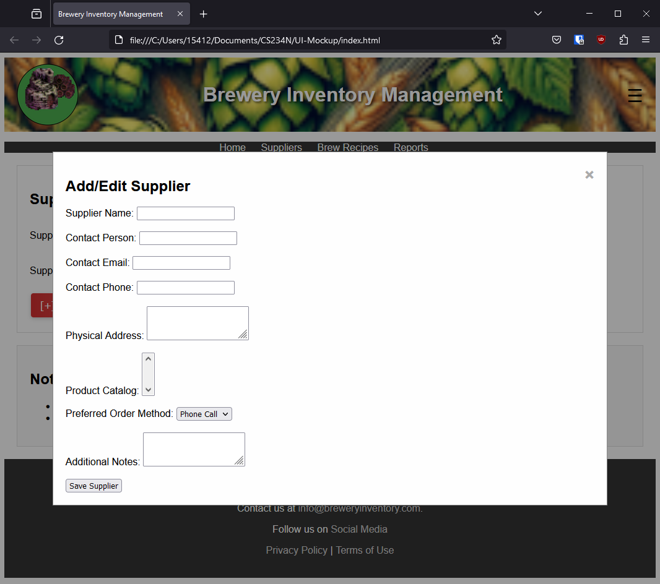.

.

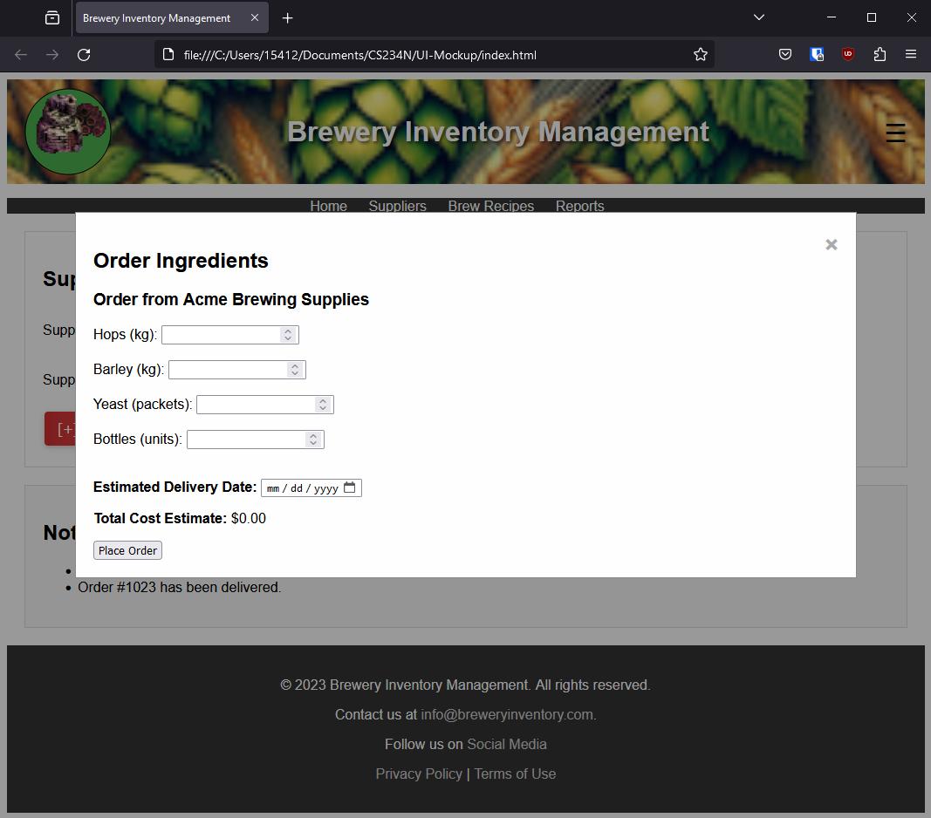.

.

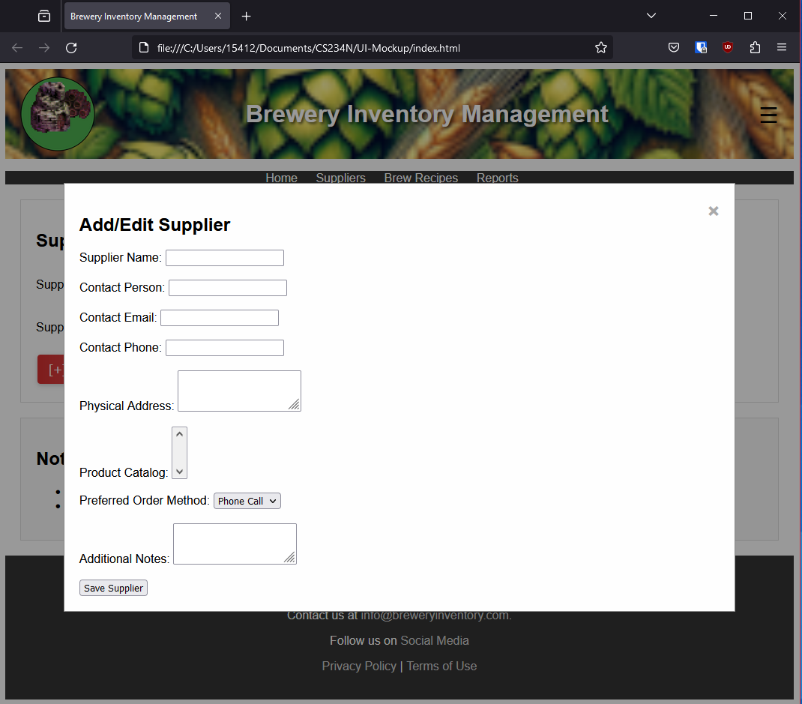.

Here are some responsive design examples:

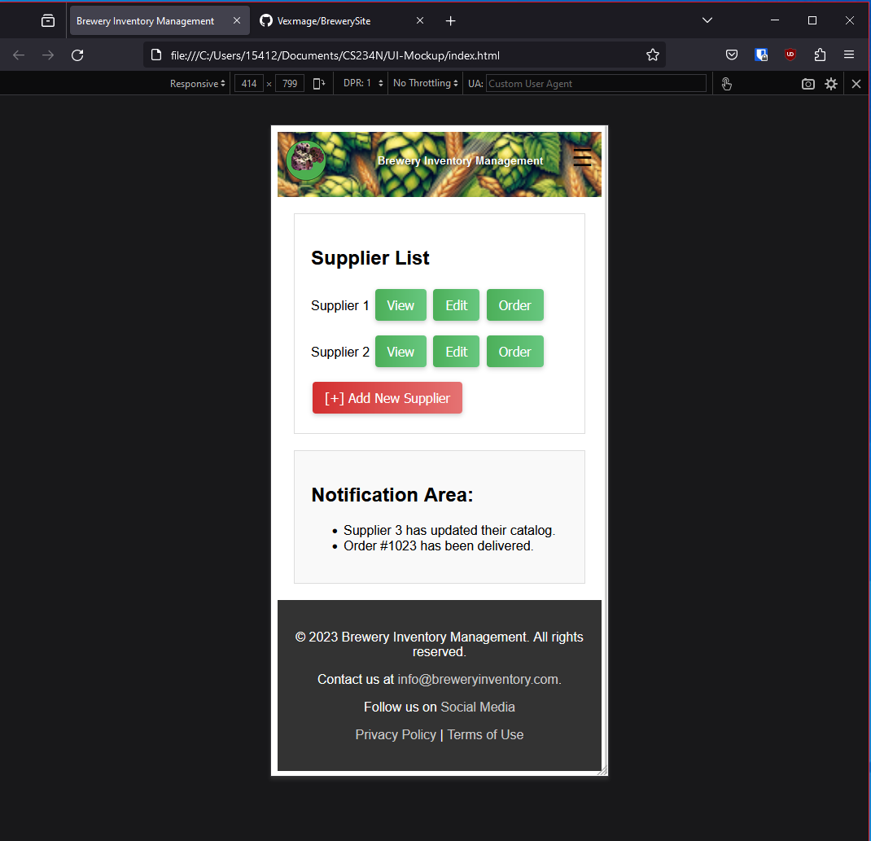.

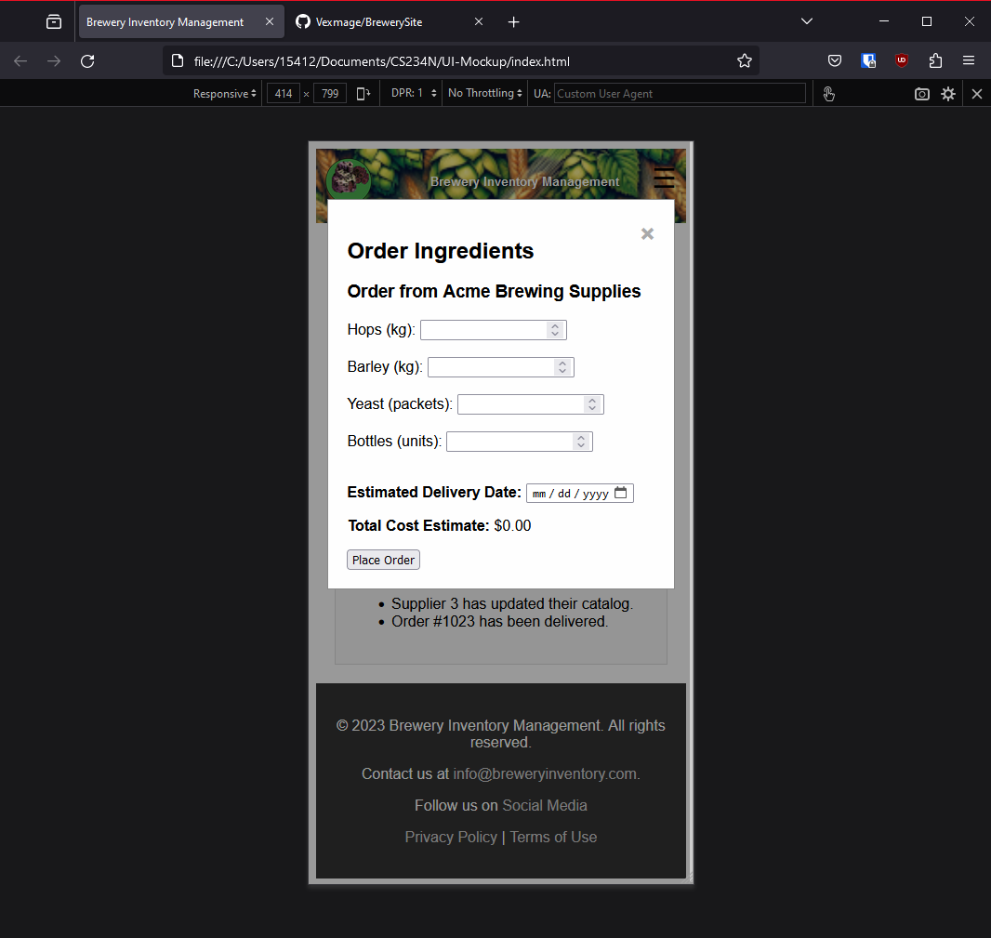.

**Reflection**

Working on this UI for the Brewery Inventory Management system was a lot of fun. The intent was to build an intuitive interface that could eventually tie into a robust back-end system. Though it is not yet a fully functional API, the current UI lays down the groundwork, showcasing how the system would look and feel in its final form.  
  
One of the coolest parts of this part of the project was diving into interactive elements like modals and popups. Implementing these for viewing, editing, and ordering from suppliers got be really hyped up because I felt like I can design a professional looking API now. Use of modals and popups transformed a static page into an interactive experience, giving a glimpse into how the final product will enable effective supplier management.

Responsive design was another key focus. Ensuring that our UI looks great and functions well on a variety of devices was crucial. Tackling this with CSS, especially with media queries, was fun. I felt much satisfaction at seeing the UI adapt smoothly to different screen sizes. This project has been an incredible learning experience, particularly in understanding the importance of user-centric design and forward planning. For fun, I might actually play with using the api endpoints and get this as a somewhat functional web app for my portfolio.