**Contents**

CHAPTER 1: INTRODUCTION 1

1.1 Introduction 1

1.2 Problem 1

1.3 Motivation 1

1.4 Objectives 1

CHAPTER 2: RELATED WORK 2

CHAPTER 3: SOFTWARE DEVELOPMENT 6

3.1 Software Design 6

3.2 Database Design 8

3.3 User Interface Design and Implementation 11

CHAPTER 4: DISCUSSION AND CONCLUSION 14

Appendix 15

Work Breakdown 15

Gantt Chart 15

Reference 16

Bibliography 17

# CHAPTER 1: INTRODUCTION

## Introduction

Student Portal is an android app that generalizes all the basic material required for the student be available in one place. In this app, users can add files and browse through the content managed under various sub category for download purpose. They also have the ability to create their own group/club or subscribe to others’. Club activity posts can be accessed easily if they are subscribed to a particular group. The facility of private messaging is also made available.

## Problem

The official website of Kathmandu University provides a limited amount of options for the students’ problems and queries. Finding the reliable resource on subjects while consulting with senior and teacher are tedious as well as huge deal of time is lost while searching for them despite of being readily available somewhere. Lack of online communication between students of university, lack of involvement of student in discussion of the course matter or the extracurricular subject and non-existence of common university student blog is the problem that we have hoped to solve with our project

## Motivation

The idea was born from the experience we had during the time of study in Kathmandu University and how we wished to have all the study material to be available in a single place .Thus, we thought of the android app to provide all the material in one portal for the ease of each and every student in KU.

## Objectives

The following are the objectives of our project:

1. To provide a medium for interaction among the university students.
2. To provide a platform for students to discuss various subjects via groups and message.
3. To allow students to share their resources with other students.

# CHAPTER 2: RELATED WORK

* 1. **Infinite Campus Mobile Portal**

(URL: <https://itunes.apple.com/us/app/infinite-campus-mobile-portal/id464352883?mt=8>)

“Infinite Campus Mobile Portal is an app designed for both iPhone and iPad where students can view assignments, grades, attendance and more” [1] .

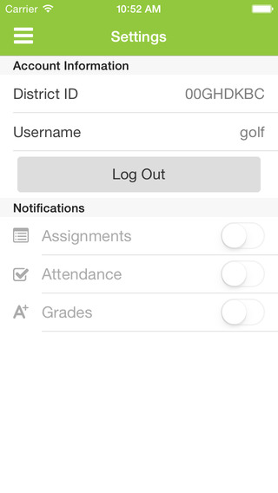

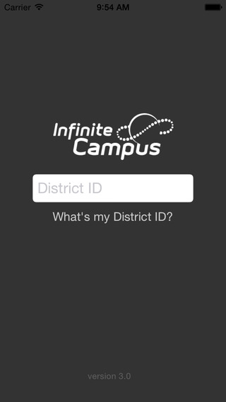Fig 1: Screenshot to Homepage Fig 2: Screenshot to Login Page

**Pros**:

1. Give information about grades and attendance.
2. Lunch Balance notifications i.e. students receive a daily notification when the account balance drops below an amount chosen

**Cons:**

1. School must be registered in their web site.
2. Doesn’t provide platform for communication between students.

**2.2 MIU Student Portal**

(URL: <https://play.google.com/store/apps/details?id=edu.miu.student>)

“MIU Student Portal is an android app that provides students enrolled in [Misr International University](https://play.google.com/store/apps/developer?id=Misr+International+University) with information regarding University Notifications, Announcements, Schedule, etc.” [2]

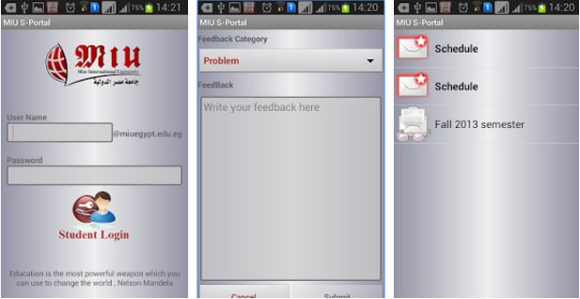

Fig 3: Screenshot to different tabs of the app

**Pros:**

1. Official app of the university thus provide relevant information.
2. Help student to sync their schedule according to university

**Cons:**

1. Poor reliability as the app often crashes
2. Low performance
3. Non interactive user interface

**2.3 JKUAT Portal App**

(URL: <http://portal.jkuat.ac.ke/app/index>)

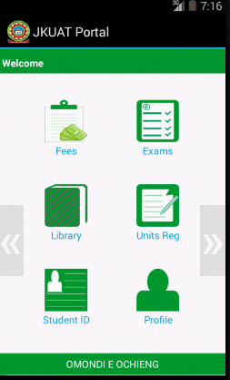“JKUAT portal is a free mobile app that lets students studying in Jomo Kenyatta University of Agriculture and Technology that provide information regarding student fees statements, exam results and library books borrowing.” [3]

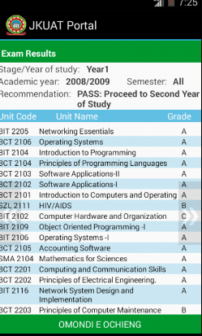

Fig 4: Screenshot to exam result Fig 5: Screenshot to Homepage

**Pros:**

1. Provides notice regarding exam ,library and other university services

**Cons:**

1. Primitive design
2. Full of bugs and many portion are not complete
   1. **Student Portal**

(URL: <https://play.google.com/store/apps/details?id=com.malaris.studentportal>)

“Student Portal is an android app that provides students with courses, assessments, time table and many more. It also provides users to manage their portfolio.” [4]

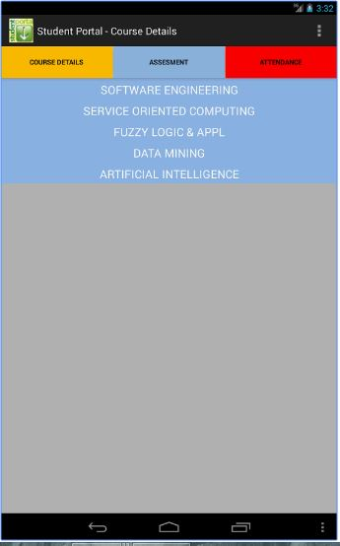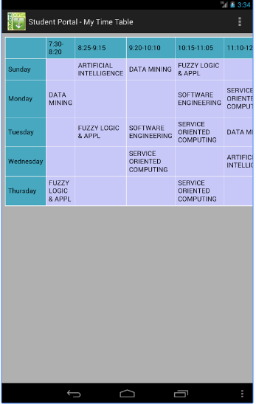

Fig 6: Screenshot to Time Table Fig 7: Screenshot to Course Details

# CHAPTER 3: SOFTWARE DEVELOPMENT

## Software Design

Software design diagrams helps to plan a software solution to the problems discussed earlier. And as such a data flow diagram was designed to plan the flow of data through Student Portal. With the help of data flow diagram an overview of the system can be can be designed. Data flow diagram of Student Portal app is shown below.

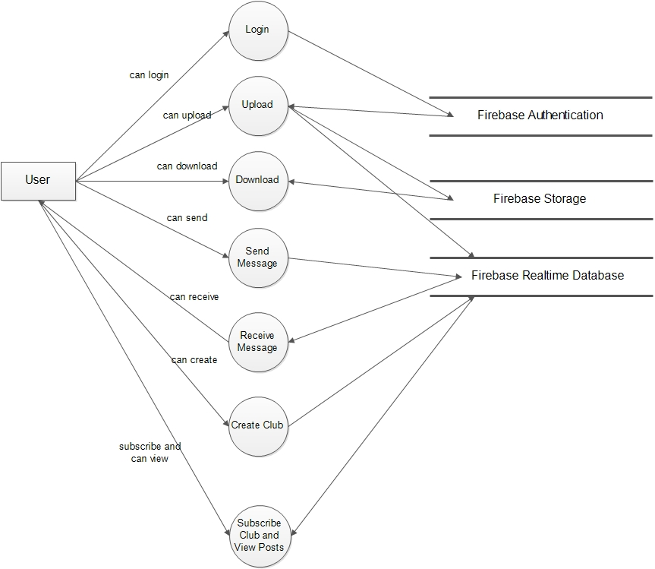

Fig 8: Data Flow Diagram

As Student Portal app provides online features and that the app requires internet to function properly, only the authorized user is allowed to engage in the app. Use case diagram of a user is shown in the below diagram. User that can successfully login is able to access the various features of app and make changes to the database.

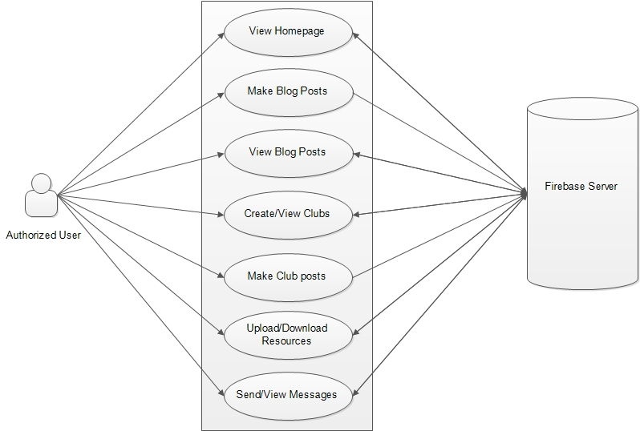

Fig 9: Use case Diagram

## Database Design

For storing the data and files, we have used Firebase. Firebase is a mobile platform that helps one to quickly **develop** high-quality apps and **grow** the user base. Firebase is made up of complementary features that one can mix-and-match to fit ones needs.

“The Firebase Realtime Database is a cloud-hosted database. Data is stored as JSON and synchronized in realtime to every connected client. Instead of typical HTTP requests, the Firebase Realtime Database uses data synchronization—every time data changes, any connected device receives that update within milliseconds. The Realtime Database is a NoSQL (originally referring to "non SQL" or "non-relational") databasethatprovides a mechanism for storage and retrieval of data which is modeled in means other than the tabular relations used in relational databases”. [5]

Each of the key/node of the NoSQL database contains the child which stores the data. The full database tree structure of Student Portal app is shown in the diagram below.

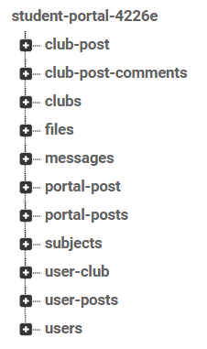

Fig 10: Firebase Tree Structure

The messages key which stores the various attributes of message is shown in the diagram below:

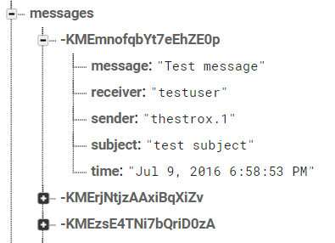

Fig 11: Message Storage Tree Structure

To map this key and its values in to the firebase database a class/model is implemented as shown below:

public class Message {

private String sender;

private String receiver;

private String subject;

private String message;

private String time;

public Message() { }

public Message(String sender, String receiver, String subject, String message, String time) {

this.sender = sender;

this.receiver = receiver;

this.subject = subject;

this.message = message;

this.time = time;

}

An object is created at run time to map these data to Jason object to store in the database as shown in fig 11.

Few other Tree structure showing the key and values of the Jason object is shown in the figures below.

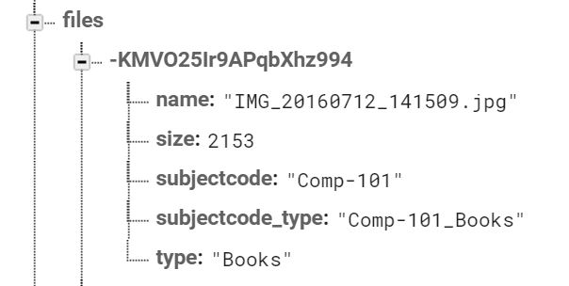 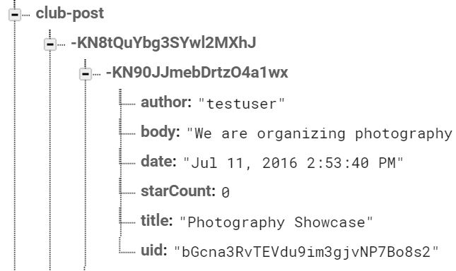

Fig 12: File key and its attributes Fig 13: Club-post key and its attributes

Firebase also provides storage facility. The files are stored in the format as shown in the figure below.

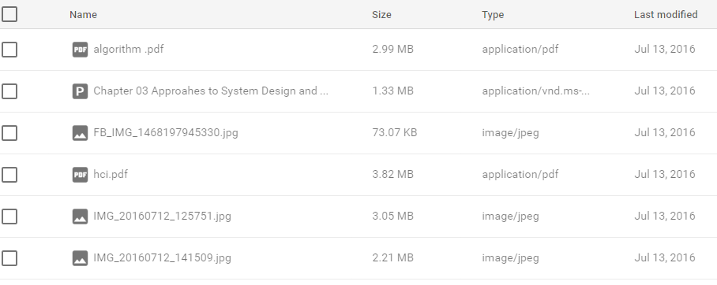

Fig 14: Structure of files in Firebase Storage

## User Interface Design and Implementation

One of our focus when developing the app was also to provide the user friendly design by following various principles of Human Computer Interaction. So, we tried to implement Google’s Material Design guidelines and principles. We used the recommended paddings, elevations, icon sizes, components of material design like floating action button, raised button, circular progress bar, swipe to refresh and many more. The result of such design are explained below.

**3.3.1 Navigation Drawer**

A good navigation menu is very important to increase the productivity of user. User should not waste time trying to figure out the way to other features of the app. Student portal app has many inner activities/screens and thus the only option to provide good navigation was to use navigation drawer as it provides very fast access to other parts of the app.

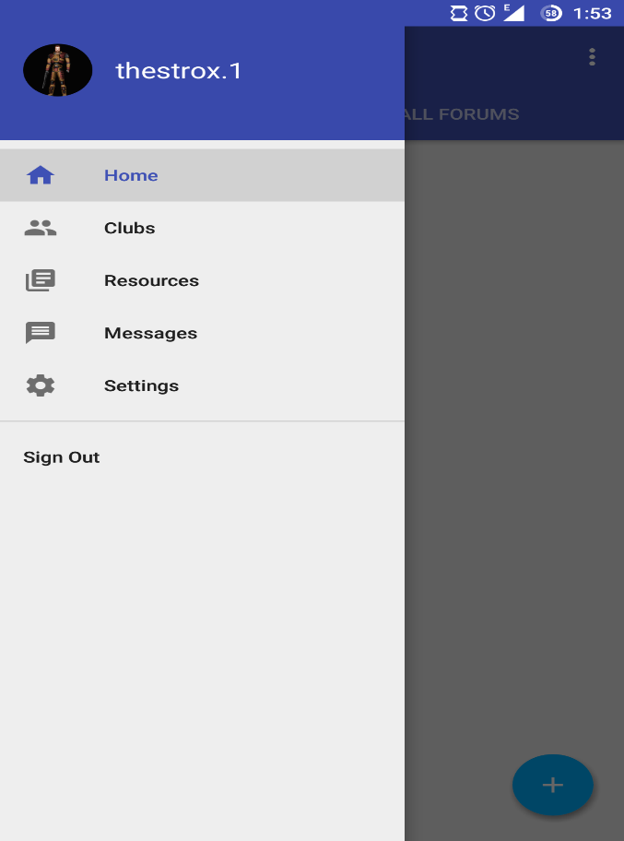

Fig 15: Navigation Drawer

**3.3.2. Club**

Club feature of Student Portal app should allow the user to create club, create posts in a particular club and post comments. Since the number of clubs can be very large in the long run we decided to provide a subscribed layout for the user so that they can easily visit the clubs they are interested in. The design is shown below:

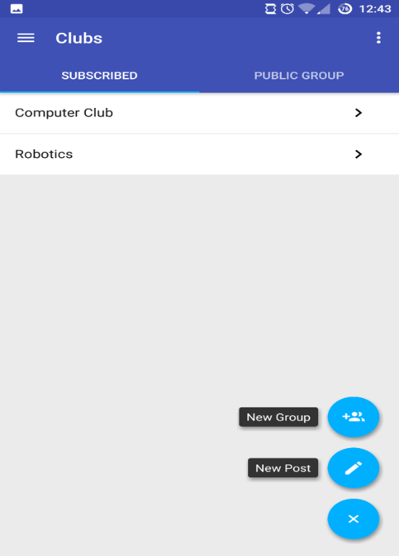

Fig 16: UI of club

**3.3.3 Resources**

Resource feature of the app should provide the medium to find the required resources to download and upload resources in the specific category. And as such the design provides the autocomplete text layout with drop down feature to enter the subject code and category and find the required files to download. The same design is used to upload files in the correct category. They designs are shown below:

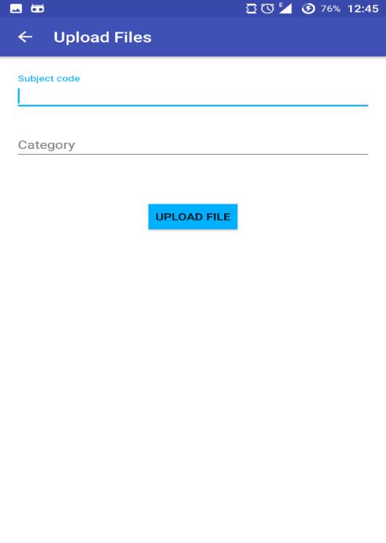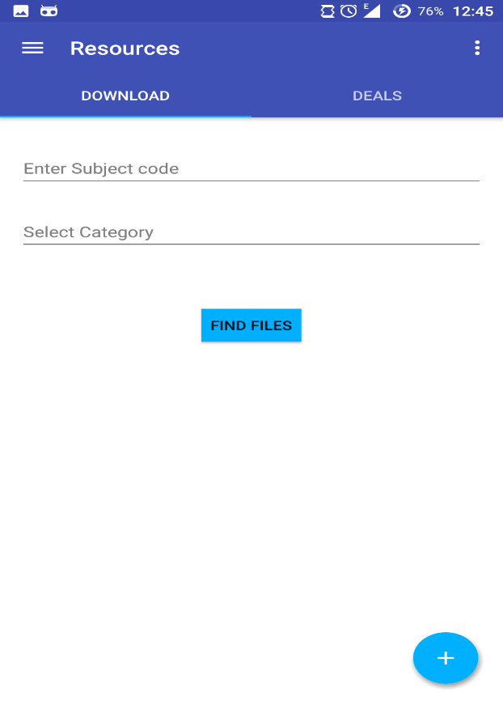

Fig 17: UI to download file Fig 18: UI to upload file

**3.3.4 Posts**

The lists of posts are shown using recycler view rather than tradition listview to increase the performance in scrolling when the large number of posts are added to the list as suggested by the material design guidelines. When clicked on the list of posts a new layout showing its detail view is presented where users can communicate in the form of comments. Quick Reply bottom bar is used for fast comment and this increasing the productivity. They design is shown below:

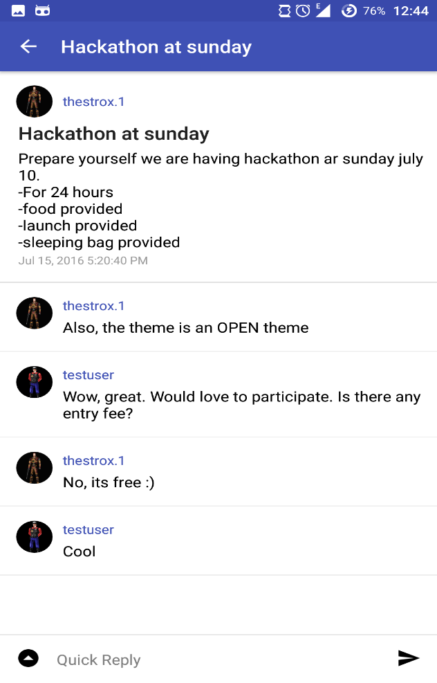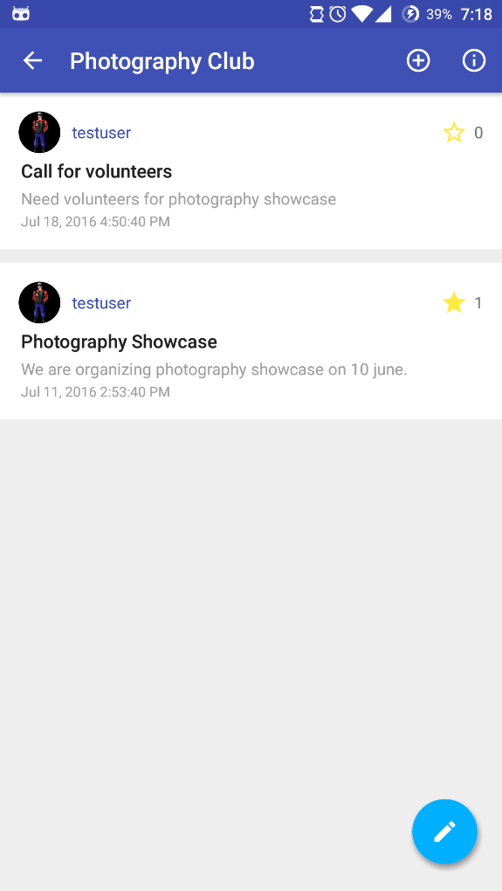

Fig 19: UI of List of posts of Club Fig 20: UI of detail view of a post

# CHAPTER 4: DISCUSSION AND CONCLUSION

Hence, to solve the problem of lack of interaction between the students, we have developed an android app that meets most of our objectives. The app helps users to discuss on various common subjects, share resources, and write blogs.

The following tasks have been accomplished:

* Facility to Upload and download resources
* Create blogs
* Subscription to specific groups
* Create posts on a specific group and post comments
* Provision of sending private messages

Despite our best efforts there are definitely some shortcomings of this app. This project has a lot of room for expansions like:

* Offline caching support
* Better post features like adding images and url.
* Admin panel
* Verification of Clubs

To sum up, working on a project by developing an entirely new concept and stretching the established concept had been quite difficult. However, our project is far from perfect but we have tried our best to make this project effective. We welcome recommendations and suggestions to make this project even better.

# Appendix

## Work Breakdown

The entire work is broken down into the following ways among our team mates:

|  |  |  |
| --- | --- | --- |
| S.N | Task | Team Members |
| 1 | Learning Firebase and Researching | Sudin, Bhupesh, Sabal, Sabin |
| 2 | UI Designing | Sabal, Sabin |
| 3 | Coding | Sudin, Bhupesh, Sabal, Sabin |
| 4 | Testing | Sudin, Bhupesh |
| 5 | Documentation | Sudin, Bhupesh, Sabal, Sabin |

## Gantt Chart

The work breakdown and time (in weeks) required to complete the specific tasks are shown as in the Gantt chart below:

|  |  |  |  |  |  |  |  |  |  |  |  |  |  |
| --- | --- | --- | --- | --- | --- | --- | --- | --- | --- | --- | --- | --- | --- |
| S.N. | Work | 1 | 2 | 3 | 4 | 5 | 6 | 7 | 8 | 9 | 10 | 11 | 12 |
| 1 | Requirement Gathering |  |  |  |  |  |  |  |  |  |  |  |  |
| 2 | System Design |  |  |  |  |  |  |  |  |  |  |  |  |
| 3 | Coding |  |  |  |  |  |  |  |  |  |  |  |  |
| 4 | Testing |  |  |  |  |  |  |  |  |  |  |  |  |
| 5 | Documentation |  |  |  |  |  |  |  |  |  |  |  |  |

## Reference

[1] I. Campus, "Infinite campus mobile portal on the App store," App Store, 2016. [Online]. Available:

<https://itunes.apple.com/us/app/infinite-campus-mobile-portal/id464352883?mt=8>.

[2] M. S. S. Education, "Student portal - Android Apps on Google play," 2014. [Online]. Available: <https://play.google.com/store/apps/details?id=com.malaris.studentportal>.

[3] JKUAT, "JKUAT students’ portal - App," 2016. [Online]. Available: <http://portal.jkuat.ac.ke/app/index>

[4] “MIU Student Portal - Android Apps on Google play,” 2015. [Online]. Available: <https://play.google.com/store/apps/details?id=edu.miu.student>

[5] "Firebase," Google Developers. [Online]. Available: <https://firebase.google.com/>.

## Bibliography

1. "Tutorial on how to draw a data flow diagram (DFD)," 2012. [Online]. Available: <https://www.visual-paradigm.com/tutorials/data-flow-diagram-dfd.jsp>.
2. "Up and running with material design,". [Online]. Available: <https://developer.android.com/design/index.html>
3. B. Hardy and B. Phillips, Android programming: The big nerd ranch guide. United States: Big Nerd Ranch Guides, 2013.