SP
STUDENTPULSE
Student Events Portal

Technical Documentation
Internet Programming II · Group Project
Core technologies: HTML · PHP · MySQL
Institution | ____________________________
Group member 1 | ____________________________
Group member 2 | ____________________________
Group member 3 | ____________________________
Group member 4 | ____________________________
Group member 5 | ____________________________
Submission date: ____________________

1. Executive Summary
  - Purpose, users and main value
StudentPulse is a secure, database-driven web application that centralizes campus event discovery and participation. Students create accounts, authenticate, browse published events, monitor live countdowns, RSVP, view their profile and submit messages to the events team. Administrators use protected management pages to create, edit and delete event records.
The project meets the assignment requirement for at least five interlinked authenticated pages while extending the minimum scope with role-based administration, event RSVPs, CSRF protection and dynamic countdowns. The interface uses a responsive modern-blue visual system for clear navigation on desktop and mobile.

Objectives
- Provide secure registration, login, session maintenance and logout.
- Store and retrieve normalized user, event, RSVP and contact-message data.
- Validate all form input server-side and safely encode all displayed data.
- Give students a clear events dashboard and administrators controlled event management.
- Supply reproducible installation instructions, sample data and a defense guide.

Technology stack
Layer | Technology | Responsibility
Presentation | HTML5, CSS3, JavaScript | Responsive interface, forms and countdowns
Application | PHP 8+ | Validation, sessions, authorization and request handling
Data | MySQL / MariaDB | Persistent relational records and constraints
Data access | PDO | Prepared statements and controlled database errors

2. Requirements Traceability
  - How the solution addresses the project specification
Requirement | StudentPulse implementation
User accounts | Unique username/email, hashed password and student/admin role in users table.
Registration | Server validation, duplicate check, password hashing and prepared INSERT.
Authentication | Email/password verification, session regeneration and role storage.
Five protected pages | Dashboard, Profile, Contact, Message Submissions and Events Hub.
Contact form | Name, email, subject and message stored in contact_messages.
Submissions directory | Escaped records displayed in a responsive HTML table.
Information hub | Events Hub retrieves event data and supports RSVP interaction.
Database export | database.sql creates schema, constraints, indexes and sample records.
Creativity | Live countdowns, RSVP workflow, role-based event CRUD and responsive UI.

User roles
Student: registers, logs in, views the dashboard and profile, browses events, adds or cancels an RSVP, submits messages and views the submissions directory.
Administrator: has every student capability plus access to event creation, editing and deletion. Each administrator route calls admin() before displaying content.

3. Database Design
  - Normalized entities and referential integrity
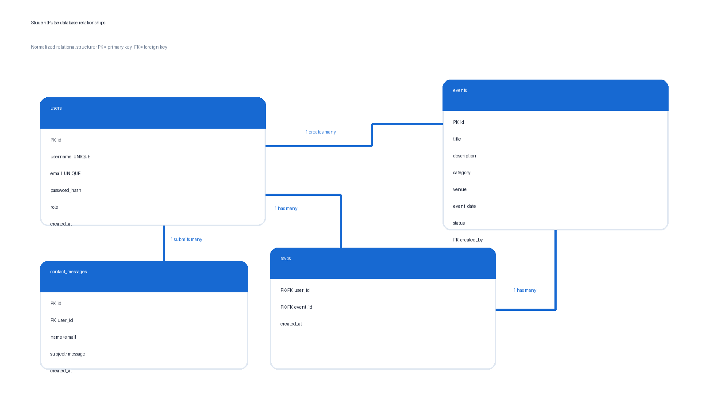
Normalization: account data is stored once in users; event data is stored once in events; contact messages are independent transactions; and the many-to-many relationship between users and events is resolved by rsvps. The composite RSVP primary key prevents duplicate attendance records.

Key constraints
- users.username and users.email are UNIQUE.
- Foreign keys preserve valid relationships and define safe cascade/set-null behavior.
- rsvps uses (user_id, event_id) as a composite primary key.
- Indexes support event date/status filtering and chronological message retrieval.

4. System Architecture
  - Request, session and database flow
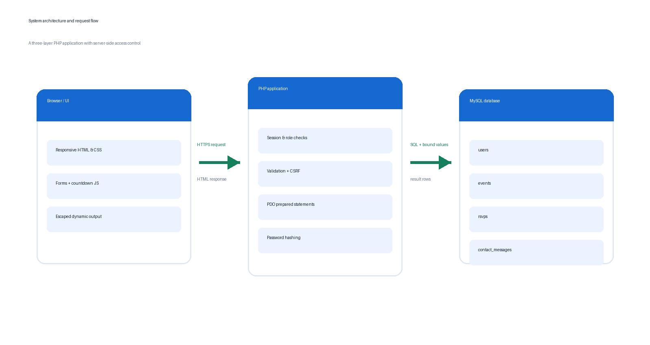

Request lifecycle
- The browser requests a PHP page and sends form values when applicable.
- Protected pages call auth(); admin routes additionally call admin().
- POST requests verify the CSRF token before processing.
- PHP trims and validates values, then executes a PDO prepared statement.
- MySQL applies unique, foreign-key and type constraints.
- Returned values are encoded with e(), which wraps htmlspecialchars(), before insertion into HTML.

Separation of concerns
config/database.php owns database connectivity. includes/core.php centralizes authentication, escaping, CSRF, redirects and flash messages. includes/header.php and footer.php maintain a consistent layout. Individual pages contain focused request logic and views.

5. Security, Validation & Sanitization
  - Controls applied to common web risks
Risk | Control in StudentPulse
SQL injection | PDO prepared statements with bound positional values; emulated prepares disabled.
Password disclosure | password_hash() stores a one-way adaptive hash; password_verify() checks login.
Cross-site scripting | e() applies htmlspecialchars(..., ENT_QUOTES, UTF-8) to dynamic output.
Session fixation | session_regenerate_id(true) runs after successful authentication.
Unauthorized access | auth() and admin() stop unauthenticated/unauthorized requests.
Cross-site request forgery | Random per-session CSRF token verified on every state-changing form.
Duplicate records | UNIQUE keys and composite RSVP primary key enforce integrity.
Information leakage | Database exceptions are logged; a generic connection message is shown.

Validation examples
- Registration: username 3–50 characters, valid email, password at least 8 characters and matching confirmation.
- Contact: name 2–100, valid email, subject 3–150 and message 10–2,000 characters.
- Event management: bounded title/description/venue, valid date, allow-listed status and integer IDs.
Sanitization is context-specific: prepared statements protect SQL context; HTML escaping protects output context. Input is also trimmed and length-limited, but trimming alone is not treated as a security control.

6. Installation Guide
  - Local setup with XAMPP
1. Install XAMPP and start Apache and MySQL.
2. Copy the StudentPulse folder into C:\xampp\htdocs\.
3. Open http://localhost/phpmyadmin and select Import.
4. Choose database.sql and run the import. It creates the studentpulse database and sample records.
5. Open config/database.php and confirm the database credentials. XAMPP normally uses user root with a blank password.
6. Visit http://localhost/StudentPulse/.
7. Log in as admin@studentpulse.test or student@studentpulse.test with password password.
8. Change the sample passwords before a real deployment.

Project structure
Path | Purpose
assets/ | Responsive CSS and countdown JavaScript
config/database.php | Central PDO connection
includes/ | Shared security helpers, navigation and footer
admin/ | Role-protected event management
database.sql | Schema, constraints and sample records
documentation/ | PDF report and defense guide
*.php | Authentication and application pages

Configuration note
If MySQL uses a different port, password or host, update only config/database.php. The application requests utf8mb4 and PDO exception mode to preserve text correctly and surface development errors through server logs.

7. Test Plan & Expected Results
  - Functional and security verification
Test | Expected result
Register valid student | Account inserted; user redirected to login with success message.
Register duplicate email | No insert; a clear duplicate warning appears.
Submit invalid email | Server rejects input and retains safe field values.
Log in correctly | Session ID regenerates; dashboard shows username.
Open dashboard while logged out | Request redirects to login.php.
Student opens /admin/events.php | Request redirects away from admin area.
Submit contact form | Message appears in submissions table.
RSVP twice | Composite key prevents duplicate rows.
Render stored <script> text | Text displays harmlessly; browser does not execute it.
Send POST without CSRF token | Server returns HTTP 403.
Log out | Session data and session cookie are destroyed; login page opens.
Mobile viewport | Navigation collapses and cards/forms remain readable.

Known deployment considerations
- Use HTTPS and secure cookie flags on an internet-facing server.
- Move database secrets into environment configuration for production.
- Add rate limiting or temporary lockout for repeated failed logins.
- Restrict the public submissions directory if messages may contain sensitive information.

8. Demonstration & Group Defense
  - Recommended presentation sequence
1. Register a new account and explain each validation rule.
2. Log in and show the protected dashboard and username session value.
3. Open Events Hub, explain the database query, countdown and RSVP table.
4. Submit Contact Us, then verify the row in Message Submissions and phpMyAdmin.
5. Log out; log in as admin and demonstrate create/edit/delete.
6. Open database.sql or the ERD and explain foreign keys and normalization.

Member responsibilities
Member | Registration number | Primary area
________________ | ________________ | Database and ERD
________________ | ________________ | Authentication and sessions
________________ | ________________ | Events and RSVP logic
________________ | ________________ | Interface and responsive CSS
________________ | ________________ | Testing, documentation and presentation

Submission checklist
- Replace all name/registration-number placeholders.
- Run the application locally and repeat every test in Section 7.
- Confirm StudentPulse/, database.sql and the PDF report are inside the ZIP.
- Ensure every member can explain prepared statements, password hashing, sessions, XSS protection and their assigned code.

