Name: Harvey Buenviaje

Section: BSIT-301

**STRIVE FOR CONSISTENCY**

TO PROVIDE A QUALITY EXPERIENCE TO YOUR USERS IT IS ESSENTIAL THAT YOU ARE CONSISTENT IN BOTH DESIGN AND CONTENT OF YOUR WEBSITES. CONSISTENCY IS THE BIGGEST FACTOR THAT SEPARATES A NEGATIVE EXPERIENCE FROM A POSITIVE ONE.



**KNOW THE USER**

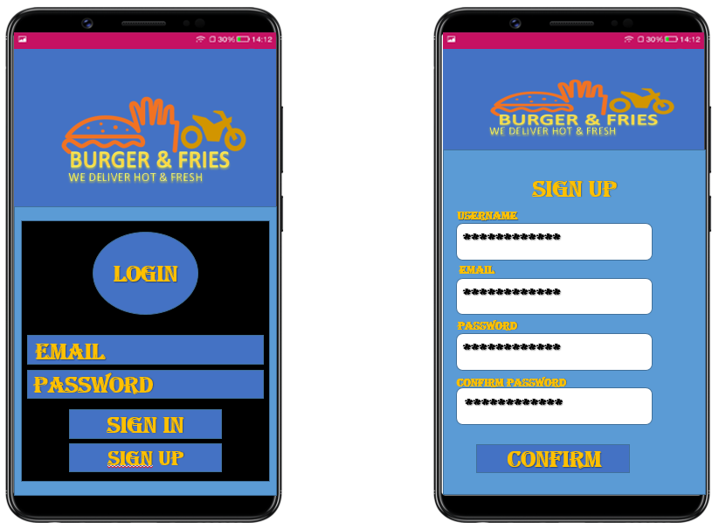In my own opinion before you create an website or mobile app, you should need first to who is using your website/mobile app. It is very important to know the user first. Because that is the first thing you need to do in order for you to create an website/mobile app. We designed/developed it for them not for us. If you don’t know the user’s target your, no one will use your website/mobile app.