Threading Applications
Project Report

Shane Lopez

Threading is useful for splitting up work, allowing each thread to execute a portion of work while the threads run concurrently on separate cores. The program orderSearcher utilizes threading to split up an input image file into chunks which threads individually analyze (one chunk per thread) according to a given criteria. Global data, regulated by a semaphore, is written and overwritten as lines of 80 bytes are found exhibiting characteristics better than the currently located best line, each thread reading from a shared memory segment mapped to the input file.
For the purposes of this project, threading turned out to be useful, allowing me to write a single template function which could be run by all threads instead of resorting to writing a new class and forking off new processes, effectively lowering the size of the project. Further, each thread is given a chunk size inversely proportional to the number of threads, leading to faster execution times. As an added bonus, to modify the behavior of the threads, only the template function needs modification, with an eye on strand.h if one intends to add criteria functions (in which case the strand struct sent to the template must also be changed). Read and write speed of the global data can be expected to change with the type of locking implemented, here a simple semaphore. Total execution time can be expected to decrease with chunk size, as threads run concurrently, but there will be a cap with the number of cores.
Upon finding a new 'best line', the values of that line are graphed in a vertical fashion in groups of 10, each tick along the horizontal axis representing an interval of MAXD, in this case 5, leading to 51 ticks, as the max value is 255 = 5 * 51 (<= 255/MAXD = MAXV = # columns), and as there are a number of rows = end index – start index = 80 for a complete line. An example is provided below.
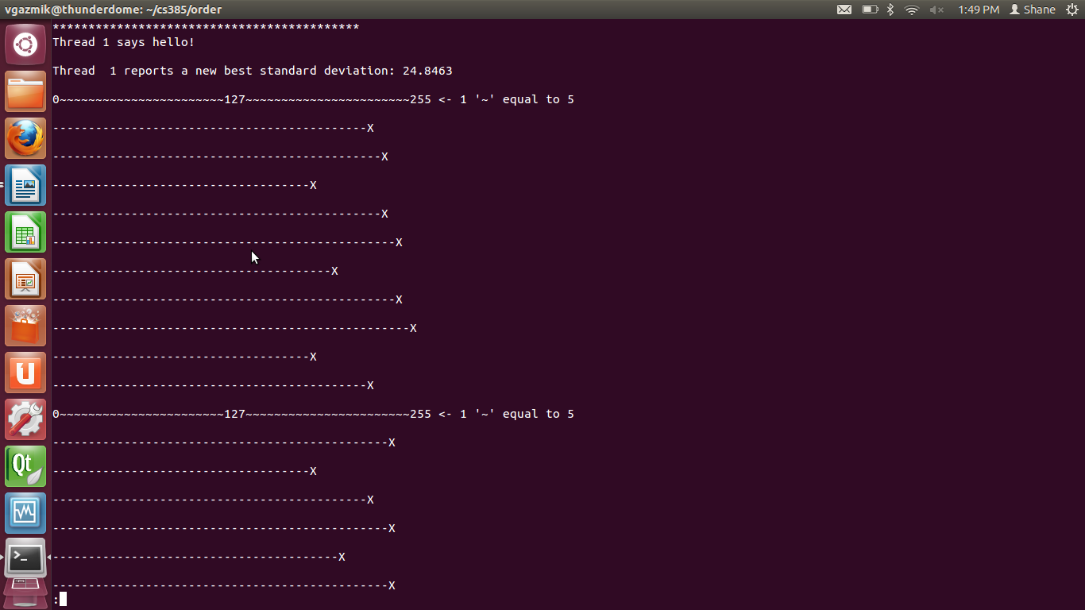
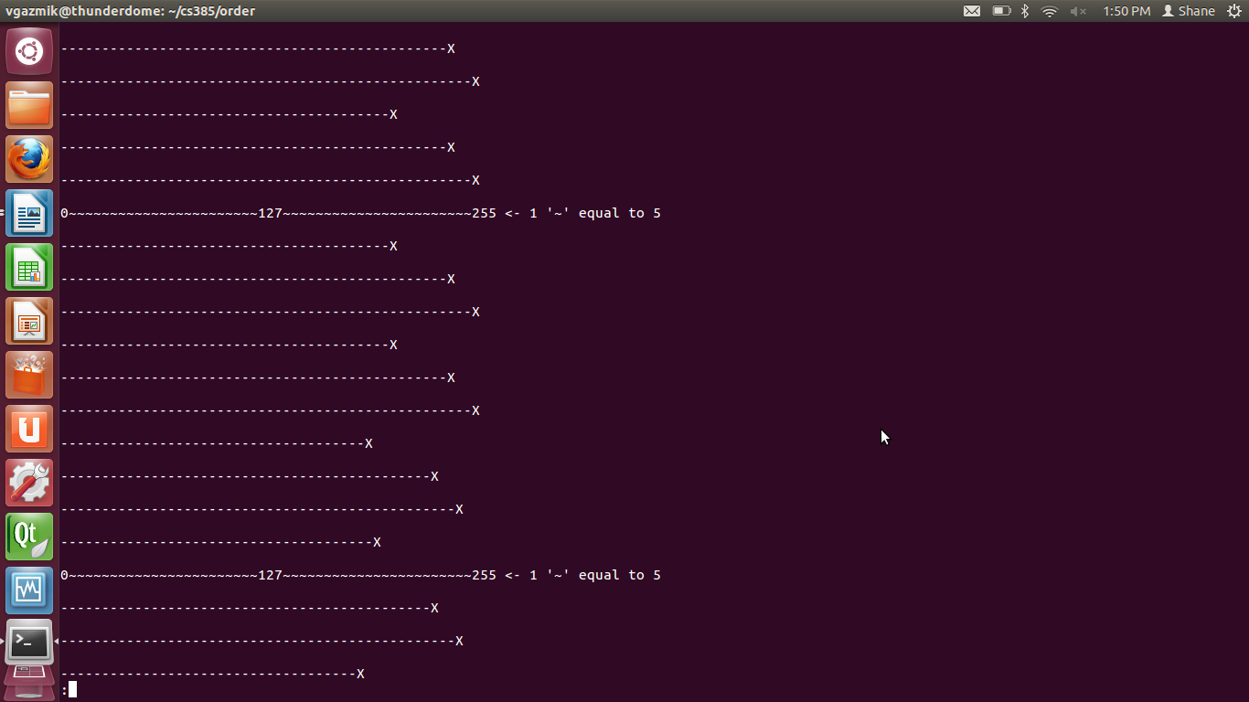
^^ Pictured above is a portion of a graph produced by one of the threads, to demonstrate how line values are graphed.

In all, this project has taught me the benefits of threading over forking, along with some cool concepts like function pointers, which I intend to make use of more often going forward.

