

**A REPORT ON SUMMER INTERNSHIP**

**Name of the Student :** Harika Vavilapalli

**Name of the College :** Vignan’s Institute of Information Technology

**Registration Number :** 22L31A4359

**Period of Internship** : 4 Weeks

**From :** 29th April 2024

**Year :** II

**Name and Address of the Intern Organization**: EISYSTEMS SERVICES 110, First Floor, Express Greens Plaza, Vaishali, Sector 1, Ghaziabad, Uttar Pradesh 201010

**An Internship Report on**

**MACHINE LEARNING INTERNSHIP**

*Submitted in accordance with the requirement for the degree of*

#### Bachelor of Technology

#### in

#### Computer Science & Engineering – (Artificial Intelligence)

By

**HARIKA VAVILAPALLI**

Under the Guidance of

**Mrs B. Pavani**

**VIGNAN’S INSTITUTE OF INFORMATION TECHNOLOGY**

**(AUTONOMOUS)**

[www.vignaniit.com](http://www.vignaniit.com) (Approved by AICTE & Affiliated to JNTUK) Estd – 2002

Beside VSEZ, Duvvada, VISAKHAPATNAM-530049. A.P.

Phone : 0891- 2755222 / 333 / 444 **::** Fax : 0891 - 2752333  **::**  E-Mail : [vignaniit@yahoo.com](mailto:vignaniit@yahoo.com)

**DEPARTMENT OF ADVANCED COMPUTER SCIENCE & ENGINEERING**

**May 2024**

# 

# DECLARATION

I, HARIKA VAVILAPALLI Reg. No **: 22L31A4359,** of the Department of **Computer Science and Engineering-Artificial Intelligence** do hereby declare that I have completed the mandatory internship from EIsystems under the Faculty Guideship of Mrs. B. Pavani, Department of Computer Science and Engineering-Artificial Intelligence, Vignan’s Institute of Information Technology.

Signature of the Student

**CERTIFICATE**

This is to certify that Harika Vavilapalli Reg. No.22L31A4359 has completed her Internship in EIsystems under my supervision as a part of partial fulfillment of the requirement for the Degree of in the Department of Computer Science and Engineering-Artificial Intelligence, Vignan’s Institute of Information Technology. This is accepted for evaluation.

**Signature of Guide Head of the department**

Mrs. B. Pavani Mrs. K. Swathi Assistant Professor Assistant Professor

# CERTIFICATE FROM INTERN ORGANIZATION

## 

## 

## ACKNOWLEDGEMENTS

I would like to express my sincere appreciation for the opportunity to complete my internship as a **Machine Learning intern** at EIsystems from 29-04-2024 to 30-05-2024. I am also grateful to Vignan's Institute of Information Technology for providing me with the necessary skills and knowledge that laid the foundation for this enriching experience. I am deeply grateful to the faculty coordinator Mrs. B. Pavani for support and guidance throughout my internship.

## CONTENTS

|  |  |  |
| --- | --- | --- |
| **S. No.** | **Particulars** | **Page. No.** |
| 1 | Personal details | 1 |
| 2 | Title | 2 |
| 3 | Declaration | 3 |
| 4 | Certificate from intern organization | 4 |
| 5 | Acknowledgement | 5 |
| 6 | Contents | 6 |
| 7 | Executive Summary | 7 |
| 8 | **Chapter-1:** Activity Log for Week1 | 8 |
| 9 | Weekly Report for Week-1 | 9 |
| 10 | **Chapter-2:** Activity Log for Week-2 | 10 |
| 11 | Weekly Report for Week-2 | 11 |
| 12 | **Chapter-3:** Activity Log for Week3 | 12 |
| 13 | Weekly Report for Week-3 | 13 |
| 10 | **Chapter-4:** Activity Log for Week-4 | 14 |
| 11 | Weekly Report for Week-4 | 15 |
| 12 | **Chapter-5:** Outcomes Description | 16 |
| 13 | Daily Activity Photos | 17 |

### CHAPTER 1: EXECUTIVE SUMMARY

This internship report provides an overview of my internship experience as a Machine Learning intern at EIsystems. The report highlights the learning objectives and outcomes achieved and summarizes the activities performed during the internship period.

#### Learning Objectives and Outcomes:

1. Objective: Foundations of Python
2. Objective: Exception Handling
3. Objective: Object oriented programming
4. Objective: Data mining and preprocessing
5. Objective: Numpy,pandas,model deployement

**Internship Organization:**

EIsystems

Information technology is making possible substantial changes in the organization and effectiveness of manufacturing activities. Equipment and stations within factories, entire manufacturing enterprises, and webs of suppliers, partners, and customers located throughout the world can be more effectively connected and integrated through the use of information technology. Information technology provides the tools to achieve goals that are widely regarded as critical to the future of manufacturing: rapid shifts in production from one product to another; faster implementation of new concepts in products and faster delivery of products to customers; more intimate interactions with customers, who more directly and completely specify what they need; fuller utilization of capital; and streamlining of operations to focus on what is essential to a business and to eliminate unnecessary activities. As this list suggests, technology is a critical enabler, but its development and implementation will be shaped by organizational, managerial, and human resources concerns. Because of these concerns, manufacturers have had difficulty getting the most out of the technology that exists today. Sensitivity to these concerns is essential to the successful development and implementation of the technologies associated with visions of manufacturing for the 21st century.

**CHAPTER 1: ACTIVITY LOG FOR WEEK-1**

|  |  |  |  |
| --- | --- | --- | --- |
| **Day** | **Date** | **Brief description of the**  **daily activity** | **Learning Outcome** |
| Day-1 | 01-05-2024 | Introduction to Machine Learning | Understand what ML is and how it differs from traditional programming  Learn the basic working principles and types of ML  Identify real-world applications of ML in industries |
| Day-2 | 02-05-2024 | Introduction to Python for ML Topics Covered: | Set up the Python development environment  Understand the basics of Jupyter Notebook and Anaconda |
| Day-3 | 03-05-2024 | Python Fundamentals - Conditional Statements & Data Types | Learn and apply Python’s basic data structures  Understand and use conditional statements for decision-making |
| Day-4 | 04-05-2024 | Python Loops & Iterations | Use loops efficiently to automate repetitive tasks  Understand different looping structures and their use cases |
| Day-5 | 05-05-2024 | Functions and Packages | Write reusable and modular Python functions  Learn how to use and install external Python packages |
| Day -6 | 06-05-2024 | Working with Various Python Libraries | Get familiar with essential Python libraries for ML  Understand their role in data manipulation, visualization. |

**WEEKLY REPORT**

##### WEEK – 1 (From Date:01-05-2024 to Date:06-05-2024)

**Objective of the Activity Done:**

##### Detailed Report:

Day 1: the internship begins with an introduction to Machine Learning (ML). Participants will understand the definition of ML, its types (Supervised, Unsupervised, and Reinforcement Learning), and its working principles. They will explore how ML differs from traditional programming and learn about real-world use cases such as self-driving cars, recommendation systems, and fraud detection.

Day 2: the focus shifts to Python, the most widely used language for ML. Participants will set up their Python development environment using Anaconda and Jupyter Notebook. They will learn the basics of Python programming, including syntax, data types, and working with variables.

Day 3: participants will explore fundamental Python concepts such as conditional statements (if, elif, else) and different data structures like lists, tuples, and dictionaries. Understanding these concepts will help in structuring data and making logical decisions in programs.

Day 4: loops and iterations will be covered. Participants will work with for and while loops, as well as loop control statements (break, continue, pass). These concepts are essential for automating repetitive tasks in data processing.

Day 5: the session will introduce functions and packages in Python. Participants will learn how to create functions, pass arguments, and return values. Additionally, they will explore Python packages and learn how to install and use external libraries essential for ML.

Day 6: various Python libraries like NumPy, Pandas, Matplotlib, and Scikit-learn will be introduced. These libraries play a crucial role in data handling, analysis, visualization, and ML model building.

**CHAPTER 2: ACTIVITY LOG FOR WEEK-2**

|  |  |  |  |
| --- | --- | --- | --- |
| **Day** | **Date** | **Brief description of the**  **daily activity** | **Learning Outcome** |
| Day-7 | 07-05-2024 | Introduction to NumPy | Understanding NumPy arrays  Creating 1D, 2D, and 3D arrays  Indexing and slicing arrays |
| Day-8 | 08-05-2024 | Data Processing with NumPy | Perform mathematical computations on data using NumPy  Handle missing or incorrect data using NumPy functions |
| Day-9 | 09-05-2024 | Introduction to Pandas | Learn how to structure and analyze tabular data using Pandas  Work with datasets for data processing |
| Day-10 | 10-05-2024 | Data Analysis using Pandas | Performing basic operations on data (filtering, sorting, merging)  Grouping and aggregating data  Handling missing data |
| Day-11 | 11-05-2024 | Data Visualization using Matplotlib | Plotting graphs using Matplotlib  Line charts, bar charts, scatter plots  Customizing plots (labels, titles, legends) |
| Day-12 | 12-05-2024 | Advanced Visualization Techniques | Using different styles in Matplotlib  Subplots and multiple plots in one figure  Styling and annotating graphs |

**WEEKLY REPORT**

##### WEEK – 2 (From Date:07-05-2024 to Date:12-05-2024)

**Objective of the Activity Done:**

##### Detailed Report:

Day 7: participants will engage in a hands-on practice session where they will apply Python concepts learned throughout the week. Small coding exercises and real-world tasks will help reinforce their understanding.

Day 8: NumPy, a fundamental library for numerical computing, will be introduced. Participants will learn how to create NumPy arrays, manipulate data structures, and perform mathematical operations on arrays.

Day 9: deeper insights into data processing using NumPy will be covered. Concepts such as reshaping arrays, handling missing values, and performing operations on large datasets will be discussed.

Day 10: participants will start working with Pandas, a powerful library for data manipulation and analysis. They will learn about Pandas Series and DataFrames, how to create and modify them, and how to import datasets for analysis.

Day 11: data analysis using Pandas will be explored in-depth. Participants will perform operations such as filtering, sorting, merging, and grouping data. They will also learn how to handle missing data, an essential step in preprocessing datasets for ML models

Day 12: data visualization using Matplotlib will be introduced. Participants will learn how to create basic plots like line graphs, bar charts, and scatter plots to visualize data trends.

**CHAPTER 3: ACTIVITY LOG FOR WEEK-3**

|  |  |  |  |
| --- | --- | --- | --- |
| **Day** | **Date** | **Brief description of the**  **daily activity** | **Learning Outcome** |
| Day-13 | 13-05-2024 | Hands-on Practice & Mini  Project | Strengthen data analysis and visualization skills  Apply Pandas and Matplotlib in real-world scenarios |
| Day-14 | 14-05-2024 | Introduction to Scikit-learn | Understand the importance of Scikit-learn for ML  Learn how to split data for model training |
| Day-15 | 15-05-2024 | Introduction to Machine Learning Models | Learn how ML models are trained and tested  Implement a simple regression model using Scikit-learn |
| Day-16 | 16-05-2024 | Data Analysis using Pandas | Performing basic operations on data (filtering, sorting, merging)  Grouping and aggregating data  Handling missing data |
| Day-17 | 17-05-2024 | Classification Models in ML | Understanding classification problems  Implementing logistic regression  Evaluating model accuracy) |
| Day-18 | 18-05-2024 | Advanced Visualization Working with Real Datasets | Using different styles in Matplotlib  Subplots and multiple plots in one figure  Styling and annotating graphs |

**WEEKLY REPORT**

##### WEEK – 3 (From Date:13-05-2024 to Date:18-05-2024)

**Objective of the Activity Done:**

##### Detailed Report:

Day 13: participants will engage in a hands-on practice session where they will apply Python concepts learned throughout the week. Small coding exercises and real-world tasks will help reinforce their understanding.

Day 14: NumPy, a fundamental library for numerical computing, will be introduced. Participants will learn how to create NumPy arrays, manipulate data structures, and perform mathematical operations on arrays.

Day 15: deeper insights into data processing using NumPy will be covered. Concepts such as reshaping arrays, handling missing values, and performing operations on large datasets will be discussed.

Day 16: participants will start working with Pandas, a powerful library for data manipulation and analysis. They will learn about Pandas Series and DataFrames, how to create and modify them, and how to import datasets for analysis.

Day 17: data analysis using Pandas will be explored in-depth. Participants will perform operations such as filtering, sorting, merging, and grouping data. They will also learn how to handle missing data, an essential step in preprocessing datasets for ML models

Day 18: data visualization using Matplotlib will be introduced. Participants will learn how to create basic plots like line graphs, bar charts, and scatter plots to visualize data trends.

**CHAPTER 4: ACTIVITY LOG FOR WEEK-4**

|  |  |  |  |
| --- | --- | --- | --- |
| **Day** | **Date** | **Brief description of the**  **daily activity** | **Learning Outcome** |
| Day-19 | 19-05-2024 | Implementing Machine Learning Algorithms | Learn how different ML algorithms work  Compare model accuracy using Scikit-learn |
| Day-20 | 20-05-2024 | Hyperparameter Tuning and Model Optimization | Perform mathematical computations on data using NumPy  Handle missing or incorrect data using NumPy functions |
| Day-21 | 21-05-2024 | Hands-on ML Project | Applying ML techniques on a dataset  Training, testing, and evaluating models  Recap of the week’s topics |
| Day-22 | 22-05-2024 | Introduction to AI and Deep Learning | Performing basic operations on data (filtering, sorting, merging)  Grouping and aggregating data  Handling missing data |
| Day-23 | 23-05-2024 | Working on ML Model Deployment | Saving and loading ML models  Introduction to Flask for deploying models |
| Day-24 | 24-05-2024 | Working on a Capstone Project | Evaluating final model performance  Writing reports and documentation |

**WEEKLY REPORT**

##### WEEK – 4 (From Date:19-05-2024 to Date:24-05-2024)

**Objective of the Activity Done:**

##### Detailed Report:

Day 19: participants will engage in a hands-on practice session where they will apply Python concepts learned throughout the week. Small coding exercises and real-world tasks will help reinforce their understanding.

Day 20: NumPy, a fundamental library for numerical computing, will be introduced. Participants will learn how to create NumPy arrays, manipulate data structures, and perform mathematical operations on arrays.

Day 21: deeper insights into data processing using NumPy will be covered. Concepts such as reshaping arrays, handling missing values, and performing operations on large datasets will be discussed.

Day 22: participants will start working with Pandas, a powerful library for data manipulation and analysis. They will learn about Pandas Series and DataFrames, how to create and modify them, and how to import datasets for analysis.

Day 23: data analysis using Pandas will be explored in-depth. Participants will perform operations such a filtering, sorting, merging, and grouping data. They will also learn how to handle missing data, an essential step in preprocessing datasets for ML models

Day 24: data visualization using Matplotlib will be introduced. Participants will learn how to create basic plots like line graphs, bar charts, and scatter plots to visualize data trends.

**CHAPTER 5: OUTCOMES DESCRIPTION**

##### Describe the work environment you have experienced:

During my virtual internship, I worked remotely with flexible hours. Communication was mainly through video calls and messaging platforms. I managed tasks independently while collaborating with my team online

##### Describe the real time technical skills you have acquired:

I have acquired technical skills in web development, including proficiency in HTML, CSS, and JavaScript. I’m experienced in using DOM manipulation, handling events, and working with arrays and objects. Additionally, I’ve learned to use advanced array methods, built-in JavaScript functions, and manage dynamic web content through event-driven programming.

##### Describe how could you improve your communication skills:

To improve my communication skills, I could practice active listening, ensuring I fully understand others before responding. I could also focus on being more concise and clear in both written and verbal communication. Regularly seeking feedback and engaging in discussions or presentations would help me refine my ability to convey ideas effectively and confidently.

##### 

##### 

##### DAILY ACTIVITY PHOTOS

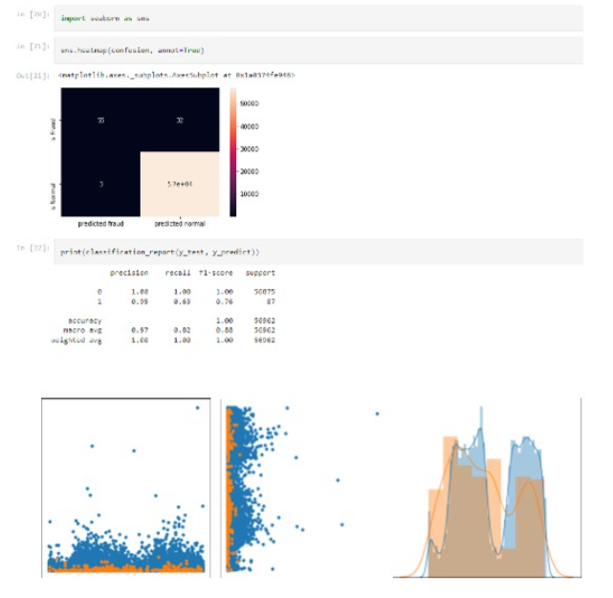

**Fig:(Training dataset and visualizing)**

.

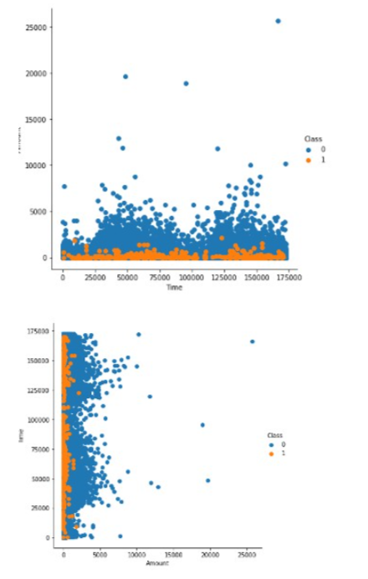

**Fig:(Dataset preprocessing live demo)**

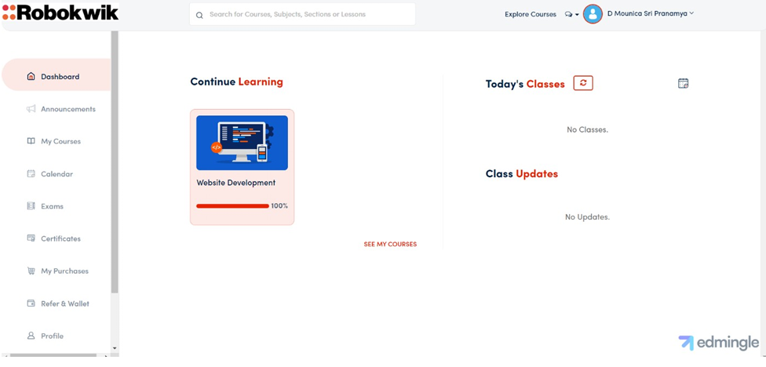

**Fig:(completion of given material)**