PROFESSOR MEETING REPORT

Frank Wolfe Output Graph Explanation Guide
Purpose and contents of every current graph

Purpose
This guide explains the role of every graph produced by the current Frank-Wolfe experiment. Each entry states what the graph contains and why it is included. It does not interpret performance or judge the results. Output 02 is the underlying every-round CSV file, so it is listed separately and is not presented as a graph.

Output index
Output | File | Graph
01 | 01_primary_online_progress.png | Primary Online Progress
02 | 02_primary_online_data.csv | Every Round Data File
03 | 03_final_attack_summary.png | Final Attack Summary
04 | 04_allocation_heatmap.png | Allocation Heatmap
05 | 05_byzantine_agent_utilities.png | Byzantine Agent Utilities
06 | 06_reputation_poison_agent_utilities.png | Reputation Poison Agent Utilities
07 | 07_detector_comparison.png | Detector Comparison
08 | 08_beta_detection_evidence.png | Beta Detection Evidence
09 | 09_attack_behaviour.png | Attack Behaviour
10 | 10_adversary_count_sensitivity.png | Adversary Count Sensitivity
11 | 11_alpha_tradeoff.png | Alpha Tradeoff
12 | 12_sigma_detector_sensitivity.png | Sigma Detector Sensitivity
13 | 13_reputation_poison_phases.png | Reputation Poison Phases
14 | 14_prediction_robustness.png | Prediction Scenario Stress Test
15 | 15_compound_attack_appendix.png | Compound Attack Appendix

01 Primary Online Progress
01_primary_online_progress.png
What the graph contains A nine-panel time-series figure covering cumulative online legitimate NSW, the fixed full-horizon offline NSW, the online-to-offline ratio, active detection rate, active false-positive rate, shadow Moradi detection rate, minimum legitimate utility, legitimate utility gap, and active malicious fraction.
Why the graph exists This is the main progress graph. It places welfare, detection, fairness, and attack activity on the same 2,000-round time axis so the reader can locate when each quantity changes.
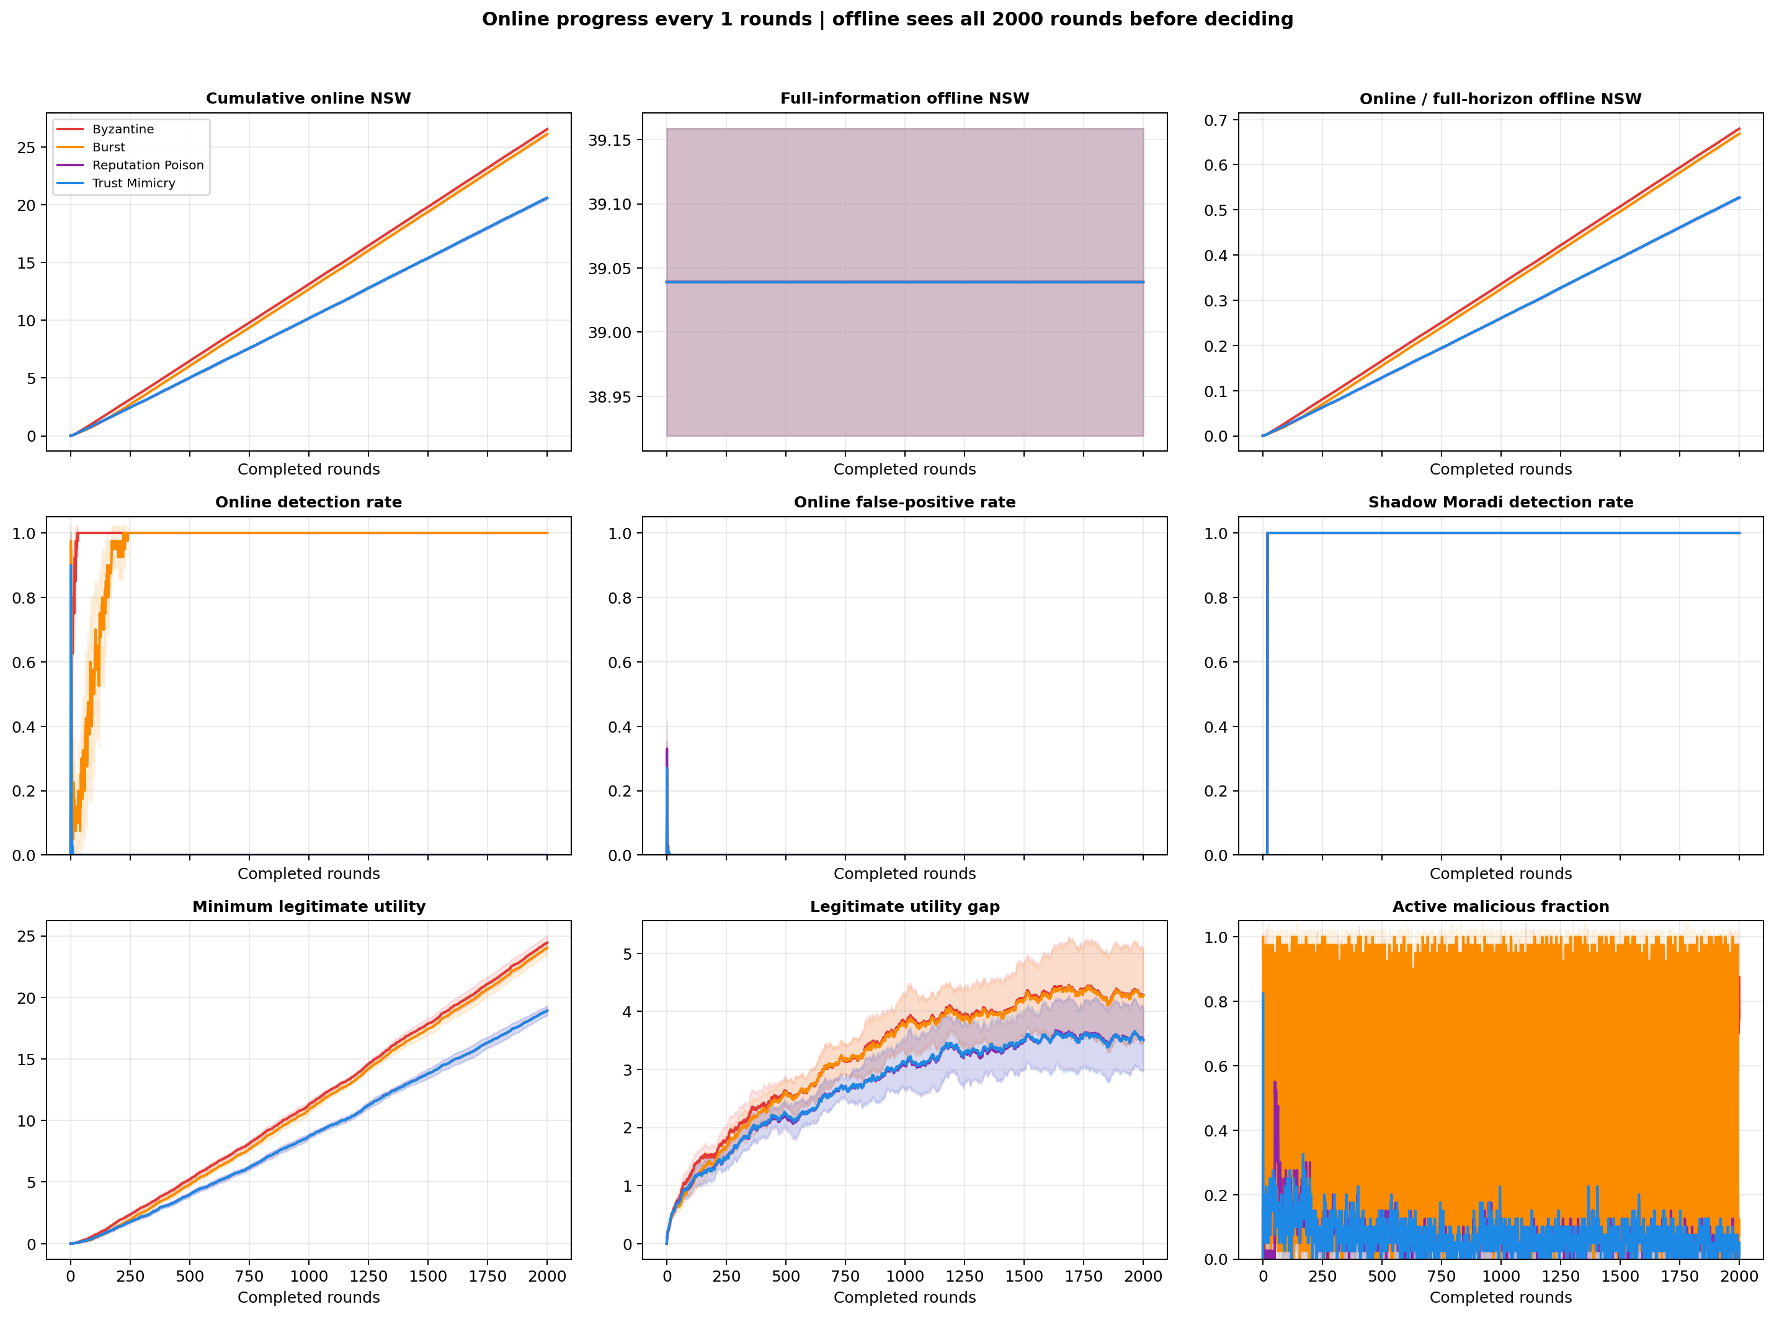
Figure 01_primary_online_progress.png

03 Final Attack Summary
03_final_attack_summary.png
What the graph contains A four-panel end-of-run summary for Byzantine, Burst, Reputation Poison, and Trust Mimicry. The panels report legitimate NSW, online-to-offline NSW ratio, Algorithm 1 detection rate, and shadow online Moradi F1.
Why the graph exists This graph provides a compact final comparison across the four focused attacks. It is intended for readers who need the main end-point metrics without reading the full time series.
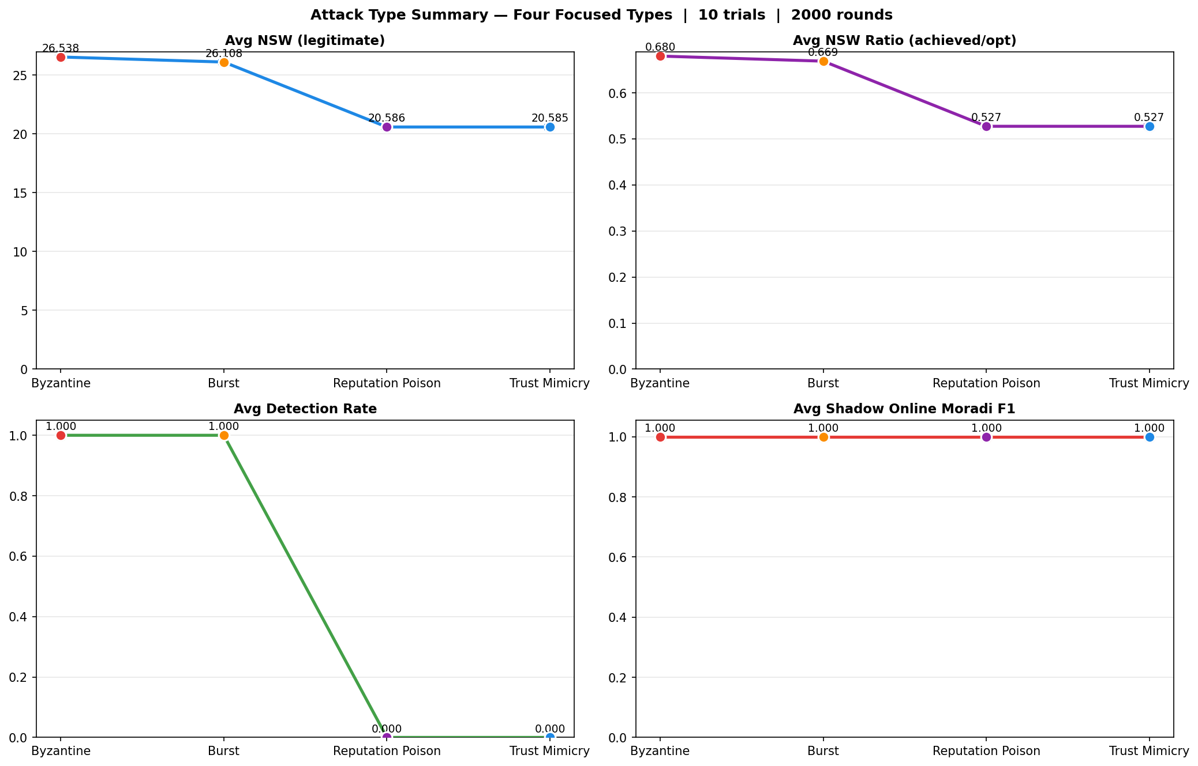
Figure 03_final_attack_summary.png

04 Allocation Heatmap
04_allocation_heatmap.png
What the graph contains A heatmap of the average allocation share assigned to every agent in each Byzantine round. Rows L0 through L9 represent legitimate agents, rows M0 through M3 represent malicious agents, and color represents allocation share.
Why the graph exists This graph shows where the unit resource goes at each round. It connects the detector's eligibility decision to the actual allocation received by each legitimate and malicious agent.
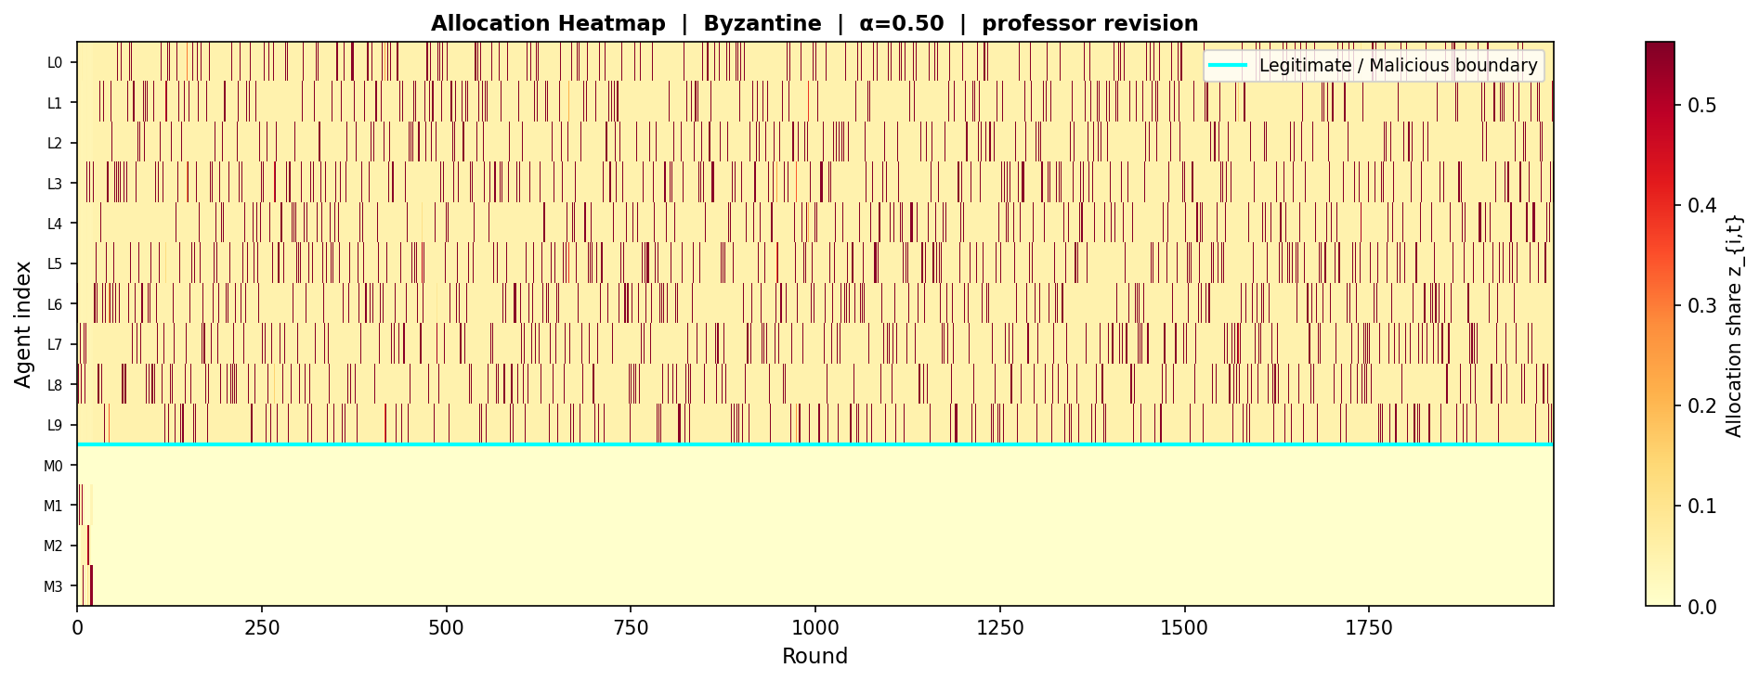
Figure 04_allocation_heatmap.png

05 Byzantine Agent Utilities
05_byzantine_agent_utilities.png
What the graph contains Two panels for the Byzantine attack. The upper panel follows cumulative utility for all 14 agents. The lower panel follows normalized Moradi weighted degree for the same agents, where a lower score indicates greater suspicion.
Why the graph exists This graph keeps agent-level welfare and graph-level suspicion visible together. It exists to show whether the agents treated as suspicious can also be tracked in their individual utility trajectories.
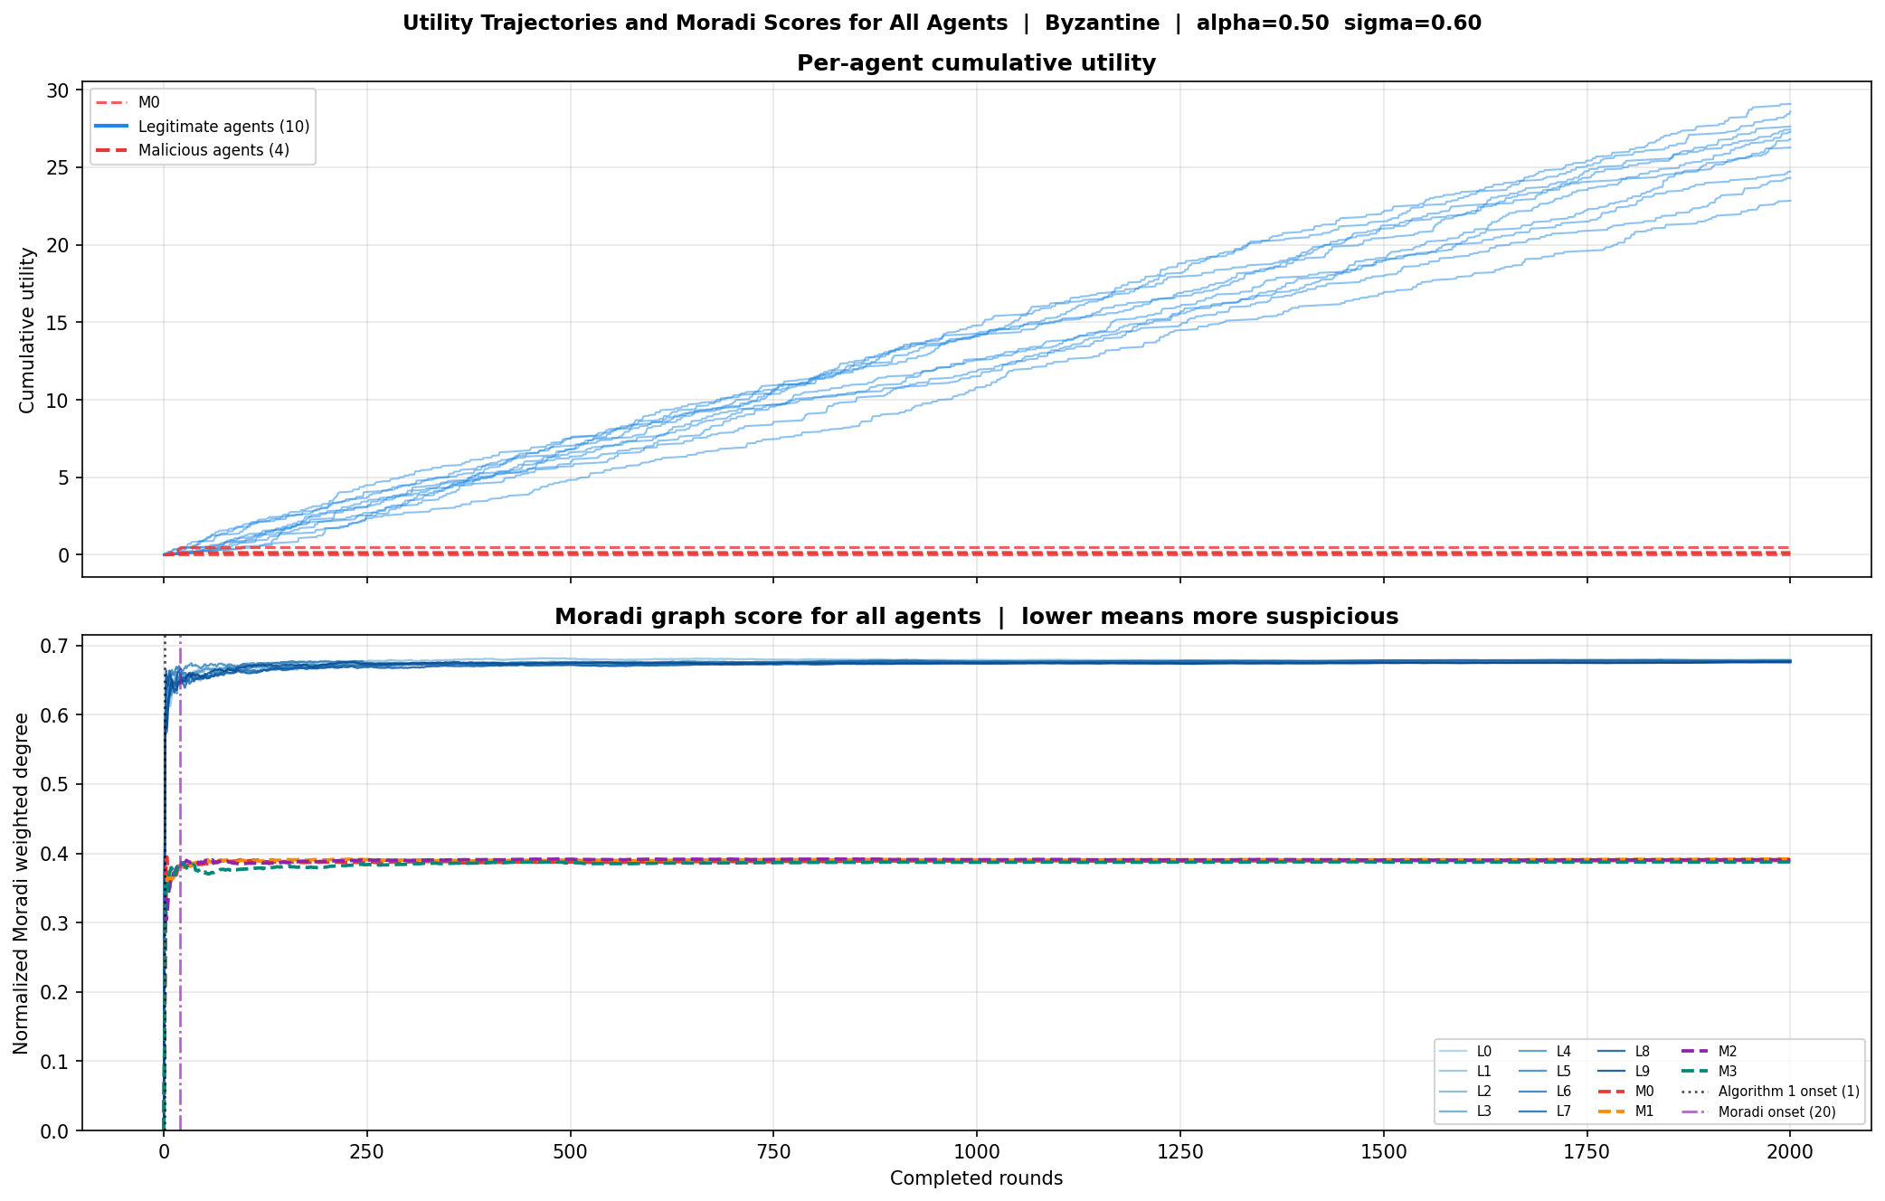
Figure 05_byzantine_agent_utilities.png

06 Reputation Poison Agent Utilities
06_reputation_poison_agent_utilities.png
What the graph contains Two panels for Reputation Poison using the same layout as the Byzantine agent figure. The upper panel contains cumulative utility for all agents, and the lower panel contains their normalized Moradi weighted-degree scores.
Why the graph exists This graph applies the same agent-level view to a stealth attack. It allows direct comparison with the Byzantine layout while keeping utility and Moradi score definitions unchanged.
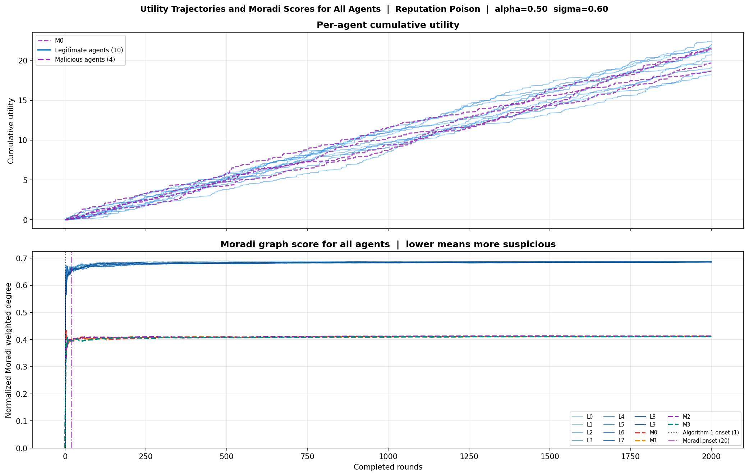
Figure 06_reputation_poison_agent_utilities.png

07 Detector Comparison
07_detector_comparison.png
What the graph contains A grouped bar chart of final F1 for Algorithm 1, spectral clustering, final Moradi graph detection, and online Moradi checkpoints under each focused attack.
Why the graph exists This graph exists to compare the detector outputs on one common metric. It separates the active detector from the alternative graph-based methods without changing the allocation experiment.
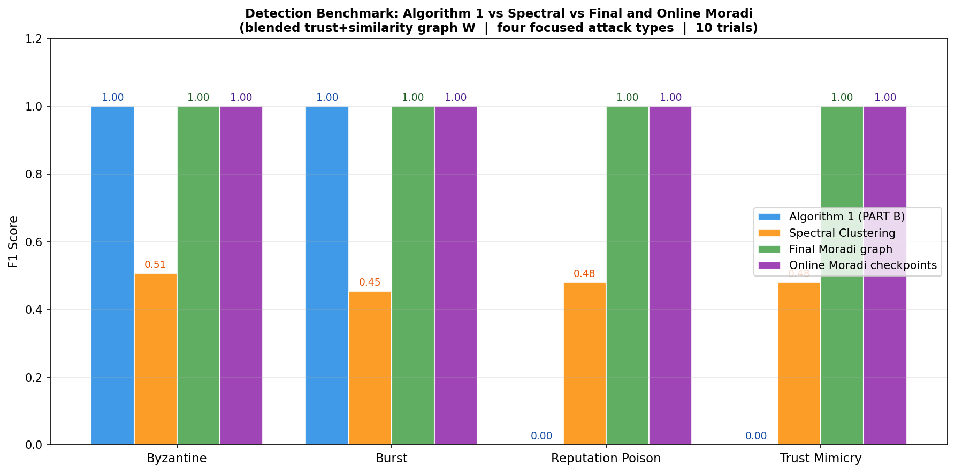
Figure 07_detector_comparison.png

08 Beta Detection Evidence
08_beta_detection_evidence.png
What the graph contains Four attack-specific panels showing the malicious beta gap, legitimate beta gap, and the Algorithm 1 threshold over 2,000 rounds, with 95 percent confidence bands.
Why the graph exists This graph exposes the quantities used by Algorithm 1. It lets the reader see the relationship between accumulated trust evidence and the threshold that determines an active detection decision.
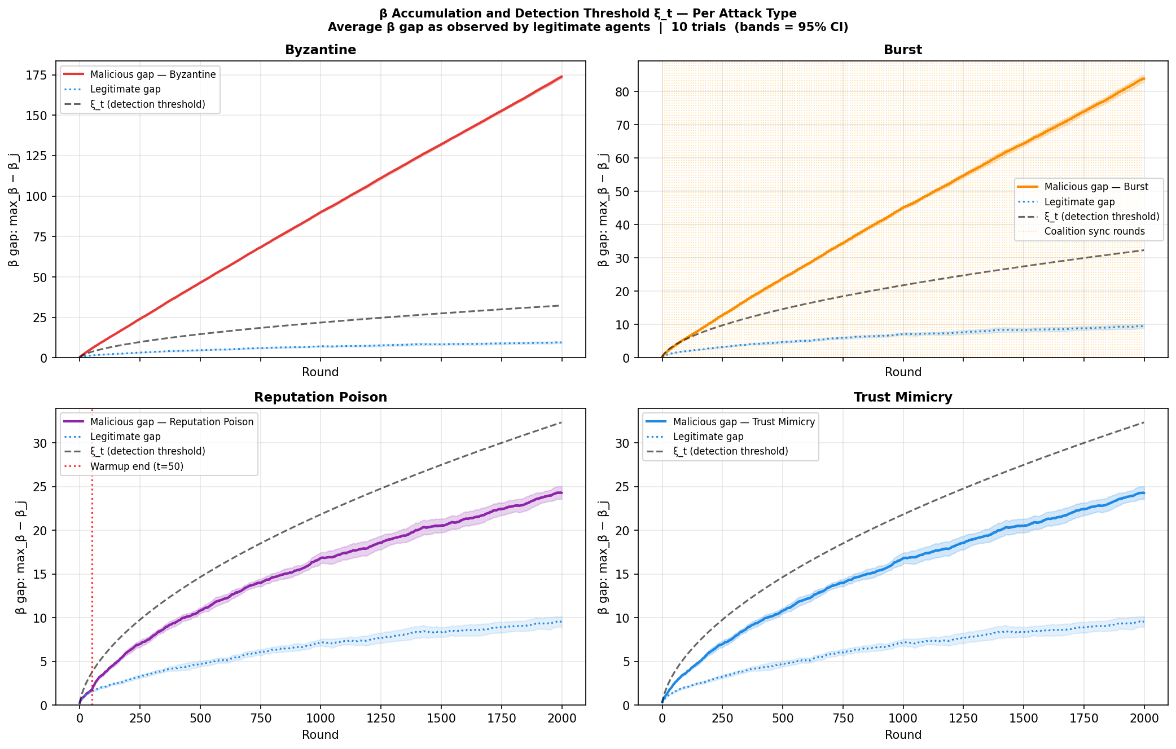
Figure 08_beta_detection_evidence.png

09 Attack Behaviour
09_attack_behaviour.png
What the graph contains Three panels describing attack activity: a rolling round-by-round attack rate, cumulative attack fraction, and phase-level average attack rate for the four focused attacks.
Why the graph exists This graph documents how often each attack is active and how that activity changes over time. It verifies that the attack generators implement distinct temporal patterns.
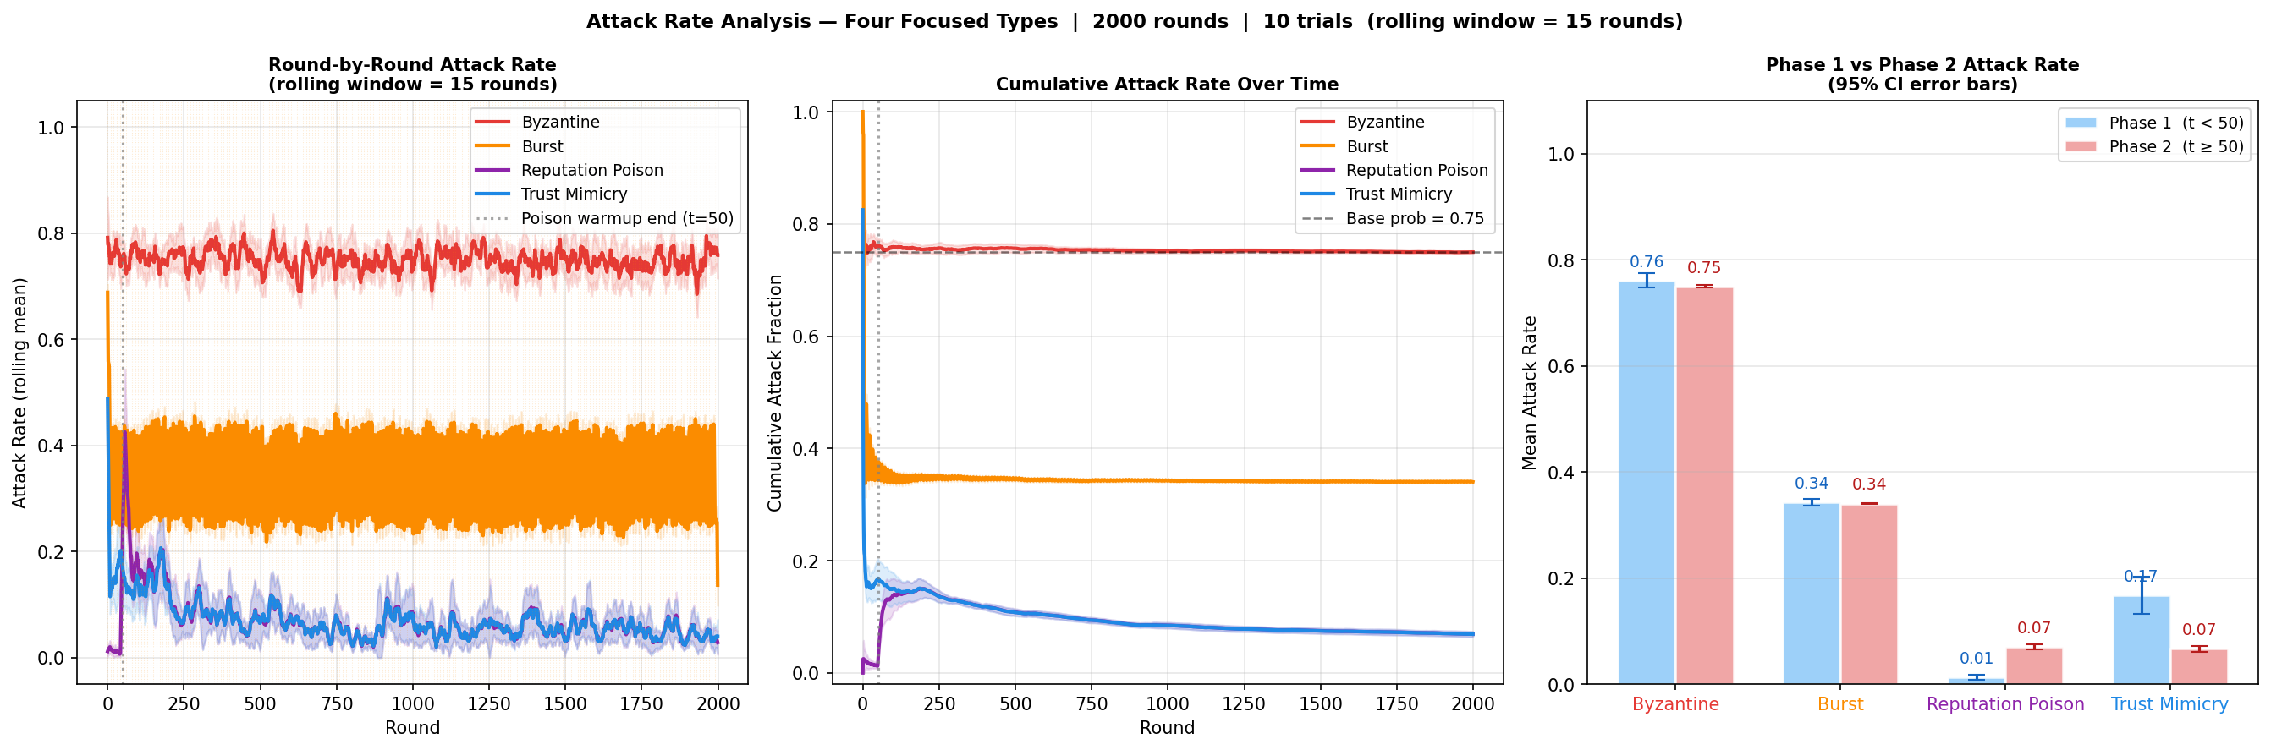
Figure 09_attack_behaviour.png

10 Adversary Count Sensitivity
10_adversary_count_sensitivity.png
What the graph contains A sensitivity curve of final online-to-offline NSW ratio when the number of malicious agents ranges from one to six. Each attack is shown with 95 percent confidence intervals.
Why the graph exists This graph checks whether the reported welfare ratio depends strongly on the chosen count of malicious agents. It also documents behavior beyond the main four-attacker configuration.
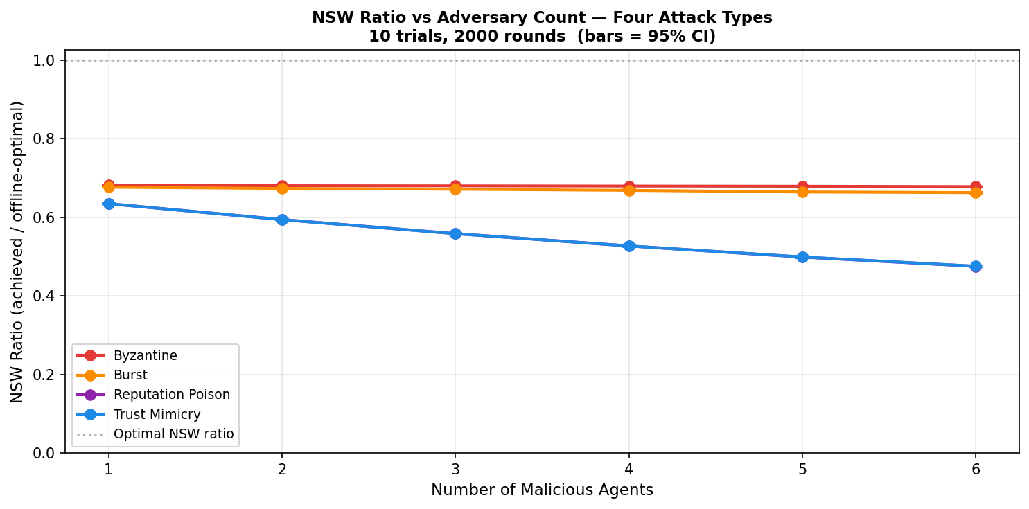
Figure 10_adversary_count_sensitivity.png

11 Alpha Tradeoff
11_alpha_tradeoff.png
What the graph contains Three sensitivity panels over alpha from zero to one. They report NSW ratio, minimum legitimate utility, and the max-minus-min legitimate utility gap. Alpha controls the split between greedy and equal allocation.
Why the graph exists This graph documents the allocation tradeoff created by alpha. It exists to show how the allocation rule changes efficiency and the distribution of utility as the equal-share component increases.
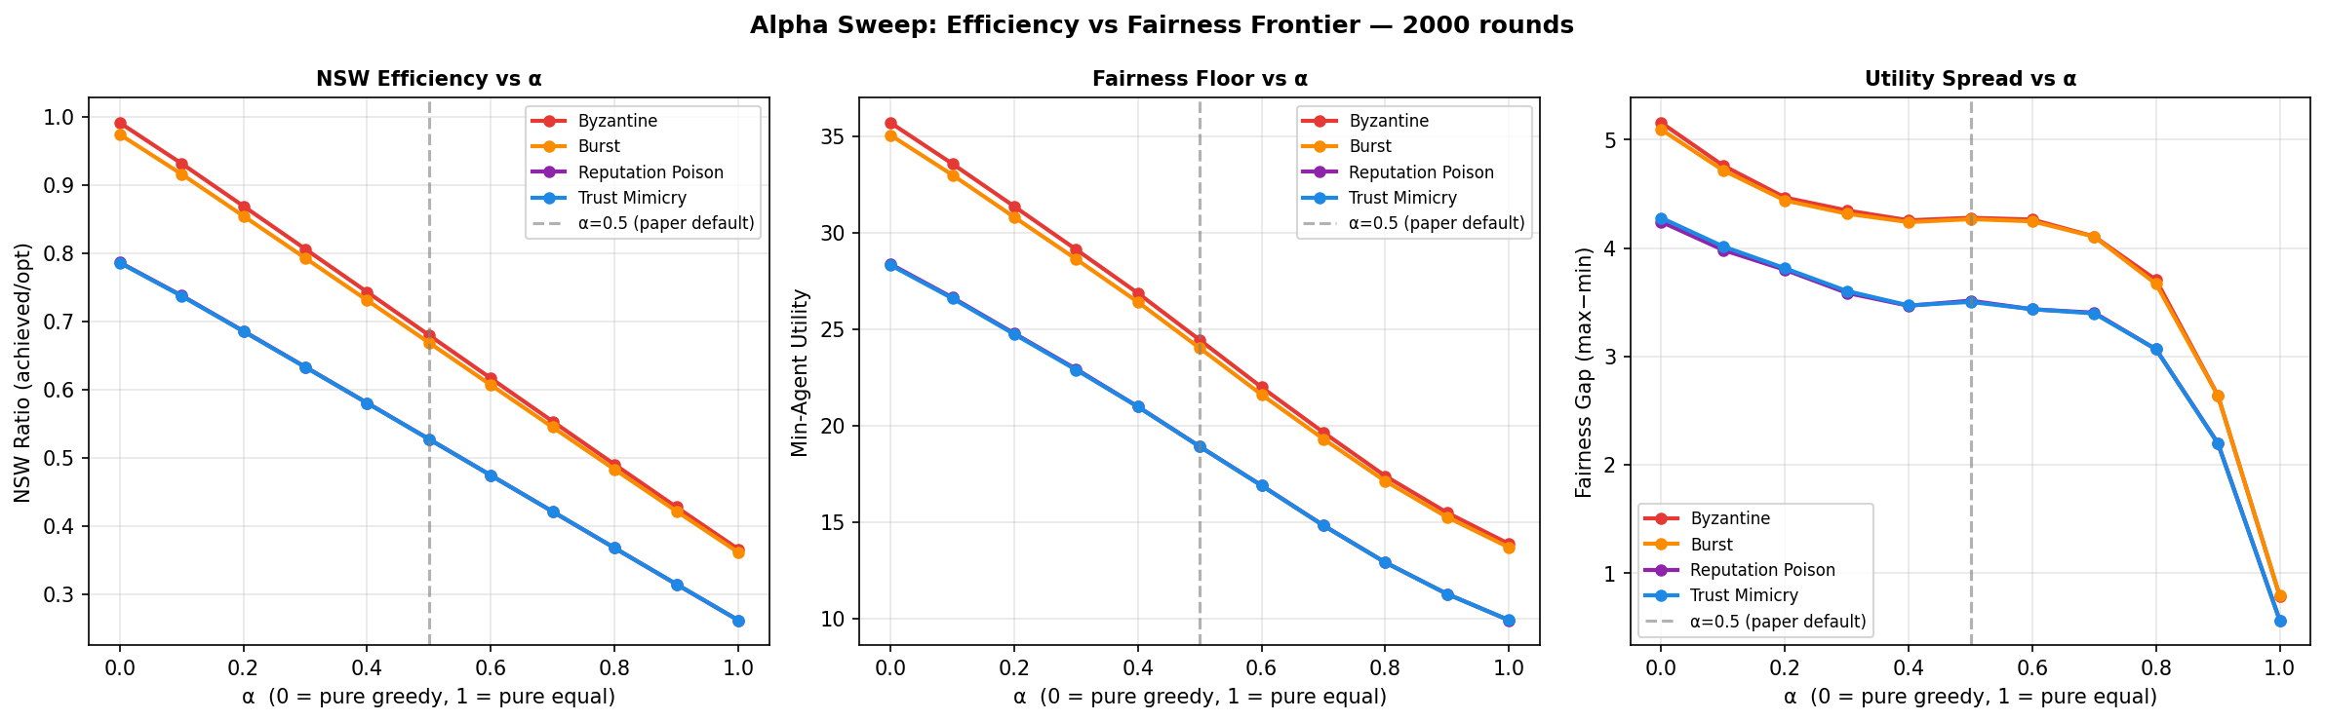
Figure 11_alpha_tradeoff.png

12 Sigma Detector Sensitivity
12_sigma_detector_sensitivity.png
What the graph contains Three sensitivity panels over sigma, the weight placed on trust in the blended Moradi graph. The panels report spectral-clustering F1, sparsest-subgraph F1, and NSW ratio.
Why the graph exists This graph documents how graph-based detection depends on the trust-versus-report-similarity blend. The NSW panel is included to show whether changing a shadow-only detector parameter changes allocation output.
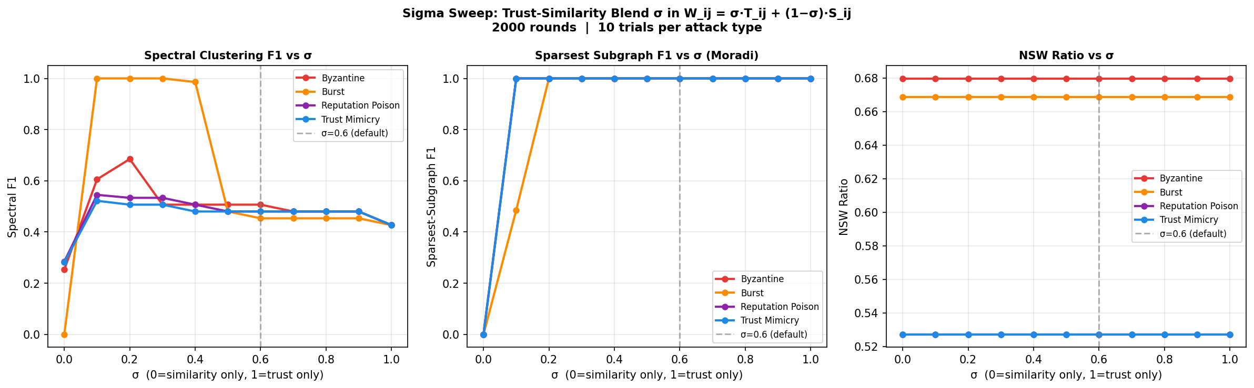
Figure 12_sigma_detector_sensitivity.png

13 Reputation Poison Phases
13_reputation_poison_phases.png
What the graph contains Three panels marking the 50-round warm-up for Reputation Poison. They show beta accumulation, detection rate over time, and legitimate NSW, with Byzantine included as a reference series.
Why the graph exists This graph separates the warm-up and later attack phase. It exists to connect the attack schedule with trust accumulation, detector output, and welfare on the same horizon.
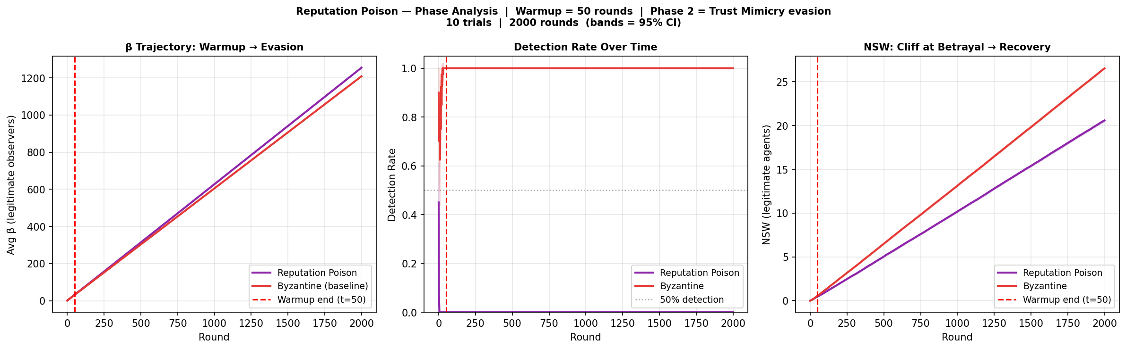
Figure 13_reputation_poison_phases.png

14 Prediction Scenario Stress Test
14_prediction_robustness.png
What the graph contains A Byzantine stress test across eight prediction scenarios. The three panels report NSW ratio, minimum legitimate utility, and detection rate, using eight trials per scenario.
Why the graph exists This graph checks how the experiment responds when the prediction input changes in structured ways. It keeps welfare, the legitimate utility floor, and detection visible as separate outcomes.
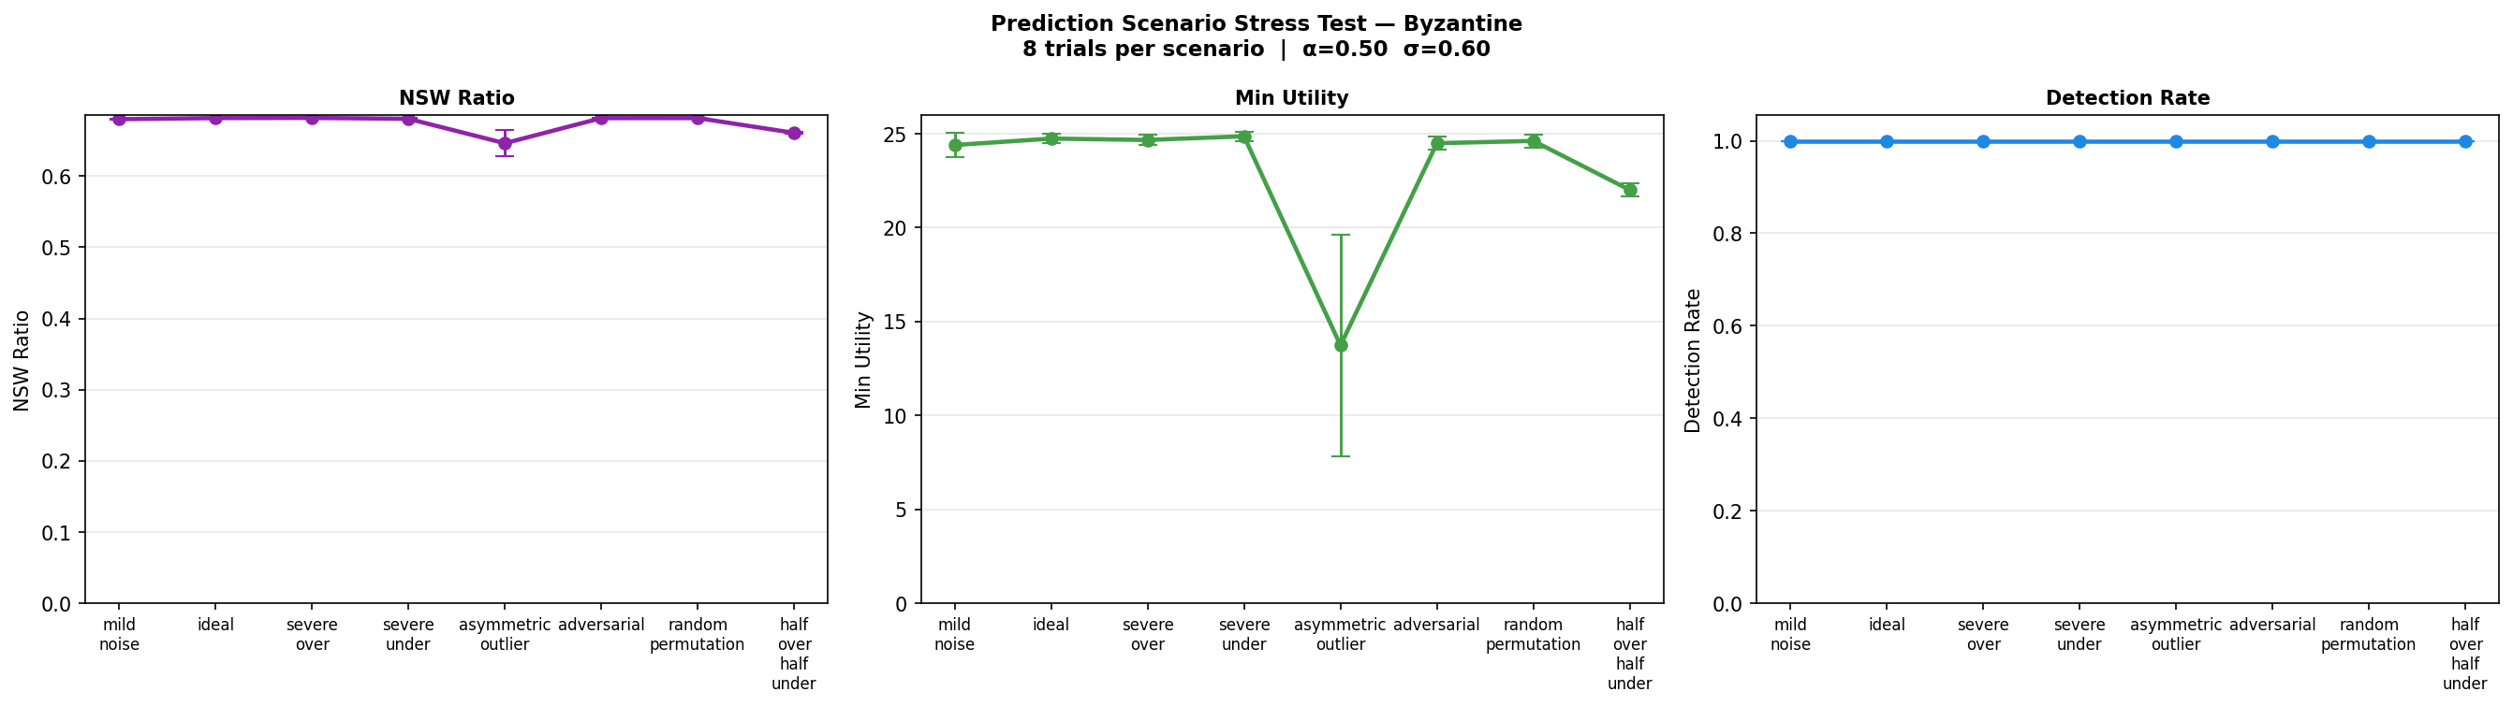
Figure 14_prediction_robustness.png

15 Compound Attack Appendix
15_compound_attack_appendix.png
What the graph contains Two panels for a heterogeneous compound attack. The left panel compares detection rate over time with individual attack types, and the right panel reports the empirical attack rate of each malicious subtype.
Why the graph exists This appendix graph documents a coalition whose malicious agents use different attack rules. It extends the focused single-type experiments without replacing them.
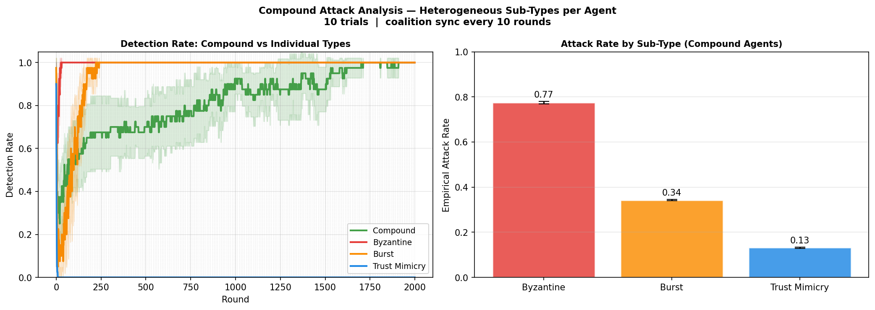
Figure 15_compound_attack_appendix.png

