NAME: | Shubham Vishwakarma
UID No. | 2021700071
BRANCH: | S.Y CSE-DS
BATCH: | D
SUBJECT | Design and Analysis of Algorithms
EXPERIMENT No. | 8
Date of Performance | 12/04/2023
Date of Submission | 18/04/2023

AIM: | Branch and bound (To implement 0/1 Knapsack problem using Branch and Bound.)
Program 1
PROBLEM STATEMENT : | Implement the 0/1 knapsack algorithm for the given scenario.
ALGORITHM/  THEORY: | Dynamic-0-1-knapsack (v, w, n, W)  for w = 0 to W do  c[0, w] = 0  for i = 1 to n do  c[i, 0] = 0  for w = 1 to W do  if wi ≤ w then  if vi + c[i-1, w-wi] then  c[i, w] = vi + c[i-1, w-wi]  else c[i, w] = c[i-1, w]  else  c[i, w] = c[i-1, w]
PROGRAM: | #include <stdio.h>  #include <conio.h>  #define MAX 100  int main()  {  int n, flag[MAX] = {0}, v[MAX], w[MAX], m[MAX][MAX], W, i, j, k;  // flag-resultant vector, v-values, w-weights  printf("Enter the number of elements: ");  scanf("%d", &n);  printf("Enter the values: ");  for (i = 1; i <= n; i++)  scanf("%d", &v[i]);  printf("Enter the weights: ");  for (i = 1; i <= n; i++)  scanf("%d", &w[i]);  printf("Enter the capacity of knapsack: ");  scanf("%d", &W);  for (j = 0; j <= W; j++)  m[0][j] = 0;  for (i = 1; i <= n; i++)  {  for (j = 0; j <= W; j++)  {  if (w[i] <= j)  {  if (m[i - 1][j] > (m[i - 1][j - w[i]] + v[i]))  m[i][j] = m[i - 1][j];  else  m[i][j] = m[i - 1][j - w[i]] + v[i];  }  else  m[i][j] = m[i - 1][j];  }  }  i = n;  k = W;  while (i > 0 && k > 0)  {  if (m[i][k] != m[i - 1][k])  {  flag[i] = 1; // to find the resultant vector  k = k - w[i];  i = i - 1;  }  else  i--;  }  printf("\n\t");  for (i = 0; i <= W; i++) // to print the first row  printf("%d\t", i);  printf("\n");  for (i = 0; i <= 10 * W; i++) // to print the line  printf("-");  printf("\n");  for (i = 0; i <= n; i++)  {  printf("%d |\t", i); // to print the vertical line  for (j = 0; j <= W; j++)  printf("%d\t", m[i][j]);  printf("\n");  }  printf("\nThe resultant vector is ");  printf("( ");  for (i = 1; i <= n; i++)  printf("%d ", flag[i]);  printf(")");  printf("\n\nThe total profit is %d", m[n][W]);  printf("\n");  /*  printf("\nThe objects selected are ");  printf("\nWeight \tProfit");  for(i=0;i<=W;i++)  {  printf("\n");  if(flag[i]==1)  {  printf("%d\t",w[i]);  printf("%d",v[i]);  }  }  */  getch();  return 0;  }
RESULT:

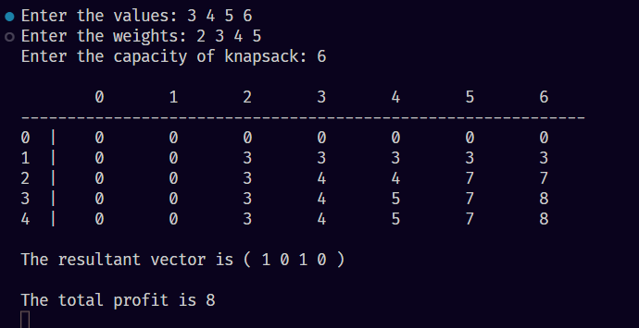

CONCLUSION : |  | In the 0-1 Knapsack Problem we have to pick the optimal set of items among all valid combinations of items. The valid combination here means that the total weight of all the selected items is less than or equal to the maximum capacity of the knapsack.

