NAME: | Shubham Vishwakarma
UID No. | 2021700071
BRANCH: | S.Y CSE-DS
BATCH: | D
SUBJECT | Design and Analysis of Algorithms
EXPERIMENT No. | 1B
Date of Performance | 30/01/2023
Date of Submission | 06/01/2023

AIM: | Experiment on finding the running time of an algorithm.
Program 1
PROBLEM STATEMENT : | For this experiment, you need to implement two sorting algorithms namely  Insertion and Selection sort methods. Compare these algorithms based on time and space complexity. Time required  to sorting algorithms can be performed using high_resolution_clock::now() under namespace std::chrono.  You have togenerate1,00,000 integer numbers using C/C++ Rand function and save them in a text file. Both  the sorting algorithms uses these 1,00,000 integer numbers as input as follows. Each sorting algorithm sorts a block  of 100 integers numbers with array indexes numbers A[0..99], A[0..199], A[0..299],..., A[0..99999]. You need to use  high_resolution_clock::now() function to find the time required for 100, 200, 300.... 100000 integer numbers. Finally,  compare two algorithms namely Insertion and Selection by plotting the time required to sort 100000 integers using  LibreOffice Calc/MS Excel. The x-axis of 2-D plot represents the block no. of 1000 blocks. The y-axis of 2-D plot  representsthe tunning time to sort 1000 blocks of 100,200,300,...,100000 integer numbers.  Note – You have to use C/C++ file processing functions for reading and writing randomly generated 100000 integer  numbers.
ALGORITHM/  THEORY: | Sorting Algorithms  Sorting Algorithms are a class of algorithms which are used to arrange the elements of a list or an array in a particular order.  There are a lot of sorting algorithms including bubble sort, selection sort, quick sort, insertion sort, heap sort, etc. This experiment focuses on insertion and selection sort. For our examples, we will consider sorting in ascending order.  Selection Sort  The selection sort algorithm sorts an array by repeatedly finding the minimum element (considering ascending order) from unsorted part and putting it at the beginning. The algorithm maintains two subarrays in a given array.  - The subarray which is already sorted.  - Remaining subarray which is unsorted.  In every iteration of selection sort, the minimum element (considering ascending order) from the unsorted subarray is picked and moved to the sorted subarray.  Following example explains the above steps:  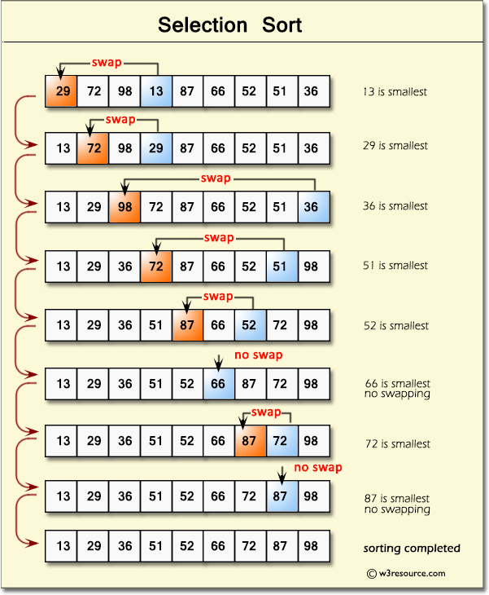  The time complexities for selection sort are given below:  Since it always has an n² time complexity, it is inefficient for large lists. We will discuss its algorithm later.  Insertion Sort  Insertion sort is a simple sorting algorithm that works similar to the way you sort playing cards in your hands. The array is virtually split into a sorted and an unsorted part. Values from the unsorted part are picked and placed at the correct position in the sorted part.  To sort an array of size n in ascending order:  - Iterate from arr[1] to arr[n] over the array.  - Compare the current element (key) to its predecessor.  - If the key element is smaller than its predecessor, compare it to the elements before. Move the greater elements one position up to make space for the swapped element.  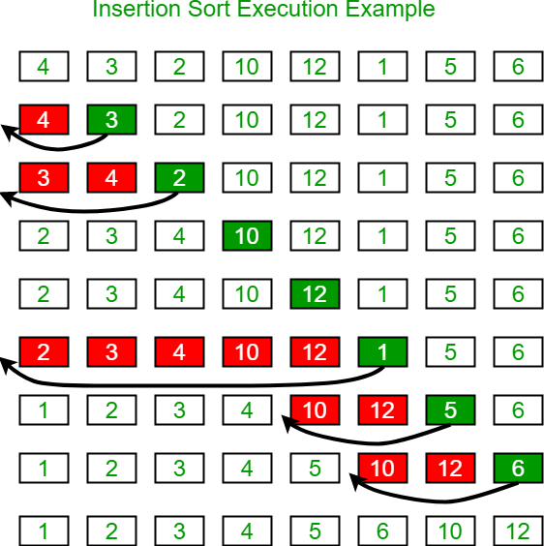  The time complexities for insertion sort are given below:  Since it always has a best-case time complexity of n, it is more efficient compared to selection sort.  Algorithms:  Selection Sort:  - START  - For i = 0 to n-2:  - minIndex = i  - For j = i+1 to n-1  - If arr[minIndex] > arr[j]  - minIndex = j  - Swap elements of array at positions i and minIndex  - END  Insertion Sort:  - START  - For i = 1 to n-1  - Key = arr[i]  - j = i – 1  - While j >= 0 and arr[j] > Key:  - arr[j+1] = arr[j]  - j = j – 1  - arr[j+1] = Key  - STOP
  Best | Average | Worst
  Ω(n²) | θ(n²) | O(n²)
  Best | Average | Worst
  Ω(n) | θ(n²) | O(n²)
PROGRAM: | #include <stdio.h>  #include <time.h>  #include <stdlib.h>  void print(int * A, int n)  {  for(int i = 0; i<n; i++)  {  printf("%d ", A[i]);  }  }  double numberGenertor(int n)  {  FILE *fp = fopen("./num.txt", "w");  clock_t start, end;  double cpu_time_used;  int p;  start = clock();  for(int i = 0; i < n; i++)  {  p = (rand() + (rand()*133));  fprintf(fp," %d\n", p);  }  end = clock();  cpu_time_used = ((double) (end - start)) / CLOCKS_PER_SEC;  fclose(fp);  return cpu_time_used;  }  void InsertionSort(int arr[], int n)  {  int i, key, j;  for (i = 1; i < n; i++)  {  key = arr[i];  j = i - 1;  while (j >= 0 && arr[j] > key)  {  arr[j + 1] = arr[j];  j = j - 1;  }  arr[j + 1] = key;  }  }  void SelectionSort(int * A, int n)  {  for(int i = 0; i<n-1; i++)  {  int min = A[i];  int pos = i;  int temp;  for(int j = i; j<n; j++)  {  if(A[j]<min)  {  min = A[j];  pos = j;  }  }  temp = A[i];  A[i] = min;  A[pos] = temp;  }  }  int main()  {  double createTime = numberGenertor(100000);  printf("\n%lf\n", createTime);  FILE * read, * fpsel, *fpins;  fpsel = fopen("./selection.csv", "w");  fpins = fopen("./insertion.csv", "w");  if(!fpsel)  return 0;  if(!fpins)  return 0;  fprintf(fpsel, "Blocks, time\n");  fprintf(fpins, "Blocks, time\n");  for(long int x = 100; x<=100000; x+=100)  {  read = fopen("num.txt", "r");  int A[x], B[x];  clock_t start1, end1, start2, end2;  // if(x % 1000 == 0)  // {  // printf("x = %ld.\n", x);  // }  for(long int i = 0; i<x; i++)  {  fscanf(read, "%d\n", &A[i]);  B[i] = A[i];  }  start1 = clock();  SelectionSort(A, x);  end1 = clock();  start2 = clock();  InsertionSort(B, x);  end2 = clock();  double t1 = (double) (end1 - start1) / CLOCKS_PER_SEC;  double t2 = (double) (end2 - start2) / CLOCKS_PER_SEC;  printf("%6d | %lf | %lf\n", x, t1, t2);  fprintf(fpsel, "%ld, %f\n",x,t1);  fprintf(fpins, "%ld, %f\n",x,t2);  fclose(read);  }  fclose(fpsel);  fclose(fpins);  }
RESULT:

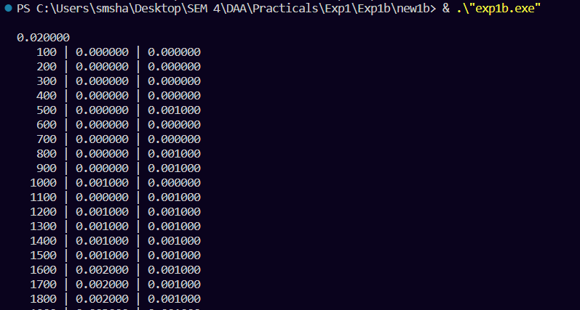
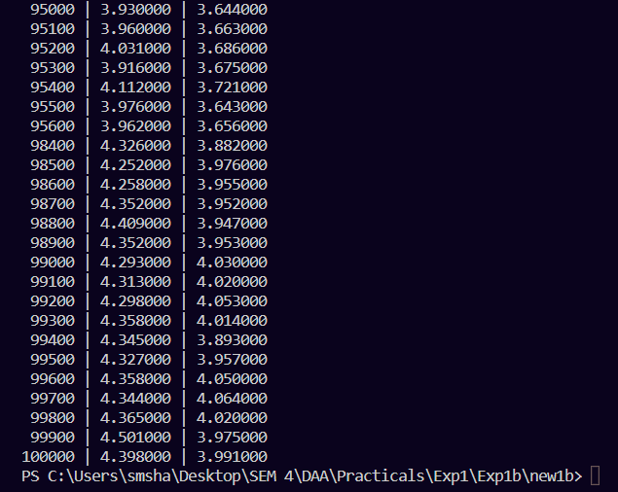

GRAPH:
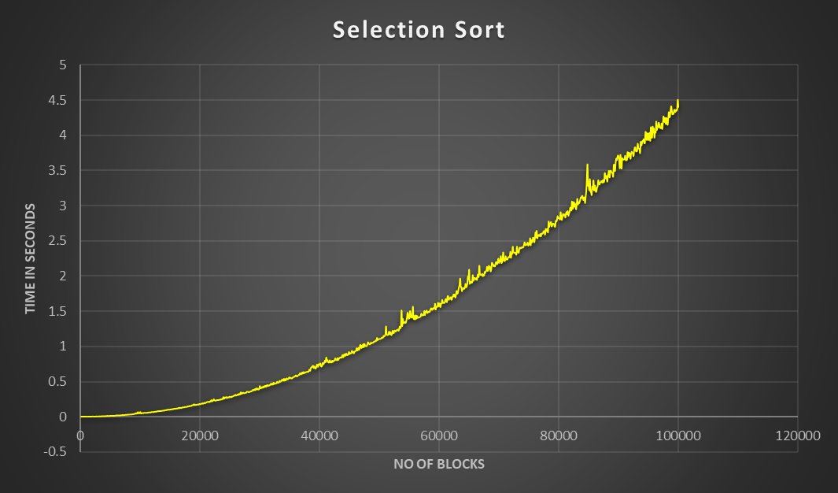

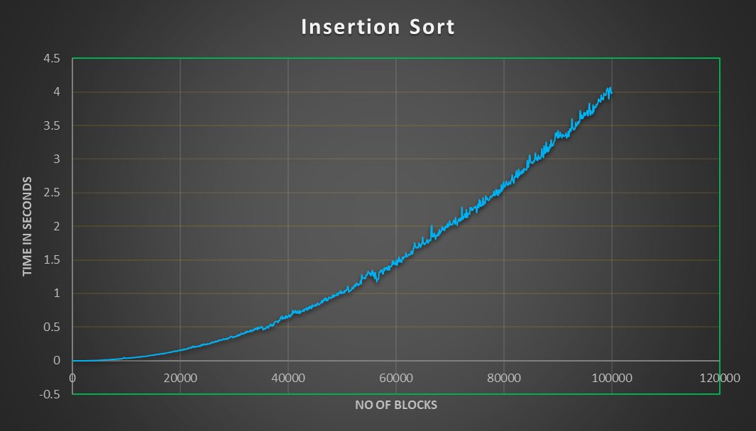
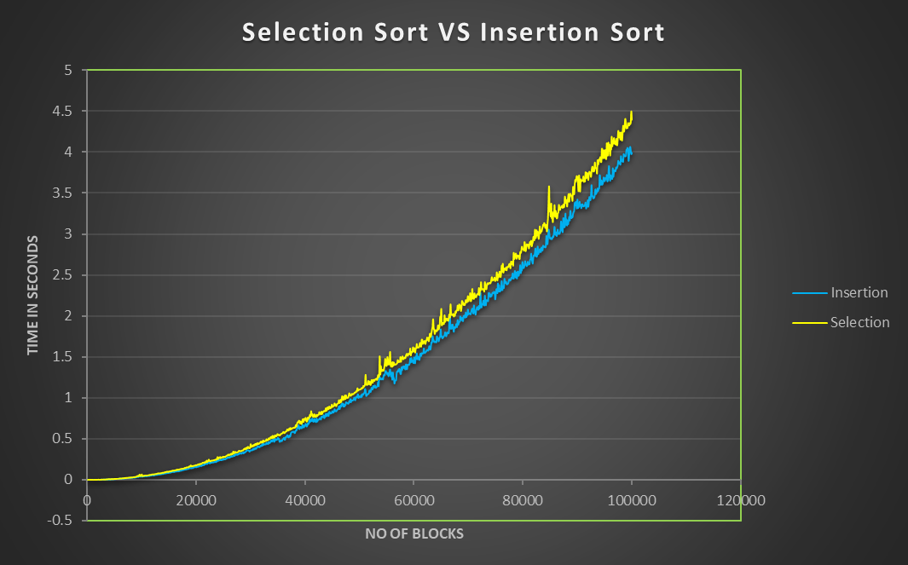

 | Best | Average | Worst
Selection Sort | Ω(n²) | θ(n²) | O(n²)
Insertion Sort | Ω(n) | θ(n²) | O(n²)

The time complexity for all 3 cases of selection sort is n². Meanwhile in insertion sort, the average and worst-case time complexity is the same – n² but the best-case time complexity is linear (in the case where the input is already sorted).
Hence, we can say that in general, insertion sort is more efficient compared to selection sort.

CONCLUSION : |  | In this experiment, we wrote a program which given 100000 integers in 1000 blocks of 100 numbers, uses the selection and insertion sort algorithms to sort them in ascending order.  In selection sort, during every iteration, we move the minimum element of the unsorted subarray to the end of the sorted subarray.  In insertion sort, during every iteration, we move the first element of the unsorted subarray to the appropriate position in the sorted subarray.  We compared the running time of insertion and selection sort by comparing the running time graph of 2 algorithms. We also analyzed the 2 algorithms in which we found that while the time complexity of selection sort is n², the best-case time complexity of insertion sort is linear (in the case where the input is already sorted). Hence, we concluded that in general, insertion sort is more efficient compared to selection sort.  Thus, we successfully accomplished the aim of this experiment.

